|  |  |
| --- | --- |
|  |  |

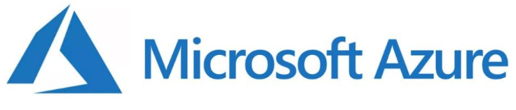

**Regions/ Zones, Subscriptions/ Accounts, Capex, Opex, Cost, SLA, IAAS-SAAS-PAAS**

**Services, Portal, VMs, App Setup Start**

- - - - - - - - - - - -

**Part 1 of 4**

**Contents**

Introduction 3

Overview of Azure 4

Main Services of Azure 4

Architecting Modern Apps on Azure 4

Cloud 4

Characteristics of the Cloud 6

Capex and Opex 8

IaaS, PaaS and SaaS 10

Types of Clouds 13

Cloud Providers 15

Azure Cloud 16

Overview 16

Regions and Zones 16

Azure Region 17

Availability zones 17

Zonal and Zone Redundant Services 18

Azure Services 23

Azure Free Account 24

Azure Portal 26

Subscription vs Account 35

Creating a Resource 36

The Resource Page 41

Azure CLI and PowerShell 46

Azure Regions 52

Resource Groups 55

Management levels and hierarchy 58

Resource tags 59

Storage Accounts 60

SLA 60

SLA Calculators 62

Cost 63

DTU ( Database Transaction Unit ) vs vcore ( Virtual Core ) 76

Setting a Budget 78

Architects and the Cloud 83

Readit App 83

Azure Compute 93

Virtual Machines 95

Removing Spending Limit 97

Creating a VM 98

The Real cost of the VM 124

Reducing the Cost of a VM 124

Availability of a VM 132

Creating Available & Cost Effective VMs 144

ARM Template 157

ARM Template in Action – Using ARM Templates 159

Deleting Virtual Machines 176

Virtual Machine Scale Set 179

Using Scale Sets 180

# Introduction

We will build something like this

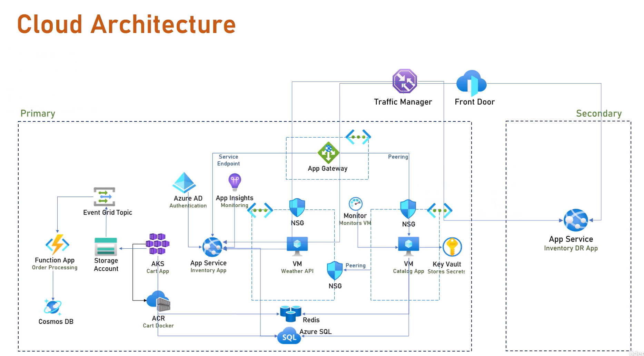

At the end of this course,you can download the Azure Architecture Summary,which is the ultimate practical guide to help you design great cloud architectureon the Azure Cloud.This handbook summarizesall what we will learn in this course,and you can use it while workingon your own projectas guidance for designing great cloud systemsin Azure.

# Overview of Azure

# Main Services of Azure

# Architecting Modern Apps on Azure

## Cloud

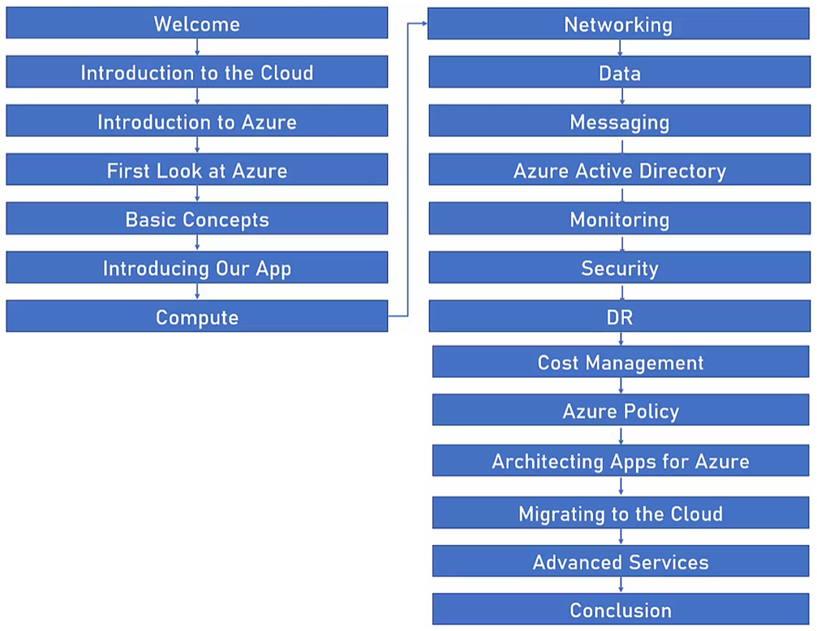

|  |  |  |
| --- | --- | --- |
| **Before the cloud . . .**  If you needed a server,  you had to:   * Buy it * Install it * Maintain it * Replace it * Have an IT team |  | **The same goes with:**   * Networking * Databases * User Management   And more... |

During regular days the CPU utilization of the Application is 60%, which is great, nothing to worry. The applications also crash and burn during peak times or Black Friday for example when the CPU utilization might jump by 300% or more. Decisions are done to increase the servers from 2 to 6 or more. Only, this time the CPU utilization stands at 90%. Now, 90% is quite good. We see that the servers are working but none of them is crashing and the website holds up. When we are back in January the CPU utilization now turns out to be only 20% of the capacity which is quite low and this continues like this for the entire year.

|  |  |
| --- | --- |
|  |  |

This is the exact problem that the cloud tries to solve.

The unscientific definition of the cloud is this.

*The cloud is compute, networking, storage, and other services managed by someone else.*







That means that there are around the world, huge data centers filled with servers, networking, storage and all other things that someone else is responsible for them to work properly. And that brings us to cloud providers.

What are cloud providers? Well, these are companies who build those huge data centers. They fill it with servers, networking,cooling, electricity, et cetera. And also, they design and install value services. And then after they do that,they make it publicly accessible.So basically, we have a huge server form that someone else is taking care of and we can just come and use it. How exactly we'll see in a minute. And here is an example of such a data center. This specific data center is Microsoft Azure Data Center in Washington.

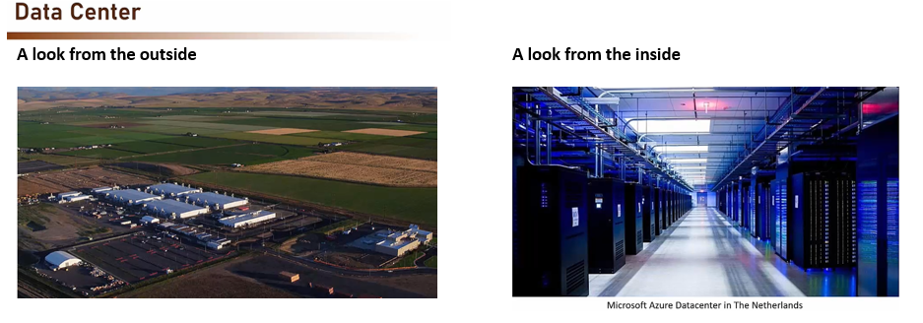

Now, in a typical data center similar to this, there are usually 100,000 physical servers. There are some larger ones, there are some smaller ones, but this is the ballpark. Now, these data centers, as we said before, contain not only servers, networking storage, et cetera, but they also have cloud services.

Now, what exactly are cloud services? Well, clouds are huge and the competition is fierce as we'll see later in this section. And that means that the cloud providers offer a lot of additional services in addition to just bare bones, virtual machines and networking. Most of them offer also AI as in artificial intelligence, IOT, as in internet of things, Kubernetes, which we'll talk about later in this course and lots more. In fact, a typical cloud provider offers hundreds of cloud services. Naturally, we want to go over all of those, but we'll discuss the most important ones. So in the cloud era, if you need a server, you can just create it in the cloud. Within minutes, of course, we will see exactly how to do that.

**Cloud Services**

Clouds are huge and the competition is fierce

Clouds offer a lot of additional services:

* **ΑΙ**
* **IOT**
* **Kubernetes**
* And lots more...

So in the cloud era, if you need a server, you can just create it in the cloud. Within minutes, of course, we will see exactly how to do that. We can use it as we wish. We pay only for what we use, we can shut it down when not needed, and then of course, we stop paying for it. And this virtual machine, this server is automatically maintained, patched, secured, and monitored by the cloud provider. All these are tasks that we and our IT team shouldn't do anymore. So that was the cloud or the introduction to the cloud.

## Characteristics of the Cloud

* **On-Demand Self Service**

What this basically means is that no human interaction is needed for resource provisioning. That means that if I need a new virtual machine or a VM, I don't need to send an email to someone or to pick a phone and talk to someone. I can do that with a click of a button. I just go to some web app, define exactly what I need, click the Create or Next or Add or something like that. And after a few minutes, I will get my virtual machine. I don't need to speak with anyone in order for that to happen. Now this provisioning is available 24/7, which made possible by the fact, again, that I don't need to speak to anyone. Everything is automated. So that is the on-demand self-service.

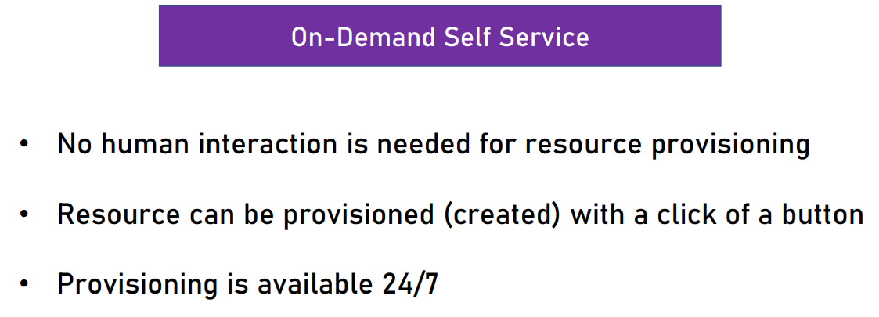

* **Broad Network Access**

Broad network access means that resources that I create in the cloud can be accessed form anywhere using the network. So I can, for example, create a virtual machine in the US and access it from my home in Israel. Now, ideally, that means that we have high broadband, because I really need good network and high bandwidth in order to access the resources that are just created on the other side of the world. In addition, no physical access is required at any time. So at no point in time do I need to access the physical host machine in the data center to perform some maintenance or to check things or maybe to take cables or anything. I don't need, and actually I can't have, and I'm forbidden to have physical access to this resource.

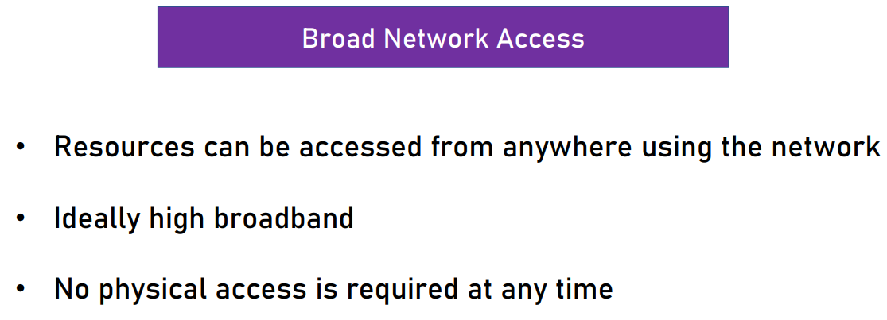

* **Resource Pooling**

Now resource pooling means that physical resources are shared between customers. So if I have a huge host machine and I create a virtual machine on it, then it's very possible that other customers, which I have no knowledge of, also will use this very same host machine to create their own virtual machine. In no way and in no time will I be able to contact these customers. I will have no idea who these customers are, and of course I won't have any access to their resources. But still the physical resources might be shared. The cloud's backbone decides which physical resource to allocate for a customer's virtual services. So in most cases, I don't have any control and I can't decide which exact or specific host machine do I want to use. This is up to the cloud backbone or the control center of the cloud. It is the one who make these decisions. Now, some advanced cloud services allow for physical resource separation, mainly for security reasons. Some services, for example, allow us to define that this service is going to be created on a separate physical host. They still don't allow us to select which host to use, but we can still define that we want to use a separate host. Of course, these services are considerably more expensive than the usual ones, but still it's possible, and it's up to us to make this decision.

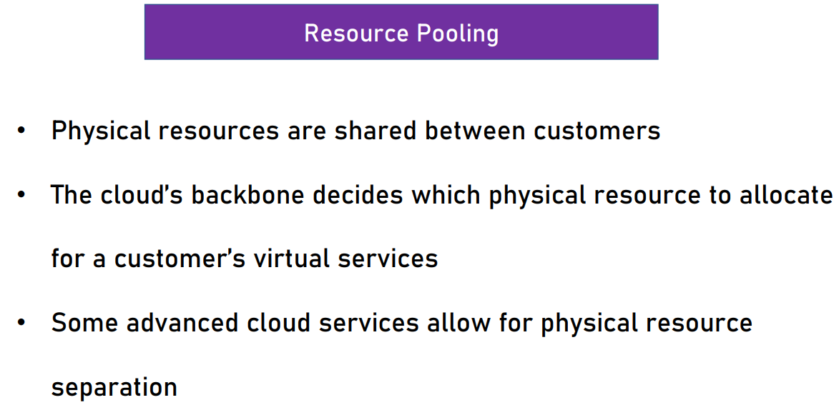

* **Rapid Elasticity**

Rapid Elasticity means that resources can be scaled up and down as needed automatically. So if you remember the example that we discussed earlier about the electric shop, then if we had this capability of scaling up and down and helping our two servers to become four on November and then back to two on December, then that would be great. And this is exactly what the cloud enables us. There is no need to purchase resources for a one-time peak scenario. Again, which was the exact problem we had in our example. And this is one of the most important capabilities of the cloud and one of the great motivations of on-premise organizations to move to the cloud. As you'll see later in our own example, this works rather well.

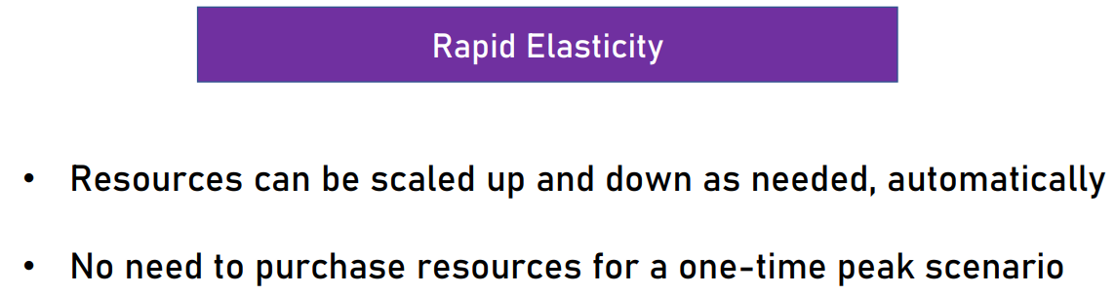

* **Measured Service**

Measured service means that the payment is done only for resources actually used. So that means, again, that if I decide to use, let's say, two virtual machines, then I pay only for those two virtual machines. If later I add another one, then I will pay for this one also. And if after that I decide to shut it down, then at this exact moment I stop paying for it. So some examples for how to measure the service we use is for example, paying for server time, which is the example we just discussed. DB storage, where we pay for the storage we use in the database function calls, which we will discuss later, and so on. So basically, as you can see, we pay only for what we actually use. The measurement usually done in high-resolution. For example, server time is measured by the second and not, for example, by the hour or by the day. And the very important bottom line here is that we don't need to invest money in non-used resources.

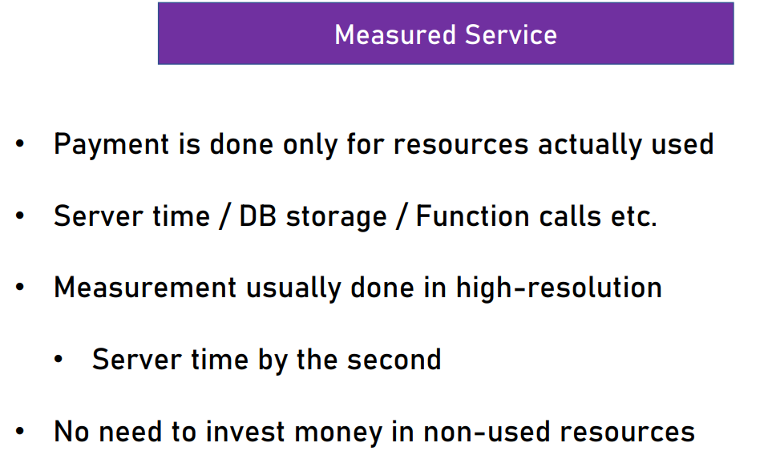

## Capex and Opex

So these are the five characteristics of cloud computing, and I hope that by now you understand better what are the advantages of using cloud and how it can help you use your resources more efficiently and effectively.

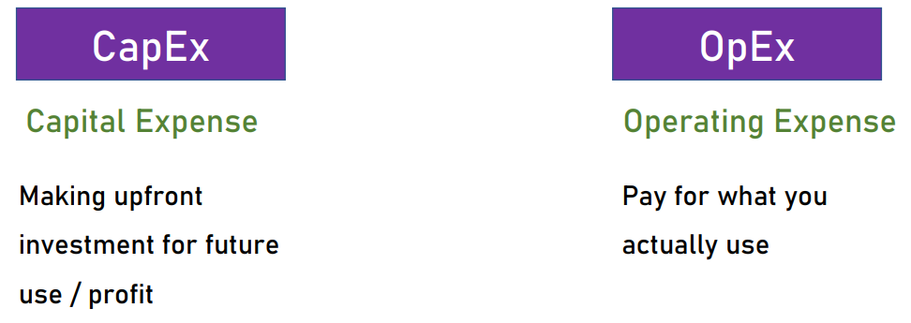

To better understand the financial aspects of using the cloud, there are two terms we need to know. These are CapEx and OpEx. These terms stand for capital expense and operating expense.

|  |  |
| --- | --- |
| **Traditional IT - CapEx Oriented**  Major investment for:   * Building data center * Purchasing servers * Purchasing air conditioning * Purchasing network devices * Purchasing software licenses (DB etc.)   . . . And only then it can be used . . .  There's also OpEx involved:   * Electricity * Salaries * Maintenance   And more . . . | **Now, what does it mean?**  Capital expense or CapEx means that we're making upfront investment for future use or profit. For example, as we discussed before, we bought the four servers, we paid for them upfront and then we just use them.  OpEx, on the other side is paying for what you actually use. Now, what's important to understand is that traditional IT is CapEx oriented. That means that we have major investment for building data center, purchasing servers, purchasing air conditioning, purchasing the network devices and of course purchasing software licenses. And only then, after doing all that, and spending all that money, we can finally use it. Now, even though traditional IT is CapEx oriented, there are also some OpEx involved. For example, electricity, usually paid by the month. Salaries, of course, we pay the IT guys every month. Maintenance is also an ongoing payment and more. So in traditional IT, we have mainly CapEx but also a lot of OpEx. |

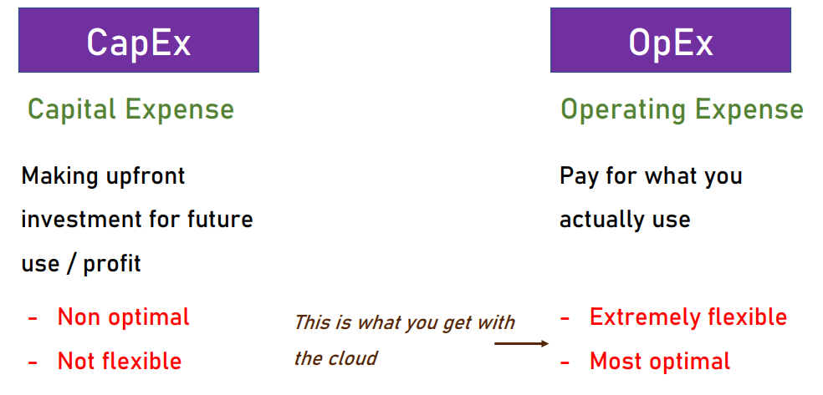

So to summarize, these are CapEx and OpEx. CapEx is non-optimal and not flexible. And OpEx on the other hand, is extremely flexible and the most optimal method we want to use and this is what we get with the cloud. The cloud enables us to make all our investment in IT OpEx, which makes it much more financially efficient.

## IaaS, PaaS and SaaS

In order to better understand what are the types of cloud services, let's take a look at the three most common types. And these types are IaaS, PaaS, and SaaS.



laaS

**Infrastructure as a Service**

The cloud provides the underlying platform

* Compute
* Networking
* Storage

The client handles, and is responsible for all the rest

So IaaS stands for, Infrastructure as a Service. And what it means, is that, the cloud provides the underlying platform, such as compute, networking, and storage. And then the client is responsible for all the rest. In other words, the cloud provides the absolute minimum infrastructure and we, the clients of the cloud, are expected to take care of all the rest. The most common example of IaaS is, Virtual machines. With virtual machines, the cloud provides the host machine, the networking, and the discs, and the client creates the virtual machine or the guest machine, and then he installs software on it, patches it, maintains it, Et cetera. So it is the responsibility of the client to make sure that the virtual machine is up and running and the cloud has nothing to do with it.

PaaS

PaaS is, Platform as a Service, And with the PaaS services, the cloud provides platform, for running apps. That means that the cloud provides the compute, networking, storage, runtime environment, scaling redundancy, security updates, patching, maintenance et cetera. and the client just needs to bring the code to run. So our responsibility as a client of the cloud is to develop our software and then upload it to the cloud, and the cloud takes care of all the rest. The most common example Of PaaS are of course, web apps. With web apps, the cloud provides the runtime for running web apps, and the client only uploads the code, and then it just runs. Now, what's important to note with PaaS is that, the Client has no access to the underlying virtual machines. While with IaaS we can, and should actually access the virtual machine and make sure that everything is fine. With Pass, we simply don't have access to this. It Is the responsibility of the cloud to make sure the application is up and running.

SaaS

And the last Type of services is SaaS. SaaS Stands for, Software as a Service. And what it means is that, it's a software running completely in the cloud. The user, or us in this case, we don't need to install anything on premises or on the machine. The provider of the software takes care of updates, patches, redundancies, scalability, et cetera. We can only use the software, but we can't and shouldn't mess with the underlying infrastructure of it. So the most common examples of SaaS are software such as Office 365 and Salesforce which are installed in the cloud. And we as users just use it. We have no idea what is the infrastructure that Office 365 and Salesforce are running on. What are the virtual machines, what language are they developed in, what is the database, and so on, we just use it. So to summarize the three types of services, take a look at this chart. So this chart depicts the level of control we need to have on each type of resource, with each type of service. So if you'll start from the left, we see that on On-Premises resources, we take control of everything. So if you'll take a look from the bottom, up we see we are responsible for the networking, the storage, the servers, the virtualization, the operating system middleware, runtime, data and applications. We take control of everything, which is just natural. These resources run on our premises. So of course we need to take con

|  |  |
| --- | --- |
| So of course we need to take control of everything. Next is the infrastructure as a service. And with IaaS, we see that the cloud takes control of the networking, storage, servers and virtualization and we control everything that's above it which is in this case the operating system, the middleware the runtime, data, and applications. In other words, the virtual machine. With the platform as a service, we control the data and the applications, the cloud controls all the rest. So it takes control on the virtualization, for example of the middleware, of the runtime, which is very important with, platform as a service or with web apps and so on. And with software as a service, we control nothing. We just use the application but we have no access to the underlying infrastructure. So as you can see the cloud controls everything with software as a service. |  |
| Now, actually, there are additional service types such as  **FaaS**, Functions as a Service,  **DBaaS**, Database as a Service,  **DaaS**, which is Desktop as a Service,  **IOTaaS** which is, IoT as a Service, and even  **AIaaS**, which is, AI as a Service.  But still the most common terms are IaaS, PaaS, and SaaS. But still the most common terms are IaaS, PaaS, and SaaS. |  |

Source:

<https://learn.microsoft.com/en-us/azure/cloud-adoption-framework/manage/monitor/monitoring>

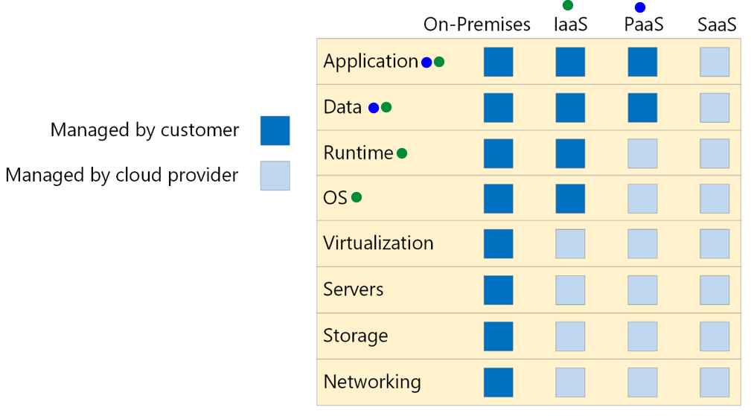

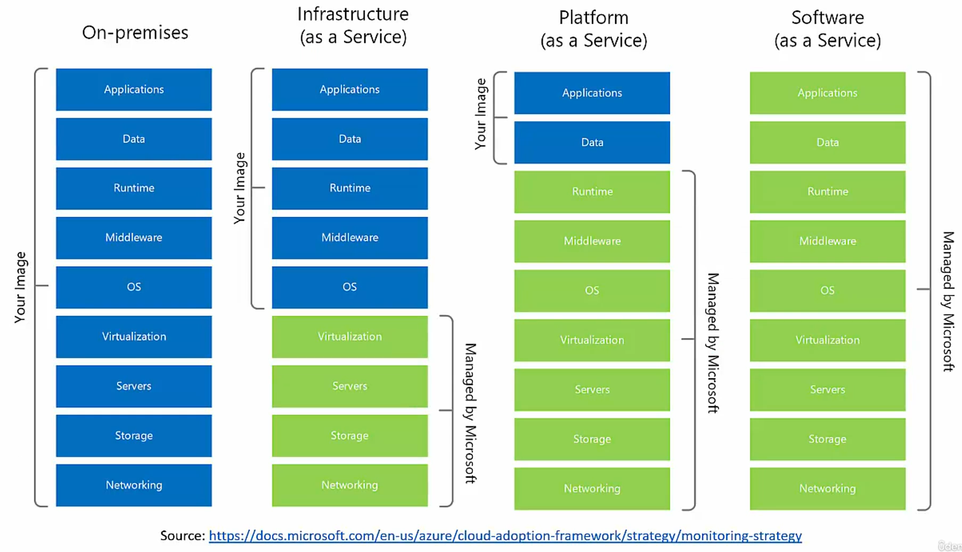

## Types of Clouds



We actually talk about one of three types of cloud. And it's important to know the differences between the three types of cloud that we have. And the three types are: Public Cloud, Private Cloud, and Hybrid Cloud. And let's begin with Public cloud. So the public cloud is a cloud that is set up in the public network. It is managed by large companies, such as Microsoft, Amazon, Google, and so on. It is accessible through the internet. So we don't need a specialized internal network to access the cloud. It is also available to all clients and users, and not only users of a specific organization. And, the clients have no access to the underlying infrastructure. This is similar to what we discussed before in the previous lecture, when we said that either with IaaS, PaaS, or SaaS, we don't have access to the underlying infrastructure of the cloud. We can only use resources that are built on this infrastructure. So, this is a public cloud. The most popular public clouds are AWS of Amazon, Azure of Microsoft, Google Cloud, and IBM Cloud. Of course, there are a lot more public clouds, such as Oracle Cloud, Ali Baba Cloud, and so on. So, this is the public cloud.

Next, is private cloud. Private cloud is a cloud setup in an organization's premises. It is managed by the organization's IT team, and is accessible only in the organization's network. So naturally, it's available only to users from the organizations, other users, other external users that are not members of this organization, don't have access to this cloud. This cloud uses private cloud infrastructure and engines, and it's usually contains only a subset of the public cloud's capabilities. Organizations usually use private cloud for security reasons, because they want the resources and data to be stored inside their organization premises, and they don't want them to be exposed in the public cloud. So some examples of private clouds, are VMware Cloud, Red Hat OpenShift, and Azure Stack.

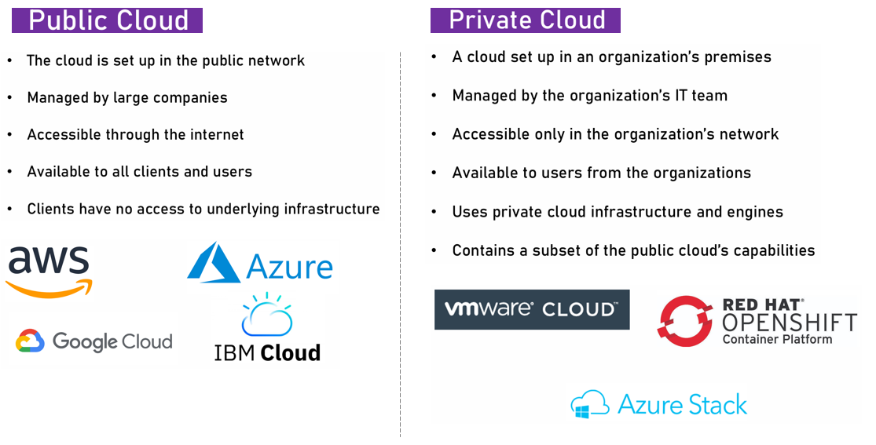

|  |  |
| --- | --- |
| Next, is a hybrid cloud. So a hybrid cloud is a cloud that is set up in an organization's premises, but it is also connected to the public cloud. That means that workload can be separated between the two clouds. For example, sensitive data in the organization's premises, and public data in the public cloud. So for example, the organization can decide that the usernames and passwords, and perhaps even the credit cards of its users will be stored inside the organization's premises. But for example, the professional profile of its users, such as the ones in LinkedIn, will be stored in the public cloud. Now, usually hybrid clouds are managed by the public cloud, which is connected to the private cloud. But this is not always the case. And sometimes you can see it the other way around. So, that the private cloud controls and manages the resources in the public cloud. So, some examples for hybrid cloud are, Azure Arc, and AWS Outposts. Both extend the public cloud into the organization's premises, and manage and control this private cloud from the public cloud. So, these are the three types of cloud. We have the public, the private, and the hybrid. We're going to discuss only the public cloud. This is the most important type of cloud. |  |

|  |  |
| --- | --- |
| Cloud Providers Well, these are basically companies which build data centers and provide public cloud services such as IaaS, PaaS, and SaaS, and of course many other services of which we'll cover quite a few in this course.  Now, these are the main cloud providers as of today, and you can take a look at the top right quarter of this magic wand, and you can see that the top three public cloud providers are Amazon Web Services, Microsoft with Azure, and Google with Google Cloud Platform, or GCP.  <https://aws.amazon.com/blogs/aws/read-the-2023-gartner-magic-quadrant-for-strategic-cloud-platform-services/> |  |

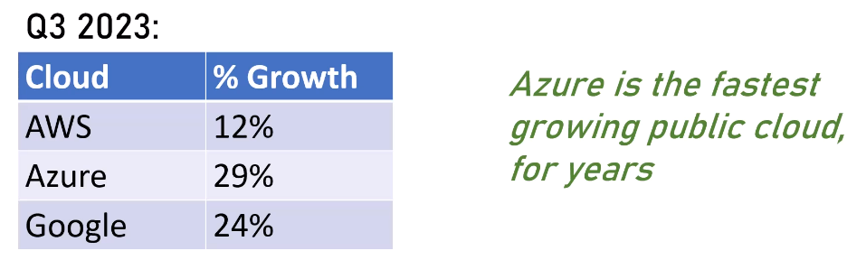

# Azure Cloud

## Overview

|  |  |
| --- | --- |
| * Microsoft’s public cloud * Announced in October 2008 * Released in February 2010 * The 2nd largest public cloud * Closing the gap… | * First focused on PaaS services * To counter AWS’s IaaS focus * Later added IaaS * Currently offers the largest variety of cloud services |

Currently, Azure offers the largest variety of cloud services, as we will see in a few minutes. Now, here are some of the major clients of Azure worldwide

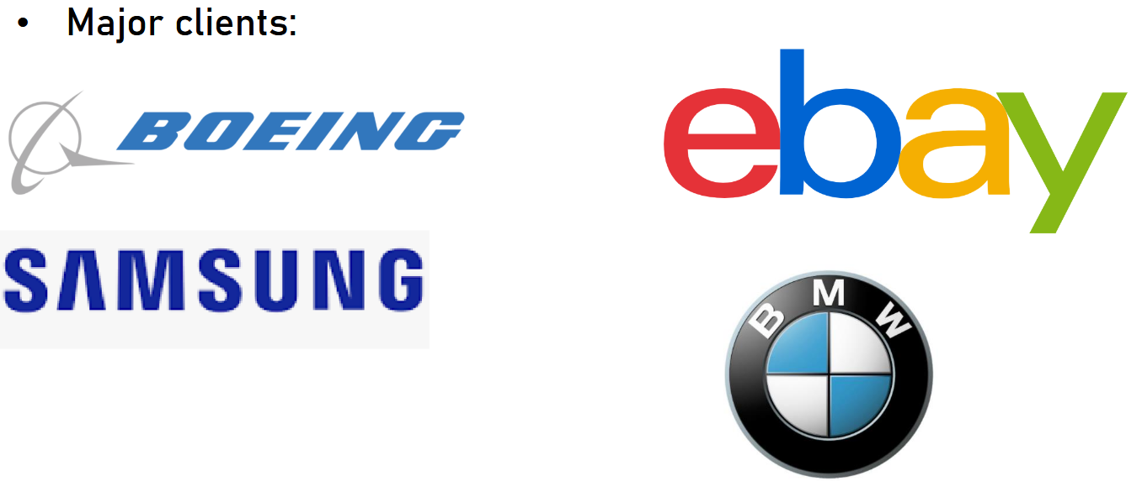

## Regions and Zones

* Microsoft built a lot of datacenters for Azure
* Each datacenters’ location is called Region
* There are ~60 Azure Regions (more than any other cloud)
* Almost every new resource in the cloud should be allocated to a region

Azure provides over 60 regions globally, that are located across many different geographies. Each region is a set of physical facilities that include datacenters and networking infrastructure. All regions may be divided into geographical areas called geographies. Each geography is a data residency boundary, and may contain one or more regions.

Many regions provide certain types of resiliency options, such as availability zones, region pairs, and nonpaired regions. When you choose a region for your services, it's important to pay attention to the resiliency options that are available in that region. This article helps you understand Azure regions, and gives you an overview of the resiliency options that some Azure regions support, while offering links to more detailed information on each topic.

Azure regions are independent of each other. However, Microsoft associates some Azure regions with another region, where both are usually in the same geography. Together the regions form a region pair. Many other regions aren't paired, and instead use availability zones as their primary means of redundancy.

Region pairs are used by some Azure services to support geo-replication and geo-redundancy, and to support some aspects of disaster recovery in the unlikely event that a region experiences a catastrophic and unrecoverable failure.

### Azure Region

|  |  |
| --- | --- |
| An Azure region consists of one or more datacenters, connected by a high-capacity, fault-tolerant, low-latency network connection.  Azure datacenters are typically located within a large metropolitan area.  Every region is contained within a single geography that serves as a fixed data residency boundary. If you have data residency requirements, it's important that you select regions within the required geography. Each geography has at least one region equipped with availability zones. |  |

Most regions are available to all Azure customers. However, some regions belong to sovereign cloud geographies, which are available to some customers in specific geographic areas with stringent data residency regulations. Sovereign cloud regions work the same way as other regions, however they're often limited in the services and features of services that they provide.

<https://datacenters.microsoft.com/globe/explore>

While all Azure regions provide high-quality services such as data residency and latency optimization, they can differ in the types of resiliency options they support.

### Availability zones

Many Azure regions provide availability zones. Availability zones are independent sets of datacenters that contain isolated power, cooling, and network connections. Availability zones are physically located close enough together to provide a low-latency network, but far enough apart to provide fault isolation from such things as storms and isolated power outages. Most Azure services provide built-in support for availability zones and you can decide how to use them to meet your needs. When you design an Azure solution, you should use availability zones to provide redundancy and fault isolation.

Many Azure regions provide availability zones, which are separated groups of datacenters within a region. Availability zones are close enough to have low-latency connections to other availability zones. They're connected by a high-performance network with a round-trip latency of less than approximately 2 ms. However, availability zones are far enough apart to reduce the likelihood that more than one will be affected by local outages or weather. Availability zones have independent power, cooling, and networking infrastructure.

They're designed so that if one zone experiences an outage, then regional services, capacity, and high availability are supported by the remaining zones. They help your data stay synchronized and accessible when things go wrong.

Datacenter locations are selected by using rigorous vulnerability risk assessment criteria. This process identifies all significant datacenter-specific risks and considers shared risks between availability zones.

The following diagram shows several example Azure regions. Regions 1 and 2 support availability zones, and regions 3 and 4 don't have availability zones.

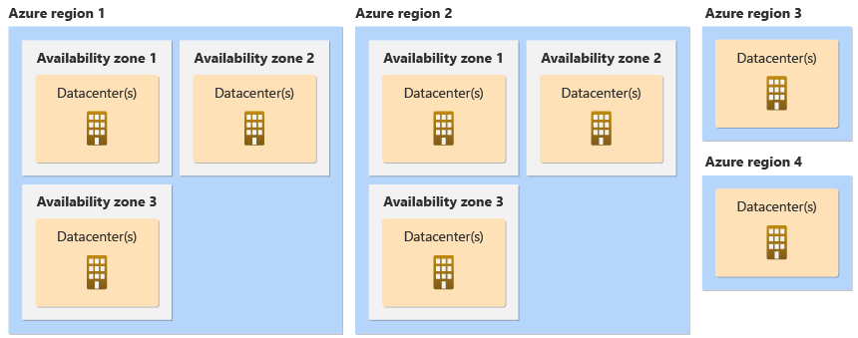

### Zonal and Zone Redundant Services

When you deploy into an Azure region that contains availability zones, you can use multiple availability zones together. By using multiple availability zones, you can keep separate copies of your application and data within separate physical datacenters in a large metropolitan area.

There are two ways that Azure services use availability zones:

**Zone-redundant resources** are spread across multiple availability zones. Microsoft manages spreading requests across zones and the replication of data across zones. If an outage occurs in a single availability zone, Microsoft manages failover automatically.

**Zonal resources** are pinned to a specific availability zone. You can combine multiple zonal deployments across different zones to meet high reliability requirements. You're responsible for managing data replication and distributing requests across zones. If an outage occurs in a single availability zone, you're responsible for failover to another availability zone.

Azure services support one or both of these approaches. Platform as a service (PaaS) services typically support zone-redundant deployments. Infrastructure as a service (IaaS) services typically support zonal deployments.

Some services don't use availability zones until you configure them to do so. If you don't explicitly configure a service for availability zone support, it's called a non-zonal or regional deployment. Resources configured in this way might be placed in any availability zone in the region, and might be moved. If any availability zone in the region experiences an outage, non-zonal resources might be in the affected zone and could experience downtime.

**Physical and logical availability zones**

Each datacenter is assigned to a physical zone. Physical zones are mapped to logical zones in your Azure subscription, and different subscriptions might have a different mapping order. Azure subscriptions are automatically assigned their mapping at the time the subscription is created. Because of this, the zone mapping for one subscription could be different for other subscriptions.

For example: A subscription named "finance" may have physical zone X mapped to logical zone 1, while another subscription named "engineering" has physical zone X mapped to logical zone 3, instead.

To understand the mapping between logical and physical zones for your subscription, use the List Locations Azure Resource Manager API. You can use the Azure CLI or Azure PowerShell to retrieve the information from the API.

az rest --method get

--uri '/subscriptions/{subscriptionId}/locations?api-version=2022-12-01'

--query 'value[?availabilityZoneMappings != `null`]

.{displayName: displayName, name: name,

availabilityZoneMappings: availabilityZoneMappings}'

[Reliability Guidance Overview](https://learn.microsoft.com/en-us/azure/reliability/reliability-guidance-overview)

Regions

* Microsoft built a lot of datacenters for Azure
* Each datacenters’ location is called Region
* There are ~60 Azure Regions (more than any other cloud)
* Almost every new resource in the cloud should be allocated to a region

( So when we build a new virtual machine, for example, we tell Azure in which region it should be built. )

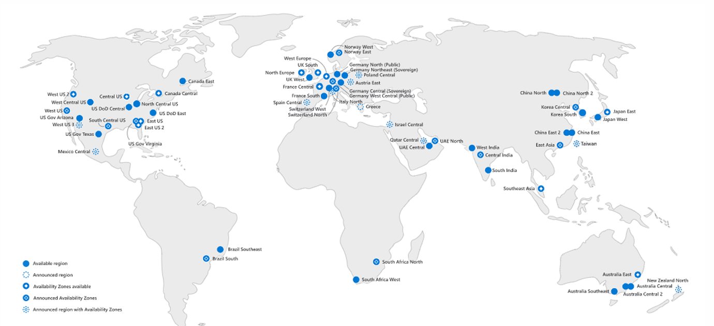

Take a look at the legend. As you can see, there are available regions, announced regions, availability zones, announced availability zones, and announced region with availability zones.

For example, right at the middle of the screen you can see Israel Central. This region was announced about a year ago and it should be up and running by the end of 2021. Now, if you count the number of regions on this map you will find out there are roughly 60 of them. So as you can see, Azure is spread across all the world and you can find Azure regions on all continents.

<https://datacenters.microsoft.com/globe/explore/>

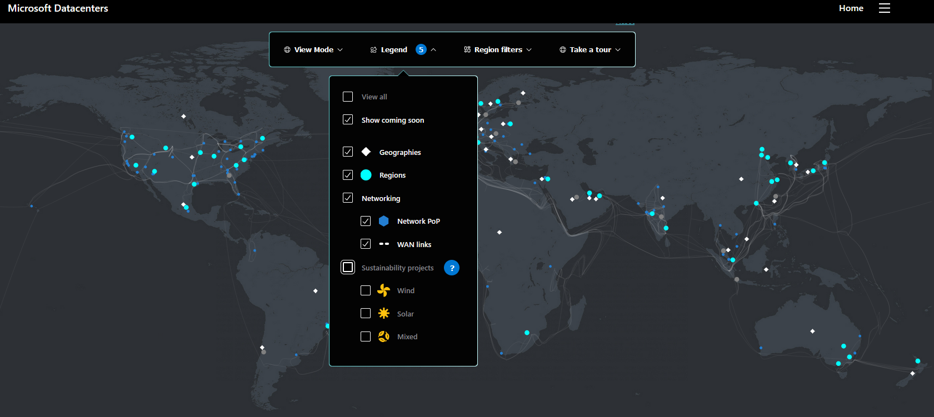

Now, when discussing regions we should also understand what is zone. So, some of the regions have more than one physical data center, and this is great for availability in case one data center fails. True, this is quite real, but it may happen. So each physical data center is called zone. And so when there are more than one data center in a region the region is said to have availability zones.

Zones

* Some of the regions have more than one physical datacenter
* Great for availability in case one datacenter fails
* Each datacenter is called Zone
* When there are more than one datacenter in a region, the region is said to have Availability Zones
* Some cloud services benefit from Availability Zones

For example, you can see that in West US 2 there are more than one zone in Canada Central, also West Europe, Japan East, and Australia East. And of course these are just examples. Take a closer look at the map and you will see there are lots more of regions with availability zones. The next concept you should be aware of is paired regions.

#### Paired regions

* Some regions have designated pair region
* For increased availability
* When a full region fails – the other one can fill its place
* Relevant for some of the cloud services
* Pairs are set by Azure and cannot be changed

Some Azure services use paired regions to build their multi-region geo-replication and geo-redundancy strategy. For example, Azure geo-redundant storage (GRS) can automatically replicate data to a paired region.

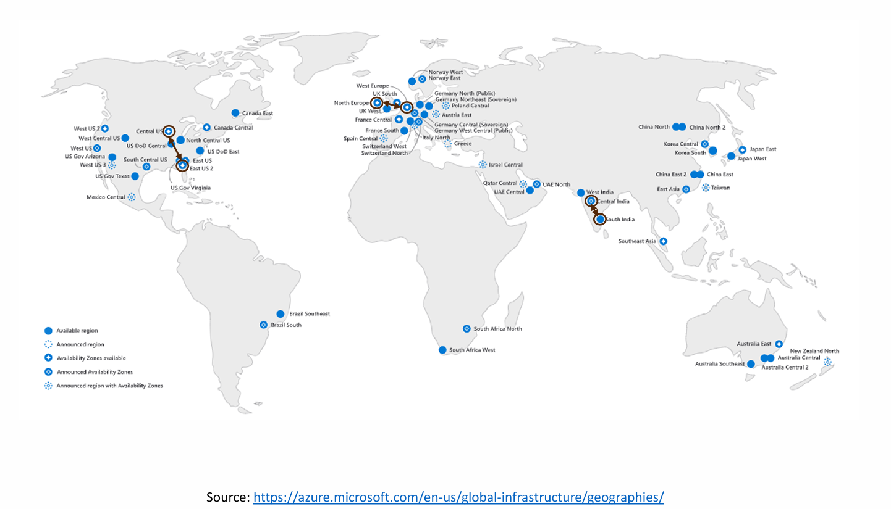

Now what this means is that some regions have designated paired region. This is done for increased availability so that when a full region, including all its zones, fails then the other one can fill its place. This is relevant for some of the cloud services, although to be fair, not many of them. Now the region pairs are set by Azure and cannot be changed. So we can't decide that for a specific service the paired region will be region X and for another service it will be region Y. The pairs are set up by Azure and cannot be changed. So if you will, again, take a look at the map, we will see the paired regions. Now, of course, this again is only an example and there are more, but as you can see, Central US and East US two are pairs. Also, North Europe and West Europe are pairs. And in addition, Central India and South India are pairs. So that means that, for example, if I have a database which have a geo replication, and we will talk in length about geo replication later, then the replicated data will go to the paired region. So that if the region, if the primary region fails then the data is available at the secondary or the third region.

If you're in a region with a pair, then using its pair as a secondary region provides several benefits:

* **Region recovery sequence**. In the unlikely event of a geography-wide outage, the recovery of one region is prioritized out of every region pair. Components that are deployed across paired regions have one of the regions prioritized for recovery.
* **Sequential** **updating**. Planned Azure system updates are staggered across region pairs to minimize downtime, impact of bugs, and any logical failures in the rare event of a faulty update.
* **Physical** **isolation**. Azure strives to ensure a minimum distance of 300 miles (483 kilometers) between paired regions, although it isn't possible across all geographies. Region separation reduces the likelihood that natural disasters, civil unrest, power outages, or physical network outages affects multiple regions simultaneously. Isolation is subject to the constraints within a geography, such as geography size, power or network infrastructure availability, and regulations.
* **Data** **residency**. To meet data residency requirements, almost all regions reside within the same geography as their pair. To learn about the exceptions, see list of region pairs.

You aren't limited to using services within a single region, or within your region's pair. Although an Azure service might rely upon a specific regional pair for some of its reliability capabilities, you can host your services in any region that satisfies your business needs. For example, an Azure solution can use Azure Storage in the Canada Central region with GRS storage to replicate data to the paired region, Canada East, while using Azure compute resources located in East US, and Azure OpenAI resources located in West US.

List of Paired Regions

The table below lists Azure region pairs:

| **Geography** | **Region in pair** | **Region in pair** |
| --- | --- | --- |
| **Asia-Pacific** | East Asia (Hong Kong Special Administrative Region) | Southeast Asia (Singapore) |
| **Australia** | Australia East | Australia Southeast |
|  | Australia Central | Australia Central 2* |
| **Canada** | Canada Central | Canada East |
| **Europe** | North Europe (Ireland) | West Europe (Netherlands) |
| **France** | France Central | France South* |
| **Germany** | Germany West Central | Germany North* |
| **India** | Central India | South India |
|  | South India | Central India |
|  | West India | South India |
| **Japan** | Japan East | Japan West |
| **Sweden** | Sweden Central | Sweden South* |
| **Switzerland** | Switzerland North | Switzerland West* |
| **United Kingdom** | UK West | UK South |
| **United States** | East US | West US |
|  | East US 2 | Central US |
|  | North Central US | South Central US |
|  | West US 2 | West Central US |
|  | West US 3 | East US |
| **US Department of Defense** | US DoD East* | US DoD Central* |
| **US Government** | US Gov Arizona* | US Gov Texas* |
|  | US Gov Virginia* | US Gov Texas* |
|  | US Gov Texas* | US Gov Virginia* |

**\*** Certain regions are access restricted to support specific customer scenarios, such as in-country disaster recovery. These regions are available only upon request by creating a new support request.

Important

West India is paired in one direction only. West India's secondary region is South India, but South India's secondary region is Central India.

West US 3 is paired in one direction with East US. East US is bidirectionally paired with West US.

Brazil South is paired with a region outside of its geography. Brazil South's secondary region is South Central US. The secondary region of South Central US isn't Brazil South.

#### Nonpaired regions

Azure continues to expand globally, and many of our newer regions provide multiple availability zones for higher resiliency, and don't have a region pair.

Many Azure services support geo-replication and geo-redundancy between any arbitrary set of regions, and don't rely on region pairs. It's important to understand how multi-region support works for the particular services you use. To learn about the details of each service, see Azure service reliability guides.

List of nonpaired regions

The table below lists Azure regions without a region pair:

| **Geography** | **Region** |
| --- | --- |
| Austria | Austria East (coming soon) |
| Israel | Israel Central |
| Italy | Italy North |
| Mexico | Mexico Central |
| New Zealand | New Zealand North |
| Poland | Poland Central |
| Qatar | Qatar Central |
| Spain | Spain Central |

While some Azure services support geo-redundancy and geo-replication by using paired regions, you can create solutions that support multiple regions even when those regions aren't paired.

<https://learn.microsoft.com/en-us/azure/reliability/regions-multi-region-nonpaired>

## Azure Services

Everything that can be done in the cloud is called Cloud Service i.e. Creating VMs, building databases, setting up networks, use AI

algorithms, using central user management etc.

Now, Azure has hundreds of them, so if you will click this link, you will see the list of Azure services.

See the list here - <https://azure.microsoft.com/en-us/products/>

So here on the side, you see the categories of services that Azure has, and if you will click on any of these categories, for example, let's click Compute, so you see that Azure has App Services, Azure Dedicated Host, Batch, Mobile Apps, Azure Functions, Virtual Machines, of course, and so on and so forth. And the list is really, really, really long.

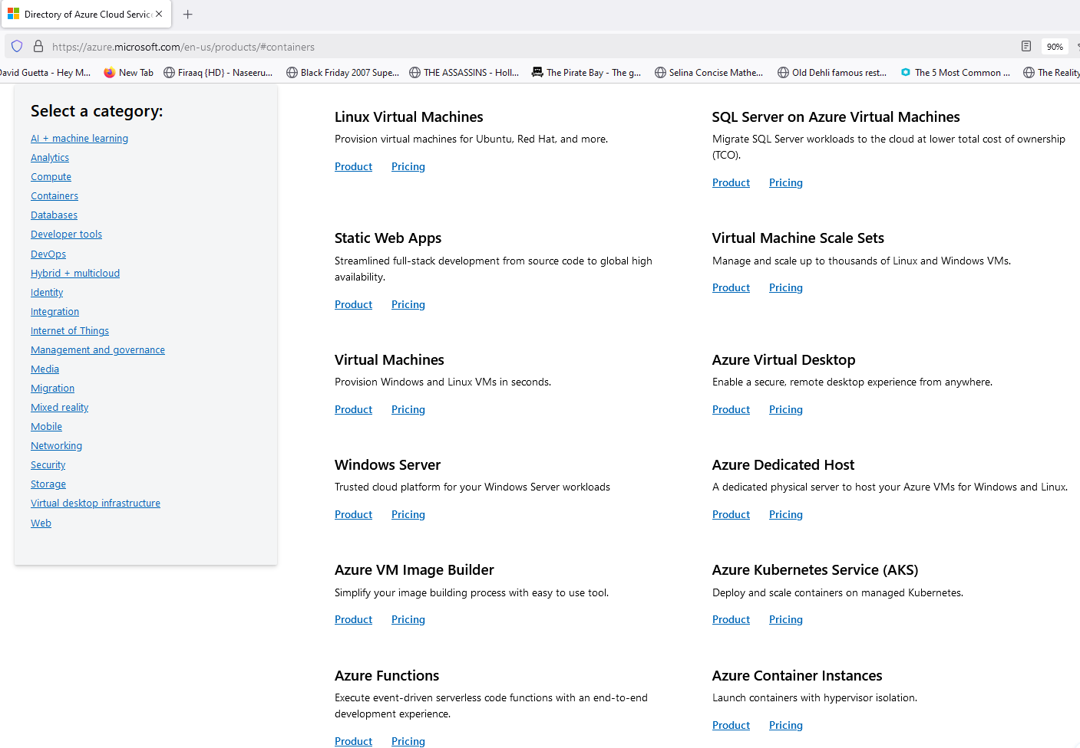



## Azure Free Account

First note, that in order to create account in Azure, you must have a valid credit card and a mobile phone. Now, the credit card, hopefully won't be charged because the free account includes a credit of $200 which should be enough for our course. But however, if you take your time and use more resources that are needed in this course, then you might hit this limit and then you will get asked if you want to use a credit card to pay for those resources. In any case, even if there will be payment, it will be quite small. So you might want to invest this amount to learn more about Azure.

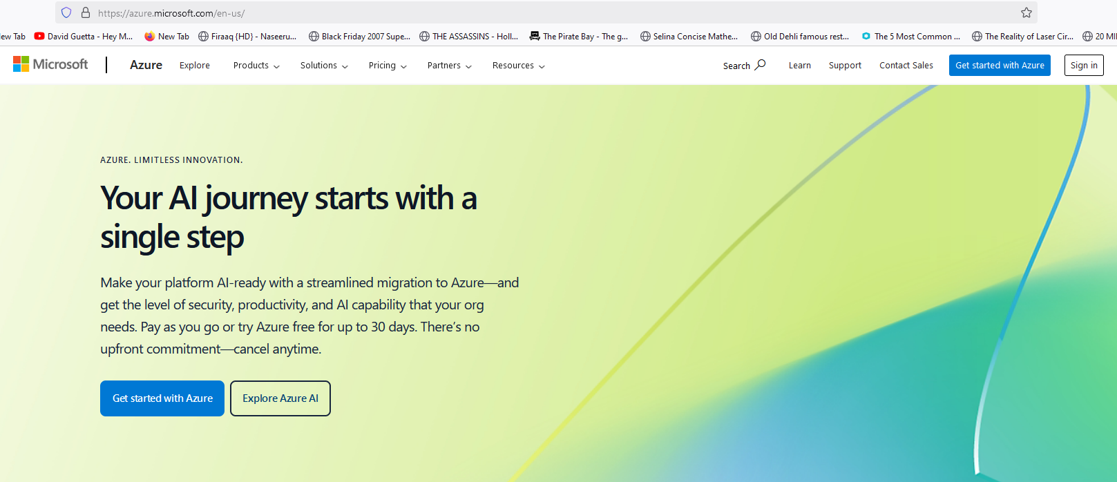

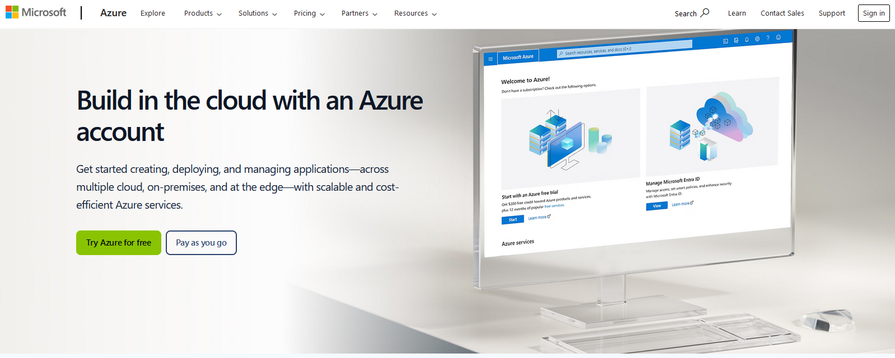

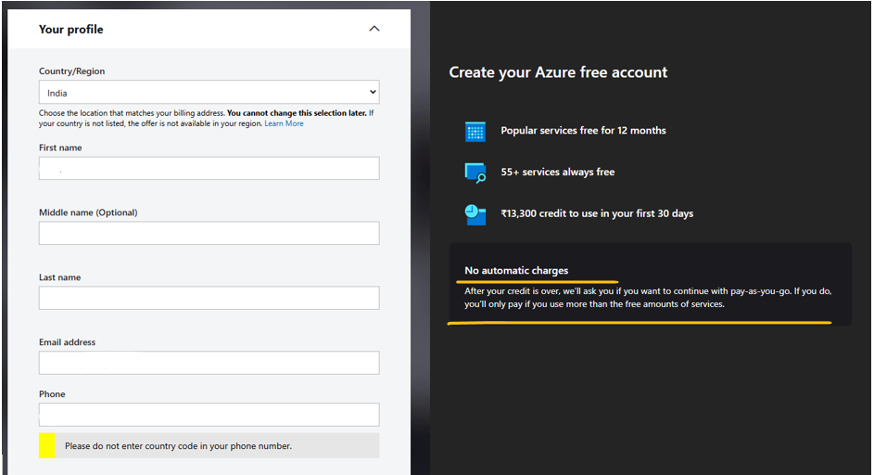

We will learn how to get notified, when we come close to the $200 limit so that you won't have surprises.

Now as the screen says, there isn't gonna be any charge on the credit card, they just want to authorized it. So when you will decide to use it, it will be pre-authorized and it can be charged. So fill in your credit card details and then click Next. Okay, great. So we've passed this step and now we need to agree to the customer agreement and privacy statement. And you can decide if you want to receive information, tips and offers from Microsoft about Azure.

Our account is up and running and now we can go to the portal.

We are now presented with the Quickstart Center of the Azure Portal.

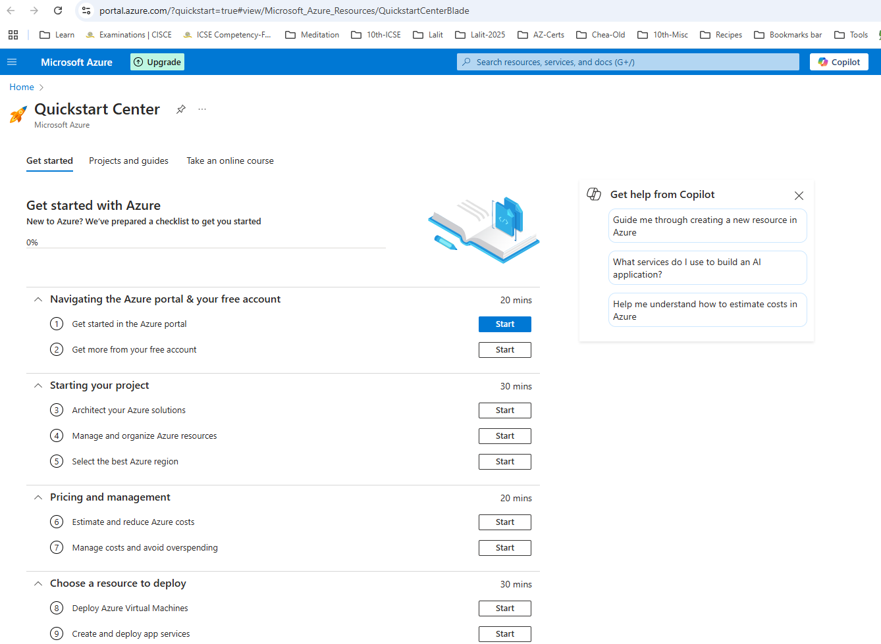

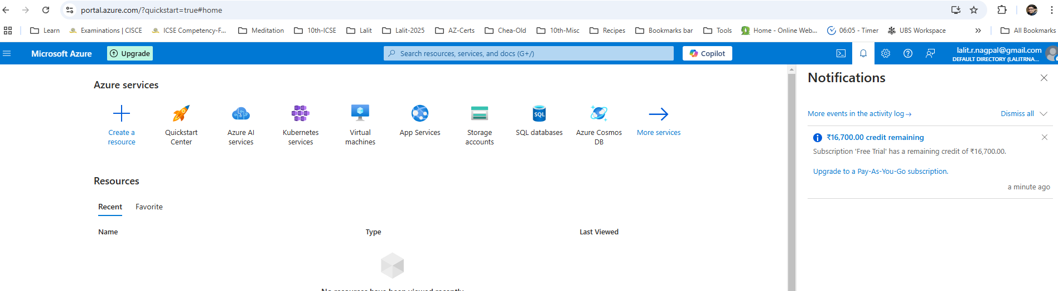

## Azure Portal

So the portal is basically the main entry point for working with Azure. From the portal, you can create, manage, view, and remove resources. And basically everything we are going to do with Azure is going to be done through the portal.

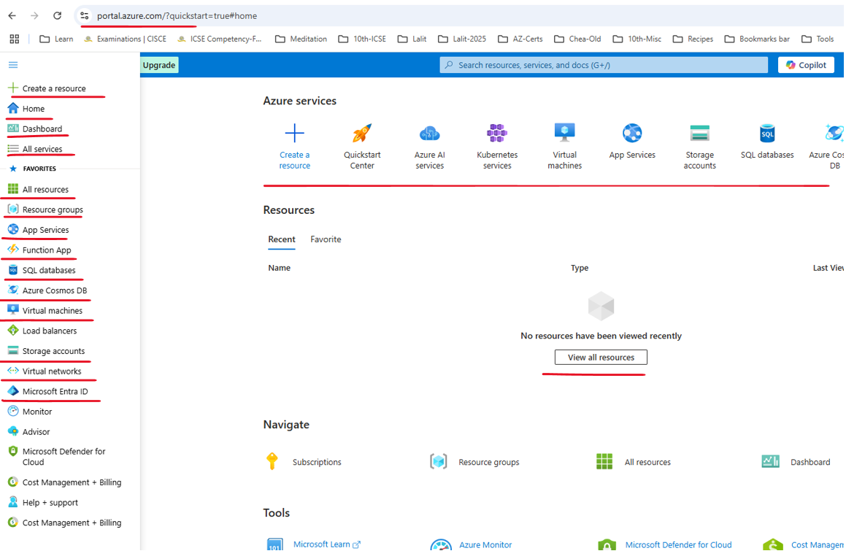

And actually what we see here are the favorite resources or the most commonly used resources in Azure. So for example, we can see here App Services, Function App, SQL databases, Cosmos DB, Virtual machines, and so on. So we can access favorite resources from this menu. And we can also take a look at all the services in the cloud and also at the dashboard.

The Settings button - let's click that. And from here you can manage the way you work with the Azure Portal and the tenant.

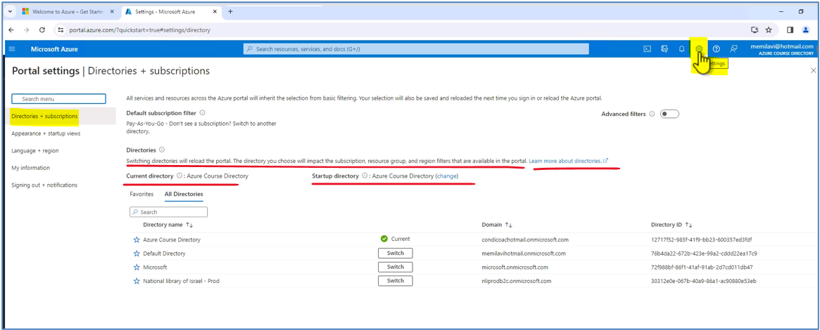

Now, right now you don't know what a tenant is. And let's say that tenant is basically the user directory that Azure is using. And in my case I have a few tenants, but I will keep using the one that I'm signed in right now.

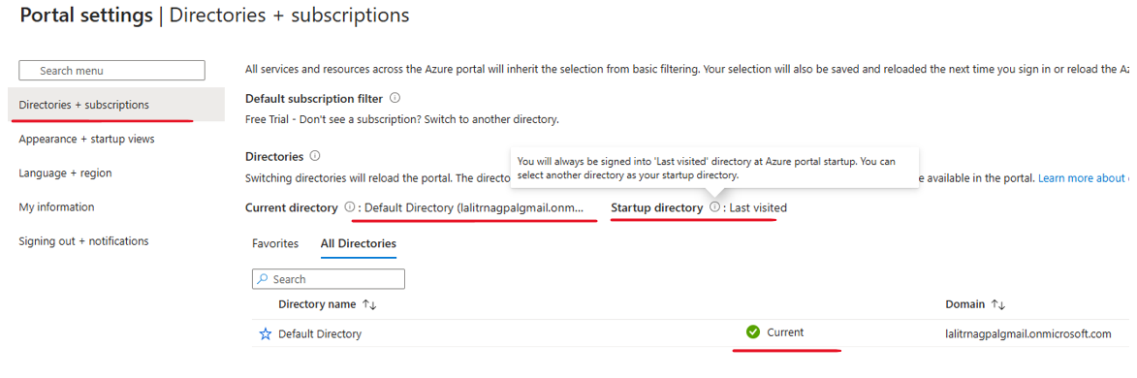

Next, let's click the Appearance and startup view, and from here you can manage the menu behavior, the theme, and the high contrast, and other visual aspects of the portal. So for example, we can say that the menu behavior that we just opened before is not flyout that will appear when we will click this button, but it is docked. And in this case, the menu will always appear right here on the left.

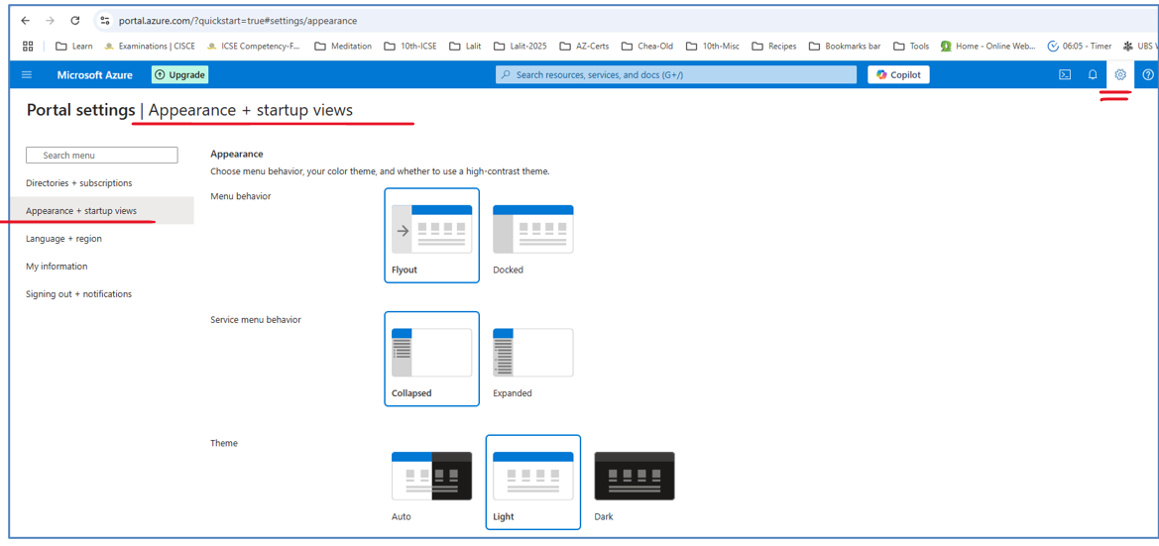

Again, I prefer the Azure theme and no high contrast. Next, you can also set the startup view whether to go to home or to a dashboard showing you various statistics about the resources you are using.

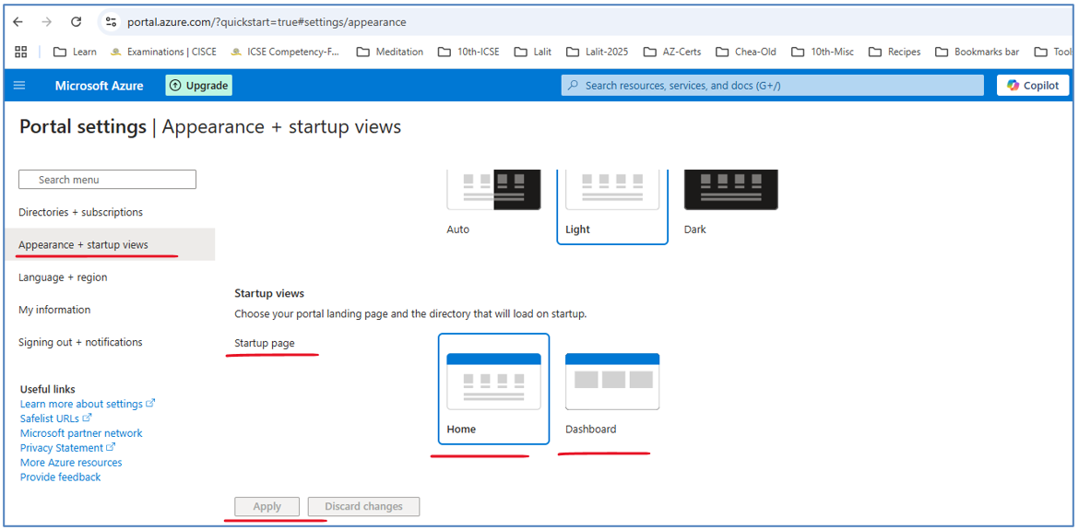

Next, you can set the language and region you are using and some information about the user that you are using. So that's about the settings of the portal.

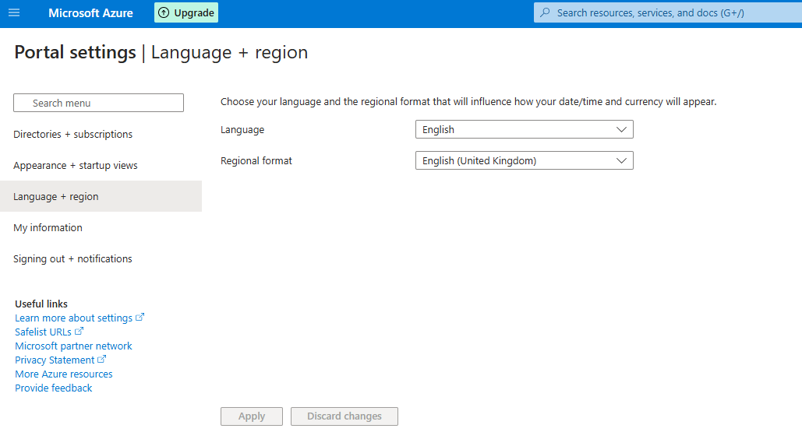

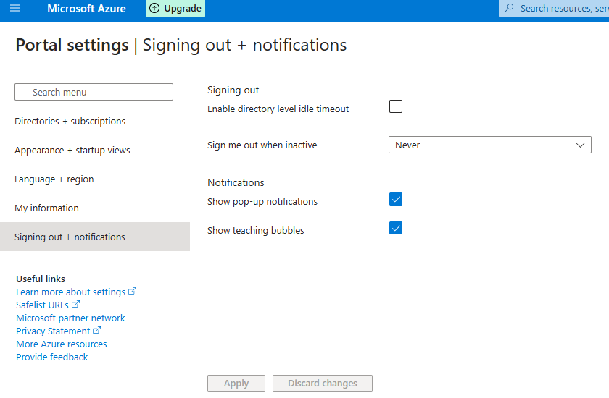

Next is notifications. And notifications are extremely important with the portal because every action you take in the portal will have a notification here.

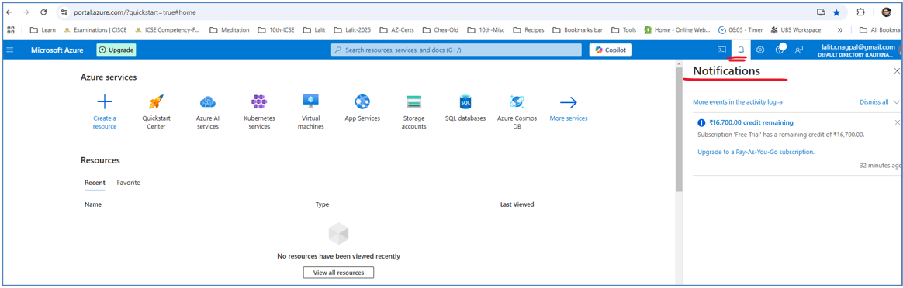

And notifications are extremely important with the portal because every action you take in the portal will have a notification here. So for example, when we will create a new, say, virtual machine, you will see a notification here telling you that the virtual machine is being created. And after creation is complete, you will see here a notification telling you that deployment is complete.

And lastly, we have this icon, the Cloud Shell. And Cloud Shell, which we will cover extensively later in this course and in this section is another way to work with resources in Azure so that instead of using a visual portal like that, you can simply type in commands to create, manage, and view resources. We will see how to work with it later.

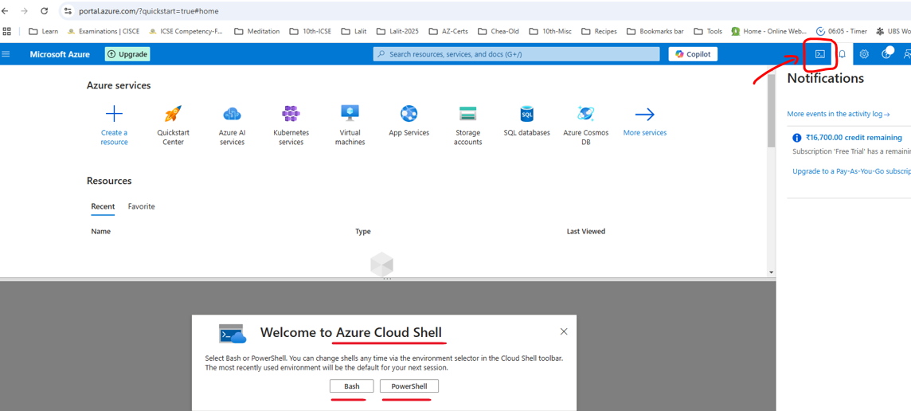

And lastly, I want to talk about the search bar. And the search bar is actually one of the most powerful resources in the portal. And using it, we can access resources and resource types. And usually when we will start working with anything in the portal, we will do that from the search bar. So for example, type here virtual, and you can see that from the search bar, we can access our virtual machines or virtual networks, or other resources with virtual in their names.

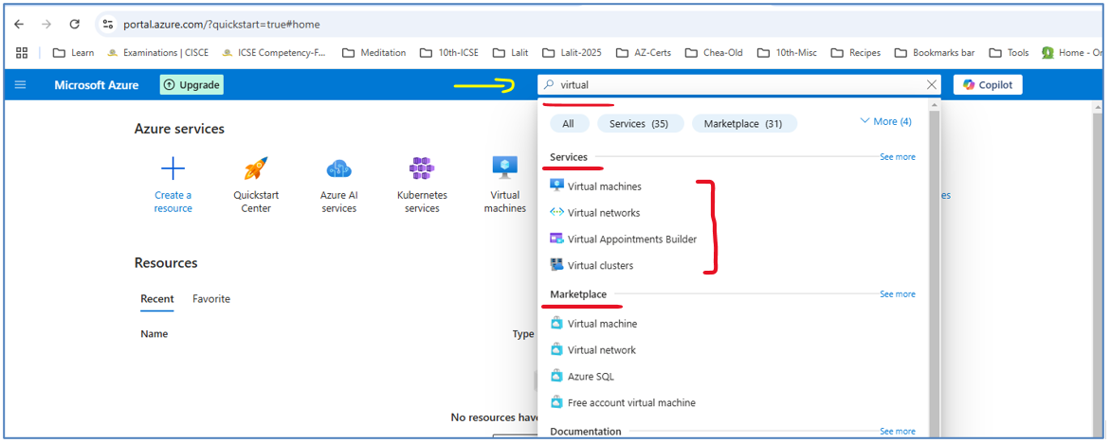

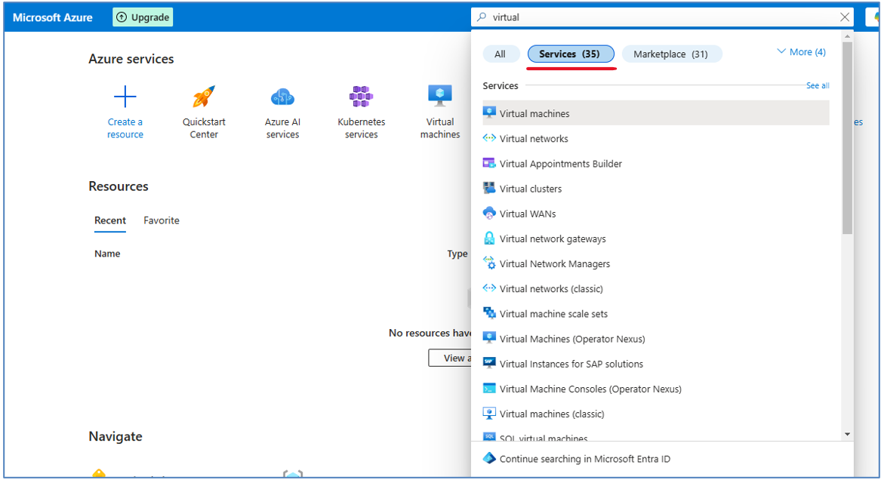

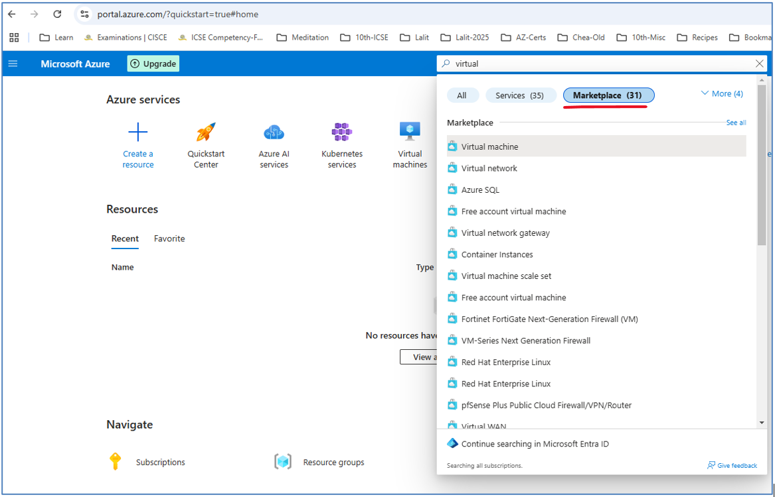



Click on the "More" link to see more options

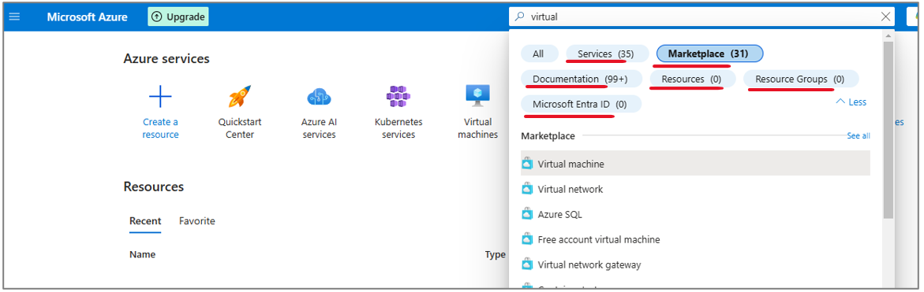

Usually we will not filter the display of this search page and we will use this default display. So anyway, whenever we'll do something with the portal, we will probably begin with the search bar.

This is how the default homepage of the portal looks ( right side column ) and menu options shown to the left side column separately, and from here, we are going to start working with Azure.

<https://portal.azure.com> is the link for this page

|  |  |
| --- | --- |
|  |  |

### Subscription vs Account

The difference between subscription and account because we saw both these terms in the portal before. So let's understand exactly what is subscription and what is account. So subscription is logical container while account is identity.

|  |  |
| --- | --- |
|  |  |

**So what exactly does the subscription contain?**

**Subscription** - contains the various resources you provision in the cloud, for example, virtual machines, databases, networks, et cetera. As you will see, everything that you create in the cloud, you pick the subscription in which they will be provisioned. Of course, you can have multiple subscriptions, and a new one was created automatically for us when we signed up to the Azure portal or to Azure in general. So you will see that every resource is going to be contained or created in a subscription, which is, again, the container for resources.

**Account** - on the other hand, is the identity with which you access the resources in the subscription. So in this example, you created a new account, and this account was automatically attached to the subscription. So we can say that when we created this account in Azure, we also created a subscription.

So a new subscription was created, a new account was created, and the account was attached to the subscription. Now note that a subscription can be attached to a lot of accounts. For example, a single subscription can be used by multiple employees of an organization, which all will use it. For example, some will create virtual machines, some will use these virtual machines, some will create databases, and so on.

In addition, an **account also can be attached to a lot of subscription**.

For example, if you'll be a cloud architect, then you probably have multiple clients. Each one will have its own subscription, so they will attach your account to their subscription and you will be able to log into the subscription that you want to work with at the moment. So these are subscription and account.

Azure is a living, breathing creature, and it changes all the time. As a result of that, there might be some changes from what you see in the lectures versus what you might be seeing when actually working with the portal.

### Creating a Resource

Let's take a look at the account and subscription that we are using. So as we saw before, right here at the top right of the page, we can see our account. So this is the account that I used to create this Azure account. And here are the subscriptions that are attached to this account.

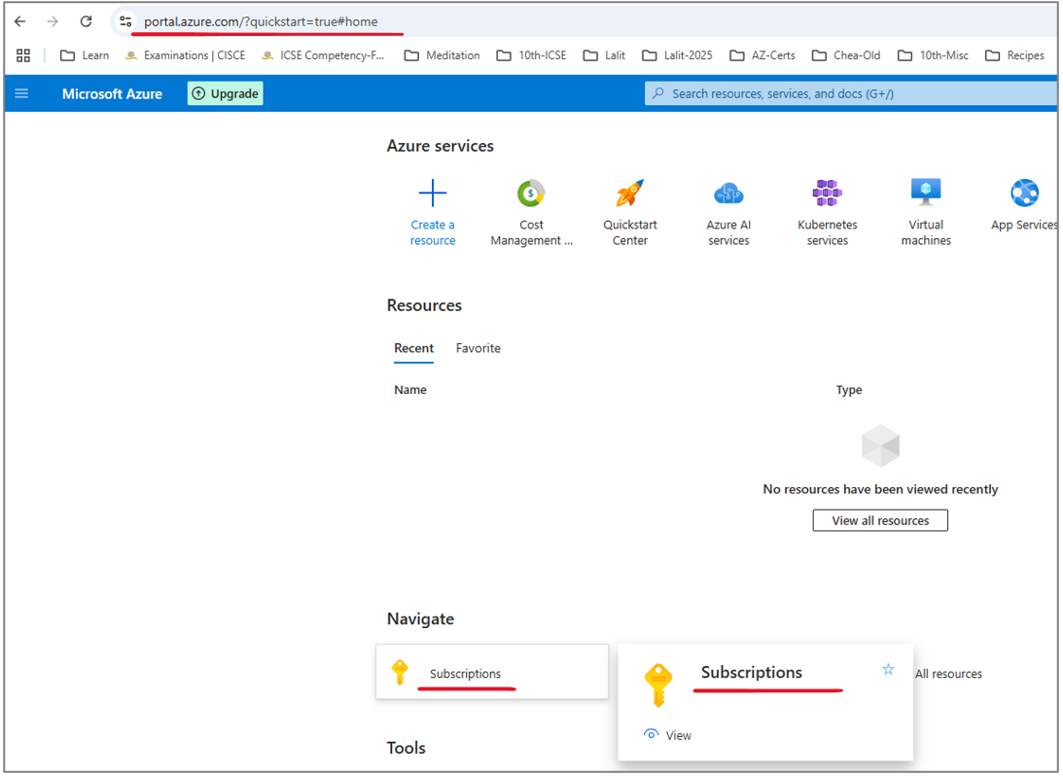

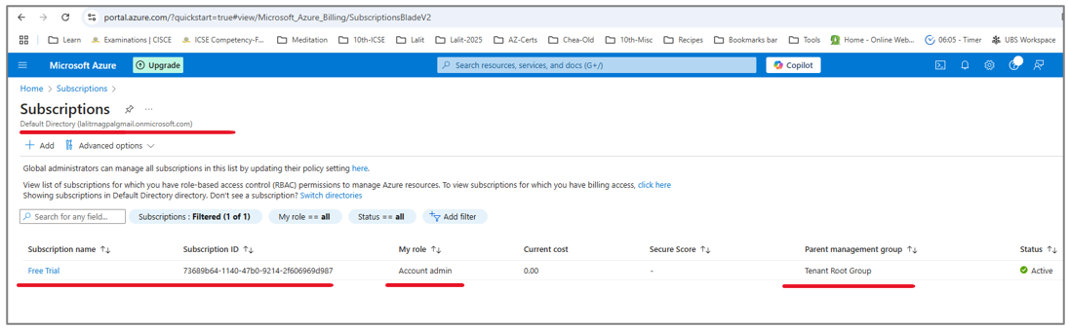

Now, this subscription was created automatically when I created this account. Now, it doesn't always have to be like that because sometimes you will create an account and then attach it to an existing subscription, and you'll see later in this course how exactly to do that. But in general, when you create a new account, then a new subscription is automatically created and attached to this account. So anyway, these are accounts and subscriptions.

And now let's create a new resource in Azure. So the resource we are going to create is a resource named, "Resource group". Now, by now, you still don't know what exactly a resource group is, and we'll explain it later in this course.

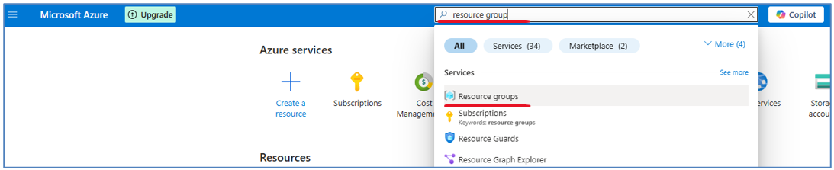

However, resource group is one of the most commonly used resources in Azure, and you will create it quite a lot. So how exactly are we going to do that? So first in the search bar type, "Resource group" And click resource groups like that.

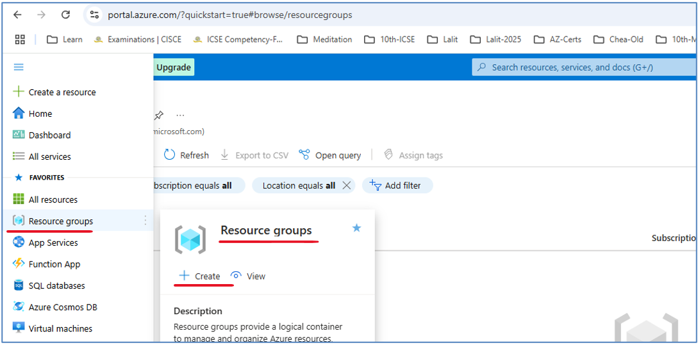

And note that again, since resource groups are such a commonly used resource, you also have a shortcut to resource groups right here.

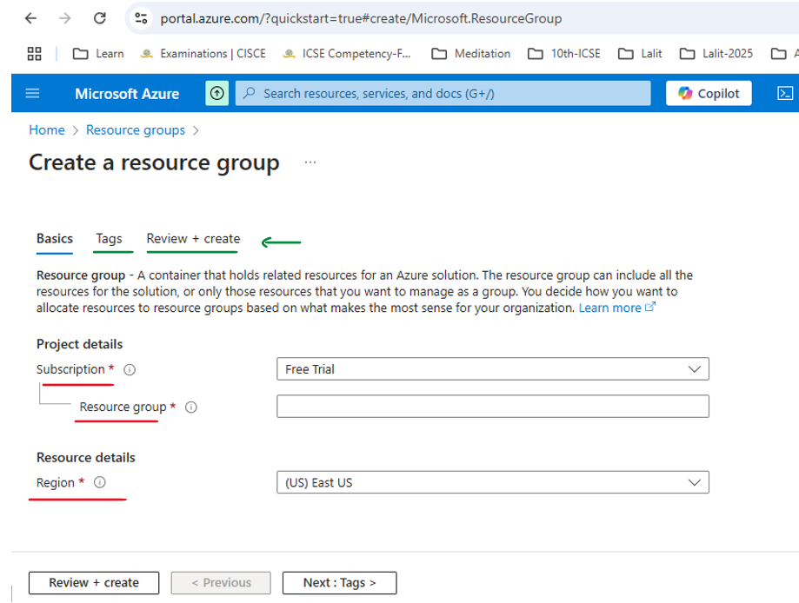

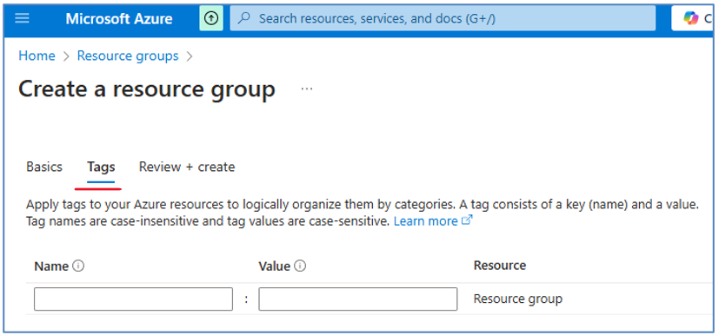

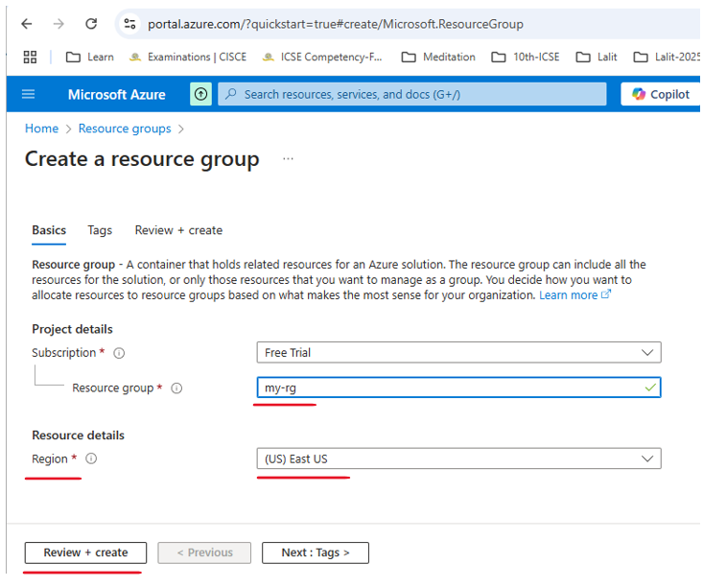

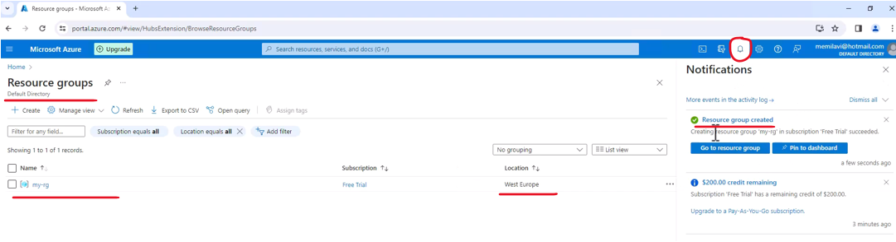

Deploying resource group in Azure is an extremely quick process and it takes a few seconds. Most other resources will take much longer to deploy and it can be as long as even 20 minutes. So it's always a good idea to take a look at the notification area and track the progress of the deployment of the resource that you asked for.

And now we see here in the list of resource groups, the resource group that we deployed. And you can also see here is the icon indicating resource group. So let's click this resource group, and here is our resource group. And note that when creating resource, you usually first see the overview section of the resource with some general details about this resource.

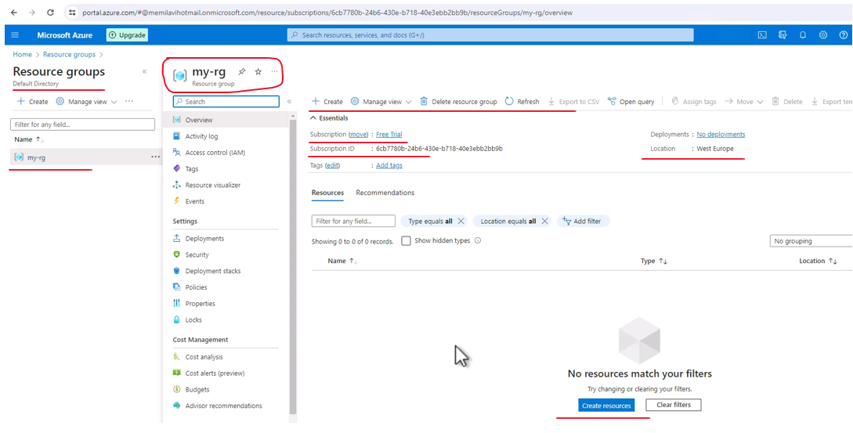

Finding the resource we created

Let's see how we can find this resource group from this homepage. And we are going to do that using the search bar.

First way – under recent resources you can see the resource group that you created

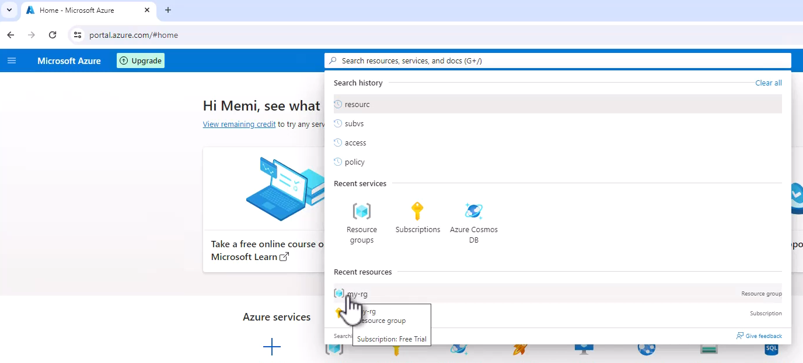

However, if you don't see it here, then there is another way to find it. And this is simply to type the name of the resource in the search bar.

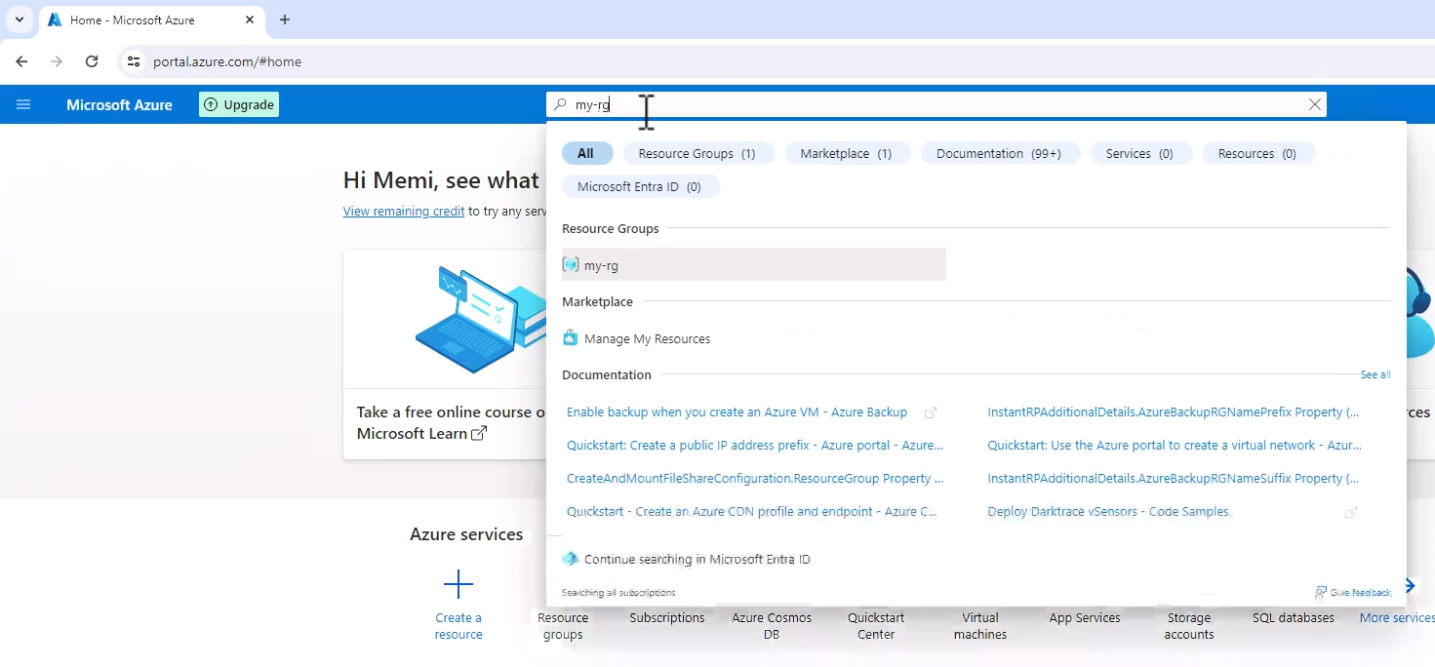

Now, if you will look for other resource types, which are not resource groups, then you will see it in a different group named resources. But the idea is the same. If you will type here of the name of the resource that you're looking for, you can find it right here in the search page.

### The Resource Page

Let's see what we see here. So first we can see here the name of the resource and underneath it the resource type, which in this case is resource group. We can also see here the icon representing this resource type.

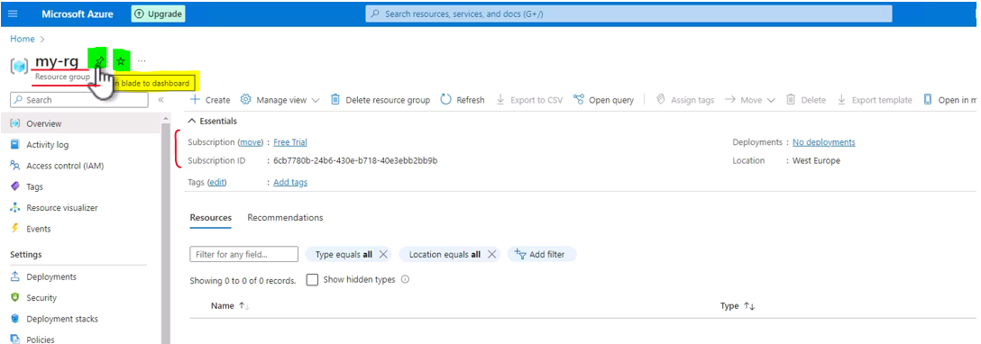

Now note these two icons ( in green ). So the first one, pin blade to dashboard allows you to pin this resource to the dashboard of the portal. And later we will see what exactly is dashboard and how to use it. And in addition to that, we can also add this resource to favorites. And what this means is that if you will do it and then open this menu, then note the favorite section right here you will see the resource right here in the favorite section on the menu. So this is this part of the resource page.

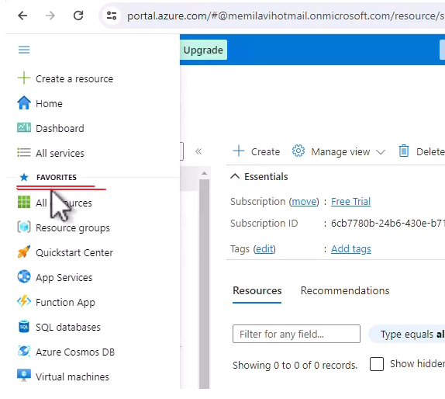

Next is the menu. And the menu is your main entry point for various actions on the resource. And you will see this menu for all the resources in Azure. However, of course, for every resource type, the menu will be different. And note that the menu is separated to sections. So for example, in the case of resource group, we have a settings section and cost management and monitoring and automation and so on.

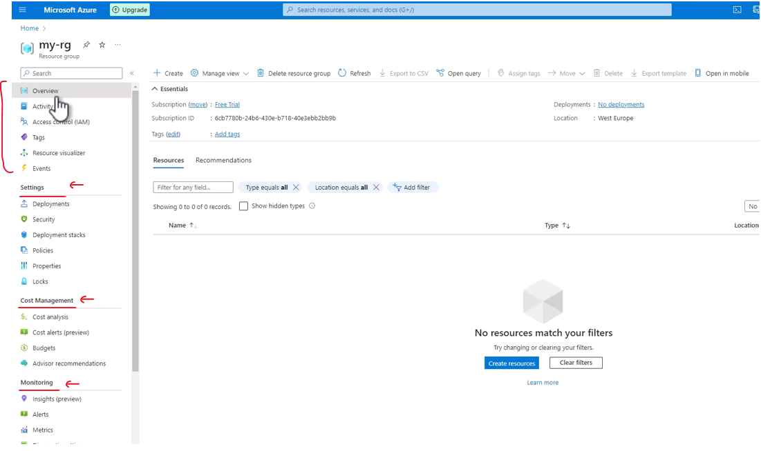

And in fact there are quite a few sections that are shared between resource types. So for example, you will see the monitoring section in almost all resource types as well as automation and help. Now the first item in the menu is almost always overview, which is what we're looking at right now. And the overview section displays major details about the resource, and it usually shows things like the location, the name, perhaps even the subscription and so on. You will see that in other resource types, for example, virtual machines, there are a lot more details in the overview section than in resource group, which doesn't have quite a lot of details. Now, in order to access the items in the menu right here, you can simply click them. So for example, click the activity log, and here you can see the last events that happened to this resource. And again, you will have activity log in almost all the resource types. Next, let's click access control, which allows you to set who can access this resource and what he can do with it. And of course, we are going to talk quite a lot about access control later in this course. And this is also an item that is shared among almost all resource types in Azure and so on and so forth.

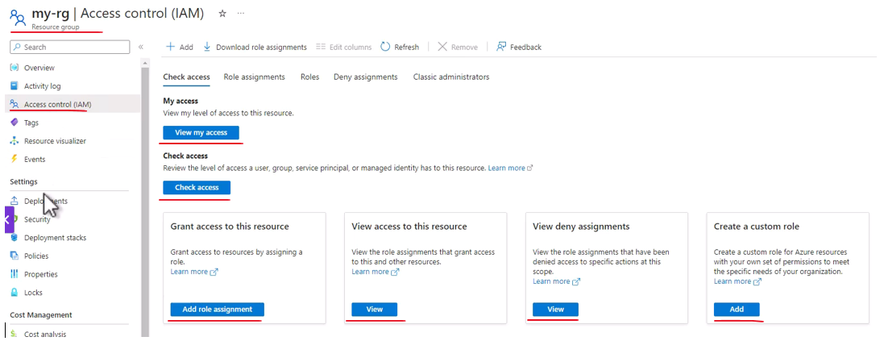

So let's go back to overview. And again, this is the basic and major entry point to the resource, and you will have it in almost all the resources in Azure.

#### Removing a Resource

So, we created a resource and we looked around, and now, of course, the question is, how do we delete a resource? So in the case of Resource group, you can see right here, that there is a button named Delete resource group. In other resource types, you will have a button named, Delete, like you see right here. So, as you can guess, in order to delete resource group, you should click this button, so click it. And now we need to type the name of the resource group in order to confirm that we actually want to delete it. And in the case of Resource group, this is really important, because Resource group might contain other resources, and you must be absolutely sure that you really want to delete it.

So for that, copy the name of the resource group and you can simply paste it here and click Delete, and then, Delete again. And now Azure is deleting our resource group and note the notification here telling us that Azure is deleting this resource group. Let's open the notification area, and you can see here the status. So this is a great place to track the actions that Azure is doing, and now let's wait for the deletion to complete. And the resource group was deleted, as we can see here in the notification area.

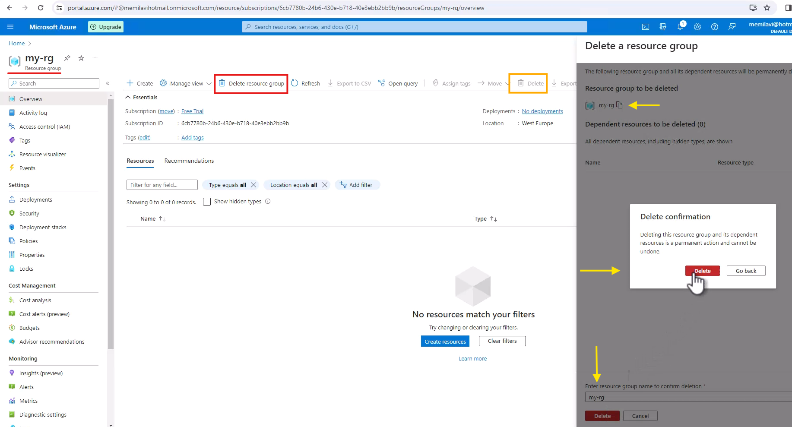

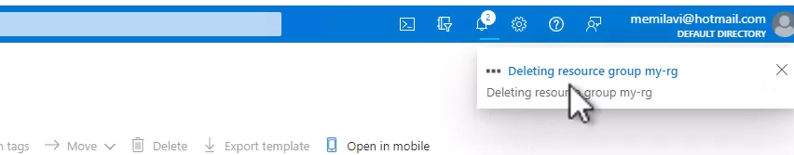



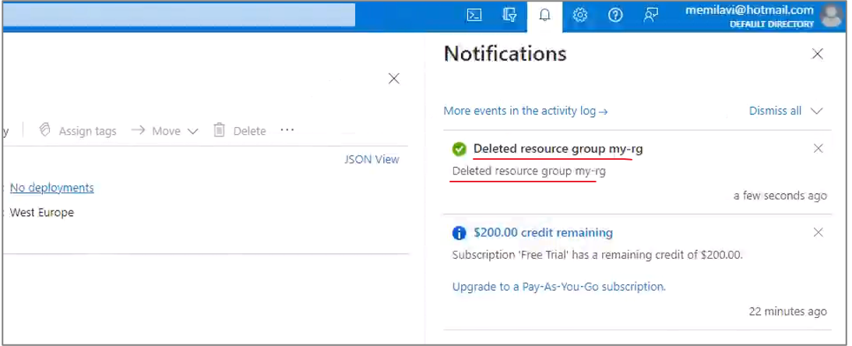

So let's make sure this is indeed the case, let's close that, and let's also close the Resource group page. And now let's try and define this resource group using the search bar. So, open it and type my-rg, which is the name of the resource group. And now we can see that we don't see this resource group in this page. In addition to that, you can also click the Resource group's button right here, and you can see that the list is empty. So indeed the resource group was deleted, and basically we now concluded our first store in the Azure portal. So we took a look at the homepage, we created a resource, we looked at this resource, and also learned how to find it, and then we deleted this resource.

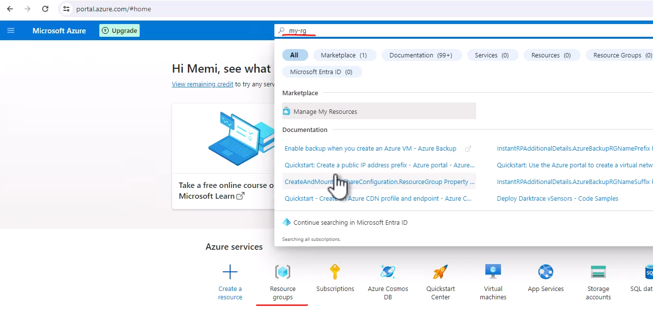

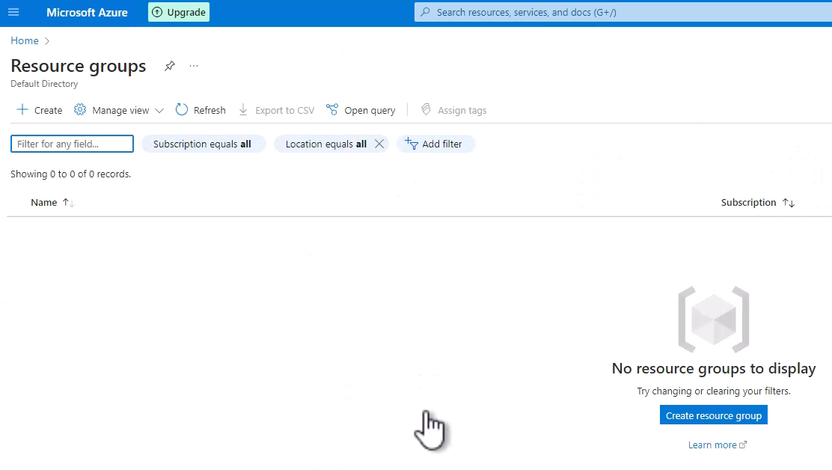

### Azure CLI and PowerShell

So far, we worked with the Azure portal in order to create, manage and delete resources. But actually there are other ways of doing that. And one of these ways is using Cloud Shell. Cloud shell is basically a terminal that is attached to the cloud, and with it we can run commands that work directly against the Azure API and perform various actions in Azure. So let's see how to do that. First we need to open the cloud shell. And for that click this button right here on the header. And note the tooltip that says this is Cloud Shell.

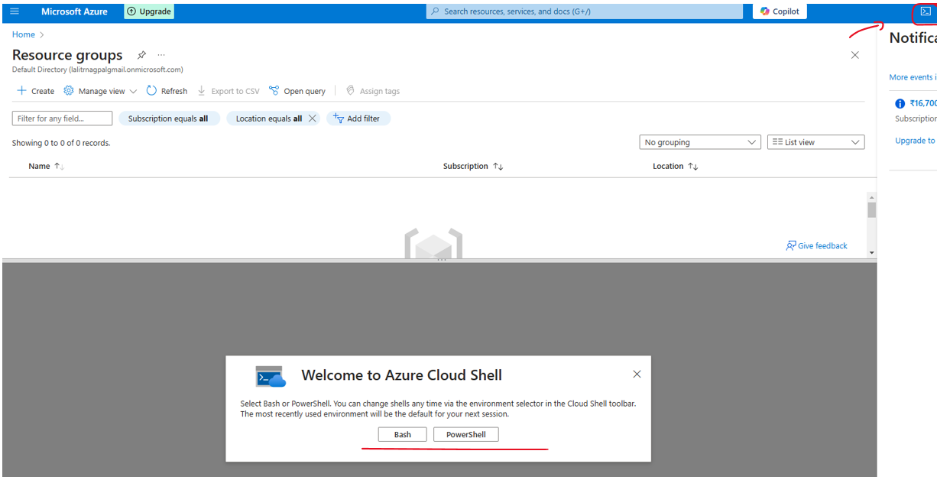

So click that and Cloud Shell is now opens. And the first thing we need to select is what kind of platform do we want to run. We can select here between bash and PowerShell.

And bash allows us to run Azure in the command line interface and PowerShell uses the well PowerShell platform in order to do the same, just with different syntax. Basically, you can select whatever you want. We will use bash. So let's do that and click bash. Next we need to select whether we want to mount storage account to the terminal. And this is required in order to persist files that we are going to upload to the terminal so that we can use them in later sessions, because by default, when we upload files to Cloud Shell, and we are going to do that later in this course, then these files are going to be deleted when the session completes and the session is considered complete a few seconds after we close the shell.

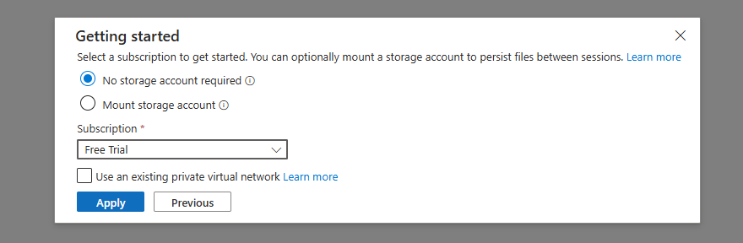

Now currently we don't require any storage that is going to be mounted to the shell, So keep the no storage account required radio button selected and select the subscription you are working on. In my case, that would be this one and apply. And now Azure is requesting a cloud shell, which is basically another way of saying that it's going to create the underlying infrastructure that is required for the cloud shell. And on the first time, it's going to take a few seconds for the cloud shell to start. So let's wait for that to complete.

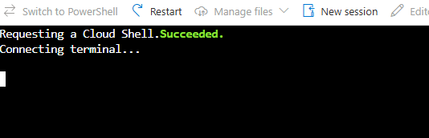

And here is the cloud shell ready for us. Now note the toolbar that we have here.

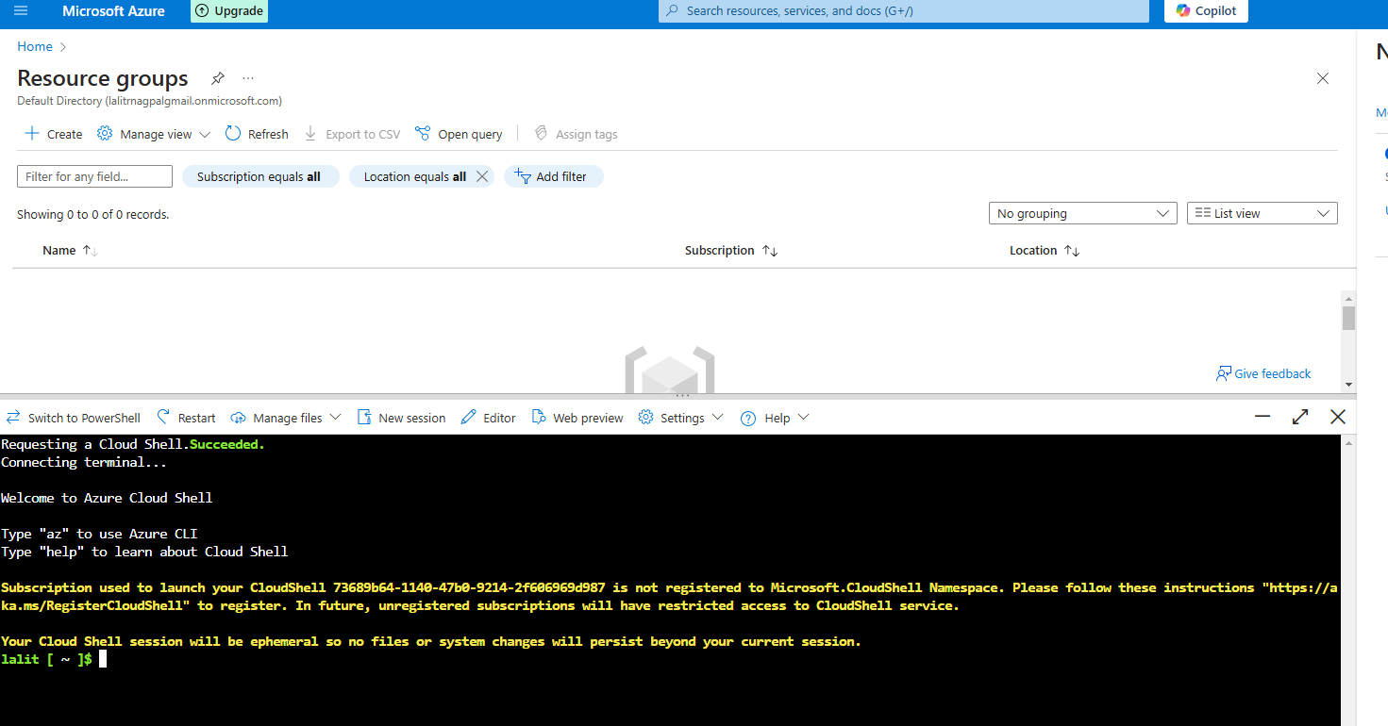



First, if you look at the leftmost hand of the toolbar you can see this button. Switch to PowerShell and this way you can switch between bash and PowerShell. We will use PowerShell later in this video. We can also restart the shell. We can manage files and using it, we can upload and download files to the shell. And we are going to use the upload function.

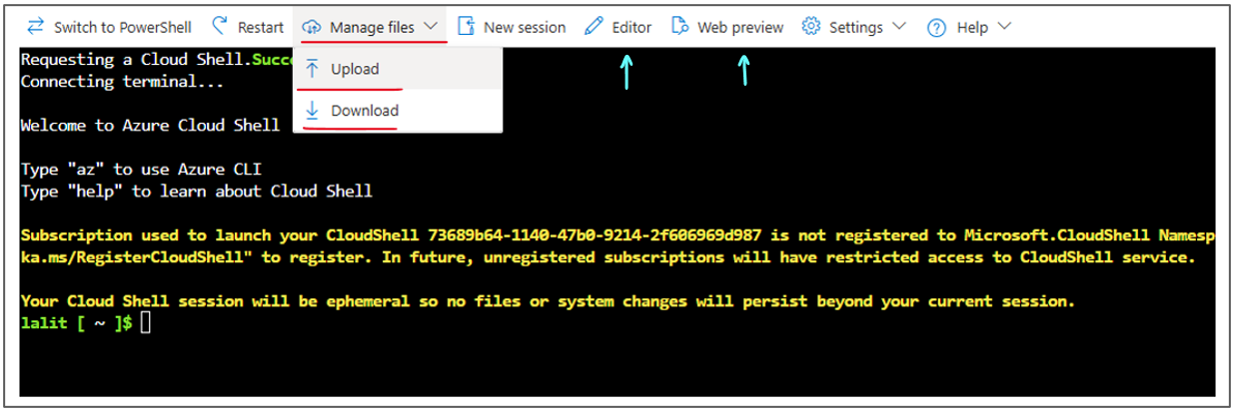

Later in this course we can begin a new session or have a newly created cloud shell for us. And we can also use a more sophisticated editor for the cloud Shell. We are not going to use it now. And also we can use a web preview, which is basically an easy way to run web contents directly from the cloud shell. But first, let's see how to use the basic capabilities of Cloud Shell.

So let's type in the following command. Just before it I'll resize the font. So let's go with large. So it will be easier for you to see. And let's run the following command as and all Azure commands in the bash in the command line interface begin with az, and after that we specify the kind of resource that we want to work with.

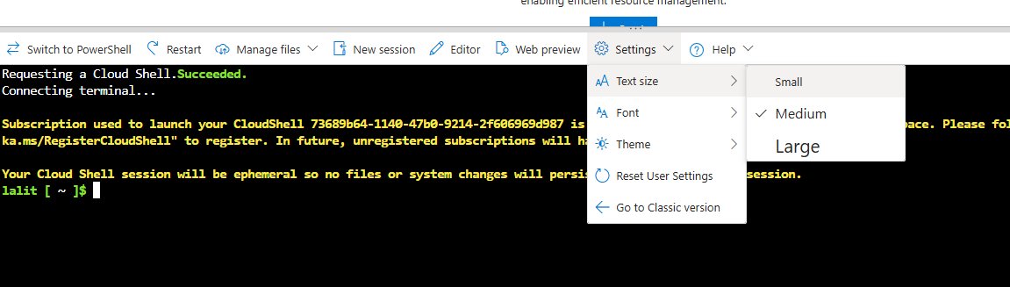

So in this case this is going to be group which is the name for resource groups in Azure CLI. And now we need to specify what is the actions that we want to do with resource group. And in this case we want to create a new resource group. So this is the typical structure of a command in Azure CLI. First we begin with AZ. Then we specify the type of resource we want to work with. And then we specify the action. And after that we specify the parameters. So here we have two parameters. We are going to specify. The first one is -l which will specify the location or the region where we want to create the resource group. So let's type in West US, and the 2nd parameter is of course the name of the resource group. So -n like that. And let's name this resource group as cli test dash rg and hit enter.

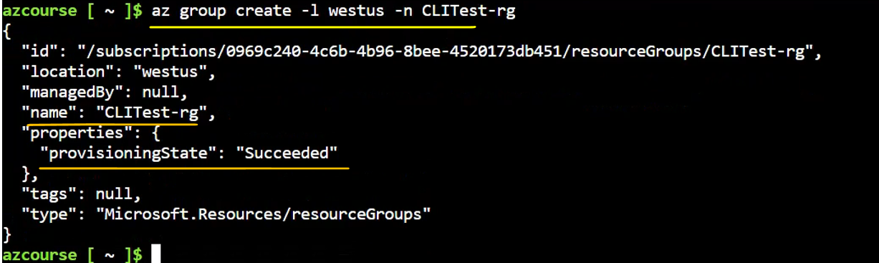

So now Azure is creating a resource group for us. And it's done. You can see here the details about the resource group. So here is the ID of the resource group, its location exactly as we asked. And the name. And the most important parameter here is of course the provisioning state which is succeeded. So the resource group was created successfully. Let's just resize that so it will be easier to see. Great. So we basically now have a new resource group. Let's make sure that this is indeed the case. So let's go to the search bar and search for the new resource group. So type CLI test and you can see it right here. Here is the resource group that we just created using Azure CLI. So click that. And here is the resource group a completely normal resource group that can contain other resources.

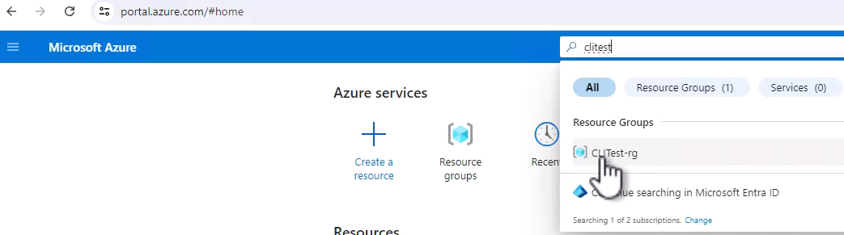



Again exactly similar to a resource group that was created using the portal. Azure doesn't really care how you created the resource group, whether through the portal or from Cloudshell. Now, since we don't need this resource group then now let's delete it. So click Delete Resource Group and copy the name from here and paste it here and delete and delete again. And now Azure is deleting this resource group. So this is how you can work with the bash environment in Cloud Shell.

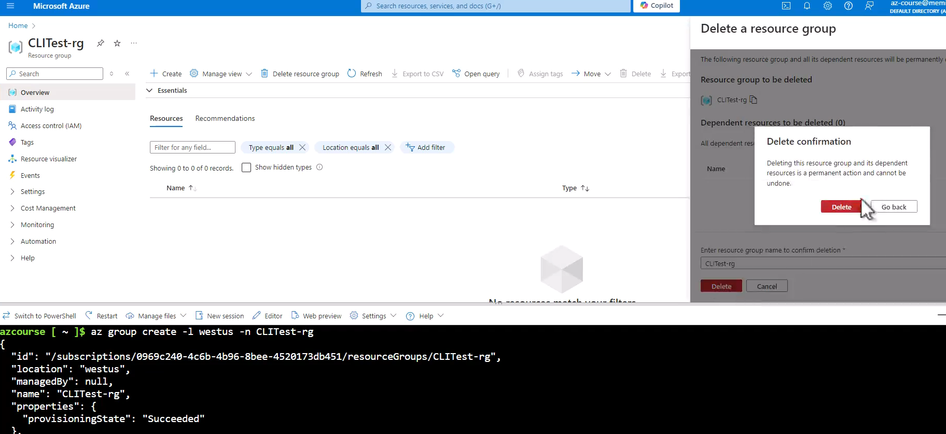

Now let's see how to work with PowerShell. So here click switch to PowerShell and confirm.

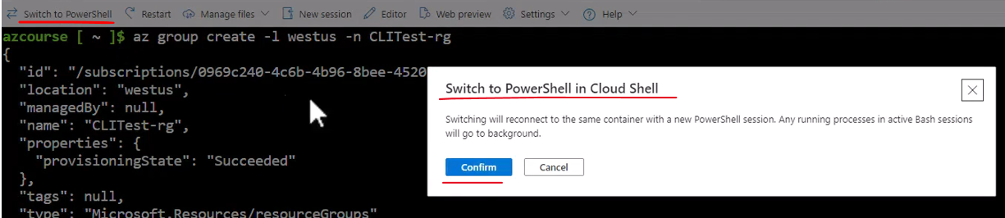

And now we are going to work with PowerShell. You can always identify the PowerShell environment by its blue background. So let's wait for that. Great. And as before let's just adjust the text size. Here it is. And now let's do the same but with the PowerShell syntax. So in this case it's going to look like this new. And note the autocomplete that we have here with PowerShell. So PowerShell suggests the new Azure Resource Group which is in fact the command that we want to use. And also it shows the parameters that we need to include in this command, which is name and location similar to what we saw with the CLI.

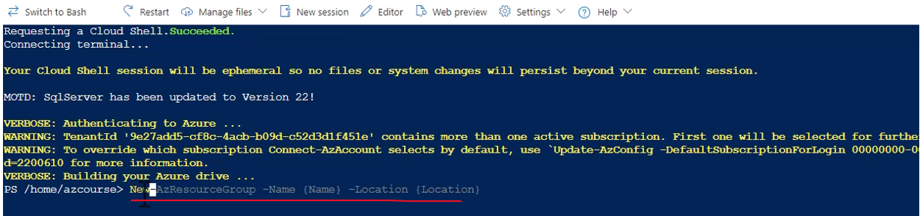

So hit the right arrow in your keyboard. And now this command was typed into the shell. And now let's set up the parameters. So the name is going to be PS test dash RG like that PS as in PowerShell. And the location or actually region is going to be the same as before. We will use the west US region like that. So again hit enter and let's wait for the resource group to be created and it looks like it created successfully. And again note the provisioning state right here which is succeeded. So again let's take a look at this resource group.

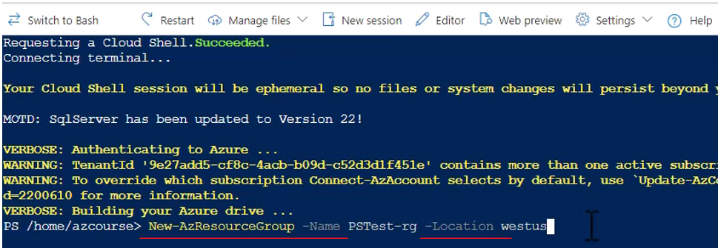

So again let's go to resource groups and note in the list here the PS test RG resource group which again looks exactly like any other resource group, and it completely identical to any other resource group. Again, Azure doesn't care how you created this resource group.

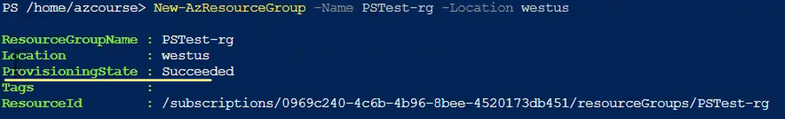

So again, as before, let's delete this resource group because we don't really need it. Copy its name from here and paste it here and delete and delete.

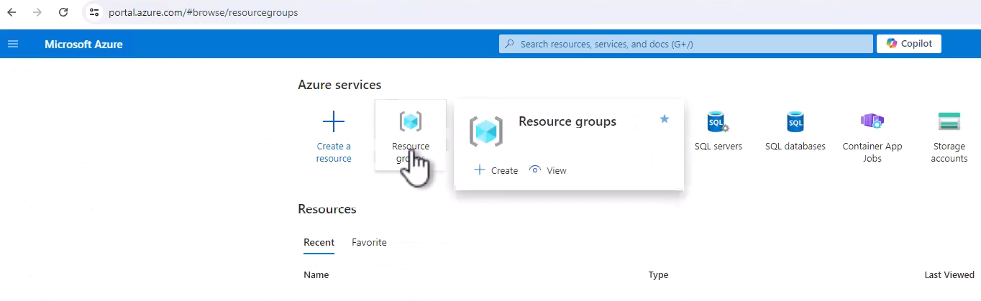

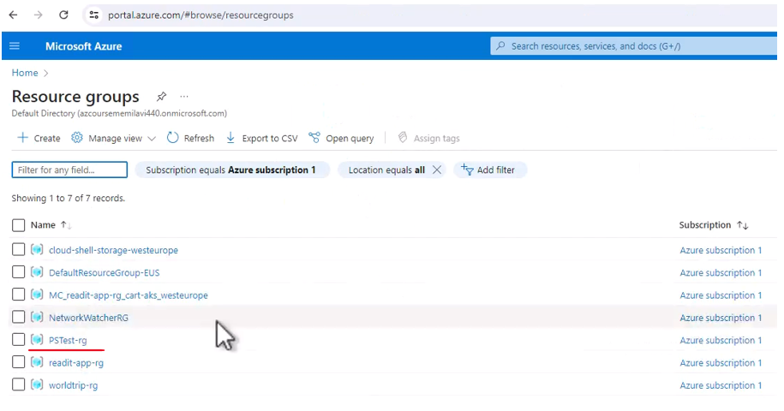

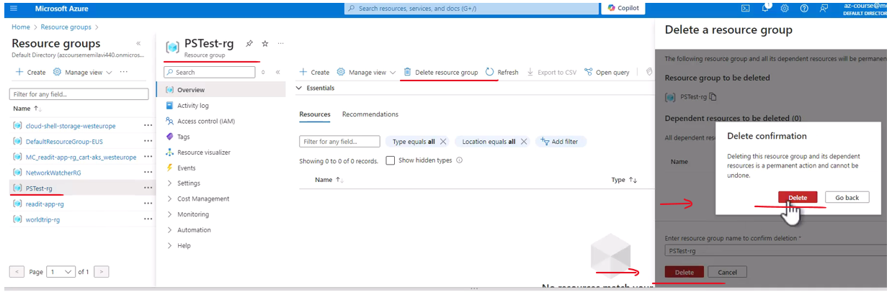

So this is Cloud Shell and this is how you can use it to run command line or PowerShell commands in order to create, manage and also remove resources in Azure. Now, one of the things you need to know about the Azure CLI or the Azure PowerShell is that you don't have to use Cloud Shell in order to run these commands. You can also download to your local computer the Azure CLI or the Azure PowerShell module that handles Azure.

## Azure Regions

There is a specific aspect of regions which I want to discuss. And this is selecting regions. So as we said, almost every resource in Azure should be placed in a region. And as you probably remember, when we created a new resource group in the porta, we had to select the region it will be placed in. So for example, also when creating a virtual machine, we need to select the region, in this case West US 2. But of course you can pick whichever region you want. So the question of course, is how to select region.

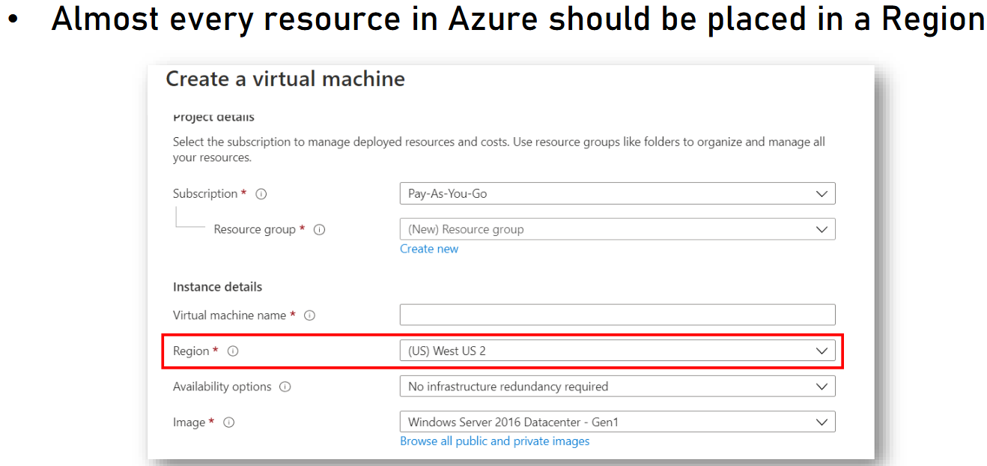

What are the factors that influence the regions that we select for our resource? So it turns out, there are multiple factors and I want to review them. So the first one is geographical proximity to the system's audience. So if you will take a look again at the regional map, you should always pick the region that is the closest to the audience you target in your system.

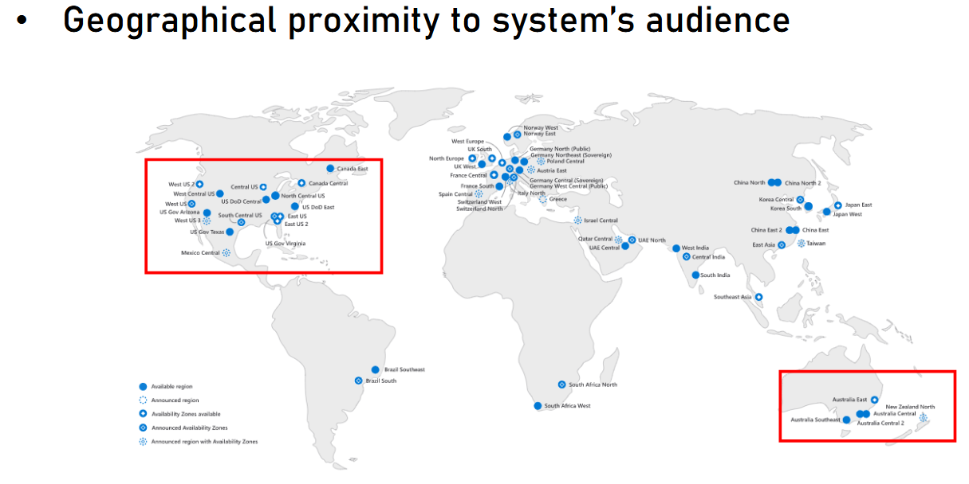

So for example, if your target audience is in the United States, then you should probably pick one of these regions. On the other hand, if your target audience is located in Australia, then you should better pick one of these. So this is the field factor, the geographical proximity.

Another one is services' availability. So it turns out, not every Azure service is available in all the regions. And as you can see from this table, which you can access using the link at the bottom of the slide, the Premium plan of Azure Functions is not available in the region, Canada East. Also the Premium plan Linux and the Consumption plan Linux of Azure Functions are not available in this region. In addition, Consumption plan Linux is also not available in West Central US region.

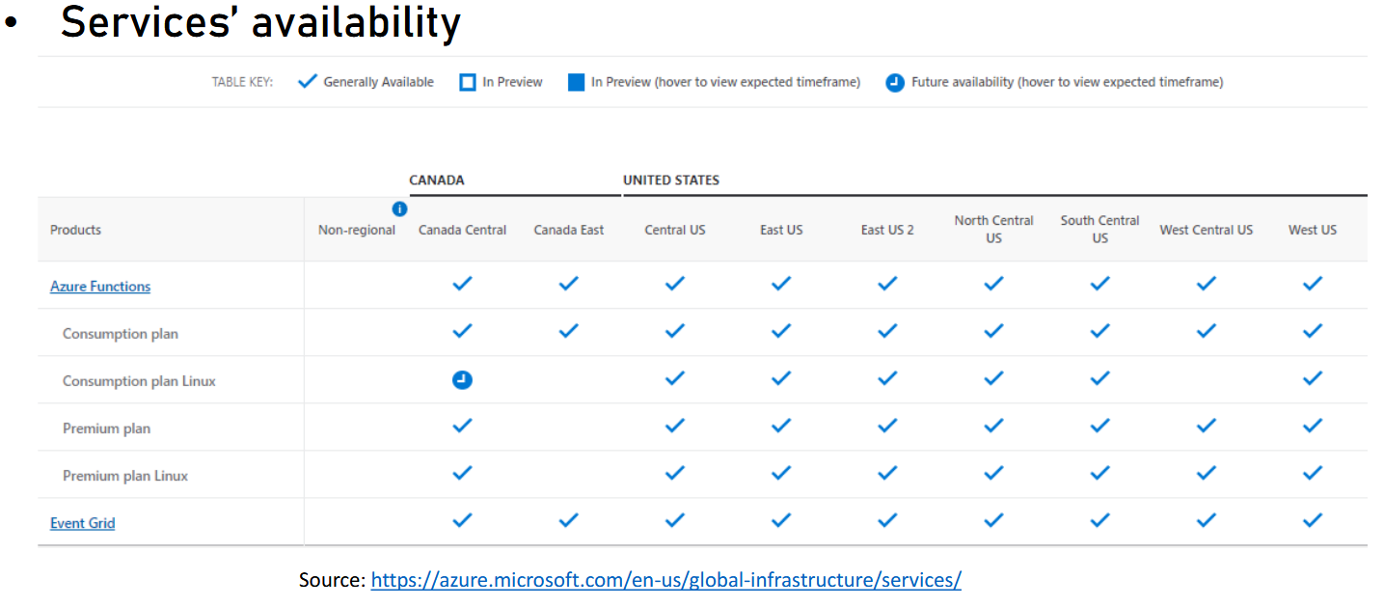

So as you can see, not all services are available in all the regions, and you should always make sure that the service you want to create is available in the region you want to use. Another factor is availability zones. So as we discussed earlier, some of the regions have availability zones, and as a reminder, an availability zone means that the region has more than one physical data center, so that if one data center fails, we have another one that will keep working in this region.

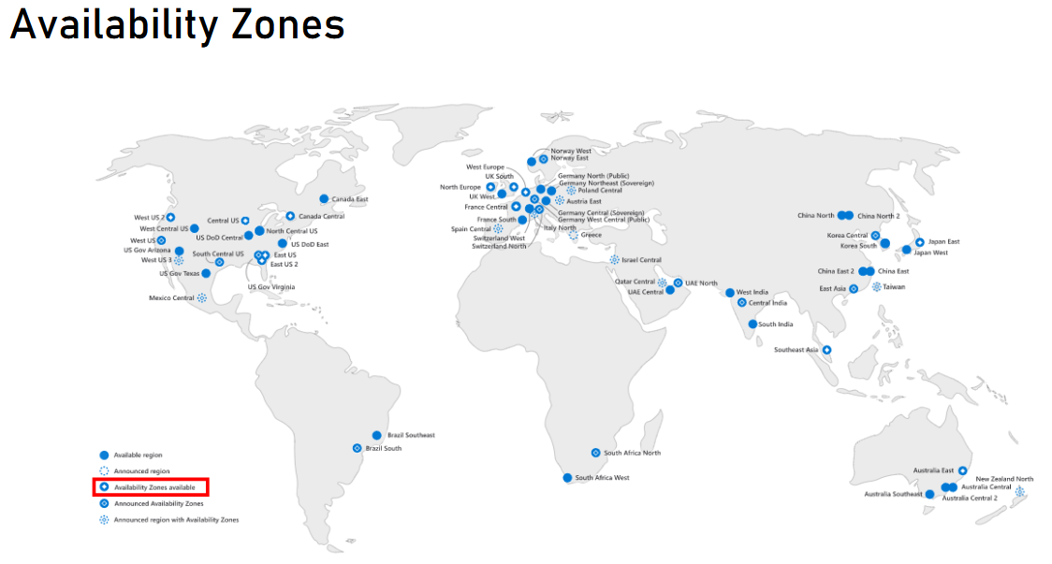

So if you have strict redundancy requirements and you want to make sure that in the case of Datacenter Fellow, the region will still be available, then you will better go with a region that has availability zones. Next is pricing, and it might surprise you but there is a difference in some cloud services pricing between regions. So for example, if you look at this screenshot, then you can see that a virtual machine, a specific virtual machine in Norway West, will cost around $192 per month. The very same virtual machine will be cheaper in West US. As you can see in this region, this machine will cost $152 per month.

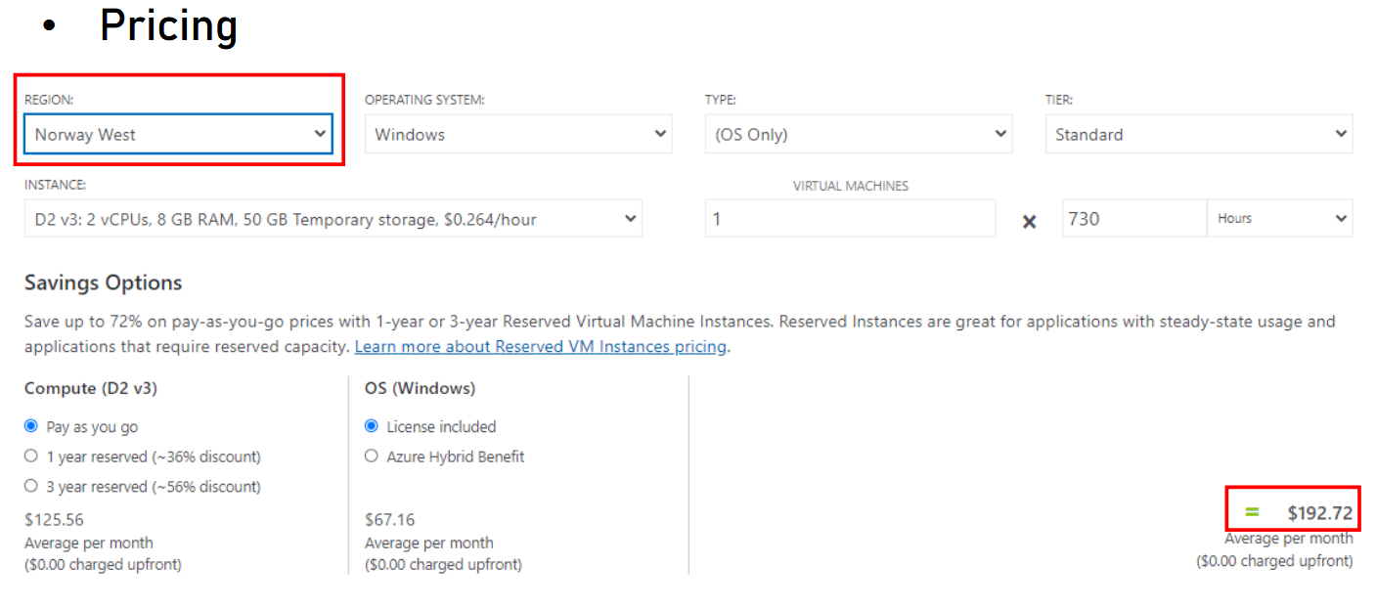

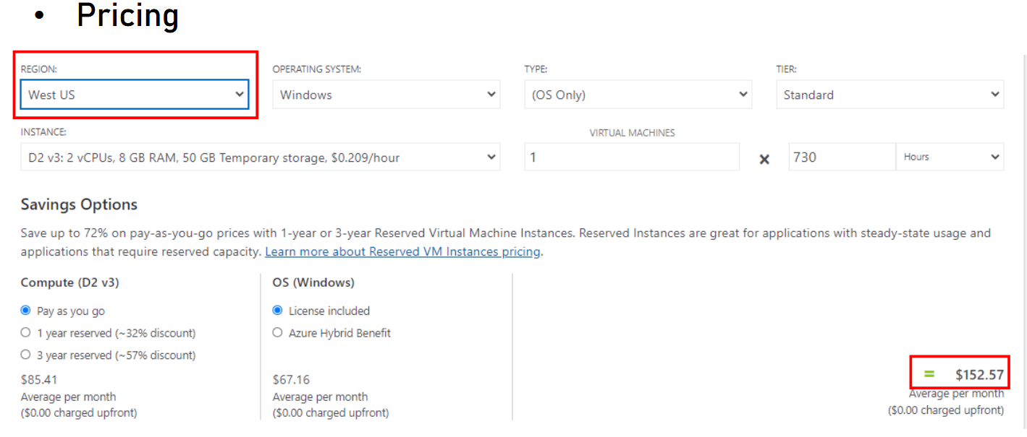

So this is another factor which affects the region selection. So these are the factors for selecting the region and I highly recommend applying them when making that decision. information alert Schedule learning time Learning a little each day adds up. Research shows that students who make learning a habit are more likely to reach their goals. Set time aside to learn and get reminders using your learning scheduler. Become an Azure Expert! Learn to design and build modern cloud apps

## Resource Groups

We have already seen resource groups in the first demo we had with Azure Portal when we created one, but we didn't explain what exactly is a resource group and this is what I want to do now. So what is actually a resource group? So a resource group is a logic container for resources. It is used for grouping resources by a logic boundary and we will see some examples for it later. It is also, as we said before, completely free and you can create as many resource groups as you want. It won't cost you a cent. Now, some examples of using resource groups are a resource group for development, test and production. So in this case, three resource groups. One will contain all the development resources. One will contain all the test resources and the last one will have all the production resources.

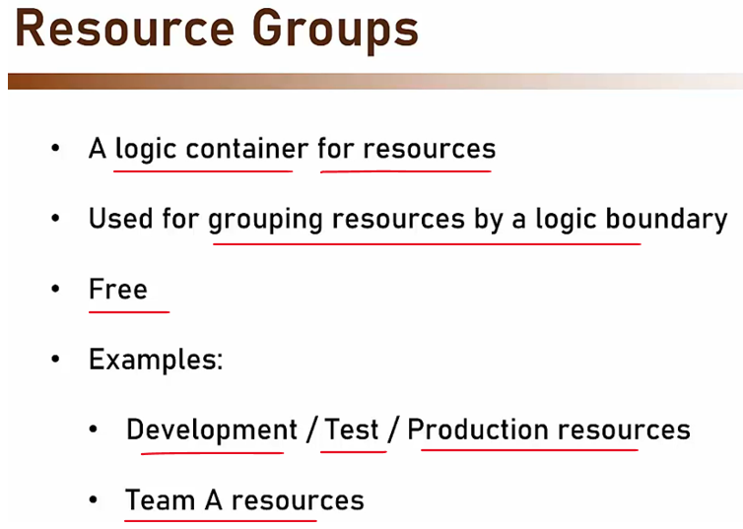

Another example is to separate resource groups by teams. So every team will have its resources in a resource group. Now, this logical grouping will come handy when identifying the types of resources you have. So for example, you might have a resource group named Production RG. And as we will see later, RG is a common suffix of resource group name. And you will see immediately that every resource in this resource group belongs to the production environment of the system.

|  |  |
| --- | --- |
|  | Now, it's important to discuss also the difference between resource groups and subscriptions because you might remember that when we talked about subscription, we said that a subscription is also a logical container and that it contains the various resources you provision in the cloud.  So what exactly is the difference between resource groups and subscriptions? |

So let's see. When we look at the hierarchy of resources in Azure, it looks like this. So as you can see from top to bottom, at the top, we have management groups, which we haven't discussed yet, and then we have subscriptions and then resource groups. And only then we come to the resources themselves.

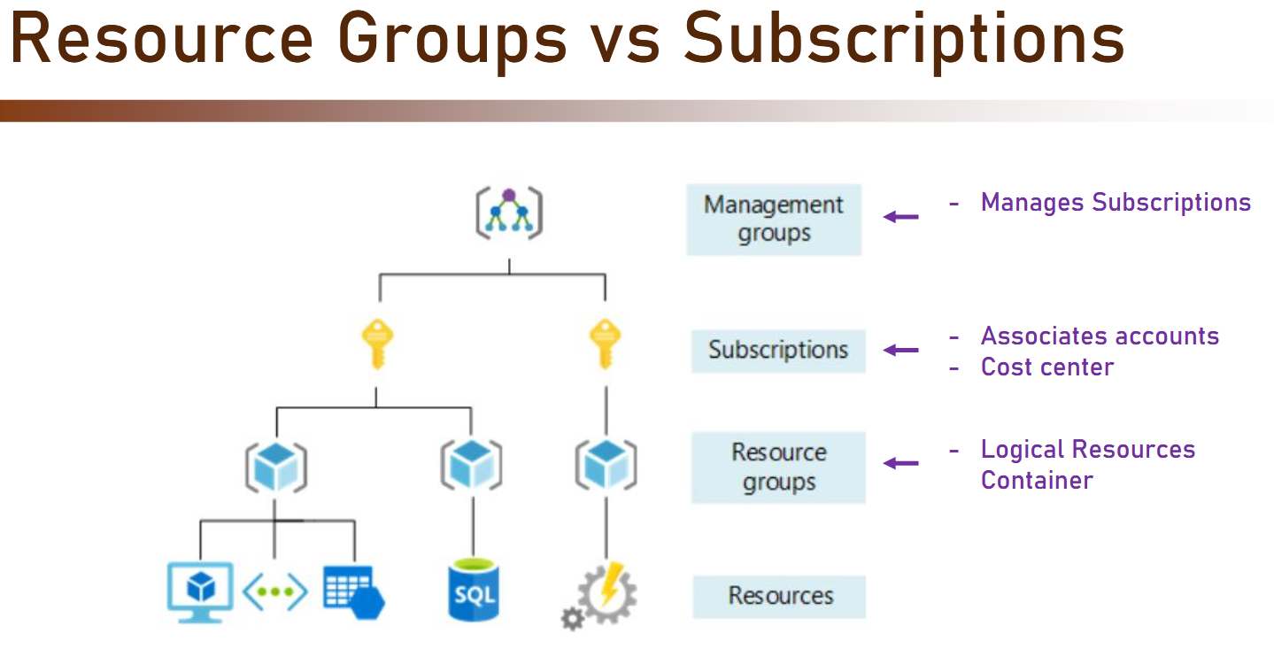

Now, what's important about subscriptions is that they have associated accounts and they are a cost center. So as you saw, when we created our own account in Azure, we immediately and automatically got a new subscription and the account was attached to this subscription. In addition and you will see that later when calculating the cost of our resources, then the cost is always per subscription. So you can think of a subscription as an account level container of resources. Underneath it, we have the resource groups, which are logical resources containers. So the resources themselves are grouped inside resource groups, and this is true for almost all the resources.

So again, you can think about subscription as a cost center and the thing that your account is attached to. And the resource groups are the actual containers for the resources.

Now, what about management groups? Well, we didn't discuss it before and we are not going to discuss it further in the course. All you need to know is that management group is a place to manage subscriptions. So if an organization have multiple subscriptions then they can all be managed using management groups.

Now, resource groups have naming conventions and it's best practice to have an rg or RG in capital as part of the resource group name. Now, this could be prefix or suffix, for example, you can call the resource group like this RG-Project-Dev, or like this Finance-Resources-rg. So that's a very good practice, and you should make sure your resource groups are following this standard. Now, almost every resource in Azure is placed in a resource group. So for example, when you will create a virtual machine then you will have to select the resource group in which it's going to be located.

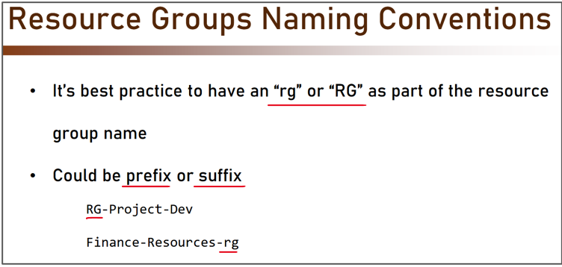

So let's go back to the portal and see how we use resource groups for creating resources. Now we won't actually create resource, but we'll just see where exactly we need to select the resource group for the resource. So let's go again to the search bar as usual and let's start to type virtual machines. And let's pick Virtual machines from here. And click Add and select Virtual machine.

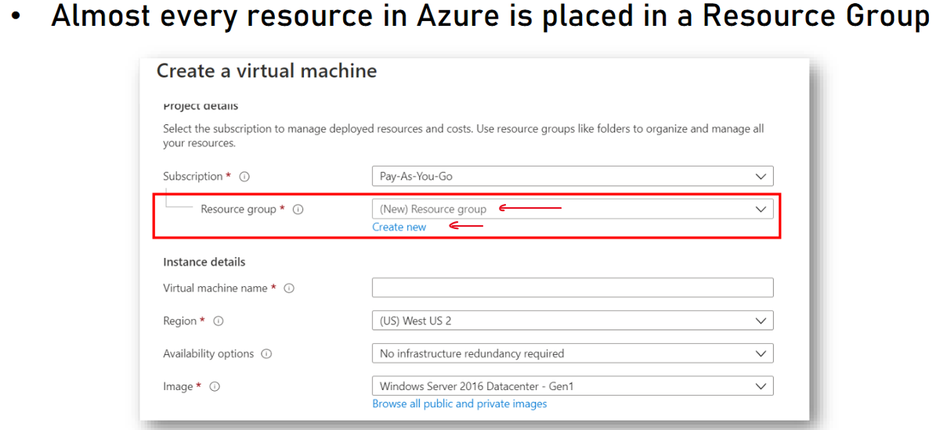

So now we see the page for creating a new virtual machine. Now, you can safely ignore all the parameters and fields right here. We will discuss it later in this course. But what I want to show you is this, the resource group. So as you can see, for almost every resource, we first need to select the subscription. And right now, we have only one subscription we can select from. And after selecting the subscription, we need to select the resource group. Now, if we don't have any resource groups that we can put the resource in then we will create a new one. But there is no such thing as creating a new virtual machine, which is not placed inside a resource group. So resource groups allow us to organize our resources in logical groups, which will make the whole work with them extremely easy, especially when we will have hundreds of them.

## Management levels and hierarchy

<https://learn.microsoft.com/en-us/azure/cloud-adoption-framework/ready/azure-setup-guide/organize-resources?tabs=AzureManagementGroupsAndHierarchy>

Azure provides four levels of management: management groups, subscriptions, resource groups, and resources. The following diagram shows the relationship between these levels.

* Management groups help you manage access, policy, and compliance for multiple subscriptions. All subscriptions in a management group automatically inherit the conditions applied to the management group.
* Subscriptions logically associate user accounts with the resources they create. Each subscription has limits or quotas on the amount of resources it can create and use. Organizations can use subscriptions to manage costs and the resources created by users, teams, and projects.
* Resource groups are logical containers where you can deploy and manage Azure resources like virtual machines, web apps, databases, and storage accounts.
* Resources are instances of services you can create in a resource group, such as virtual machines, storage, and SQL databases.

Management Settings Scope

You can apply management settings, such as policies and role-based access control, at any management level. The level determines how widely the setting is applied. Lower levels inherit settings from higher levels. For example, when you apply a policy to a subscription, that policy applies to all resource groups and resources in that subscription, unless explicitly excluded.

Start with applying critical settings at higher levels and project-specific requirements at lower levels. For example, to make sure that all resources for your organization deploy to certain regions, apply a policy to the subscription that specifies the allowed regions. The allowed locations are automatically enforced when users in your organization add new resource groups and resources.

Tip - Use management groups to organize and govern your Azure subscriptions. As the number of your subscriptions increases, management groups provide critical structure to your Azure environment and make it easier to manage your subscriptions. To learn more, see Management groups design considerations and recommendations.

Create a management structure

To create a management group, subscription, or resource group, sign in to the Azure portal.

* To create a management group to help you manage multiple subscriptions, go to Management groups and select Create.
* To create a subscription to associate users with resources, go to Subscriptions and select Add.
* To create a resource group to hold resources that share the same permissions and policies:

1. Go to Create a resource group.
2. In the Create a resource group form:
3. For Subscription, select the subscription in which to create the resource group.
4. For Resource group, enter a name for the new resource group.
5. For Region, select a region in which to locate the resource group.
6. Select Review + create, and after the review passes, select Create.

Note - You can also create resources programmatically. For examples, see Programmatically create Azure subscriptions and Create a management group with Azure PowerShell .

Naming standards

A good naming standard helps to identify resources in the Azure portal, on a billing statement, and in automation scripts. Your naming strategy should include business and operational details in resource names.

* Business details should include the organizational information required to identify teams. For example a business unit, such as fin, mktg, or corp might be used.
* Follow the guidance for abbreviations for resource types.
* Use a consistent naming convention for all resources. For example, use a prefix that identifies the subscription or resource group, workload type, the environment the resource is deploy in, and the Azure region.
* Operational details in resource names should include information that IT and workload teams need. Include details that identify the workload, application, environment, criticality, and other information that's useful for managing resources.

To learn more about naming Azure standards and recommendations, see Develop your naming and tagging strategy for Azure resources.

Note - Avoid using special characters, such as hyphen and underscore (- and _), as the first or last characters in a name. Doing so can cause validation rules to fail. Names of tags are case-insensitive.

## Resource tags

Tags can quickly identify your resources and resource groups. You apply tags to your Azure resources to logically organize them by categories. Tags can include context about the resource's associated workload or application, operational requirements, and ownership information.

Each tag consists of a name and a value. For example, you can apply the name environment and the value production to all the resources in production.

After you apply tags, you can easily retrieve all the resources in your subscription that have that tag name and value. When you organize resources for billing or management, tags can help you retrieve related resources from different resource groups.

Other common uses for tags include:

* Workload name: Name of the workload that a resource supports.
* Data classification: Sensitivity of the data that a resource hosts.
* Cost center: The accounting cost center or team associated with the resource. In Microsoft Cost Management, you can apply your cost center tag as a filter to report charges based on usage by team or department.
* Environment: The environment in which the resource is deployed, such as, development, test, or production.

For more tagging recommendations and examples, see Define your tagging strategy.

Apply / Remove a Resource Tag

**To apply one or more tags to a resource group:**

* In the Azure portal, go to Resource groups and select the resource group.
* Select Assign tags in the navigation at the top of the page.
* Enter the name and value for a tag under Name and Value.
* Enter more names and values or select Save.

**To remove one or more tags from a resource group:**

* In the Azure portal, go to Resource groups and select the ellipses menu for the group, and then select Edit tags.
* Select the trash can icon for each tag that you want to remove.
* To save your changes, select Save.

## Storage Accounts

Storage account is a special type of resource in Azure which is used to store almost anything. Oftentimes, it is used transparently by various services to store things that you, as the user of Azure, is not even aware of. For example, it can be used to store database backups VM disks, diagnostic data, and lots more.

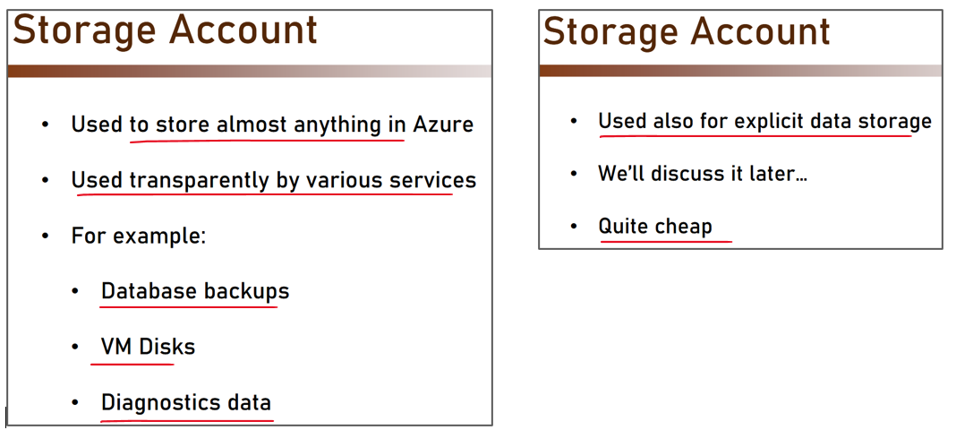

In addition, it is also used for explicit data storage, and we will discuss this option later in this course. Now, storage account, as you'll see, is extremely cheap, and you can store hundreds and thousands of gigabytes of data in it and pay only a few dollars. So again, you will see references for storage accounts when creating various types of of services, and it's important to understand what exactly it means. So this is the storage account.

## SLA

Now you might have heard of SLA before since it's quite a common term in software architecture, but still, let's quickly reiterate it. So SLA is **service level agreement** and it basically defines the uptime percent of a cloud service. Here is an example of some SLAs.

|  |  |
| --- | --- |
| So as you can see, a service which has 95% SLA actually means it can be down for 18 days, six hours, 17 minutes, and 27 seconds annually.  On the other end, a service with SLA of 99.99% can be down for 52 minutes and 35 seconds annually. So as you can see, there is a big difference between the various SLAs. |  |

Now when creating a new cloud service, always check the SLA of this service and let's look at some examples. So for example, an App Service in Azure can have a 99.95% SLA and sometimes it will have no SLA at all depending on the tier that is used.

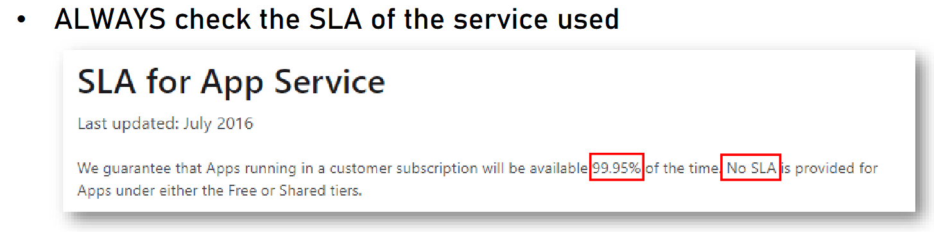

Another example is from Azure SQL, a database in Azure. So as we can see again, this resource can have multiple SLAs, depends on the exact tier that we are using. So when using the business critical or premium tier configured as zone redundant deployments, we have an SLA of 99.995%, which is great SLA and is actually the second best SLA in all Azure. Now of course right now, you have no idea what exactly is SQL database business critical or premium and what exactly is zone redundant deployment, and that's fine we'll discuss it, but it's still important that you see that SLA can differ depends on the exact tier and the pricing scheme we are using.

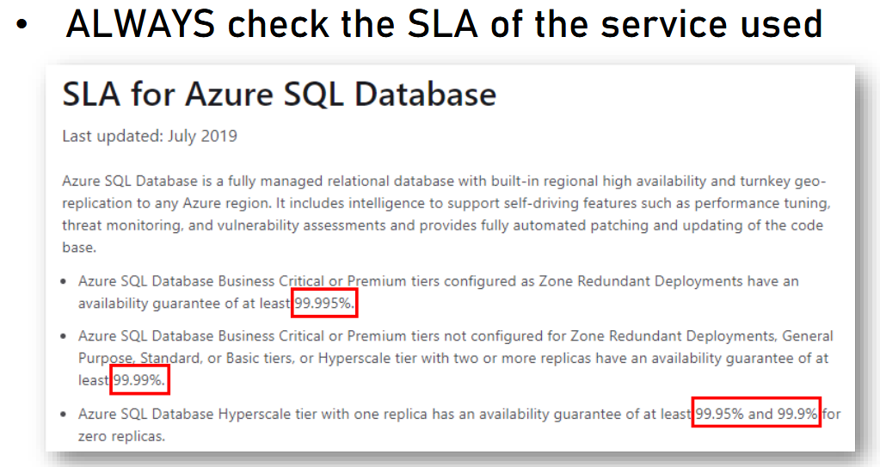

So if you will take a look at the bottom line, you can see that sometimes Azure SQL can have an SLA as low as 99.9%. Still it's quite a high SLA but it pales in comparison to the 99.995% of the first line. Now when talking about SLA, it's always important to remember that the actual SLA of the system should be calculated and we can't just use the SLA of the resource we are using. So what it means is that in order to get the actual system SLA, we need to **multiply the various SLAs of the participating service**. And let's see an example. Let's say we have an App Service.

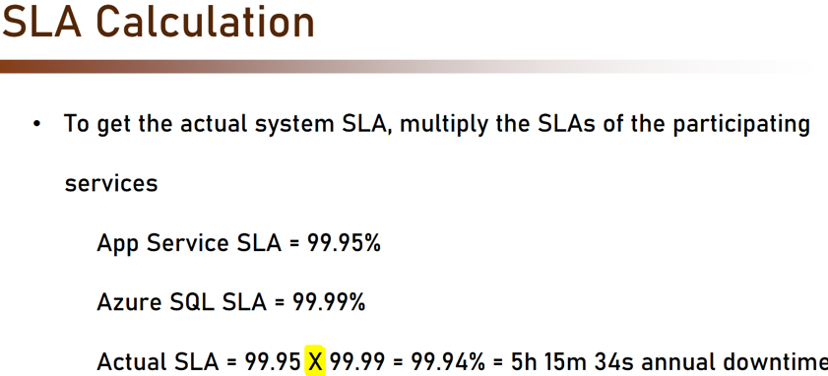

Now as we saw before, the App Service SLA is 99.95 and then we also have Azure SQL, a database, and each SLA is 99.99% because the tier we are using in this case has this SLA. Now to get the actual SLA of the system, we need to multiply both the SLAs. So we multiply 99.95 and 99.99 and what do we get, it's 99.94%, and this is our SLA. Now this SLA equals to five hours, 15 minutes, and 34 seconds annual downtime. Whether it's acceptable or not that's naturally depends on the system requirements, but still it's important to understand how exactly to calculate the actual SLA of the system.

### SLA Calculators

There are many online tools to calculate SLA.

For example, if you want to know how much downtime is allowed with 97% SLA - then SLA calculators will really help you with that.

My favorite tool is:

<https://uptime.is/>

It is dead simple - just type in the SLA, hit Enter, and see the numbers.

Highly recommended.

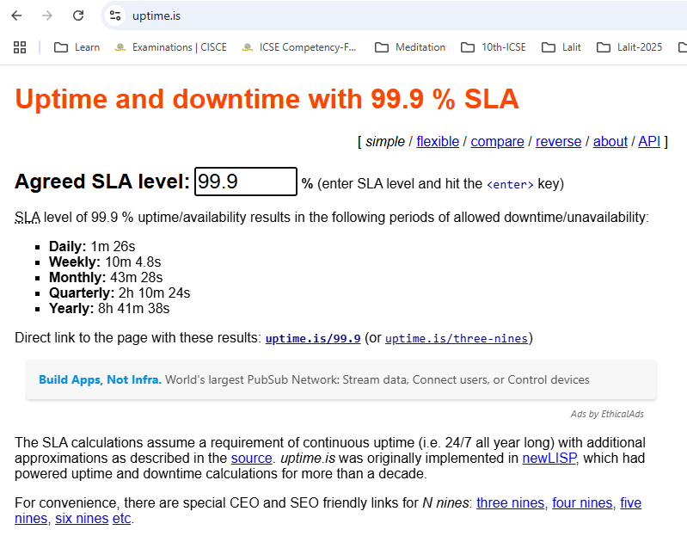

## Cost

Almost everything in the cloud costs money. So whenever you create a new resource, assume you are going to pay for it. There are some exceptions, for example, resource groups that we discussed before, which are absolutely free. And there are also some additional resources that are free. But in general, everything costs money. Now there are a few pricing models in the cloud. There is a pricing model in which you pay per resource. For example, if you create a new virtual machine, you pay for this virtual machine.

Another pricing model is per consumption. That means that you are not paying for the resource itself. For example, function app, which we will discuss of course later and for which you are not paying for the creation of the function app. What we do pay is for using the function app. So whenever we make a call to the function app, we pay a very small amount.

Another pricing model is reservation. With reservation, we can pay upfront for the resource with a commitment of using it for certain amount of time. For example, we may commit to use the virtual machine for three years, and for that case, we pay upfront for three years and get a hefty discount on the price. Now the rule of thumb here is quite simple. Always check the resource's cost before provisioning. So before creating a new resource, always check how much you are going to pay for it. And if it's too expensive then always check for more cost-effective alternatives. For example, when possible and available, look for reservations. Some resource types allow reservations, which as we said before, is an upfront payment with discount. And if that might fit your needs then definitely use it.

|  |  |
| --- | --- |
|  | * ALWAYS check resource’s cost before provisioning * Check for more cost-effective alternatives * Look for reservations when available and relevant |

Now the prime way of figuring out how much a service is going to cost you is using the Azure calculator. And this is a link to the calculator. And let's take a look at it. So click this link and let's go through the calculator together. So here is the Azure pricing calculator and what we see here is basically the list of categories of services with the featured services or the most popular services displayed here. And we can simply click the resource we're interested in, fill in some parameters and see the cost.

Azure Calculator - <https://azure.microsoft.com/en-us/pricing/calculator/>

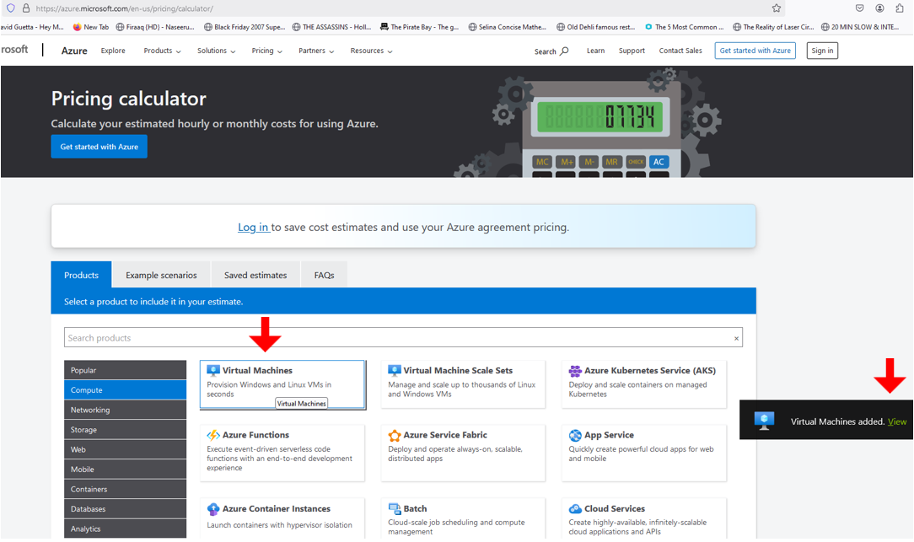

So let's begin with virtual machines. So let's click this and now the Azure pricing calculator will add it at the bottom of the page. So we'll click the View. And here we are in the Virtual Machines section of the Azure pricing calculator. Now we need to fill in what exactly we are looking for in the virtual machines. So first, let's set the region. As we said before, region can affect the pricing. So in my case, I will go for West Europe, which is the region I will use across this course. You of course are free to use whatever region you want, preferably one that is close to you. So after selecting the region, we will go for the operating system and we'll select the correct operating system for us. I will leave it with Windows.

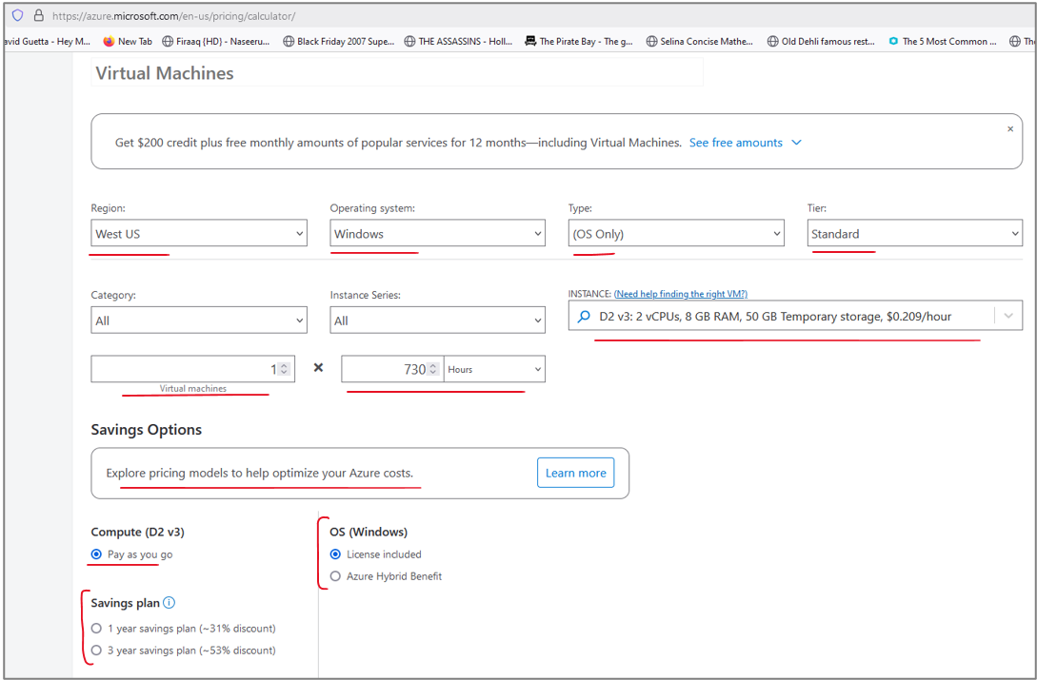

|  |
| --- |
| Options as below |
|  |
| |  |  |  | | --- | --- | --- | |  |  |  | |
|  |

Other part of the page is as below

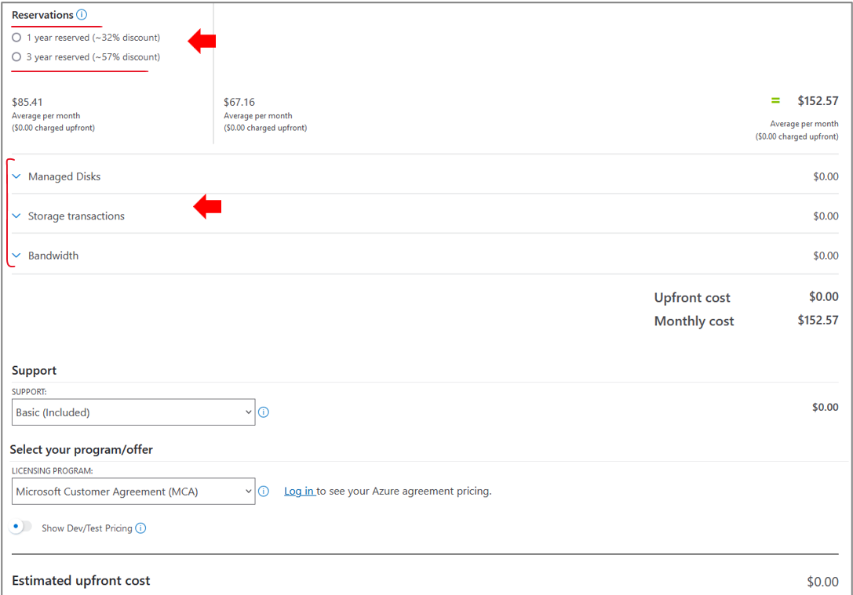

|  |  |
| --- | --- |
| **Managed Disks, Storage Transactions and Bandwidth expanded** | |
|  |  |

The type is OS Only, I don't want any pre-installed software on this virtual machine. I will also stay with the standard tier. And then I need to select the specific instance type of the virtual machine. So the default here is an instance called D2 v3, which offers me two vCPUs and eight gigabyte of memory with 50 gigabyte temporary storage. So just for the example, let's leave it this way. Now I also can select how many hours this virtual machine will be operating in a month. Now in Azure, the default number of hours per month is 730. So again, because I want to get a monthly estimation, I will leave it as is. And now let's look at the actual cost. So what I see here is for this virtual machine in this region with this operating system and of this instance type, I'm going to pay $154.76 per month.

Now there are additional five cents here because Azure assumes I'm gonna use storage account quite extensively. Now because the cost of it is quite low, I will leave it as is. So this is the final price I probably going to pay for this machine. But remember we talked about reservations. So here I can select my reservation and if I decide that reservation is good for me then I can opt for the three years reservation. And now I can see that the price went down substantially. And instead of $154 per month, I now I'm looking at $105.63 per month.

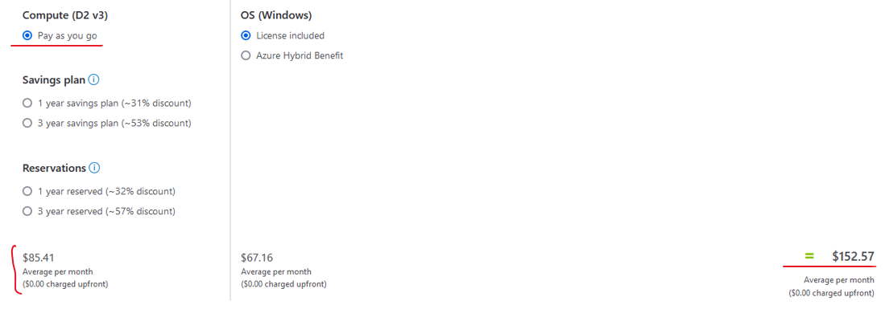

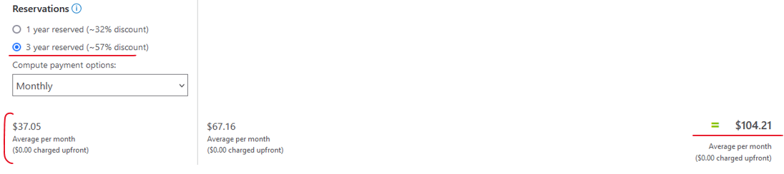

Now if I decide that I don't really need the Windows operating system and I can do with Linux then the price will go down even more and even more substantially. And now for the very same machine on the very same region, I'm gonna pay only $38.47 per month, which is extremely low compared to the original price that we looked at.

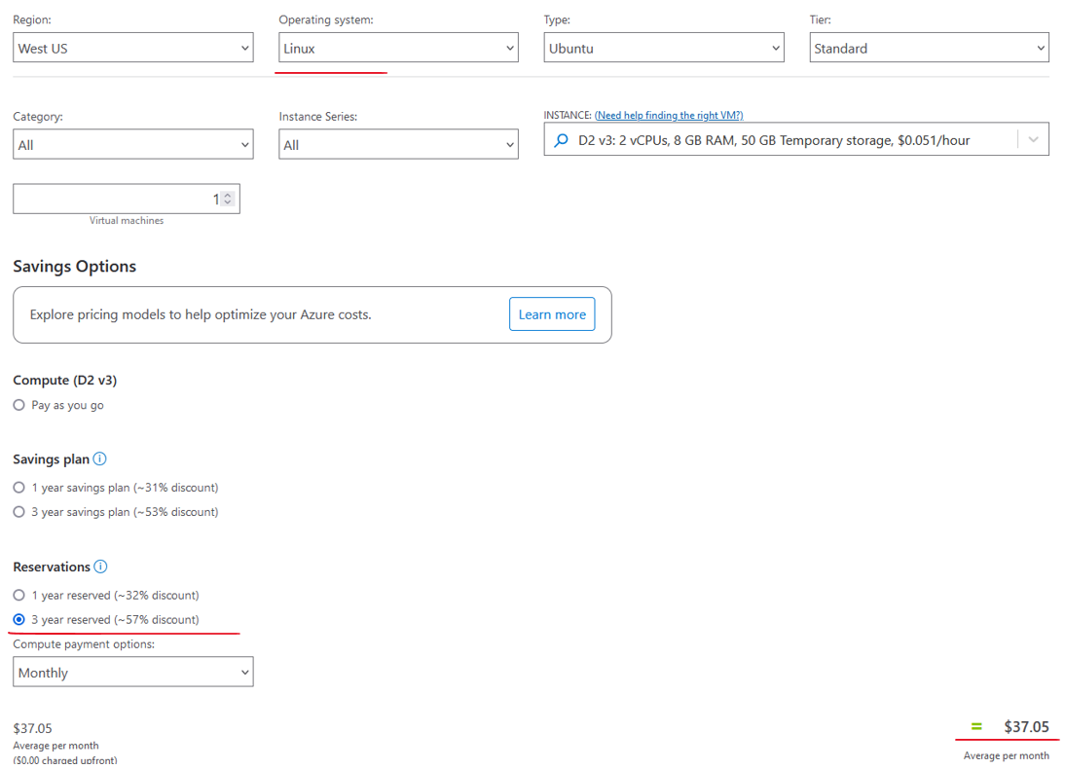

So as you can see, there are many factors that affect the price and you should always choose the most cost-effective one. So if for example, you don't really need the Windows operating system and Linux will do, then go for it. If you can use a smaller instance and for example, you don't really need the eight gigabyte of memory and you can do with less than that, then do that. And of course if you can also can commit to three years reservation, then again do that. It will save you a lot of money.

Now let's look at another example. So that was virtual machine and now let's look at Azure SQL.

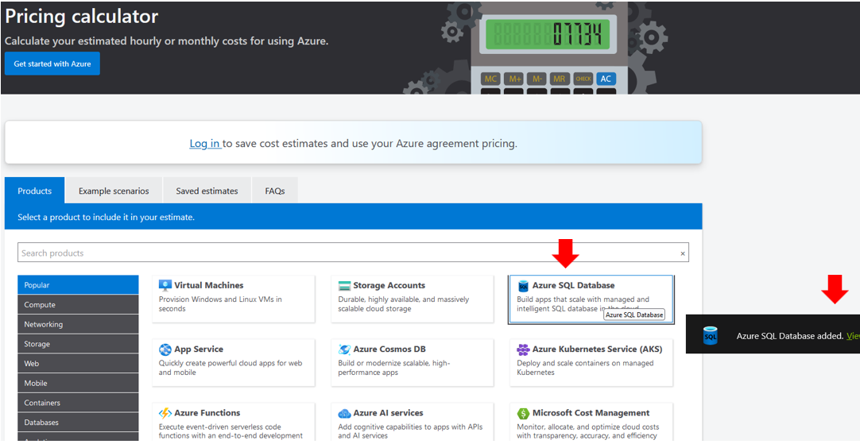

Again, we will go in depth with Azure SQL later. I just want to show the calculation of the price of it. So again, let's pick the region. I will go for West Europe as usual. Here I will pick a Single Database with regarding to the backup storage there, I will leave it as is. All the rest I will leave again as is. And as you can see, the price here is quite high.

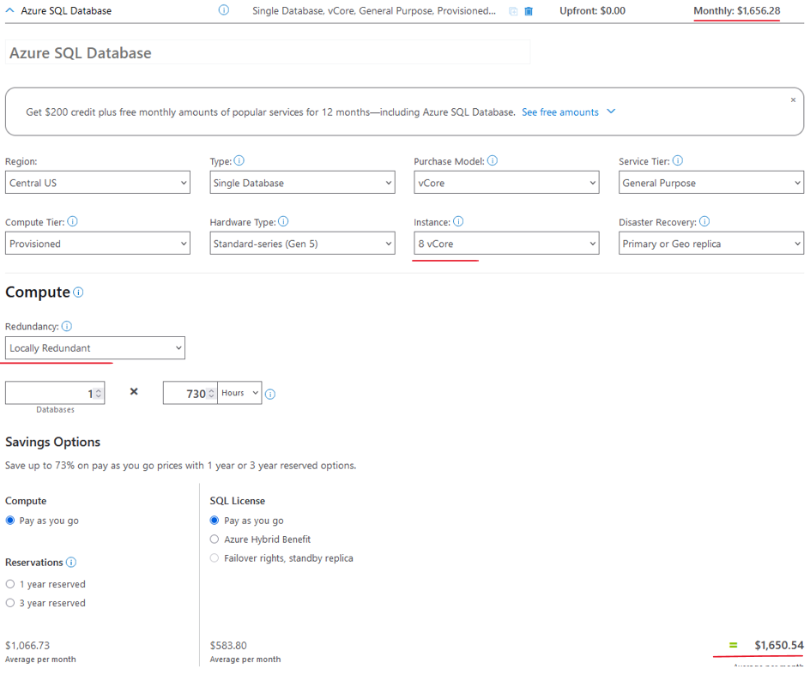

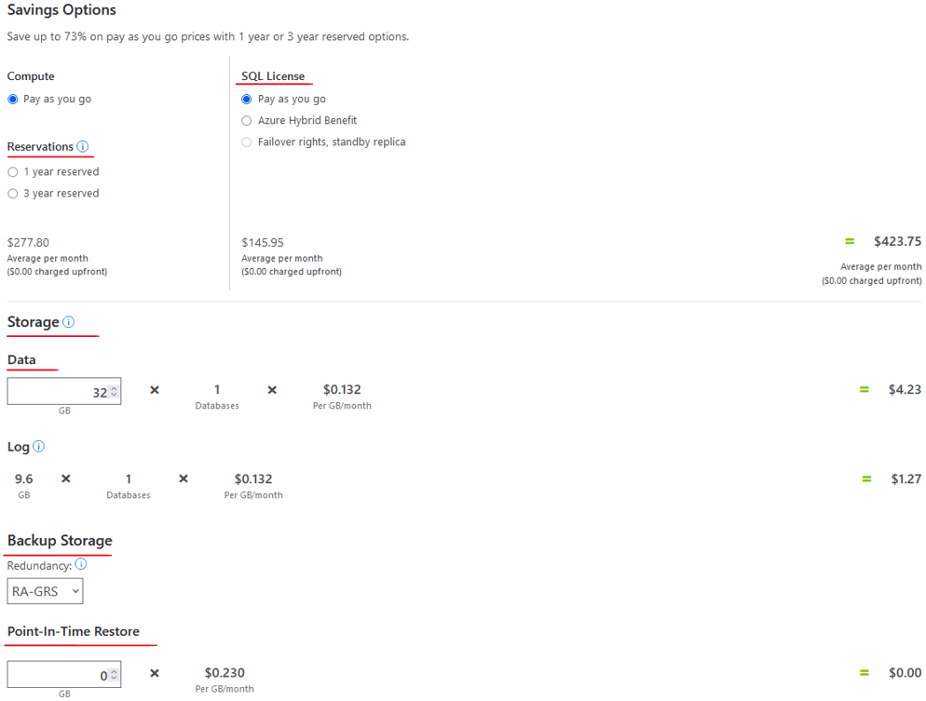

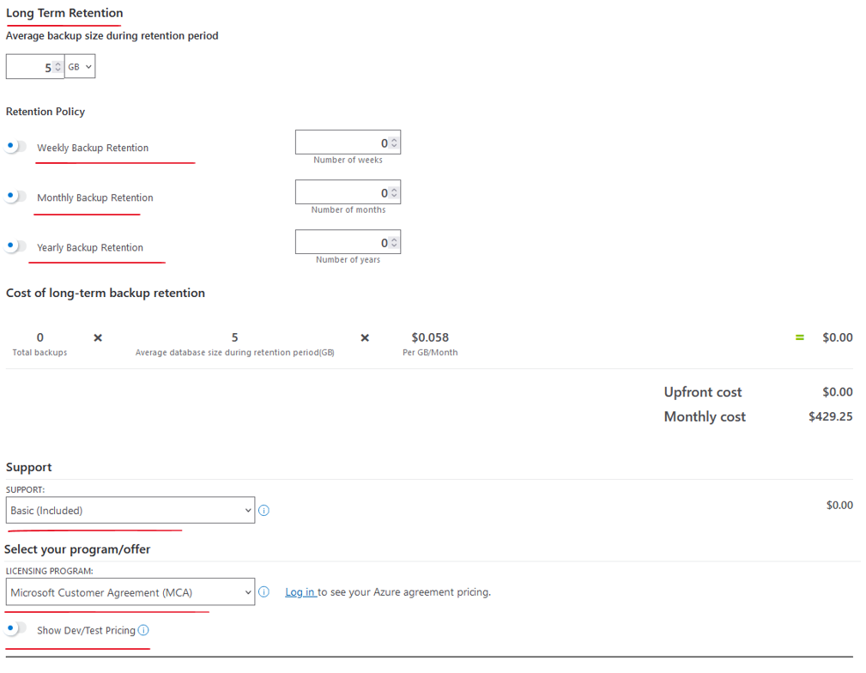

So here we are looking at $1,561 per month, which is a lot. Now, one way to bring down the price is to pick a smaller instance. Now the default instance of Azure SQL is eight vCores, let's say I can do with two vCores. So we see a substantial decrease in the price. And if also I can go for reservation, I can see immediately that the price went down even more. Now actually there is even a better way to bring down the price of Azure SQL.

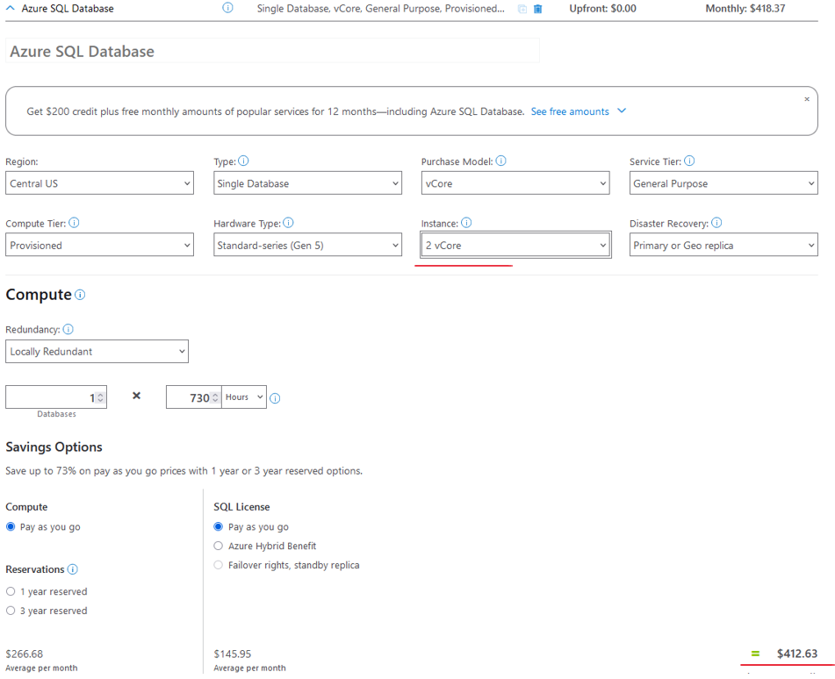

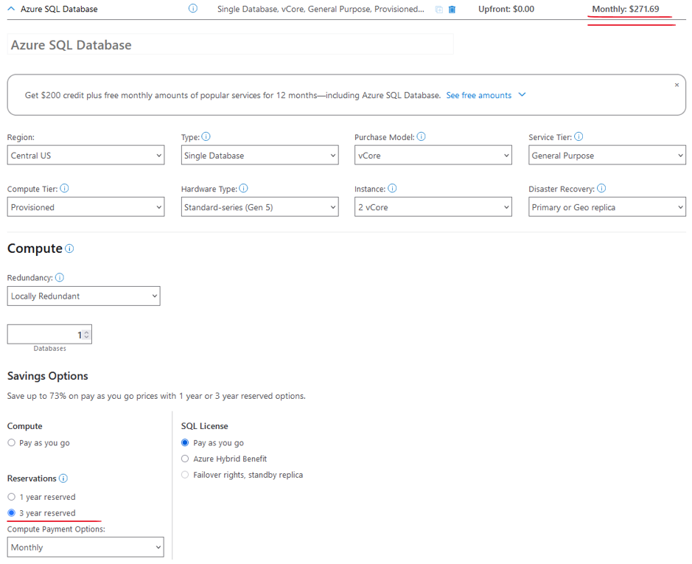

So if instead of the purchase model of vCore, I will go with DTU, and I will stay with the basic tier and five DTUs. Then we are looking here at a ridiculous price of less than $5 a month.

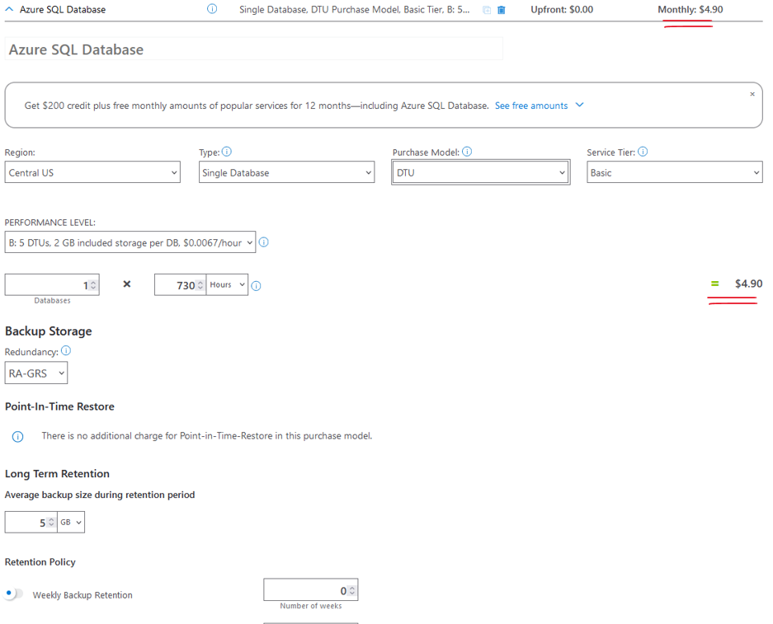

So of course later we'll discuss what exactly is a DTU versus vCore purchasing model. But you can see that there is a lot of margin here in the pricing of Azure SQL and that's the same also for other resources. So that was about the Azure calculator. I highly recommend to always leave it open and before creating new resources in Azure, pay a visit to the calculator and make sure you pick the most cost-effective option of the resource you are going to create.

### DTU ( Database Transaction Unit ) vs vcore ( Virtual Core )

<https://www.youtube.com/watch?v=CnsVLqDhb2g>

<https://pragmaticworks.com/blog/dtu-vs-vcore-whats-the-difference>

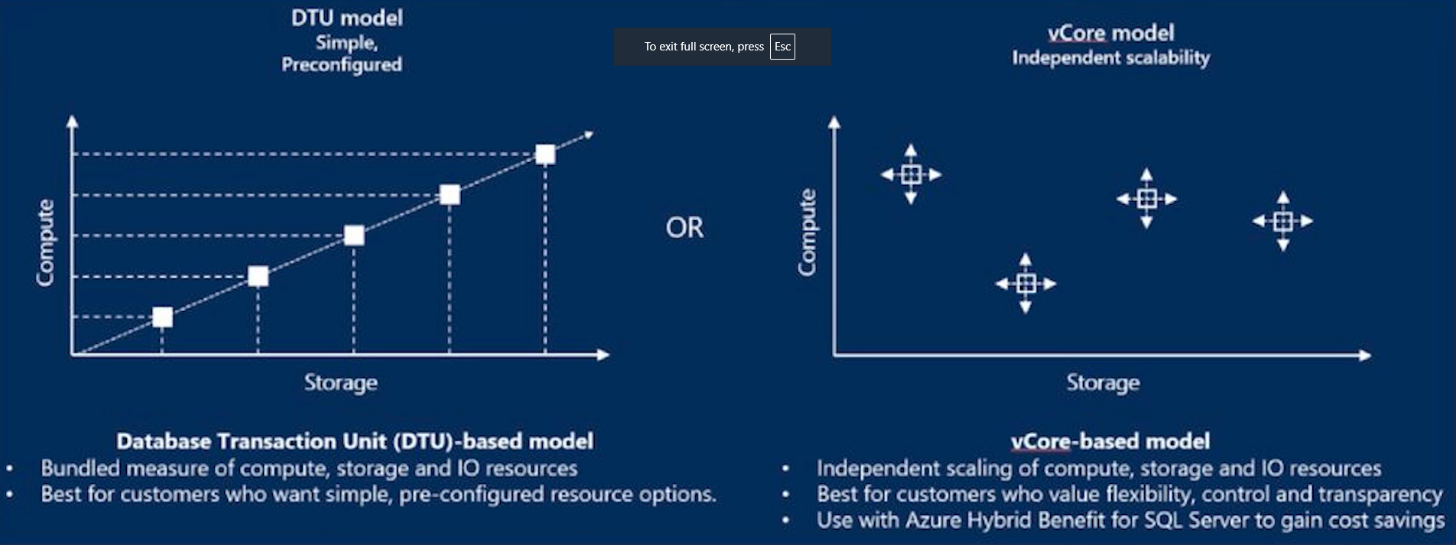

We want to migrate from an on premises SQL Server into some sort of cloud representation of that and an Azure SQL database is a great tool to be able to do that exact thing with but there's a little bit of confusion when it comes to how do we determine what is the purchasing and pricing model I should look at when I'm creating an Azure SQL database there are two options that you are provided whenever you are provisioning this inside of the Azure portal a DTU or a **database transaction unit** and a vcore which stands for a **virtual core** so which one should I choose and what's the difference between them.

Let's talk about DTU or a DTU (Database Transaction Unit) database transaction unit is going to be this Blended measure that's going to combine CPU, memory data, IO and is best suited for users who prefer really a simplified approach to a management of performance now this is going to essentially abstract the underlying Hardware into a single unit of measure so instead of separating out CPU memory and IO we're going to make it One Singular unit to make it easier to understand for users, who may not have an in-depth knowledge of database performance tuning.

A DTU purchasing model comes with a predefined set of performance tiers such as basic standard and premium and with each comes its own set of fixed resources and corresponding vCore (Virtual Core) limits now on the other hand a virtual core or a vcore is going to provide more of granular control over the resource allocation it's going to allow users to ultimately choose the number of vores allowed to them which is going to offer them some flexibility to be able to scale up and down resources based on a very specific workload requirement now vcores and purchased models are going to be preferred by users who are going to want to have more precise control over their resource allocation so what are the key differences between them well really a DT is going to be this bundled measure of resources.

So a vcore is going to be more grad so you have more control over the CPU and memory separately where a DTU is going to come as this prepackaged object. With flexibility vcore is going to be much more flexible in being able to Resource your allocations and things like that and have a set of defined compute, while DTU is going to come with only fixed tiers and you can't have specific things that might be scaled up for one thing and less for another DTU, its ultimately going to be a simpler object to manage and understand especially for users who may not have this extensive experience with database performances but vcore is going to have maybe a little bit more flexibility and some options including an ability to go with a serverless option as well.

Now the cost structure between these two can be vastly different as well

Azure now also has some of the other types of service tiers around the DTU purchasing model include the standard which has a set different set of s0 S1 S2 S3 sets that include how many DTUs you're going to be provisioned now by default the basic standard s Service tier is going to have 10 dtus but I have this sliding scale where I can slide that up for more and more and more and more and you'll notice here the different places I put my scale you're going to see a different cost associated with that essentially the more Det use or the more compute you have the more you're going to pay for that of course now we other have this also option to be able to increase the max size of that DTU database as well so if I go through and start sliding this scale over for the DTUs.

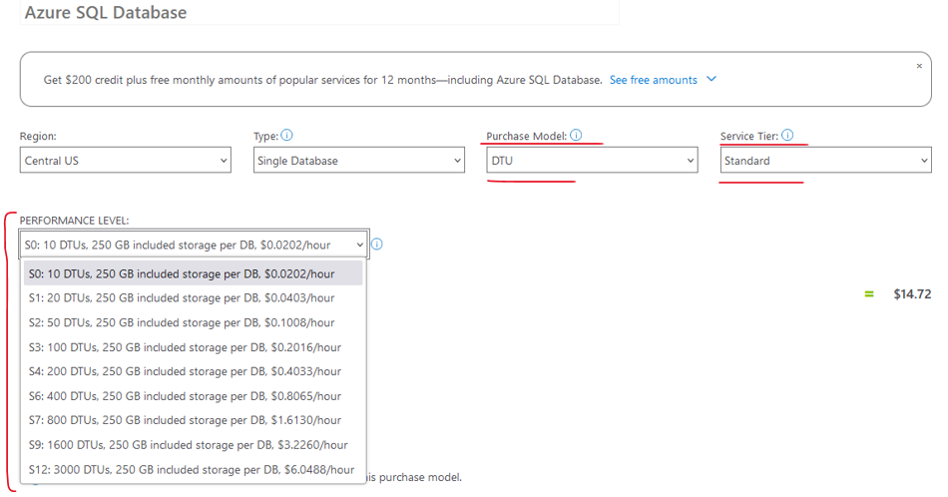

You'll notice that that data Max size will actually decrease as well because we actually have more data that we can store if we get more database units for ourselves so as we go through and need to work with more larger data sets you might need to scale that up simply for the reason of being able to store more of your data now there are going to be a predefined set of different gigabytes that you're going to have depending on your DTU structure but you can always go above that allotment as well and you can pay for additional storage that goes beyond what the DTU covers by default.

Now let's go over to the vcore purchasing model and let's check out that one for the general performance of this you'll notice that you have two options in your compute tier you have the ability to work with provisioned or serverless compute provision means that you have dedicated a set of resources and they're pre-allocated and they are build per hour now a serverless is not going to have pre-allocated compute meaning that you're not actually having compute that's available to just you it's going to be used when necessary and it's build as a per second of vcores used so that's an option right away you have to determine for yourself and how you want to have that control now some of the other things you can do is set up your Hardware configuration of that aure equal database using the VC cor purchasing model you can also go through and determine your Max vores and your men vcores when you're working with serverless when you go through and you provision this you only have the option to choose how many vcores you want by default so serverus is going to give you this dynamic range between two numbers vcores with general purpose and provision is going to give you one specific number that you can go through and determine to allocate to best fit your specific needs well hopefully we have some better understanding of what the difference between the dtus or the database transaction units and the vcores or virtual cores are for inside of azure SQL databases when determining what would be the best compute tier for you so if you have more questions definitely check out my blog around this topic where I talk a little bit more in depth around the topics and the generalities of what we can work with when it comes to adders equal databases

### Setting a Budget

Another nice feature that can help us when monitoring the cost of our resource usage. So, let's see how to do that. In the Search bar, type, cost, and go to Cost Management right here, and again, we are going to discuss this section of the portal quite thoroughly later in this course, but now, I want to focus on a very specific capability of it, which is Budgets.

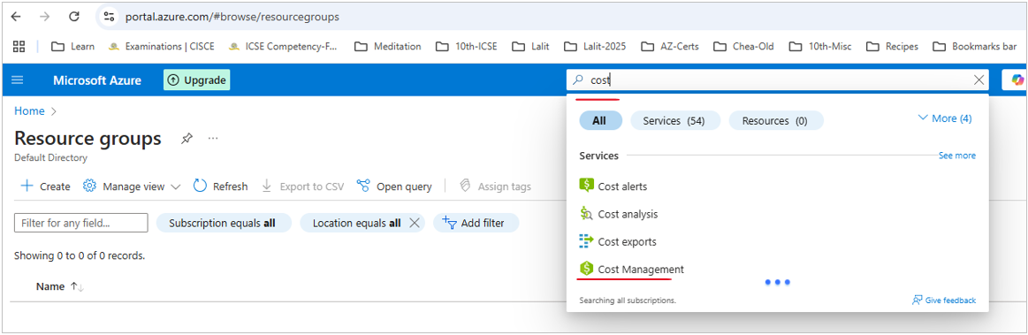

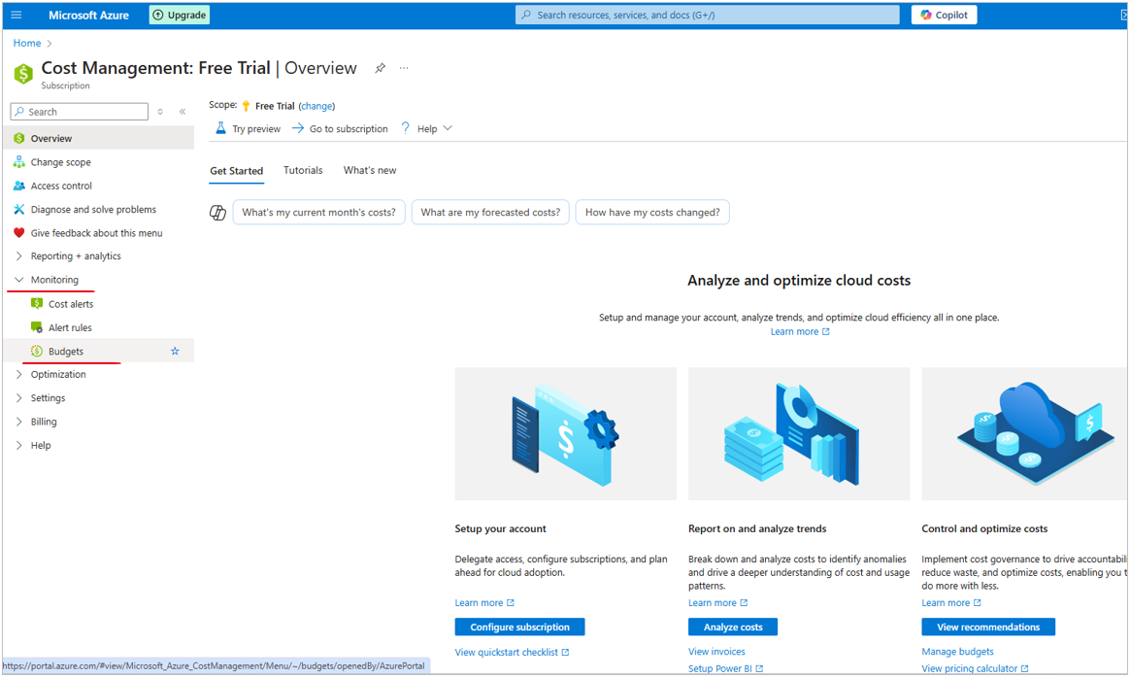

So, click that, and with budget, what we can do is to define a budget that we want not to exceed from in our Azure usage, and when we exceed it or coming close to exceed it, then we can get an alert from Azure, and this is extremely important when using a free trial, because as you probably remember, the free trial is for $200, and we don't want to start paying after exceeding this amount, and therefore, we want to get alert when we come close to $200, and we can achieve that using budgets.

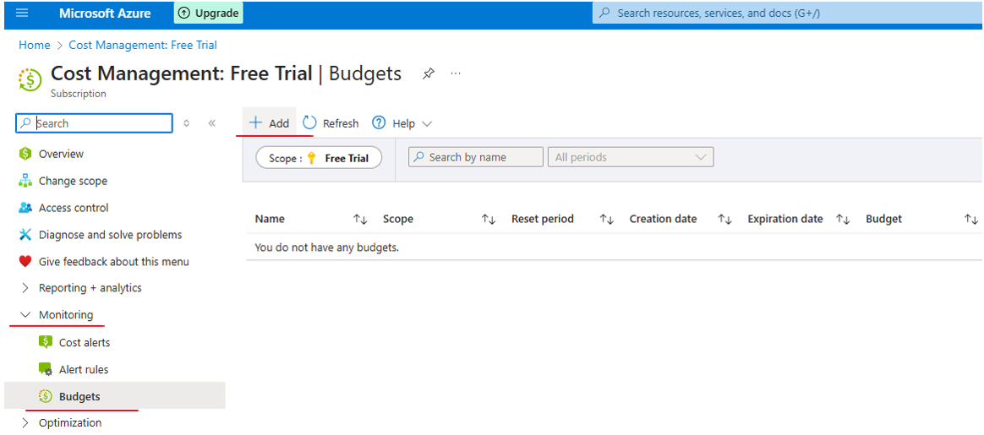

So, let's see how to do that. Here is the list of budgets we currently have, and naturally, we don't have any. So, click Add, and let's define our budget. So first, let's name it, so let's call this budget, Close to 200, like that, and we want the budget period to be annually, because these $200 budgets that we have is not per month, but a total, and therefore, annually will be the best here.

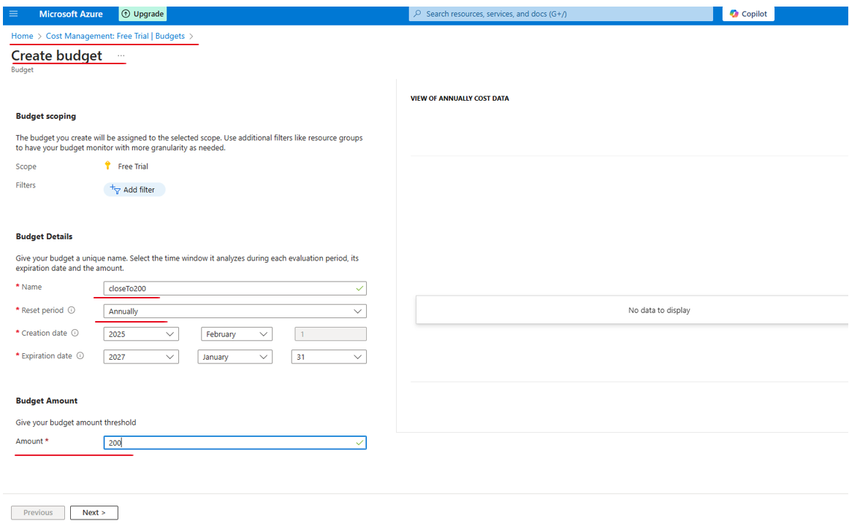

Now, by default, Azure suggests that we'll calculate this budget from the beginning of this year to the end of next year, so let's stick to that, and now, we need to set the amount of this budget, which is, in our case, 200. Great, now, let's click Next, and now, we want to define when and how we should get alerted when we come close to exceeding this budget.

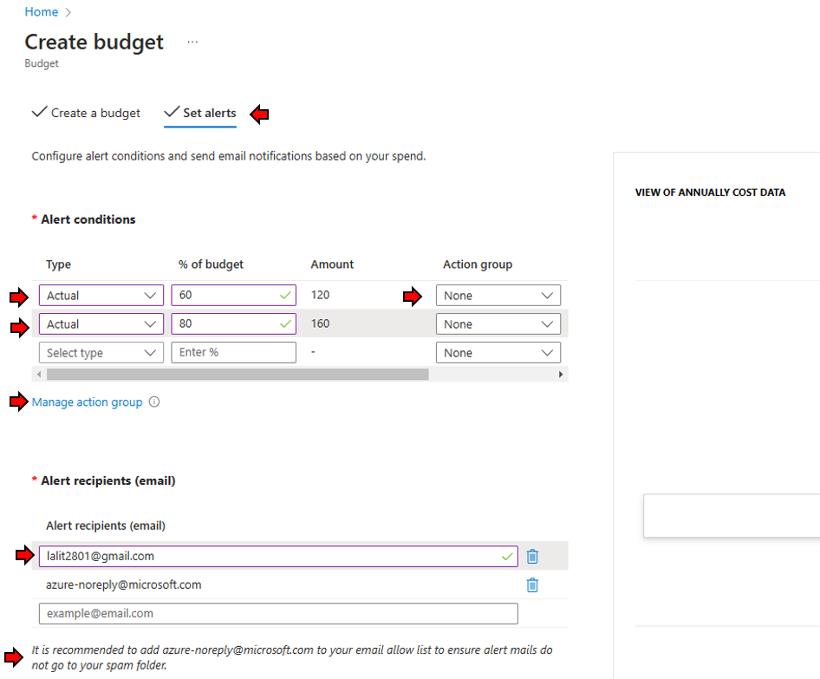

So now, what we want to do is to select the type of condition of this budget, and we are going to set the alert to be based on the actual spending that we have. So, what we want to say is when the actual spending is, let's say, 90% of this budget, which means that we are spending $180, we want to get an email alerting us about that. Now, let's type here the email address we want to use for this alert, so I will type my email address, which is memi@memilavi.com. You, of course, will type your own, and we can even select the language which will be used for this alert, and as you can see, the list is quite long. I will stick with English.

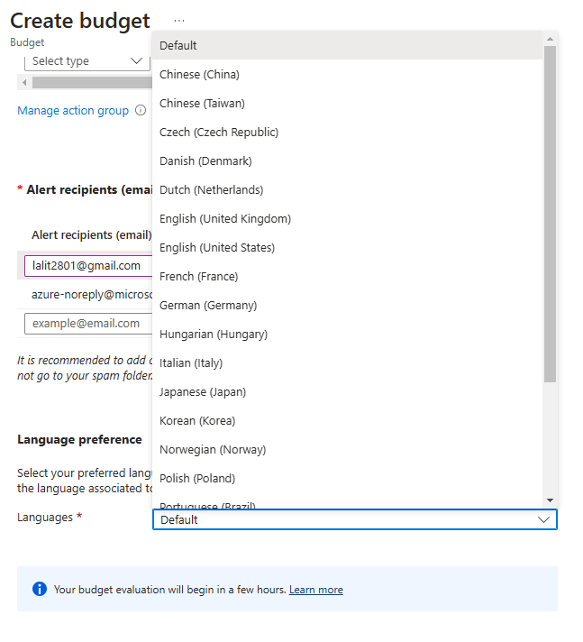

So, that's it, basically, and this is a budget that will alert us when we will cross the $180 bar. So, let's click Create, and now, Azure is validating and creating this budget, and here is our new budget. So again, the name is Close to 200, the period is annually, and we can track here the progress of this budget, so we will be able to see here in this bar how close we are to exceed this budget.

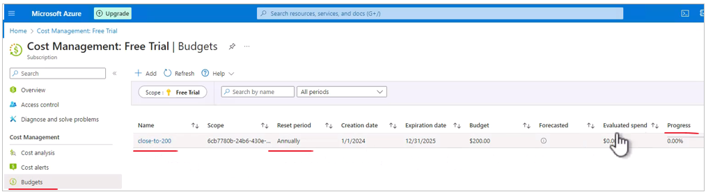

So again, we are going to discuss cost management in Azure quite thoroughly later in this course, but it's important to have budget in place as soon as possible.

## Architects and the Cloud

Traditionally, software architects that were designing regular systems, needed to know the non-functional requirements of the system, the technology stack, the components architecture, and the communication patterns. This is all true for traditional systems.

|  |  |
| --- | --- |
|  |  |

But, cloud-based systems require, in addition, also infrastructure knowledge. So, the architect will often need to design the networking, the firewalls application gateways, the VPN's, the load balances, et cetera. The architect also has to know a lot about the security. And what I mean here, is of course, the unique aspects of security that are relevant to the cloud, and to the infrastructure, because of course, a great architect must be fluent in securing application as integral part of its role. And, many times the architect has to have a great hands-on knowledge and experience with the cloud, because no one else in the organization is as expert and knowledgeable about the cloud, as the architect. So, these three skills are unique to cloud-based systems, and usually traditional architects, are not dealing with it when designing on-premises system.

# Readit App

We are going to build together an app and put it in the cloud. And in this section I want to introduce you to our app. So say hello to ReadIt! ReadIt! is your bookshop on the cloud. This is a full-blown bookshop which simulates a real life bookshop. And as every other bookshop it contains four main services. It has a books catalog from which you can pick the book you want to buy. It has a shopping cart, an inventory management system and of course an order engine. So we are going to take this app and put it in the cloud in the best way possible. Now, some technical details about the ReadIt! app. First, it is developed using .NET core and nodeJS. But no worries. You don't have to be familiar with these platforms. I provide you with all the code you need. All we will do is see how to deploy it in the cloud and add the relevant cloud services. You don't have to know how to develop using .NET core and nodeJS.

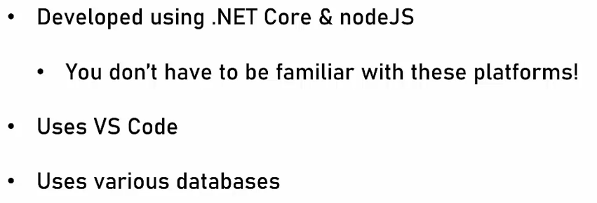

We are going to extensively use VS Code which is the most popular code editor in the industry right now and we're going to use various databases. You will see that we'll use relational database as well as NoSQL database and even an object store. So what we'll do, we'll begin with a basic app and run it locally. We won't even touch the cloud at this stage. We'll just make sure that everything works fine. After that, we are going to move it to the cloud while demonstrating values deployment options which are the compute options or the way we actually run the code.

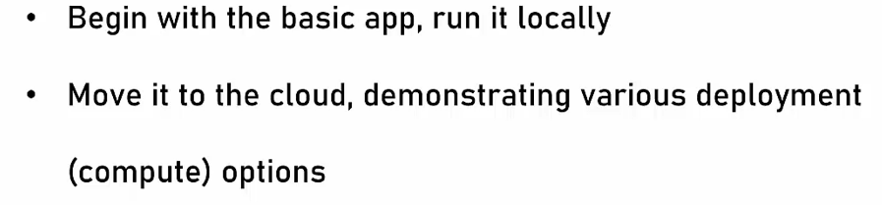

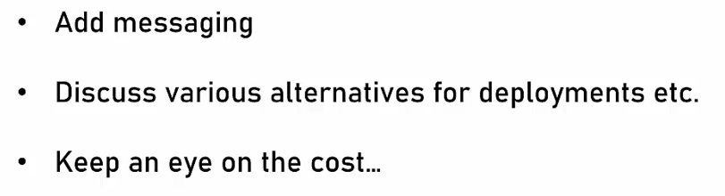

Then we'll add networking and security and database support. And after that we'll add the messaging between the various services. Then we'll also discuss various alternatives for deployments. And of course, and perhaps the most important part is we are always going to keep an eye on the cost. So this is the description of the app.

The Read it to website has four major components: the catalog, the shopping cart, the inventory, and the order engine. Now the order engine has no visible elements so I won't be able to demonstrate it.

**Catalogue**

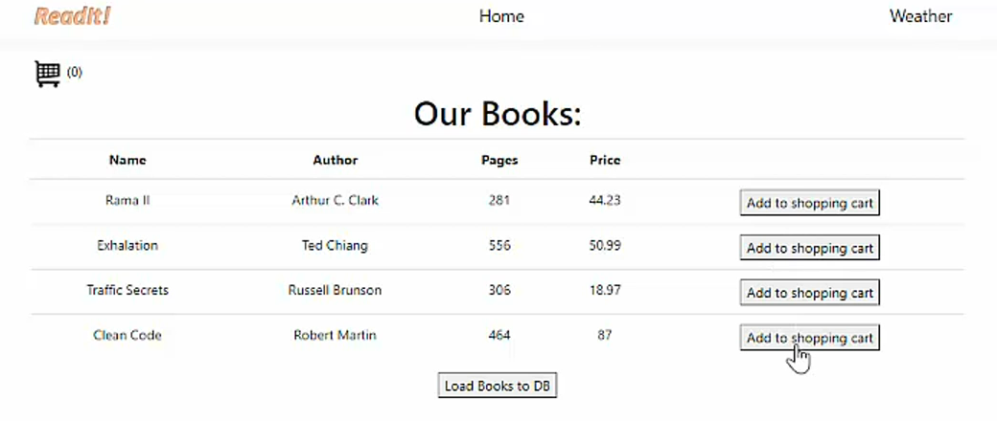



After adding two books to the cart by clicking Add to shopping cart button, we can see

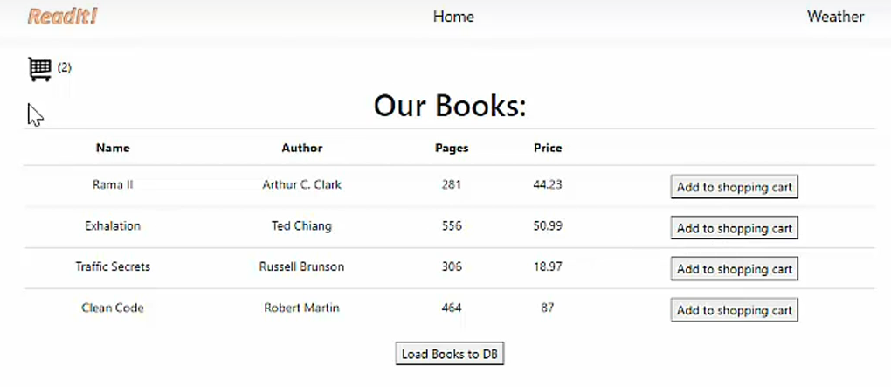



**Shopping Cart ( we can see the two books we added in the cart now )**

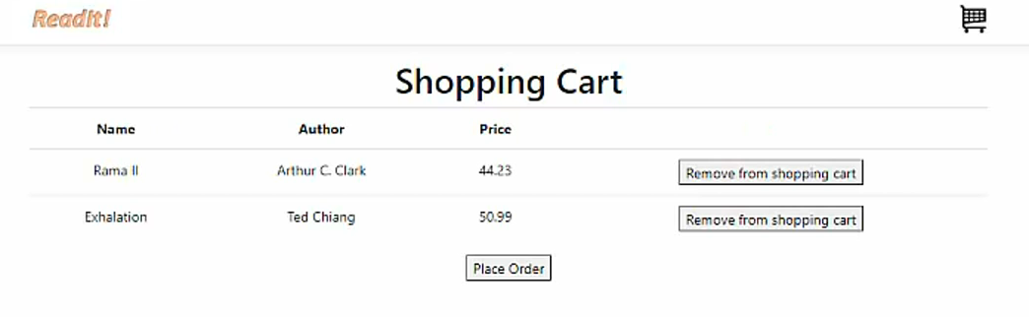

**Inventory Management page**

Naturally this should be accessible only to the shops employees, so we have a sign-in page that makes sure only the employees can access this page.

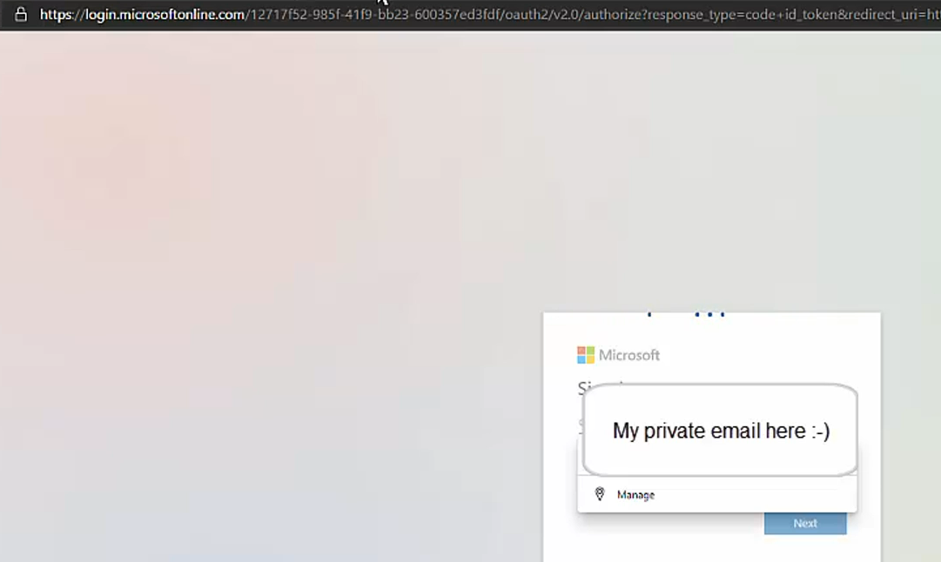

After authenticating we see the inventory management page of the shop

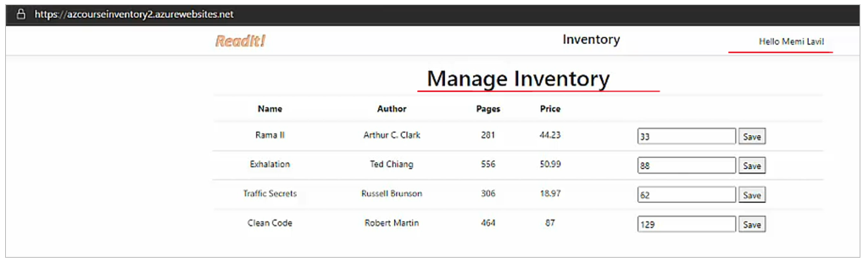

The above also displays your name at the top right

This has the current inventory of all the books, we can modify the inventory here by chaning the input box numbers and save it.

If we modify the inventory as 0, then we would see this as

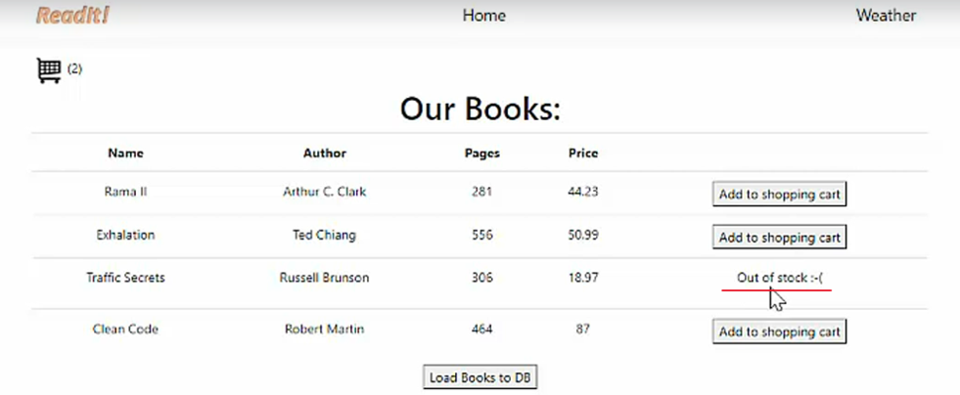

Also observe that whenever you add a book into the shopping cart, the number reduces in the Manage Inventory count

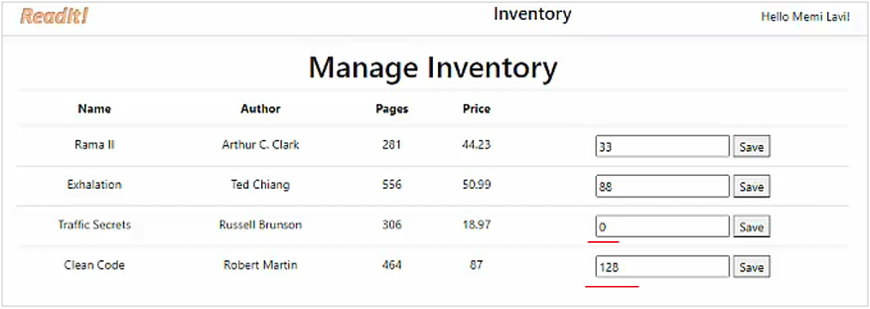

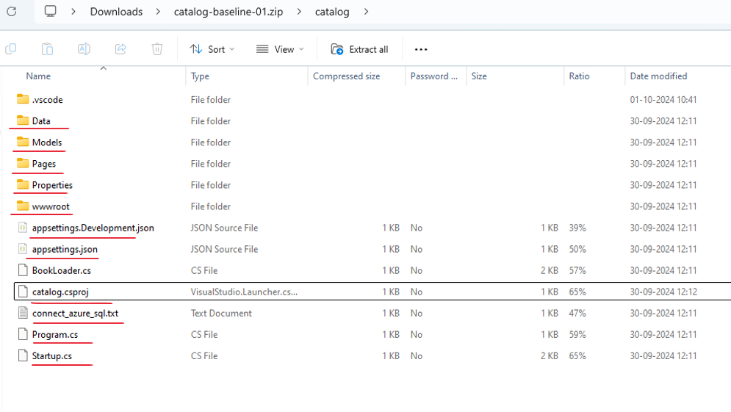

**Startup.cs**

using Microsoft.AspNetCore.Builder;

using Microsoft.AspNetCore.Hosting;

using Microsoft.Extensions.Configuration;

using Microsoft.Extensions.DependencyInjection;

using Microsoft.Extensions.Hosting;

using catalog.Data;

using Microsoft.EntityFrameworkCore;

namespace catalog

{

public class Startup

{

// CHANGE THIS TO false WHEN MIGRATING TO AZURE SQL

private bool useInMemory = true;

public Startup(IConfiguration configuration)

{

Configuration = configuration;

}

public IConfiguration Configuration { get; }

// This method gets called by runtime. Use this method to add services to container.

public void ConfigureServices(IServiceCollection services)

{

services.AddRazorPages();

if (useInMemory)

{

services.AddDbContext<BookContext>(

options => options.UseInMemoryDatabase(databaseName: "test"));

} else {

services.AddDbContext<BookContext>(

options => options.UseSqlServer(Configuration.GetConnectionString("BooksDB")));

}

}

// This method gets called by the runtime.

// Use this method to configure the HTTP request pipeline.

public void Configure(IApplicationBuilder app, IWebHostEnvironment env)

{

app.UseDeveloperExceptionPage();

//app.UseHttpsRedirection();

app.UseStaticFiles();

app.UseRouting();

app.UseAuthorization();

app.UseEndpoints(endpoints =>

{

endpoints.MapRazorPages();

});

}

}

}

**appsettings.Development.json**

{

"Logging": {

"LogLevel": {

"Default": "Information",

"Microsoft": "Warning",

"Microsoft.Hosting.Lifetime": "Information"

}

}

}

**BookLoader.cs**

using System.Collections.Generic;

using catalog.Data;

using catalog.Models;

using System.Linq;

namespace catalog

{

public class BookLoader

{

public static void LoadBooks(BookContext ctx)

{

// First - remove all books from the DB

ctx.Books.RemoveRange(ctx.Books);

// Now - create list of books

var books = new List<Book>

{

new Book{ Name="Rama II", Author="Arthur C. Clark",

Pages=281,ImageUrl="rama.jpg", InStock=54, Price=44.23 },

new Book{ Name="Exhalation", Author="Ted Chiang",

Pages=556,ImageUrl="exhalation.jpg", InStock=13, Price=50.99 },

new Book{ Name="Traffic Secrets", Author="Russell Brunson",

Pages=306,ImageUrl="traffic.jpg", InStock=65, Price=18.97 },

new Book{ Name="Clean Code", Author="Robert Martin",

Pages=464,ImageUrl="clean.jpg", InStock=15, Price=87.00 }

};

// Add the book to the context

ctx.Books.AddRange(books);

// Save changes to the DB

ctx.SaveChanges();

System.Console.WriteLine($"Loaded {ctx.Books.Count()} books");

}

}

}

**catalog.csproj**

<Project Sdk="Microsoft.NET.Sdk.Web">

<PropertyGroup>

<TargetFramework>net8.0</TargetFramework>

</PropertyGroup>

<ItemGroup>

<PackageReference Include="Microsoft.EntityFrameworkCore.Design" Version="6.0.3">

<IncludeAssets>runtime; build; native; contentfiles; analyzers; buildtransitive</IncludeAssets>

<PrivateAssets>all</PrivateAssets>

</PackageReference>

<PackageReference Include="Microsoft.EntityFrameworkCore.InMemory" Version="6.0.3" />

<PackageReference Include="Microsoft.EntityFrameworkCore.SQLite" Version="6.0.3" />

<PackageReference Include="Microsoft.EntityFrameworkCore.SqlServer" Version="6.0.3" />

<PackageReference Include="Microsoft.Extensions.Logging.Debug" Version="6.0.0" />

<PackageReference Include="Microsoft.VisualStudio.Web.CodeGeneration.Design" Version="6.0.2" />

<PackageReference Include="ServiceStack.Redis" Version="5.9.2" />

</ItemGroup>

</Project>

**connect_azure_sql.txt**

///////////

// FIRST - moidfy the:

// private bool useInMemory = true;

// to:

// private bool useInMemory = false;

//

// Then:

// Installs the migrations tool

dotnet tool install --global dotnet-ef

// Create the migrations files

dotnet ef migrations add -c BookContext InitialCreate

// Actually updates the database

dotnet ef database update

**Program.cs**

using System;

using System.Collections.Generic;

using System.Linq;

using System.Threading.Tasks;

using Microsoft.AspNetCore.Hosting;

using Microsoft.Extensions.Configuration;

using Microsoft.Extensions.Hosting;

using Microsoft.Extensions.Logging;

namespace catalog

{

public class Program

{

public static void Main(string[] args)

{

CreateHostBuilder(args).Build().Run();

}

public static IHostBuilder CreateHostBuilder(string[] args) =>

Host.CreateDefaultBuilder(args)

.ConfigureWebHostDefaults(webBuilder =>

{

webBuilder.UseStartup<Startup>();

});

}

}

**Properties/launchSettings.json**

{

"iisSettings": {

"windowsAuthentication": false,

"anonymousAuthentication": true,

"iisExpress": {

"applicationUrl": "http://localhost:47708",

"sslPort": 44303

}

},

"profiles": {

"IIS Express": {

"commandName": "IISExpress",

"launchBrowser": true,

"environmentVariables": {

"ASPNETCORE_ENVIRONMENT": "Development"

}

},

"catalog": {

"commandName": "Project",

"launchBrowser": true,

"applicationUrl": "https://localhost:5001;http://localhost:5000",

"environmentVariables": {

"ASPNETCORE_ENVIRONMENT": "Development"

}

}

}

}

**Models/Books.cs**

using System;

using System.ComponentModel.DataAnnotations;

namespace catalog.Models {

public class Book {

public int ID {get; set;}

public String Name { get; set; }

public int Pages { get; set; }

public String Author { get; set; }

public String ImageUrl {get; set;}

public double Price {get; set;}

public int InStock {get; set;}

}

}

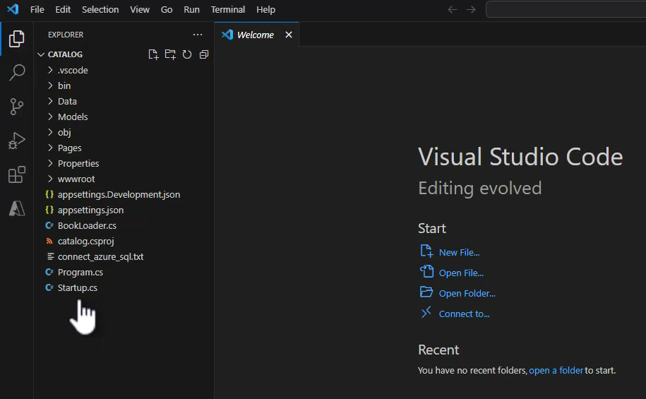

Files are ready for running.

Hit F5 to build the code and then run it. Terminal opens and builds this and runs it.

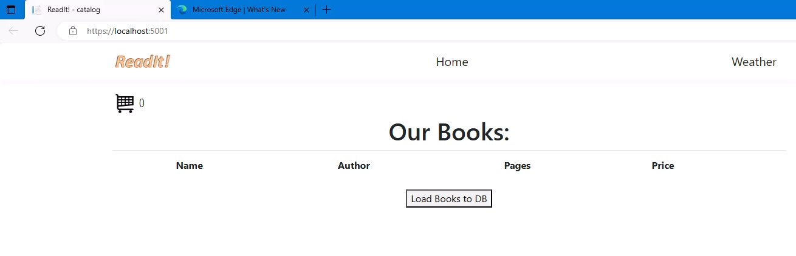

We are using a in-memory database, so just click on Load Books to DB to get the books

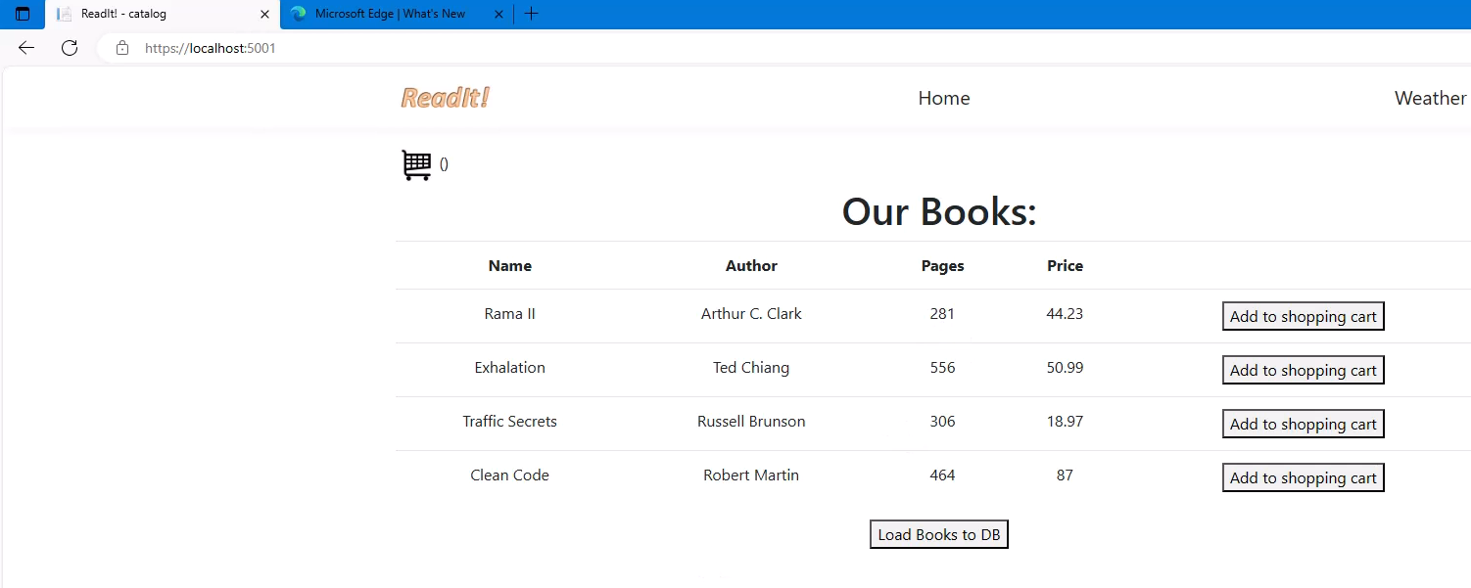

**Going through the Code Video skipped**

# Azure Compute

Azure Compute, which is probably the area of Azure which you are going to use the most. So what exactly is Compute in Azure? So Compute is a set of cloud services for hosting and running applications. It allows you to upload your code and then run it, and it offers various levels of control and flexibility on your application, on your code, and on the underlying infrastructure on which it runs.

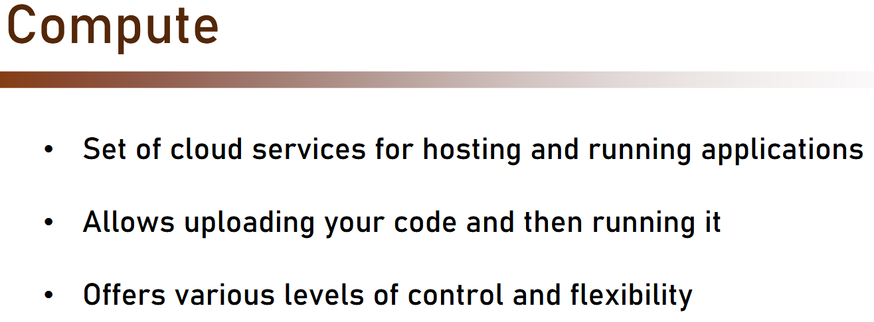

Now I want to go back a little and talk against the various types of cloud services. As we discussed, there are basically three types of cloud services. There are IaaS, Infrastructure as a Service, with which the cloud manages the underlying infrastructure, but you, the user, controls the operating system, middleware, runtime, data, and applications. There is PaaS, or Platform as a Service, where you control the application and data. And there is also the Software as a Service, or SaaS, where the cloud controls everything. Now, when we talk about Compute, we actually talk about IaaS and PaaS. And as you will see in this section, sometimes it's best to use IaaS services, and sometimes PaaS is the best fit for your needs.

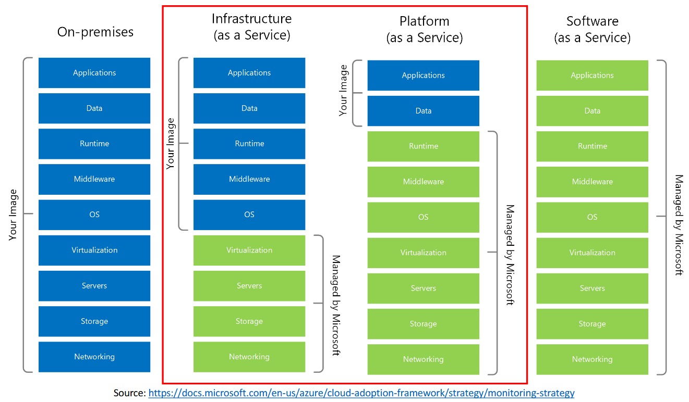

So we are going to talk about four types of Compute services. We will talk about Virtual Machines, App Services, AKS, and Azure Functions.

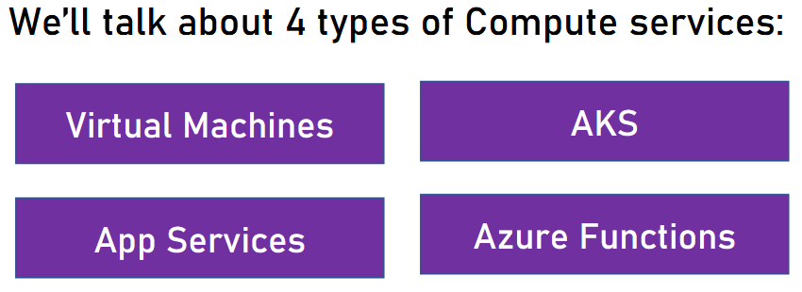

And let's begin with Virtual Machines.

## Virtual Machines

A virtual machine is a virtual, as in not real, server running on a physical, as in real, server. Using virtual machines, we can create new servers extremely quick, because it is based on existing resources of the physical server. In other words, we ask the physical server to create a virtual machine that will use its resources. Now, the most important thing about virtual machines is that, from the user's point of view, that's a completely regular server and there is nothing new. We work with it as if it was a real, physical server. We connect to it, whether using RDP or SSH protocols, we can install software on it, we can upgrade it, we can do with it whatever we want and whatever is possible with regular server.

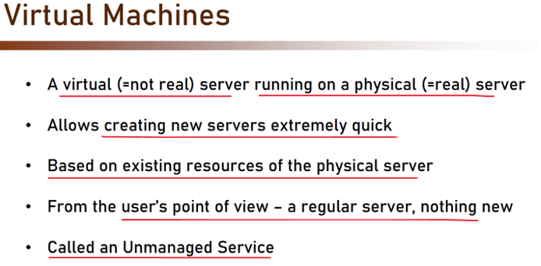

Now, this service is called an unmanaged service, and why is that? That's because Azure doesn't manage what's happening inside the virtual machine. This is our responsibility. Again, remember the IAS service we discussed? Well, this is a classic IAS service. Azure has nothing to do with what is happening inside the virtual machine, and if it will stop working because we installed a bogus software or didn't make sure there is an antivirus in place which caused the machine to go down, well, this is our problem. Azure won't manage that for us. So what is the architecture of a virtual machine?

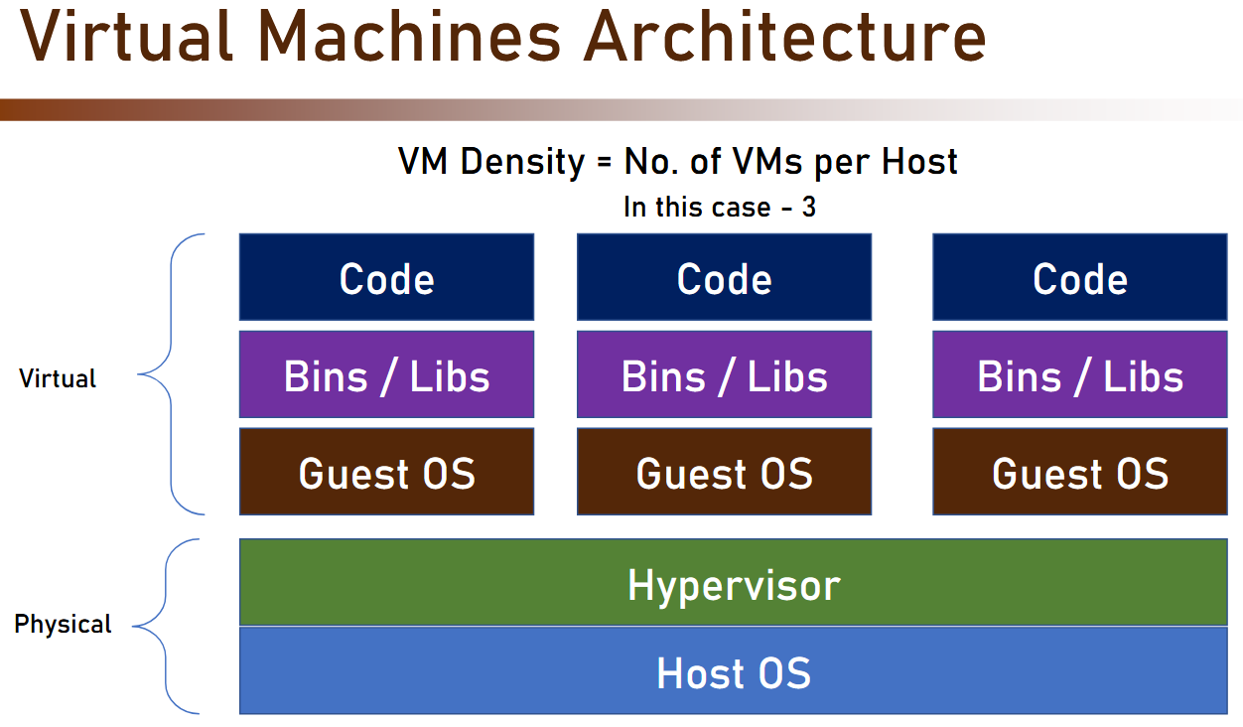



So if you will start from the bottom up, then at the bottom, we have the host operating system. This is operating system of the physical server. On top of it, we have the hypervisor. Hypervisor is a piece of software that manages the virtual machines on the physical server. So both these components are physical, and they are actual servers that you can see installed in the racks in the data centers. On top of the physical layers, we have the guest OS, or the guest operating system, which can be whatever operating system we want. The host operating system can be, for example, Windows, and the guest operating system can be, for example, CentOS or Ubuntu or whatever.

And inside this operating system, as any other server, we have our binaries and libraries. We can install software, we can do whatever we want, and of course, we can put there our own code. And these three layers are virtual. They do not exist in a physical real server. They are all virtual and based on the physical server resources. Now, one of the nice things about virtual machines is that on a single host, we can install multiple virtual machines. This is called VM density, virtual machine density, which represents the number of virtual machines per host, which in this case, is three, because as you can see, there are three virtual machines on a single host. So this is virtual machine in general. How it works in Azure? So in Azure, the bottom layers, the physical layers, are completely managed by Azure, and we have no control and no access to these layers.

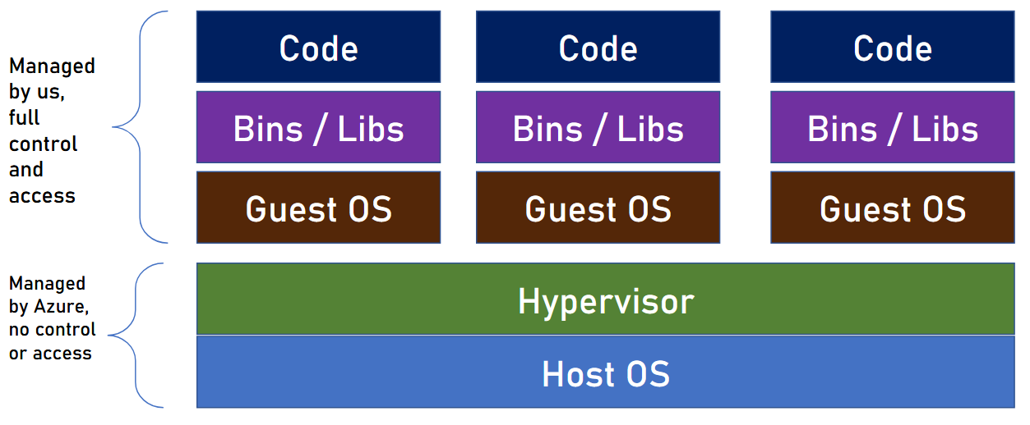

They are hidden for us, and for a good reason, because Azure is extremely good at managing the host servers, and it knows how to allocate the resources in the most effective way to save power and costs. The virtual part is managed by us, and we have full control and full access.

So as we mentioned before, Azure won't look inside our virtual machine. We can do with it whatever we want, which also puts all the responsibility for it on us, so we have to make sure that everything works correctly in our virtual machine, and basically that means that we have no one to blame if something goes wrong. So how to create virtual machines in Azure? These are the steps we need to take. First, we need to select the location, or the region, of the virtual machine, then we select the image.

|  |  |
| --- | --- |
|  | N E V E R  F O R G E T  T O  **C H E C K**  **T H E**  **P R I C E** |

The image of the virtual machine is basically the definition of the operating system plus any other pre-installed software that we want on this virtual machine. Now, usually, we select the image based on the operating system it has, and after that, we install whatever software we need. And this is also what we will do in our demo. After that, we select the size, or the CPU and memory, and well, that's it basically.

Now, of course, never forget to check the price. Prices of virtual machines can vary wildly, and you have to make sure you pick the most efficient and cost-effective virtual machine. So let's see that in action.

### Removing Spending Limit

In the next lecture you're going to deploy your first Azure VM, an exciting moment :-)

Recently Microsoft implemented a new restriction on new subscriptions, and added a spending limit that might prevent new VMs from being created.

If this is the case, you'll see the following error message when trying to create a Virtual Machine:

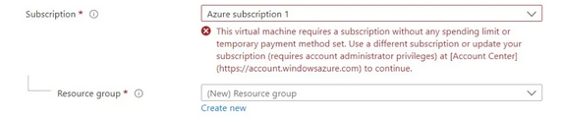

In order to get rid of the error and deploy the VM, please follow the steps in the following Microsoft article, which remove the spending limit from your subscription:

<https://learn.microsoft.com/en-us/azure/cost-management-billing/manage/spending-limit#remove-the-spending-limit-in-azure-portal>

### Creating a VM

Let's create our first virtual machine in Azure and we are going to begin our journey in the pricing calculator. And it's always a good habit to first check the price of a resource before actually deploying it because we really want to avoid surprises. So let's see how much virtual machine is going to cost us. So in the pricing calculator in the virtual machine section, click Add to Estimate and here click View. And here we can see how much virtual machine is going to cost us.

Azure Calculator - <https://azure.microsoft.com/en-us/pricing/calculator/>

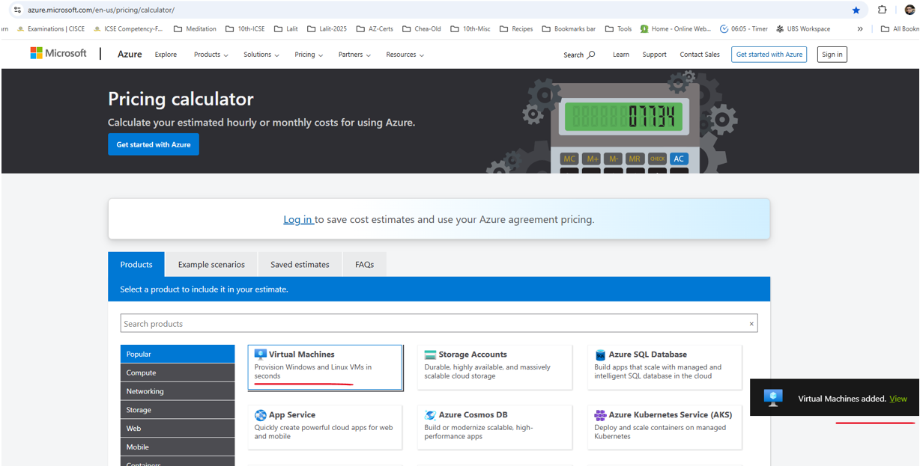

And note that this is based on various parameters that will going to take a look at. So first, select the Region where you want to deploy the virtual machine. You select the region that is most closest to you. I will go for example for West Europe and know that prices can differ based on region. So if you think about various regions and you are not sure which one of them to select, then check the price differences between them. You might be surprised. Regarding operating system, we are going to deploy a Windows VM and we want to deploy only an operating system. We don't want any pre-installed software on this VM. And the tier that we want to use is the standard one. We don't want the basic and limited virtual machine, so stick to standard. Next, we need to select the instance that we want to deploy. And there are quite a few instance sizes of virtual machines. So if you open this list, you can see that there are basically hundreds of instances that you can choose from. And what is the best way to make sure you select the right one?

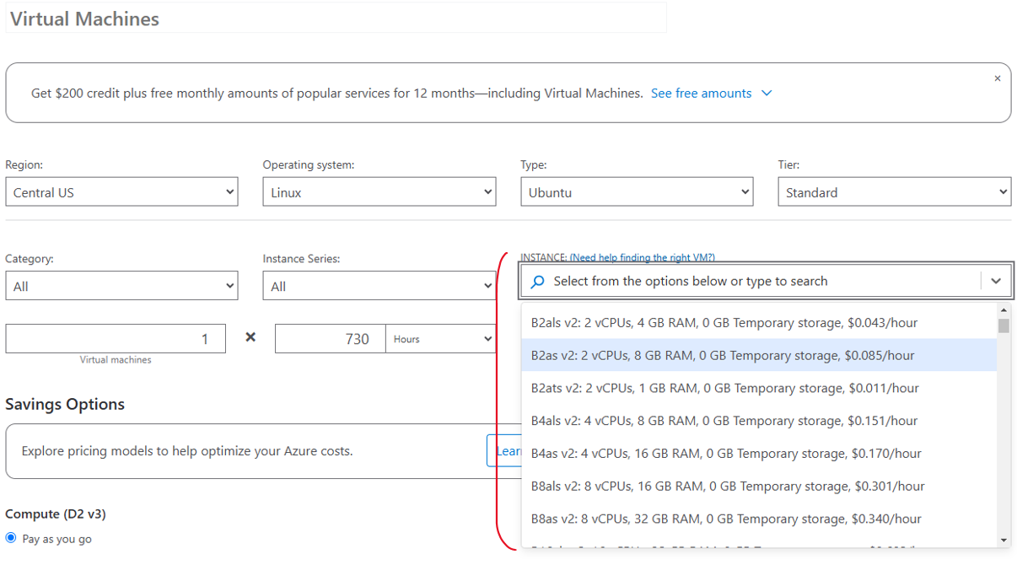

Well, you can filter either by category or instance series or both of course. So let's begin with a category. And here you can filter the results or the instances based on what exactly you plan to do with this virtual machine.

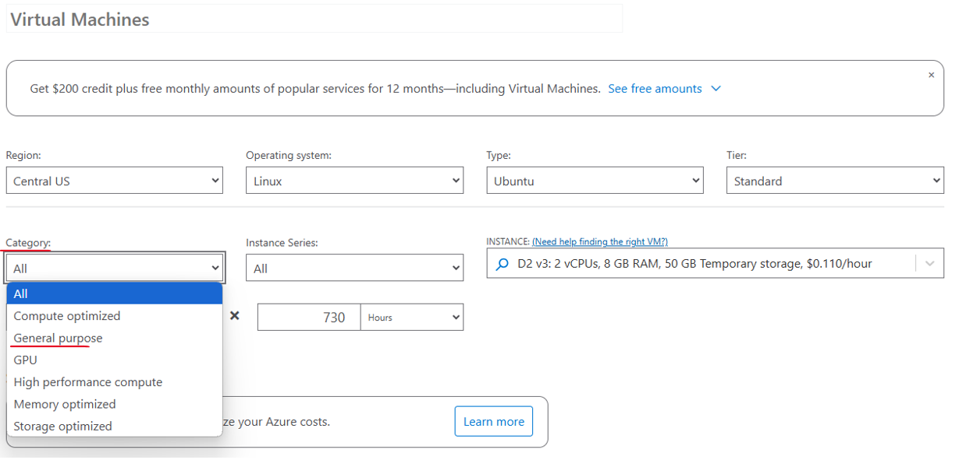

So usually you will go for the general purpose machines right here, but if you are looking for compute optimized machine with quite a lot of CPU or memory optimized, that offers a lot of memories and pick one of those two. If you are looking for a machine with a GPU, then go for this category. For HPC, high performance compute, select this one. And if what's really interesting for you is the storage of the machine, then go for storage optimized. Now note, and currently I will leave it with all not the price differences between the various instances. And you can see the price per hour right here.

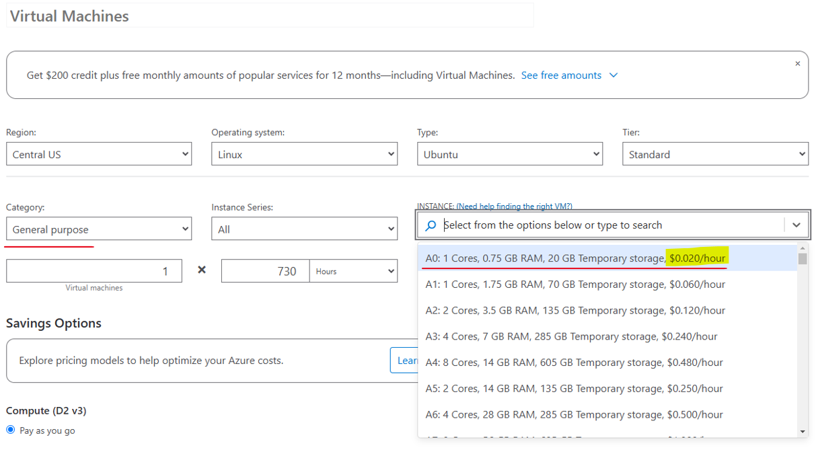

So for example, on this machine, which is probably the cheapest one that there is in Azure, you are going to pay only 2 cents per hour, which is really quite low price. So if you will check this one and let's scroll down and take a look at the total price, then this machine is going to cost only $14 per month, which is really quite low.

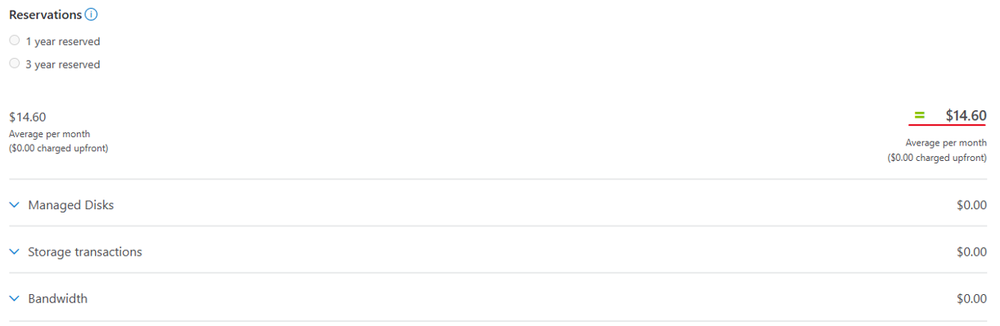

On the other hand, and let's open this again and scroll to the bottom of the list. If you will go for example for this one, the NV48s machine, which offer 72 vCPUs and 880 gigabyte of RAM and it is also a GPU machine. Then your price is going to be, as you can see, $5,854.60 per month. So the differences here are simply huge. Now let's start filtering the instance. So in the category select general purpose.

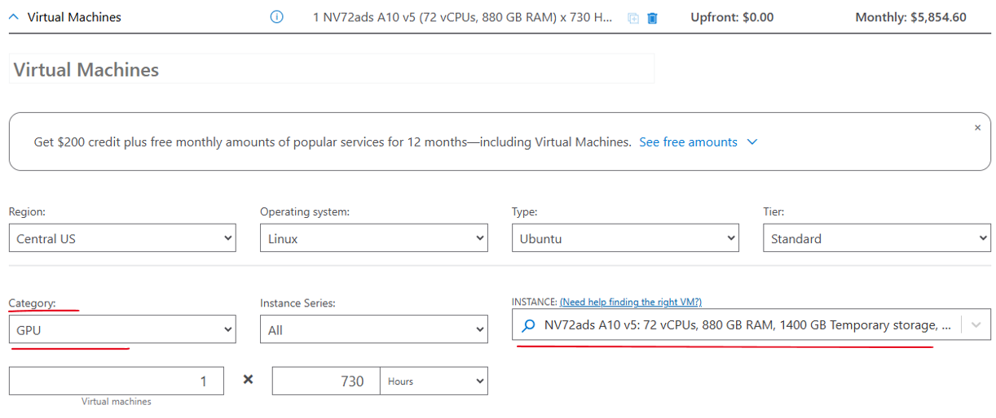

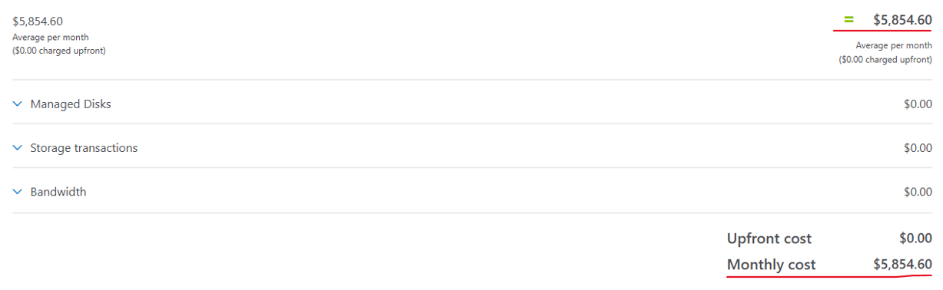

And again, you will usually use general purpose when creating virtual machine for say information system. And then under general purpose, we have all these series, and again, there are quite a lot of series here. Usually for a let's say web server, you will go with one of the D series. So let's for example go for the DV3 series and from here we can select what is a specific instance that we are looking for. For example, we are going to use the D2 v3 instance, which offers two vCPUs and eight gigabyte of RAM and is going to cost us $154 per month. Now not that of course we're not going to actually pay this first because we are using a free account. And second, because the machine is going to be up only for a few minutes. So the actual price is going to be negligible.

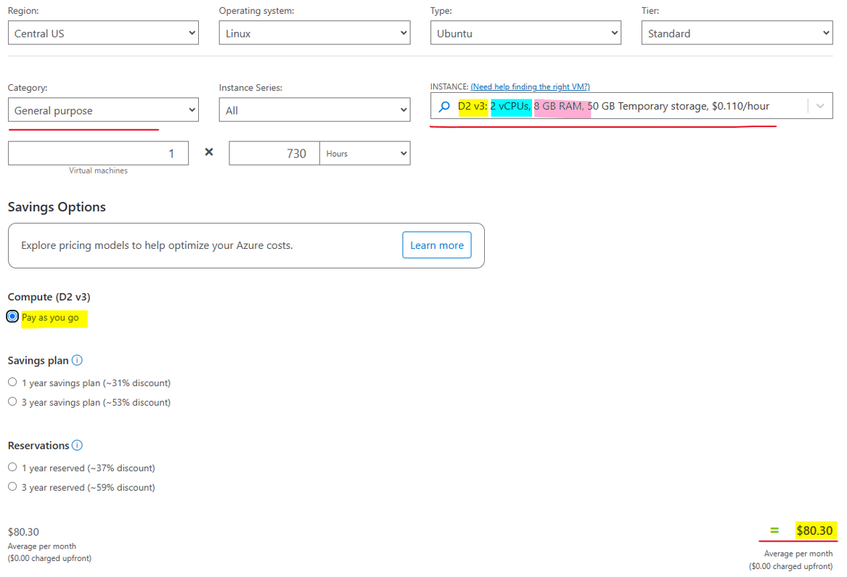

Now note that there are various saving options here for the virtual machine. The default is pay as you go, which means we are going to pay this price, but we can use saving plans or reserved instances. And both these methods basically allow you to commit to a predefined usage and then you get a predetermined discount. So for example, for reserved instances, if you are going to commit to use this instance for say three years, then you are going to get a 56% discount, which is quite substantial. In addition, if you have an Azure hybrid benefit from Microsoft, **this will allow you to move your Windows license from on-prem to the cloud** and then you are not going to pay for the license, which will give you additional discount. So for this example, if you will use the three year reservation and Azure hybrid benefits and price goes down from $80.30 per month to, as you can see, $32 per month, which is definitely substantial.

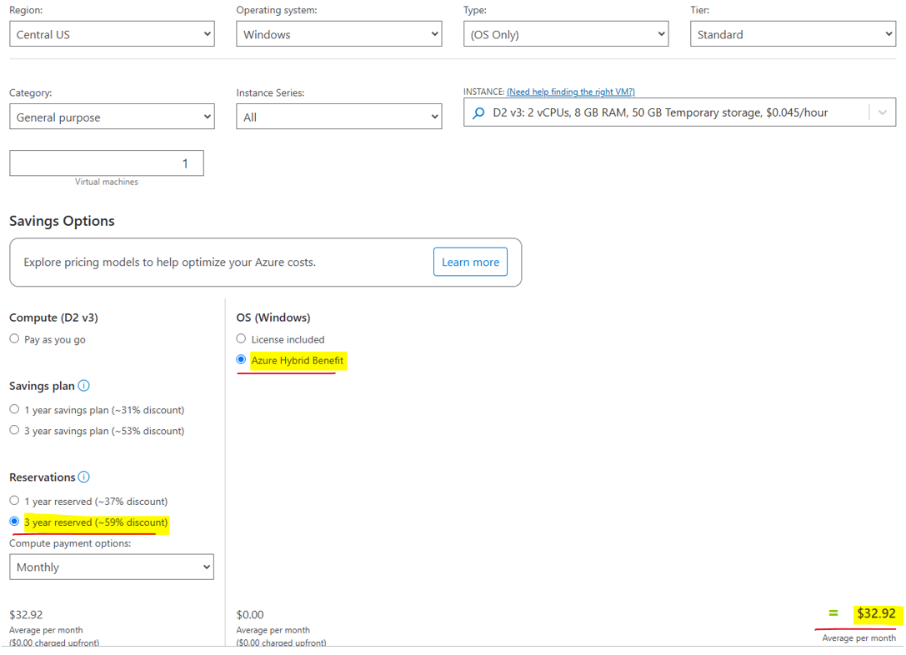

Above is for a windows machine as we can see. For Linux machine price drops from $80.30 to $32.92 as we go from pay-as-you-go to 3 year reserved ( comes at 59% discount )

So this is how you can see and estimate the price of a virtual machine in the pricing calculator. And again, always check the price of the resource you are going to deploy before actually deploying it. So now let's deploy our virtual machine. So go to the Portal and in the search bar here, type Virtual Machines and click Virtual Machines.

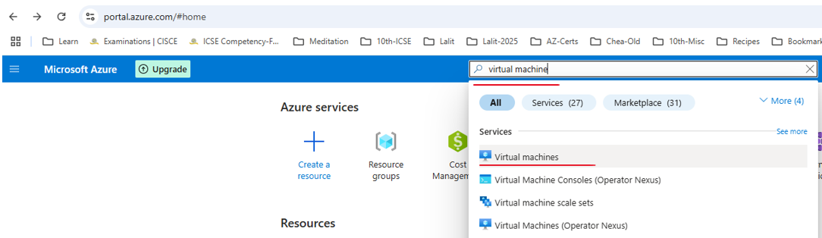

And here is a list of virtual machines that we currently have. Naturally the list is, and let's create a new one. So click Create and we want to create an Azure virtual machine and nothing else. So click Azure Virtual Machine.

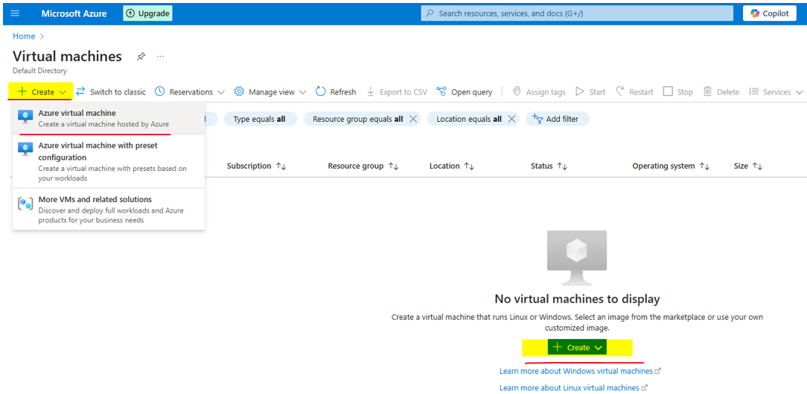

And now we should fill in the various parameters for this virtual machine. We are not going to go through all these parameters because there are quite a lot, but we will look at the most important ones. So first the subscription, we are going to use our own subscriptions, the ones that was created for us when we created the account. Next, the resource group. And we already explained what a resource group is. And for this deployment we are going to create a new one. So click Create New and let's name this resource group first-vm-rg. RG as in resource group. So click Okay, that is going to be the name of the resource group. Next is a virtual machine name. We will name it first VM. Next, select the Region.

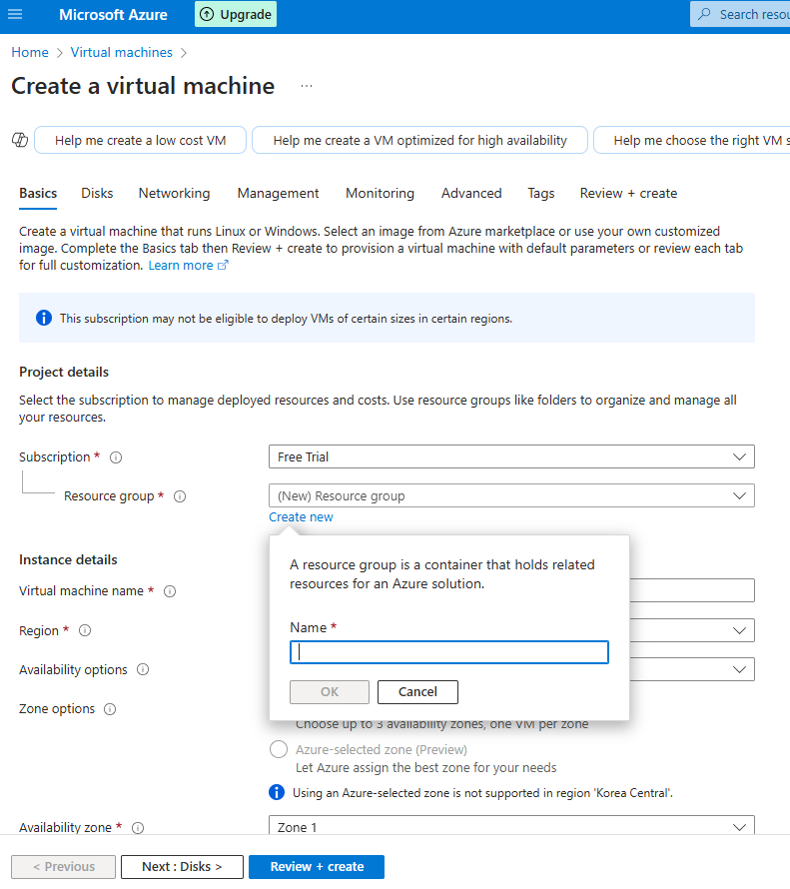



Again, I will go with Europe, you pick whatever you want and I will keep this selected region. Next is the availability options. We'll discuss availability options later in this course, but currently we are not looking for any redundancy or availability, so no infrastructure redundancy required.

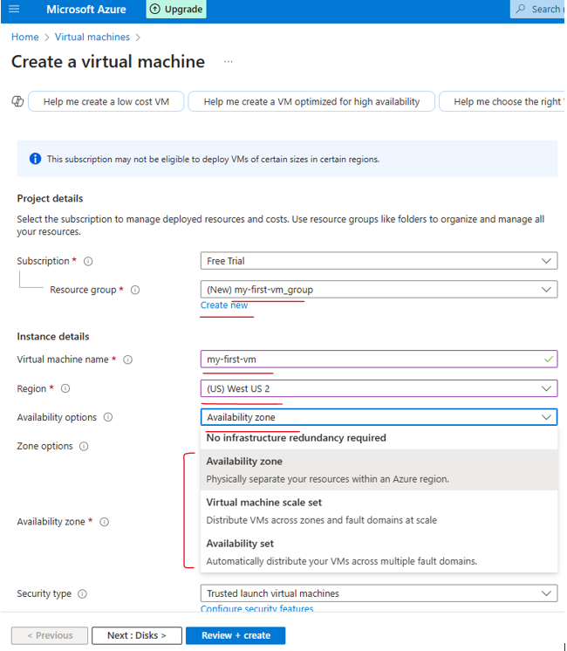

Next we are going to select the image or the operating system that will power the virtual machine. And in this case we are going to go with Windows. So go for Windows Server 2022. Great, and now the size of the machine.

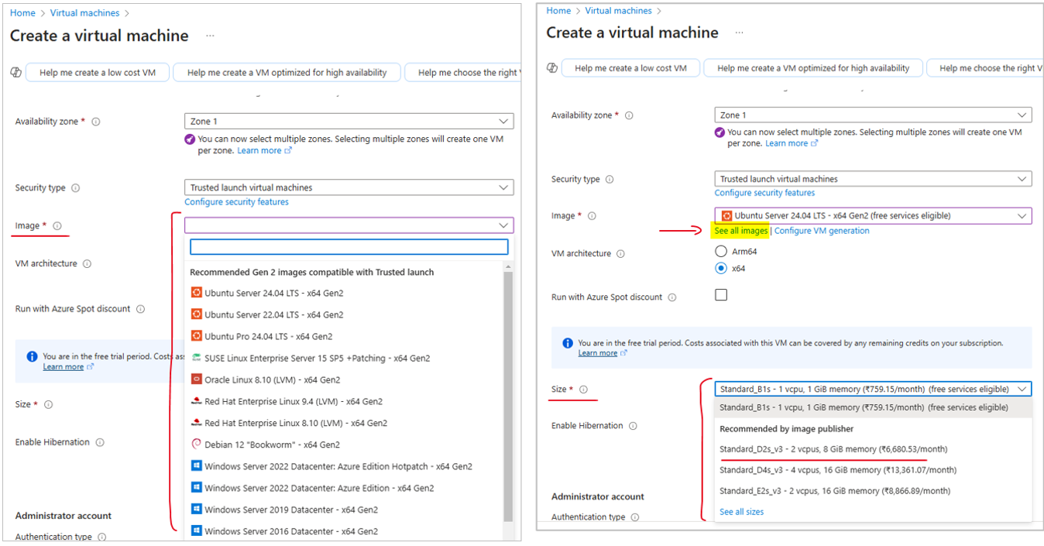

Now before when using the calculator, we already took a look at the D2 v3 machine and this is also the default right here, but you can see all the sizes that are available for you. So click the See All Sizes and note that based on your location and subscription type, you might see a different list. But you can see here all the sizes that you can select for your virtual machine. And note that you almost certainly see some sizes that are not available for you and some incompatible or unsupported sizes.

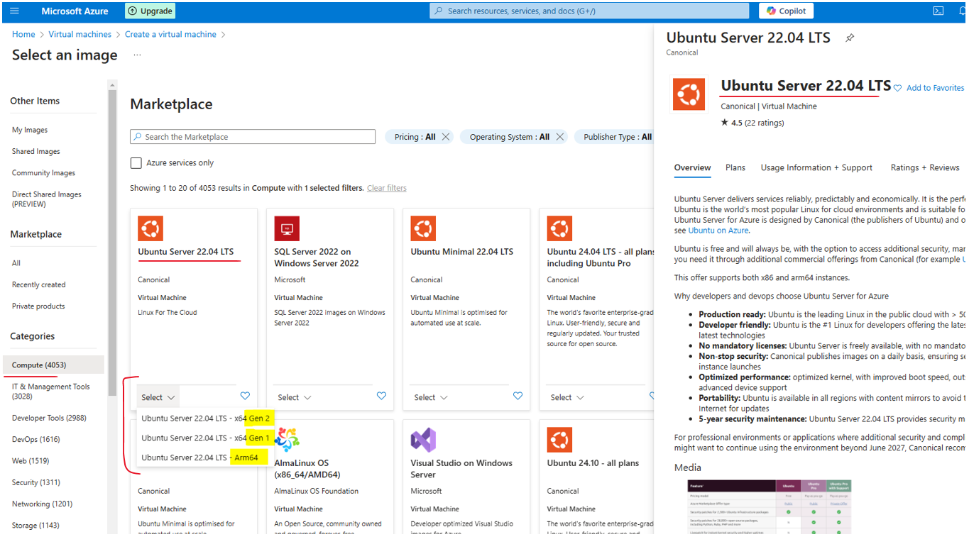

So anyway, here you can select the size that you prefer for the virtual machine that you deploy. Let's close this because we are going to stick to the default one. Now since we are going to deploy Windows machine, then we need to set the username and the password. So pick any username you want, I will go with Memi admin and a password. Note that the password should be at least 12 characters long. So select a password and confirm it. Great.

Next, we need to select the inbound port rules or in other words, which port we want to be open in this machine. And by default, Azure suggests that we'll open the RDP port so that we will be able to connect to this machine using RDP. That sound reasonable? And we are going to leave this option as is. But note that there is a security risk here because the port is going to be open for all external IPs, not only for your own IP.

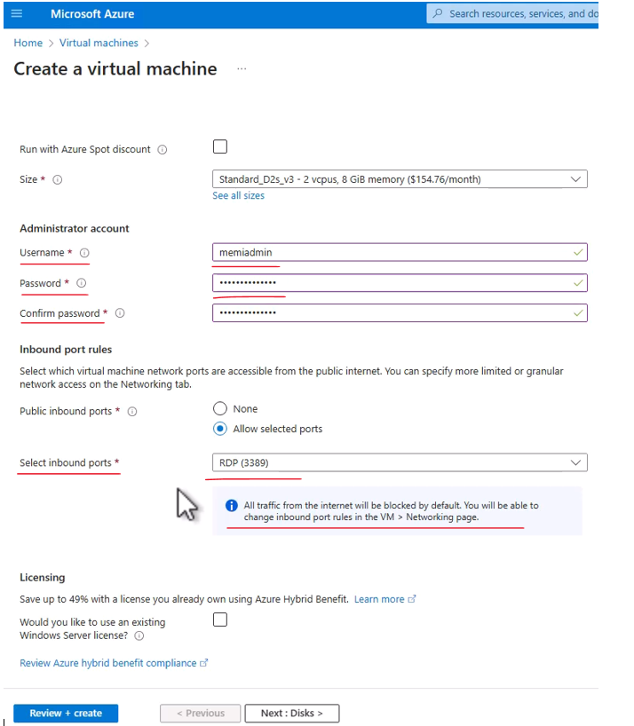

So the first thing you will need to do when creating a virtual machine is to limit the source IPs that can connect to this port. **Otherwise your machine is fully exposed on the internet.** Great. So next is licensing. We don't have any special licensing that we can put on this machine. So now let's create it. So review + create and let's wait for the validation to complete. Great and validation has passed.

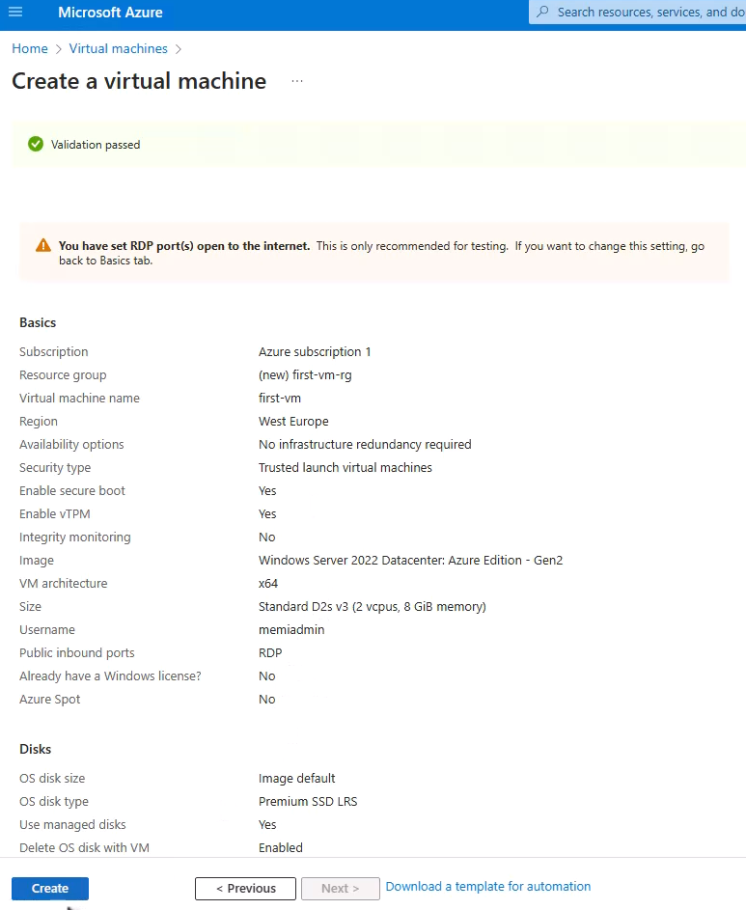

You can see here what exactly we are going to deploy and click Create. And now Azure is starting the deployment of this virtual machine. And note that whenever you deploy anything on Azure, then Azure creates something that is called deployment task. And this is basically a task containing all the elements and the configuration that you want to deploy. And this task is going to be submitted to a queue, to a task queue in Azure.

And when it's time will arrive, which usually happens within a few seconds, Azure will deploy the resource. So this is what happens now, this is basically the name of the deployment task. And note what we see here, remember that we asked to deploy a virtual machine. However, if you take a look at this list, then you can see that Azure actually is going to deploy five resources and not only one. And the reason for that is because these resources are required by the virtual machine.

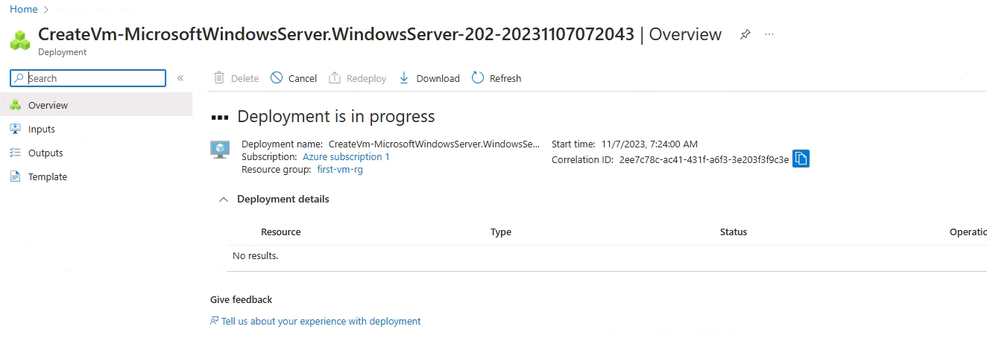

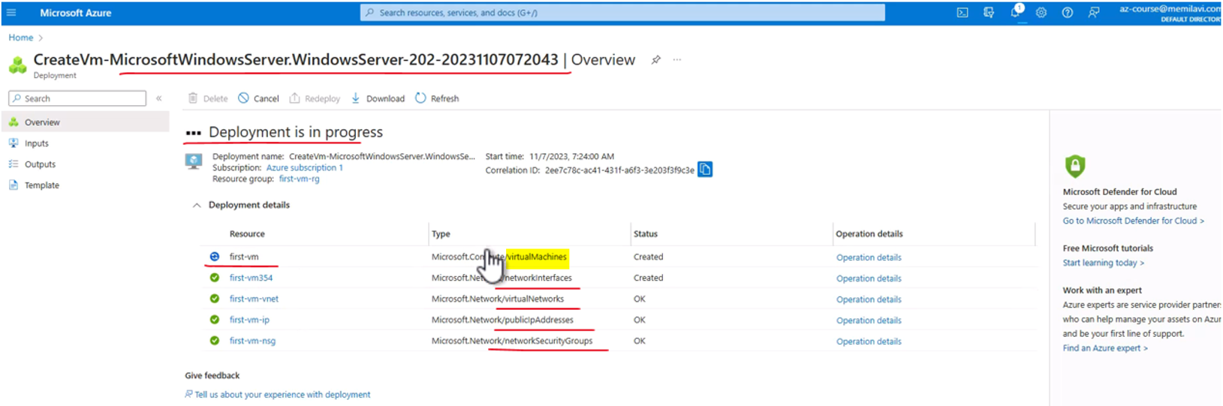

And let's see what we are going to deploy here. So first of course is the virtual machine itself. You can see in the type of the resource that this is indeed virtual machine. But in addition to that, Azure is going to deploy also network interface, which is basically the network card, the virtual network card. Of course that will connect the VM to the network. And that means that we are also going to deploy a network because every virtual machine in Azure is going to be connected to a network and we see that the deployment is complete. Let's just finish going through this list. So we have the virtual network, we have also public IP address because of course if we want to connect to this virtual machine then it's better have a public IP address. And lastly, there is also something that is called network security group, which is basically a mini firewall that enables you to control who can access this VM. We are going to discuss network security groups or NSG in length later in this course.

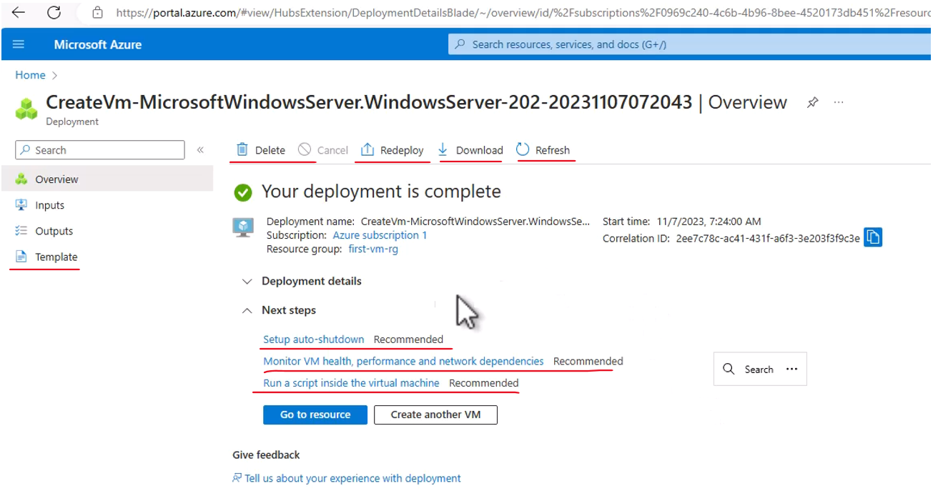

So you can see that we ask to deploy a single resource, but we actually deployed five and actually we deployed more than that because there is another resource that is not in the list, which is the disk. And of course every virtual machine must come with a disk and a disk was indeed deployed as part of this deployment. So anyway, our VM is ready. And now let's take a look at it. So click Go to Resource, and here we can see the various data about our virtual machine. And the first thing we see is the overview section of the VM and we can see various interesting things here. First, the status of this machine is running, which means we can actually connect to it. Its location is exactly where we asked for the operating system is the one we asked for the Window Server 2022. And the size again is D2s v3. In addition, this is the public IP address which we are going to use when connecting to this machine. And as we mentioned, every virtual machine in Azure is connected to a network. And this is the name of the network. First VM VNet and VNet in Azure is a general name for networks.

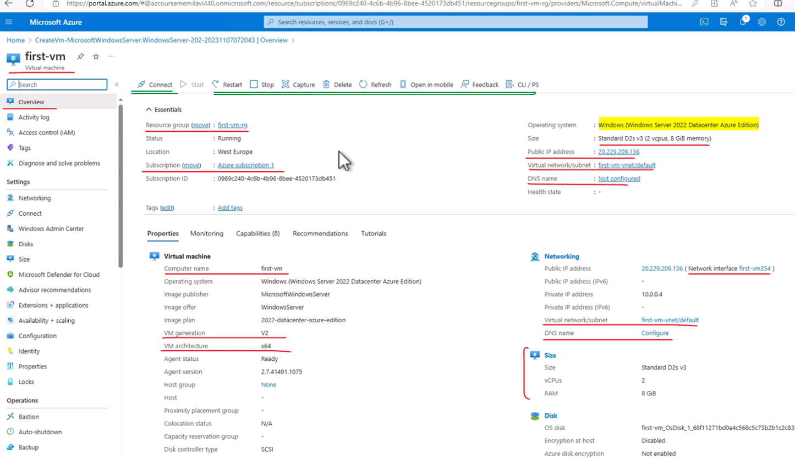

So Azure simply took the name of the virtual machine and added a VNet at the end. And in addition, we have, here's something that is called subnet and its name is default. We are not going to discuss this right now, but we'll talk about VNet and subnets in length later. So this is our machine and it looks like it's running just fine. And now let's connect to it. So click Connect and Azure now tells us that the best way to connect to our machine is using a native RDP, meaning we are going to connect from our local machine to this virtual machine using the RDP protocol, which is used by Windows. So select it. And now we can see various data about the configuration of the VM. And you might be seeing this error message which deals with a just in time operation of this virtual machine, but you can safely ignore it.

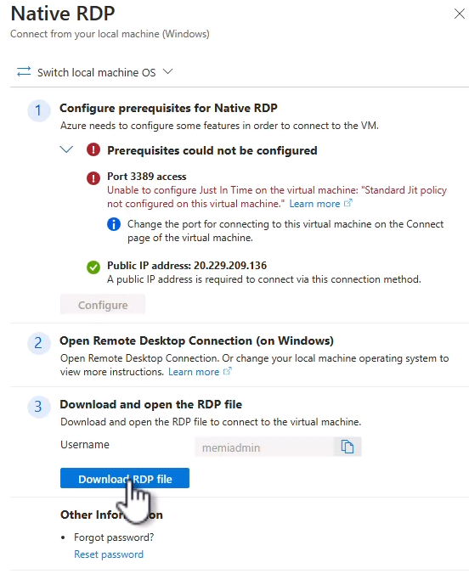

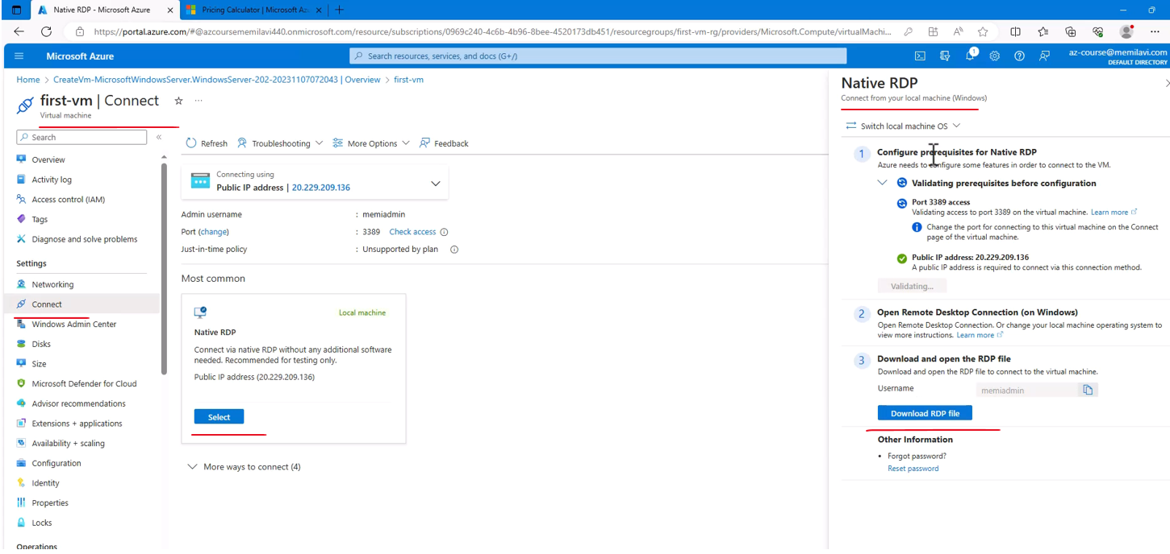

And now click the Download RDP File. And yes, I want to keep this file and let's open it and connect. And now let's enter our username and password.

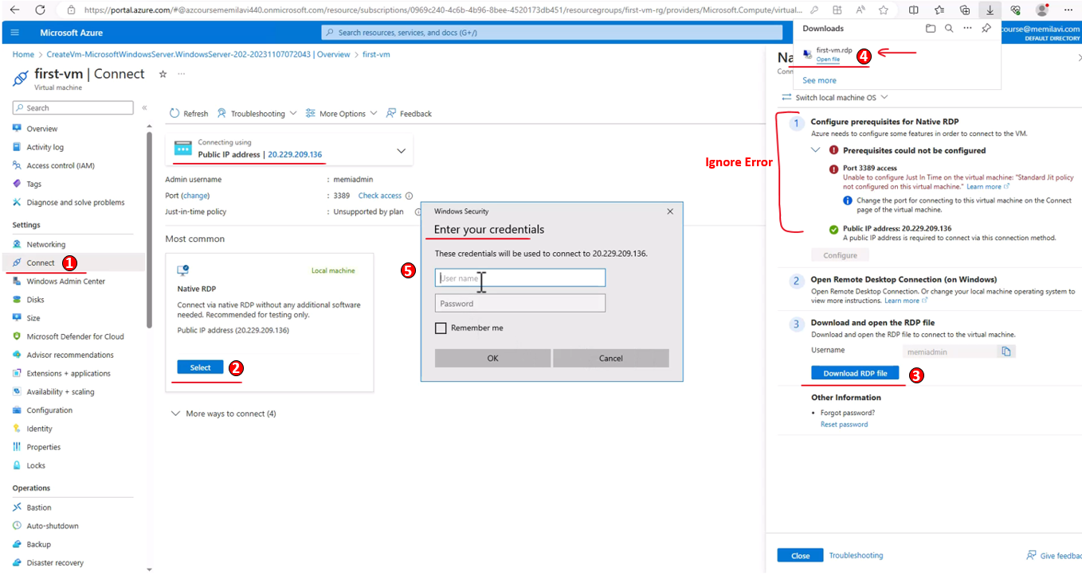

So for the username, type the one that you selected, and it's always a good idea to prefix it with dot and slash to make sure that the RDP understands that we are going to connect to the virtual machine with this IP. So again, username and password and okay and yes, and we are connected to the machine.

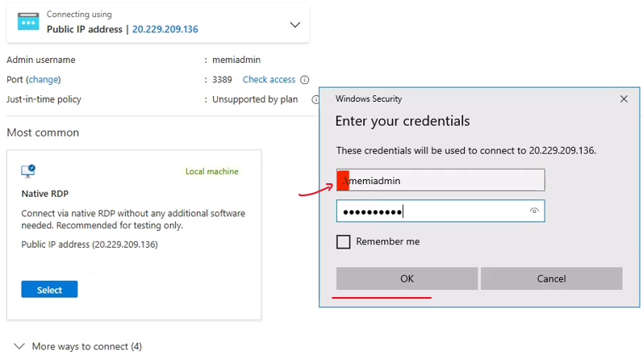

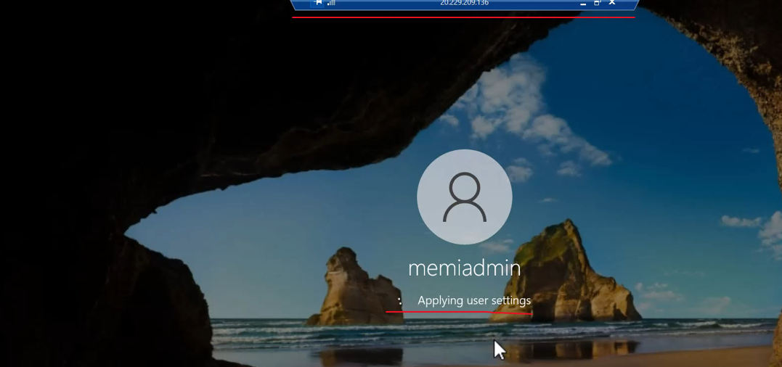

Now the first time we connect to it, there is some maintenance that is going on. It's gonna take a few seconds. And note here this panel that tells you that you are connected to a virtual machine with this IP address. And this is indeed the external IP address that was assigned to our machine. Let's wait for the machine to fully start. And our machine is up and running. And note that this is a completely regular machine, the very same as yours, of course, this is a server and not a desktop. We can close this one. And as part of it being a server, then we have also the server manager that can help us manage our server, but we don't need it right now. So you can simply close it and note that from here, from this menu, you can launch applications.

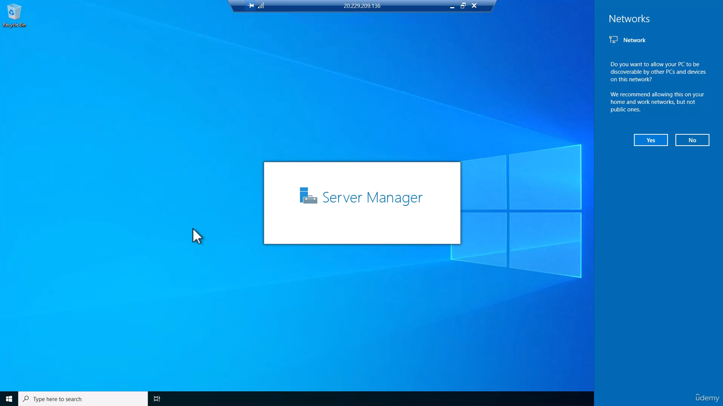

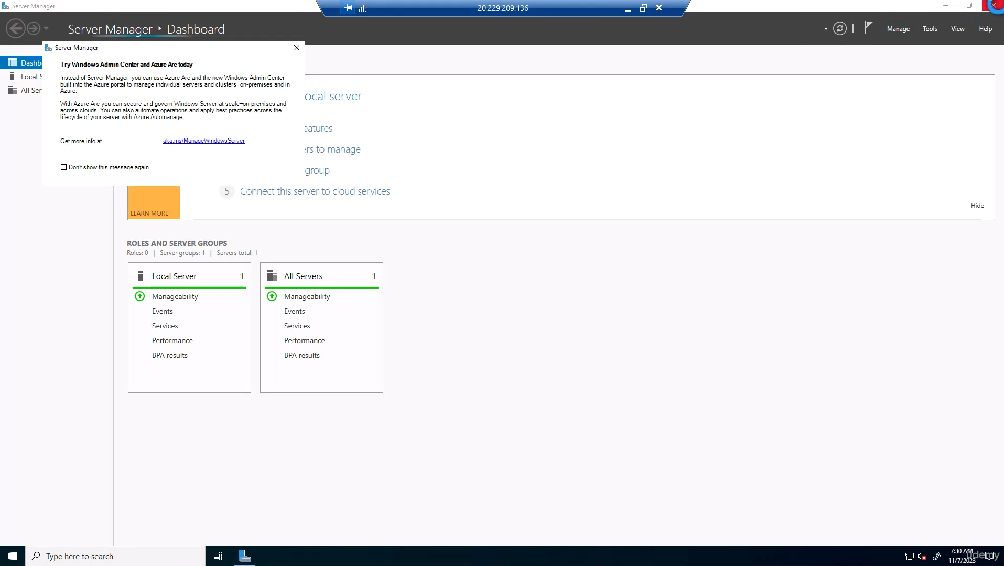

And on this machine you can upload and deploy your code, install software and do with it whatever you want. This is a full blown machine that you can do with it anything that you want. And you can see how easy it is to create and use this virtual machine in Azure. Great. So this is how virtual machine is created and used, and now we don't really need it.

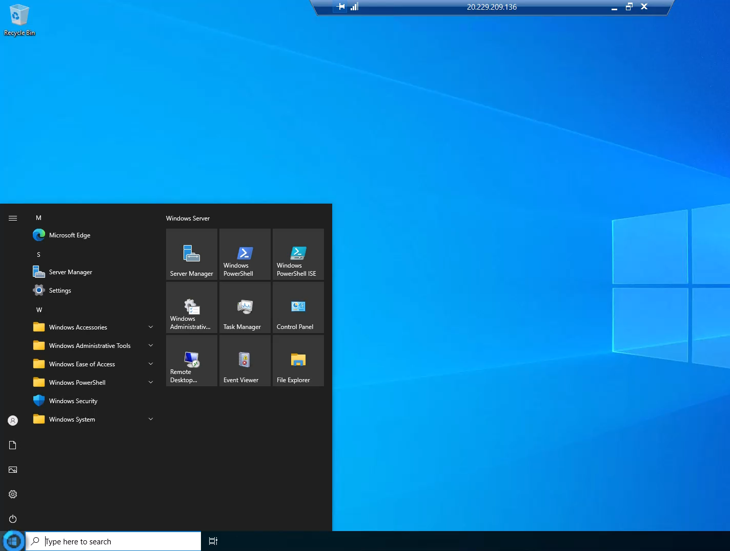

So let's close the RDP connection and yes. Okay, and now we want to remove this virtual machine. Now as we saw before, when deploying virtual machine, there are other services that are deployed along it and we want to make sure that everything that we deployed is going to be deleted because we don't want to pay additional costs that we didn't plan for. For example, for the disk or for the IP address. So the best way of doing that is to go to the overview here and delete not just the machine, but the whole resource group. So click the Resource Group and you can see here the list of all the resources that were created together with the virtual machine.

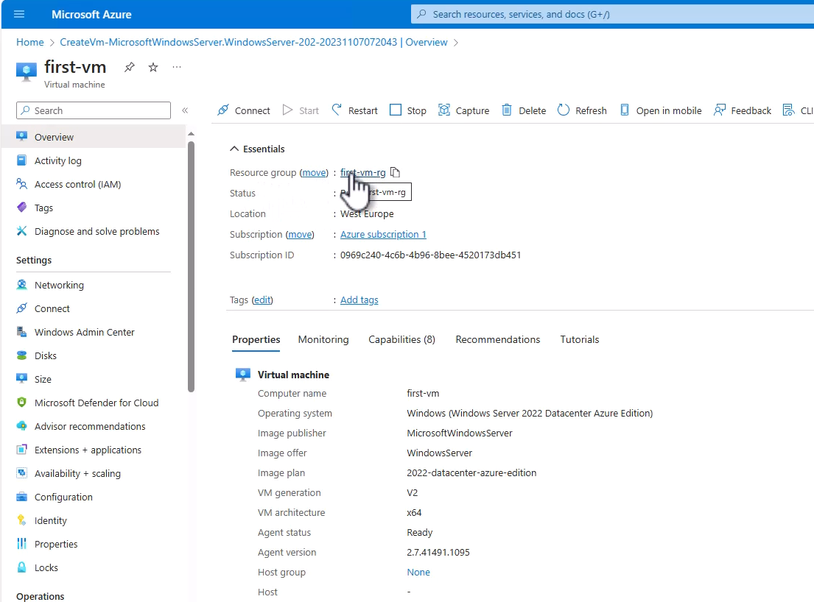

And here are the first five resources that we saw in the deployment task. And in addition to them there is also the disc. And we want to delete all these resources. So click Delete Resource Group.

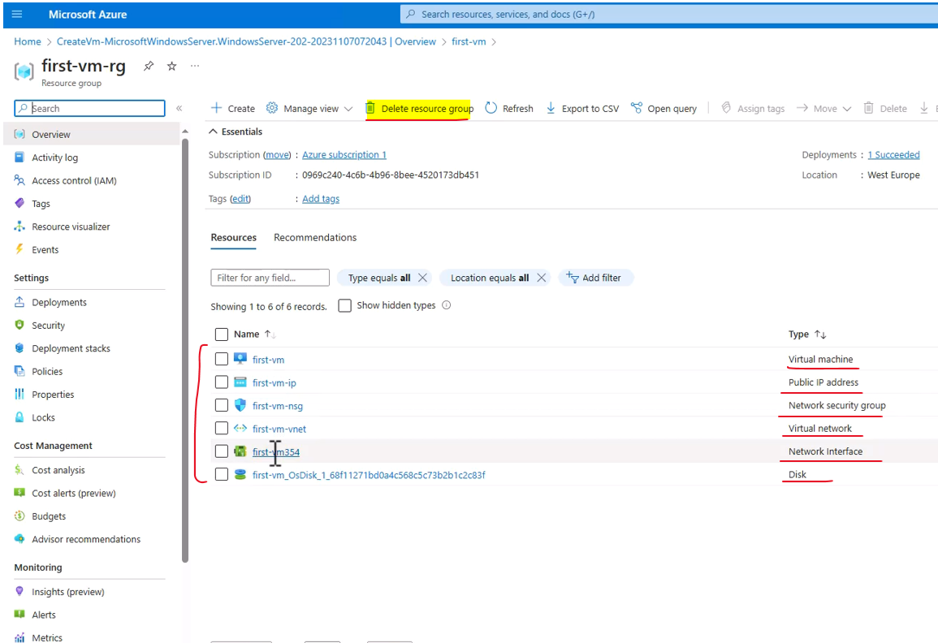

And in order for the deletion to actually take effect, we need to enter the resource group name and also check this checkbox to make sure that all the resources that are used by the virtual machine are going to be deleted. So enter the resource group name, that would be first VM RG like that.

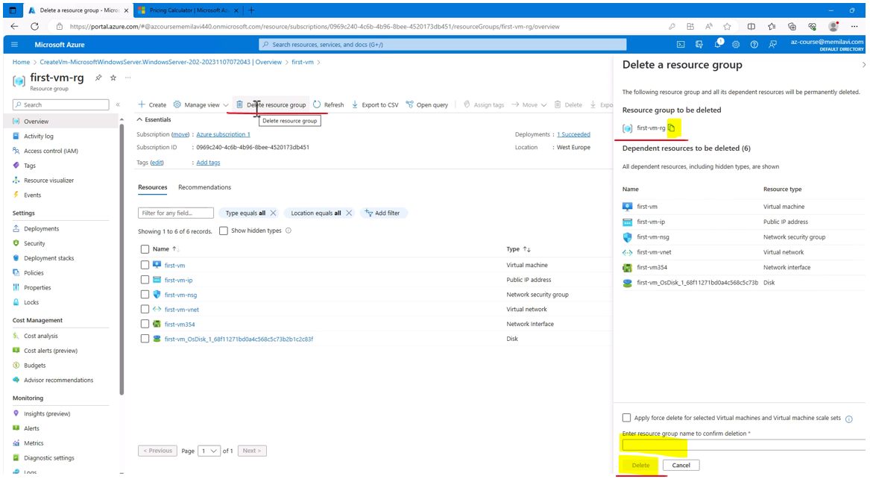

And click Delete and Delete again. And now the resource group is being deleted. So this is how you create, configure, use, and remove virtual machines in Azure. And of course we don't need to wait for the deletion to complete and we can now move on to the next tasks.

### The Real cost of the VM

When talking about the cost of a virtual machine, we need to think about the real cost of a virtual machine which includes the virtual machine itself as is presented in the Azure calculator, the disc of the virtual machine, the IP, the public IP that is exposed by the virtual machine. And here, I should mention that the price of the IP depends on the exact type of the IP that is exposed. And not all IP addresses or public IP addresses have a cost and the storage, well, the storage is where the image of the virtual machine is stored. If you remember, we talked about storage account earlier in this course and I mentioned that storage accounts are involved in many resource types, even if we are unaware of them. And this is a great example for this because the image of the virtual machine is stored in a storage account which we have no access to because it all happens behind the scenes and we need to pay for this storage.

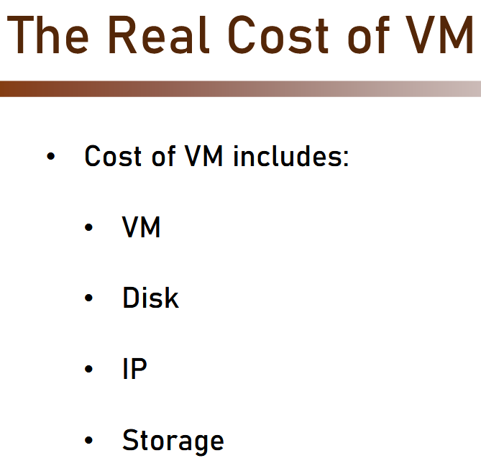 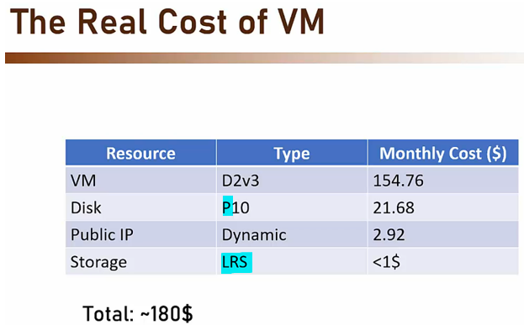

Now, as you will see, the price of the storage here is extremely low. So, what are we looking at cost-wise? Well, here is a typical setup for a virtual machine. So as you can see, the price of the virtual machine itself and we're talking here about the D2v3 virtual machine which we used in our demo, is around $154 per month. The disc, assuming we are using a premium disc as can be identified by the P at the beginning of the disc claim will cost us a little more than $20 a month. The public IP can be up to almost $3 a month. And the storage, which in this case is an LRS storage, meaning the backup of the storage happens in the same zone where the virtual machine resides will be less than $1. So all in all, we are looking here at around $180 a month. So you should definitely take that into account when calculating the actual cost of the virtual machine.

### Reducing the Cost of a VM

|  |  |
| --- | --- |
| We just saw that the real cost of a virtual machine can be higher than the cost that is displayed in the Azure calculator, but there are some techniques to reduce the real cost, and the most effective techniques of doing that is auto shutdown, reserved instances, spot instances, and disk optimization. |  |

Auto Shutdown

Let's begin with auto shutdown. What it basically means is that it automatically shuts down the machine when not needed. This is relevant mainly for test or dev machines, which shouldn't be up and running 24/7, but we need them only for specific errors per day. Now note that the storage and IP, if the IP is static and is going to cost us money, are still incurred in this machine. Now, using the auto shutdown, we can achieve a substantial reduction of the price, even more than 50% of the list price of the machine. And here is how it looks like in the Azure portal when creating a new virtual machine. So as you can see, we have an Auto-shutdown section in the portal, which allows us to enable the auto shutdown. So that is the first technique.

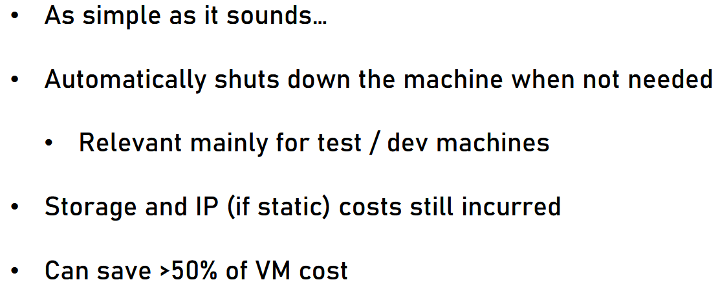

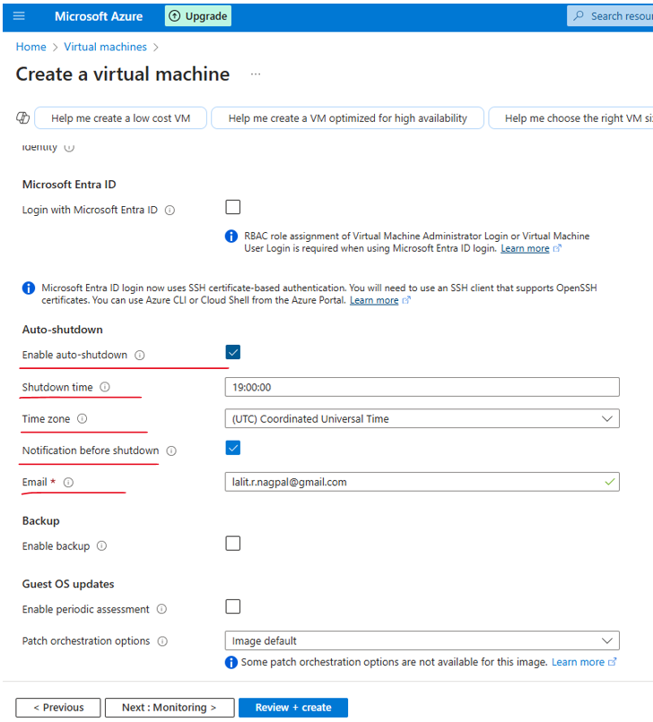

Reserved Instances

The second one is reserved instances. Now, reserved instances allows upfront payment with substantial discount, meaning we basically commit to using this very same machine for a specified duration of time. And we are paying upfront and not each month. Reserved instances are usually offered for one or three years, and they are great for production machine which run continuously. So if the auto shutdown was perfect mainly for dev and the test machine, the reserved instances are great for production machines, which would be up and running 24/7.

|  |  |
| --- | --- |
|  | With reserved instances, we can get great discounts up to 62% of the list price, and this payment can be divided to monthly payment. Now you should note that after reserving a machine, this reservation cannot be stopped or refunded, meaning you pay the upfront fee for the machine, and you can't get a refund if, say after six months, you decide you don't need this machine any longer.  Unless, and this is a rumor, you know who to talk to in Microsoft and get your money back. But again, it's just a rumor I never did it myself. So as you can see in the Azure calculator, here is the place where you can see the discount you will get if using reserved instances. |

So in this instance, you see that the discount can be up to 56%, which is a huge discount. And again, if you are talking here about a production machine and you are not planning on replacing it with another machine then the reserved instances is definitely the place to go to reduce the price.

Via the pricing calculator we can see the option

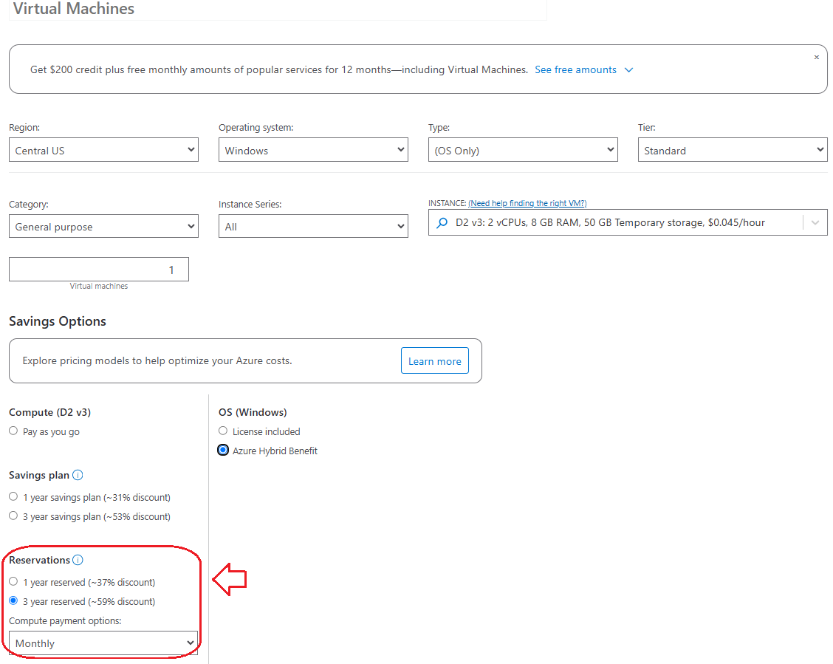

Spot Instances

The next technique is spot instances. These are machines that run on unused capacity in Azure. So Azure has huge data centers and not all the servers in the data center are in use all the time. So you have the opportunity to use the unused capacity or the unused servers in these data centers for a reduced price. Now, because you are using a capacity that is currently not in use, then you must be aware that these machines can be evicted any moment when needed by Azure. So if a customer will now create a new virtual machine and Azure decides that your machine is the one it wants to use for this then your machine will be evicted as in shutdown or even deleted, and you will get a very short notification for this eviction.

Now, spot instances offer up to 90% discount, but the price fluctuates according to demand. So if there isn't a high demand for the compute power you are using then the price will be quite low. But if demand goes up, then the price will go up to. Spot instances are great for non-critical and non-continuous tasks.

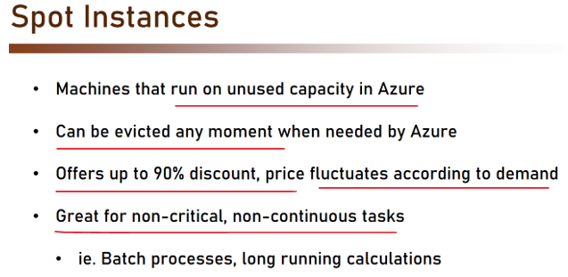

So you want to put your web app on a spot instance because it can go down any minute. But for batch processes or long running calculations that can stop in the middle and continue later when the server will go up again then spot instances are a great alternative you should definitely consider, and this is how it looks like in the Azure portal.

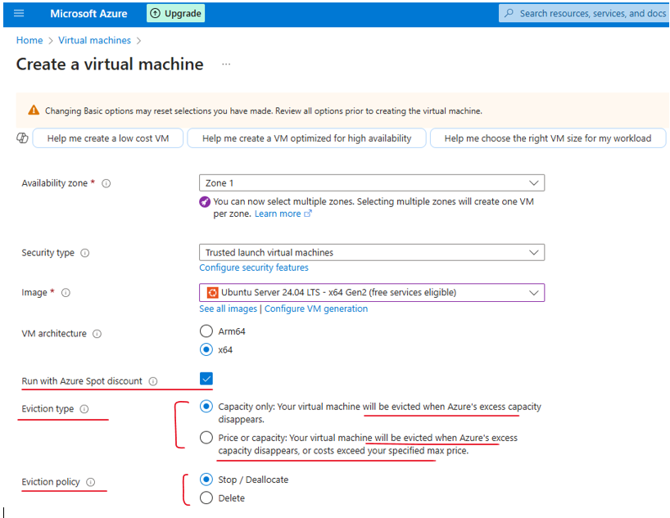

So as you can see, you can enable the Azure spot instance and then you select the eviction type. So that basically means when Azure will evict or shut down the machine. So the eviction type can be based on capacity only. So when Azure needs this server, it will simply shut down your machine and it could also be based on price or capacity. So we said before that the price fluctuates and you can set a maximum limit for the price. And when the spot instances price hits this limit then Azure will shut it down. In addition, you can also select the eviction policy. So the machine will be either stopped as in shut down or it might be completely deleted. Again, this is up to you. So this is the third technique for reducing price.

Disk Optimization

The last one we will discuss is disk optimization. Make sure you select the right disk for the machine. For many VM instance types, the default is premium SSD, which is the most expensive option. This is because it is the fastest disk and it also offers a better SLA.

|  |  |
| --- | --- |
|  | But if your machine is non IO-intensive then you can probably do with standard SSD, which is a little bit slower, but again, the IO or the input-output in your machine is not very important. And the difference in the SLA as we will see later is not really substantial.  So for example, VMs that are used as App servers or in-memory cache can usually do with standard SSD. So as we said before, the disk type might affect the SLA and this is also something you should consider when creating the virtual machine. So you can select the disk type in the portal when creating the virtual machine under the Disks tab in the new virtual machine page. |

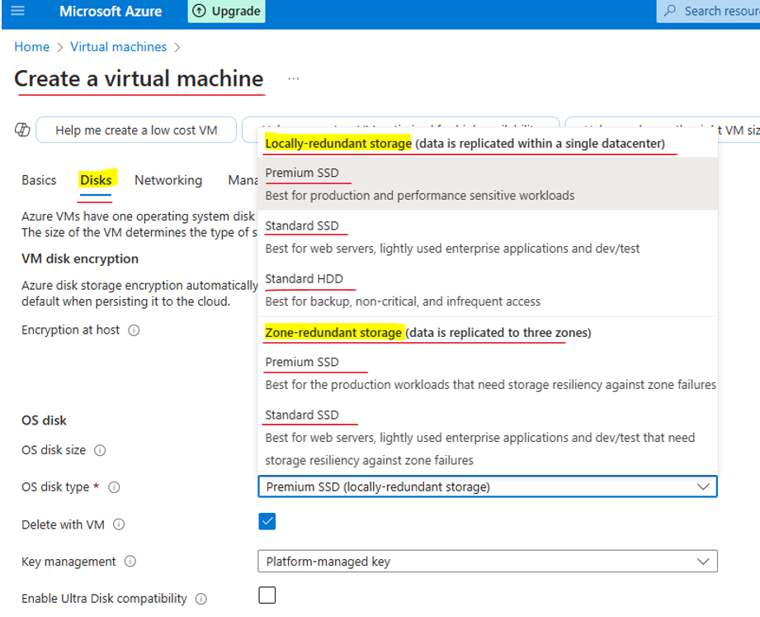

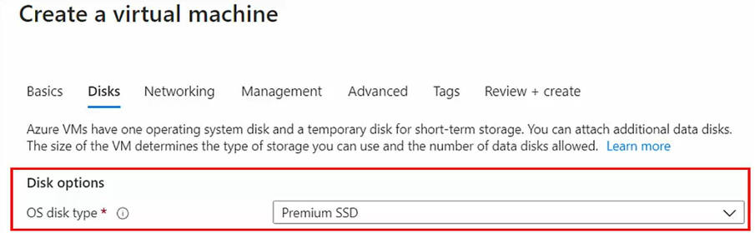

So these were the main techniques for reducing virtual machine price, but actually there are more.

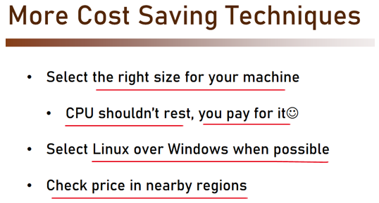

First, always select the right size for your machine. Don't forget, **CPU shouldn't rest. You actually pay for it.** So you don't want to see your CPU at zero or 10% utilization. You want to see it somewhere **around 70% or even 80% utilization** because again, you pay for it. So it will better work.

In addition, when possible, select **Linux over Windows** because **Linux VMs are cheaper than Windows because there is no Windows license involved in the pricing.** And also check the price in nearby regions.

As we demonstrated earlier, **price might vary between regions for the very same resource type**. So always check the pricing for this virtual machine in neighboring regions. So that was the techniques for reducing the virtual machine price, and I highly recommend you use them when creating your own machine.

CMK Screenshot

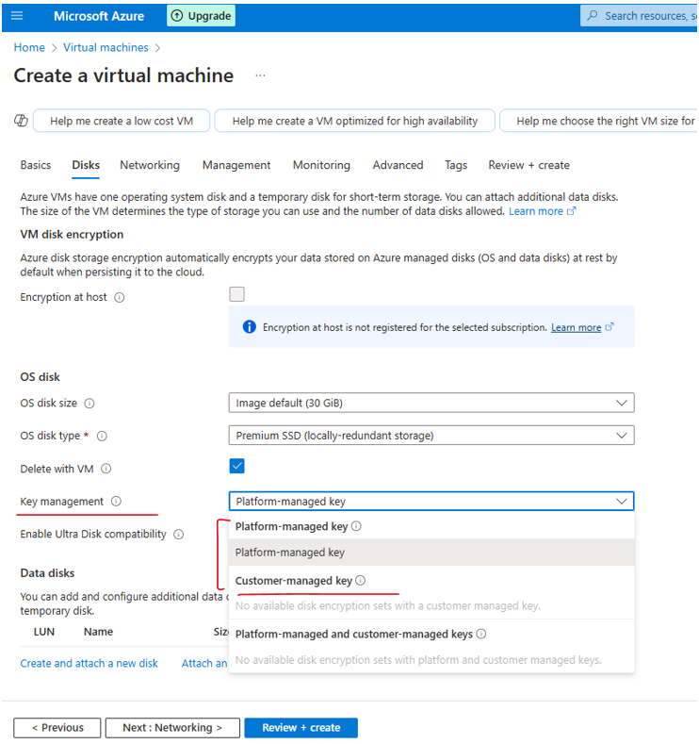

Managed Disks

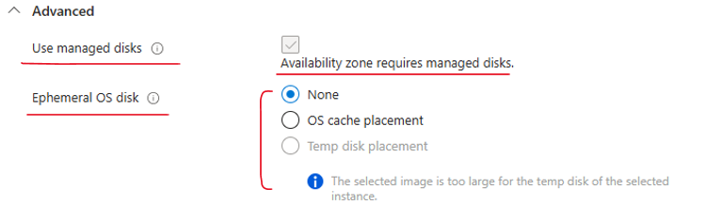

### Availability of a VM

Availability is such an important topic, and basically what it means is how to make sure the virtual machine I've created won't go down suddenly and leave me with nothing to work with. Now note that usually when talking about availability of a virtual machine, that means we are going to create other instances of virtual machines that will work together.

So the main discussion here, will be around how to effectively distribute the virtual machines instances across Azure. So first, let's examine the SLA of virtual machines. There are actually five SLAs in this paragraph.

* For virtual machines that have two or more instances deployed across two or more availability zones, the SLA can be 99.99%, which is quite good SLA.
* For Single instance of VMs the SLA varies depending on the type of disk – premium SSD/ standard SSD/ Standard HDD

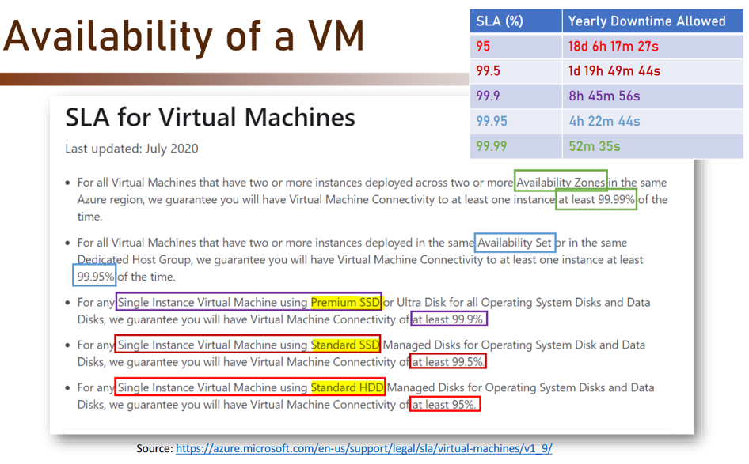

VM SLAs - <https://www.azure.cn/en-us/support/sla/virtual-machines/>

* For all Virtual Machines that have two or more instances deployed across two or more Availability Zones in the same Azure region, we guarantee you will have Virtual Machine Connectivity to at least one instance at least **99.99%** of the time.
* For all Virtual Machines that have two or more instances deployed in the same Availability Set or in the same Dedicated Host Group, we guarantee you will have Virtual Machine Connectivity to at least one instance at least **99.95%** of the time.
* For any Single Instance Virtual Machine using Premium SSD or Ultra Disk for all Operating System Disks and Data Disks, we guarantee you will have Virtual Machine Connectivity of at least **99.9%.**
* For any Single Instance Virtual Machine using Standard SSD Managed Disks for Operating System Disk and Data Disks, we guarantee you will have Virtual Machine Connectivity of at least **99.5%.**
* For any Single Instance Virtual Machine using Standard HDD Managed Disks for Operating System Disks and Data Disks, we guarantee you will have Virtual Machine Connectivity of at least **95%**.

And just as a refresher, this is the actual figures of yearly downtime allowed for each SLA.

* So for **99.99%,** the machines can go down for **52 minutes and 35 seconds yearly**.
* Now if using availability set, which again we will explain later, then the SLA is **99.95%,** which is still quite good. That means that the machine can go down for a **little more than 4 hours per year**.
* Now when talking about single instances of virtual machines, then the SLA varies based on the disc the machine is using.

So we talked about premium SSD and the standard SSD, and as you can see,

* **Premium** **SSD** offers **99.9%,** meaning the machine can go down for a little less than **9 hours** per year.
* **Standard SSD**, the SLA is **99.5**, meaning **1 day 19 hours 49 minutes and 44 seconds** per year.
* Now if you will go down even more, and we use a standard HDD disc, which I will never recommend for any virtual machine in Azure, then our SLA is going to be **95%**; which is more than **18 days per year** and is **highly not recommended.**

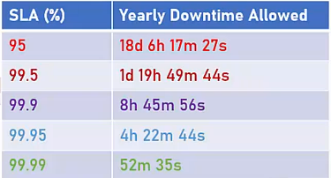

So you can see, that the SLA varies depending on the deployment options, and whether we deploy single instance or multi instances of the virtual machines. So let's understand how exactly all this is working. So we're talking about availability of virtual machines in Azure; there are four concepts we need to be familiar with. And these are; fault domain, update domain, availability set, and availability zone.

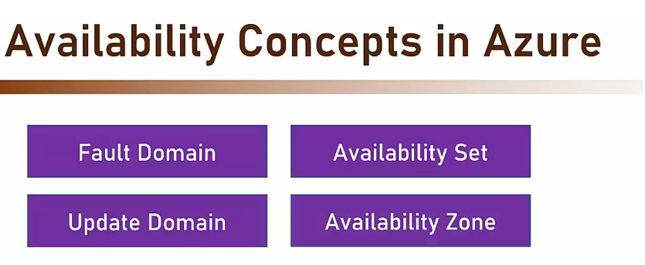

#### Fault Domain

Fault domain. So fault domain is a logical group of physical hardware that share a common power source and network switch.

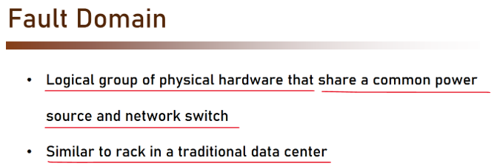

Now if that sounds quite complicated, then well basically you can think of it as a rack in a traditional data center. A rack looks like this.

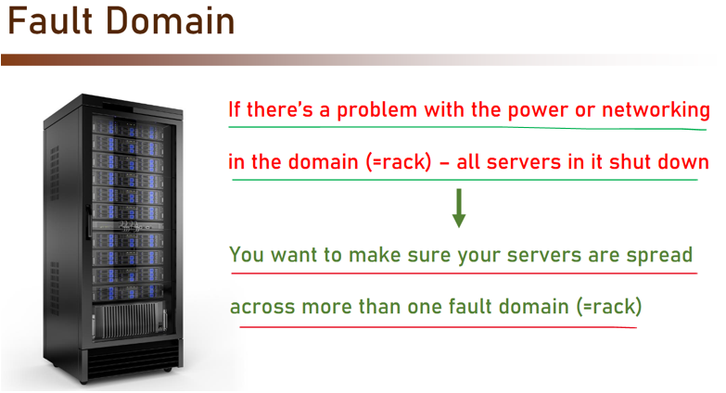

This is basically a cabinet with a single power source and network source, which can host multiple servers. The black rectangles you see in this cabinet in this rack are the actual servers. Now if you are looking at this rack as a single source of power and networking, then if there is a problem with a power or networking in the domain, or in the rack, then naturally all servers in it shut down. And that means that you want to make sure your servers are spread across more than one fault domain. So basically rack is a fault domain; and if a rack goes down, then all the servers in it also go down. So you want to make sure that if you have more than one server or more than one virtual machine, they are not located in the same fault domain or in the same rack. So this is fault domain.

#### Update Domain

An update domain is a logical group of physical hardware, that can undergo maintenance and be rebooted at the same time. So what this means, is that Azure is in control of updating and rebooting the underlying hardware of the virtual machines; because it always makes sure that the host machines are up to date and secure, and have all the hot fixes that are needed. And, as part of this maintenance process, sometimes the host machine can be rebooted; and naturally when the host machine reboots, then all the virtual machines installed on it also reboot. Now this maintenance is done by Azure at its own discretion, and we have no control whatsoever on when and where this is going to happen. So, that means that if all your servers are in the same update domain, they will reboot at the same time during maintenance. So naturally you want to make sure your servers are spread across more than one update domain.

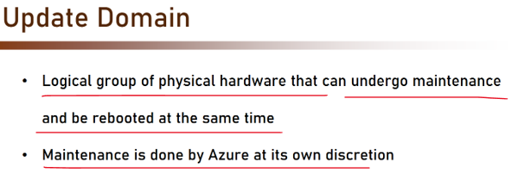

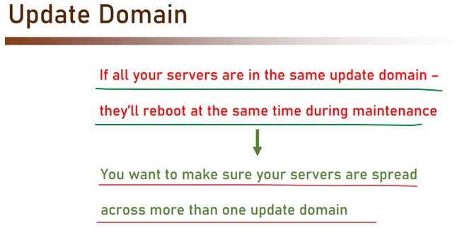

Now note, that update domain is not identical to fault domain.

Fault domain is a physical hardware; it's a rack.

Update domain is a logical definition.

So, host machines in update domain can be spread across multiple fault domain. But they are still part of the same update domain; again, because update domain is a logical definition.

#### Availability Set and Availability Zone

So, these were fault domain and update domain. Which brings us to availability sets.

* Availability set is a collection of fault domains & update domains your virtual machines will be spread across.
* Availability set can contain up to 3 fault domains and up to 20 update domains.
* And all these domains, fault and update, are in the same zone.

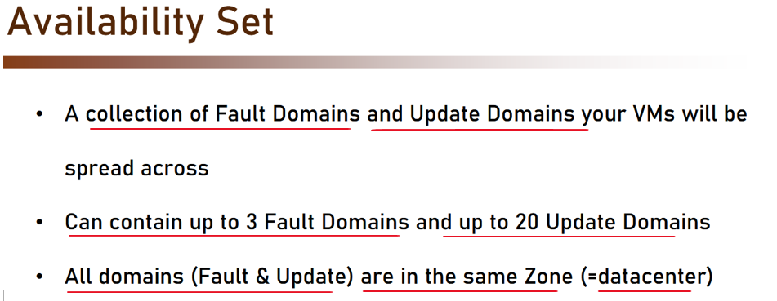

Remember a Zone is a Physical DataCenter

You can get this by searching for Availability Sets in the Seach Bar

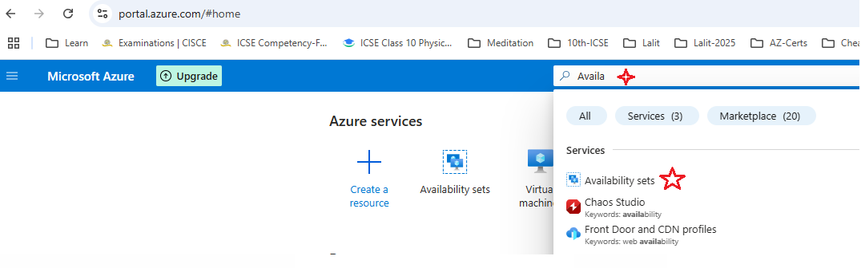

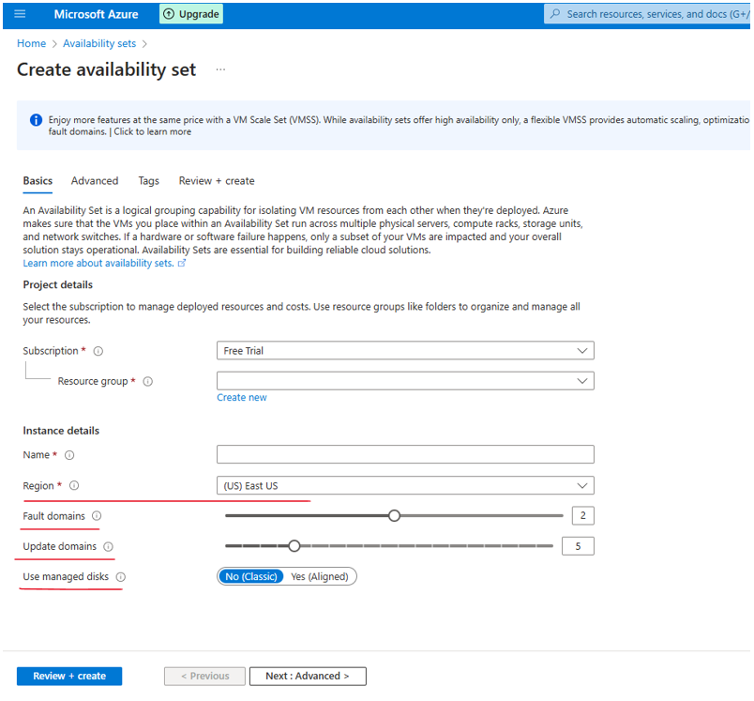

And remember that zone is basically a physical data center. Now if that sounds a little bit complicated, then let's look at an example.

So in this example, we create a new availability set, and we define it to have two fault domains and three update domains. And what we get now is this. So as you can see, we have two fault domains displayed as red rectangles, and we have three update domains displayed as green rectangles.

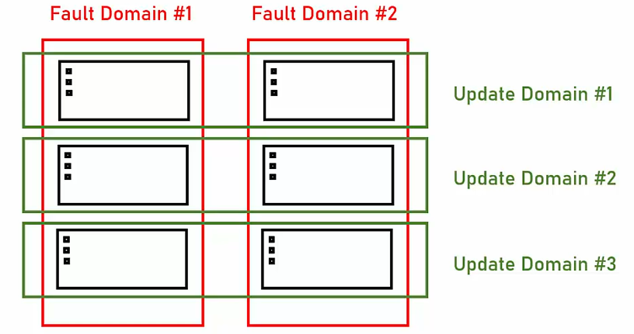

Now as you can see, the update domains are spread across the fault domain. So in this specific example, each update domain is spread across two fault domains. Now let's assume we deploy two virtual machines. One here, or in Fault Domain 1 and Update Domain 2, and another one here, in Fault Domain 2 and in Update Domain 1.

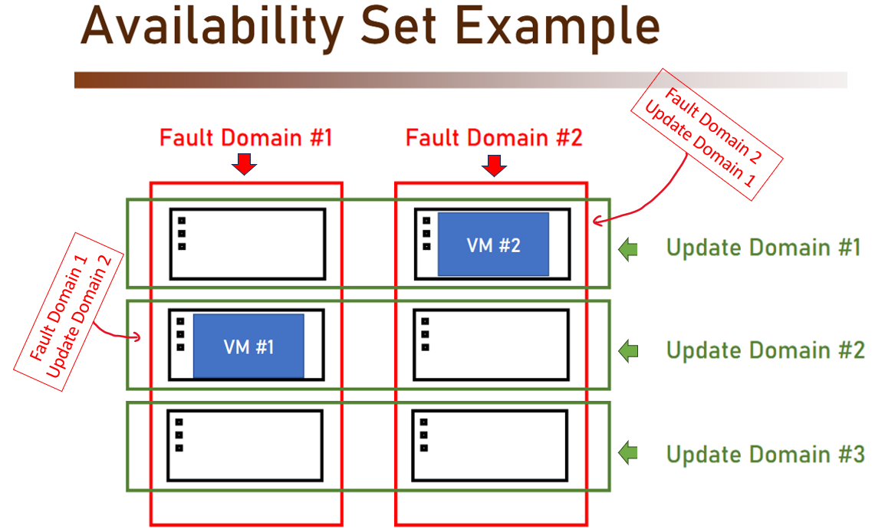

Now let's see what happens.

|  |  |
| --- | --- |
| Let's say that Update Domain 2 reboots, because this is what Azure decided that should happen because it just updated the host machine.  So what will happen is that the machines, all the machines in Update Domain 2 are now shut down, but we still have a virtual machine; the one that is located in Fault Domain 2 and Update Domain 1, up and running, and everything is good. |  |
| Now, what happens when Fault Domain 1 fails?  Well, in this case, again the first virtual machine is shut down and is not operative. But the second one, which was located at Fault Domain 2 and Update Domain 1, is still up and running. |  |

And that happens because we defined our availability set, and we told Azure to place those two virtual machines on the same availability set. And since an availability set is a pre-defined collection of fault domain and update domain, then Azure knew to spread those machines on separate fault domains and update domains.

|  |  |
| --- | --- |
| So what would've happened without availability set?  Well, if we didn't define any availability set, then Azure could have decided to place both the machines on the same fault domain; because Azure had no idea that these two machines belong to the same application, or to the same system, and that it's not allowed that both of them will go down.  And then in this case, if there was a problem with Fault Domain 1 and it failed, then we lost both the machines. And now our system is down. |  |

**So, how do we use availability set? How do we take advantage of this feature?**

Well, when deploying identical virtual machine, we must deploy them into the same availability set; and that ensures that they won't be shut down simultaneously when a single fault domain shuts down or an update domain reboots. Now if needed, for example if these virtual machines are of a web app, then you can deploy also load balancer to route between those virtual machines and we will see later how exactly to use this load balancer.

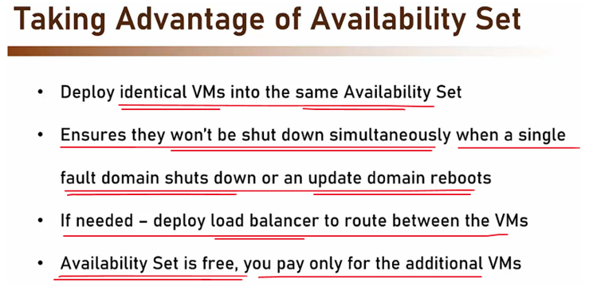

Now note that availability set is free, you pay only for the additional VMs. So it doesn't really matter cost-wise if you deploy the virtual machine into an availability set or not; the price stays the same. So, if you are going to deploy more than one virtual machine for the same system, then make sure to deploy them into an availability set. Unless you want to use instead of availability set, the availability zone.

Availability Zone

This is a physically separate zone within an Azure region. Or technically, a building containing an autonomous data center. So you probably remember that we talked in length about regions and zones, and we said that zone is basically a building; basically a data center. So this is what's happening here. When using availability zone, we spread our machines across zones in the same region, but still it's in a completely different building. And each zone functions as a fault and update domain. But to be honest, when talking about availability zone, we don't really talk about fault and update domain. The fact that the deployment is spread across physical building is enough for us, and we don't go into the resolution of fault and update domain.

|  |  |
| --- | --- |
| Now, what availability zone offers us that does not exist with availability set, is a protection against a complete zone shutdown. If you remember, we say that availability set is always located in the same zone.  So all the fault domains and update domains that are part of the availability set, are in the same data center. While with availability zone, we are protected from the case where a complete data center goes down. And this is the reason why there is a better SLA for availability zone, as opposed to availability set. |  |
| So how do we use the availability zone? Well simply, deploy identical virtual machines into separate availability zones in the same region. And that ensures that they won't be shut down simultaneously when the zone shuts down. Which is of course very rare, but still it can happen. Now if needed, deploy load balancer to route between the virtual machines. Again, similar to what we discussed about availability set. So if your virtual machine are going to be used as web apps that receives requests from the public internet, then you definitely need a load balancer in front of them to route between the virtual machines. And this load balancer will also be aware of any machine that is currently not active, and will not route the request to the active virtual machine. |  |

Now, similar to availability set, availability zone is also free. You pay only for the additional virtual machines. So the rule of thumb here is simple. If you can use availability zone, then do that. If not, use availability set. And now let's see all of this in action.

Additional Definitions

* "**Availability Set**" refers to two or more Virtual Machines deployed across different Fault Domains to avoid a single point of failure.
* "**Availability Zone**" is a fault-isolated area within an Azure region, providing redundant power, cooling, and networking.
* "**Azure Dedicated Host**" provides physical servers that host one or more Azure virtual machines with the (default) setting of autoReplaceOnFailure required for any SLA.
* "**Data Disk**" is a persistent virtual hard disk, attached to a Virtual Machine, used to store application data.
* "**Dedicated Host Group**" is a collection of Azure Dedicated Hosts deployed within an Azure region across different Fault Domains to avoid a single point of failure.
* "**Fault Domain**" is a collection of servers that share common resources such as power and network connectivity.
* "**Operating System Disk**" is a persistent virtual hard disk, attached to a Virtual Machine, used to store the Virtual Machine’s operating system.
* "**Single Instance**" is defined as any single Virtual Machine that either is not deployed in an Availability Set or has only one instance deployed in an Availability Set.
* "**Virtual Machine**" refers to persistent instance types that can be deployed individually, as part of an Availability Set or using a Dedicated Host Group. A virtual machine can be deployed in a multi-tenant environment in Azure or in an isolated, single-tenant environment using Azure Dedicated Hosts.
* "**Virtual Machine Connectivity**" is bi-directional network traffic between the Virtual Machine and other IP addresses using TCP or UDP network protocols in which the Virtual Machine is configured for allowed traffic. The IP addresses can be IP addresses in the same Cloud Service as the Virtual Machine, IP addresses within the same virtual network as the Virtual Machine or public, routable IP addresses.

### Creating Available & Cost Effective VMs

Let's create Azure Virtual Machine. We will put it in a new resource group. And let's name this resource group, optimized-vm-rg, like this. And the machine name is going to be optimized-vm. Now, for the region. And now let's take a look at the availability options. And if you will open this list, then there are basically four options here.

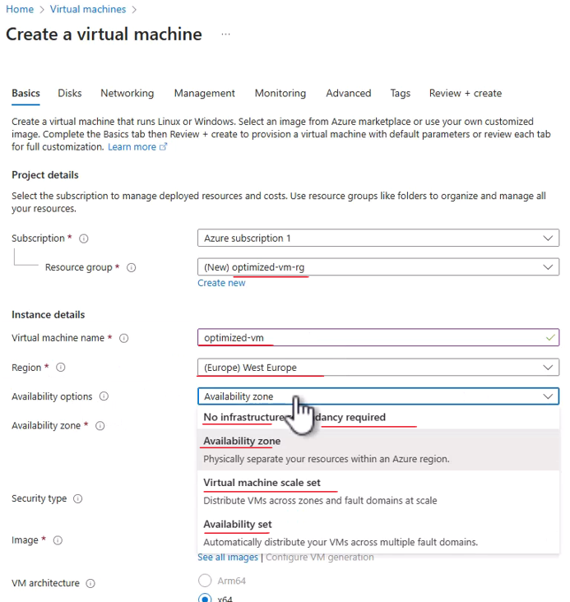

The first one is **No Infrastructure Redundancy Required**, meaning no availability whatsoever for the machine. And if the rack or zone where the machine is located will go down, then the machine will go with it. This is naturally less interesting for us right now.

Next is **Availability** **zone**. And remember, by selecting Availability zone, we basically mean that we want to place the virtual machine in a specific zone in the region. And remember that a zone is basically a data center, a physical data center. So if you will select this option, which is by the way the default option, and you will open the Availability zone list, then you can see that you can select the zones in which you want to deploy the virtual machine. And if you will select more than one, then Azure will create duplicates of the virtual machine and will put each one of them in the zone that you selected. So in this case, if I will check Zone 1 and 2, then Azure will create two virtual machines. You can see it right here. And will place each one of them in the zone that we selected.

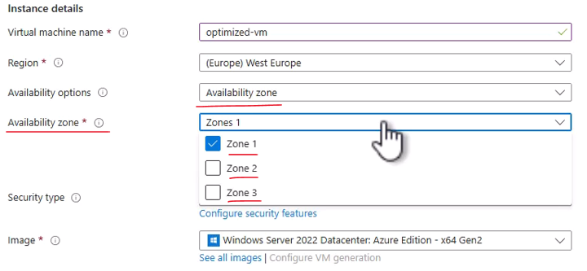

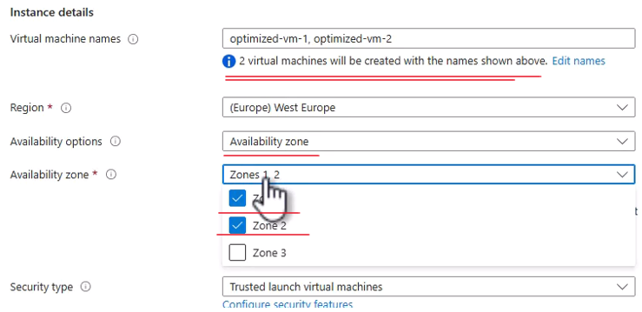

We, of course, don't want that, so let's uncheck this one. And now we set the zone where the VM will be deployed. Now note that the number of zones depends on the regions that we selected, but actually almost all regions as of today have three zones. And Microsoft declared that they aspire to have all regions having at least three zones, if not more than that. So this is availability zone.

Now, let's take a look at the next option, which is **Availability set**. And I'm not going to talk about scale set since we'll dedicated a lecture for that later. So let's go to Availability set.

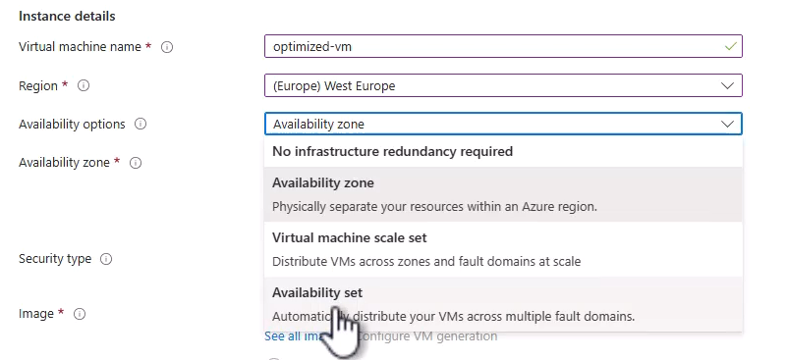

And as we mentioned before, with Availability set, we basically have a set of update domain and fault domains. And we can be sure that if you will deploy multiple machines in the same availability set, then Azure will make sure that these machines will not be deployed in the same fault domain and update domain. So currently, we don't have any availability set, so let's create one. So click Create new, and let's name this set my-av-set, like this. And by default, Azure offers us that this set will have two fault domains and five update domains. So five is quite a lot for what we actually need, so let's slide it back to three.

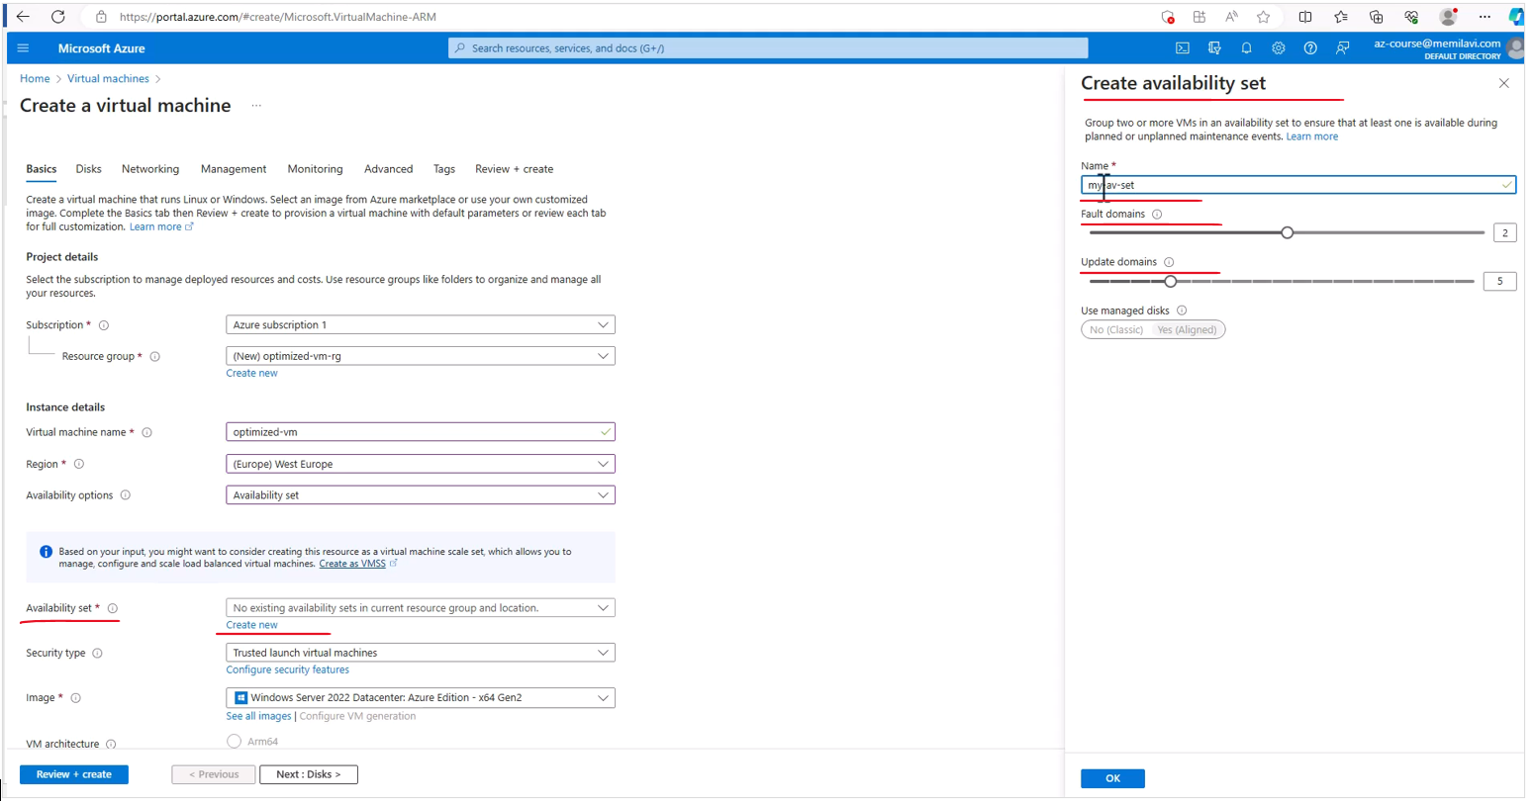

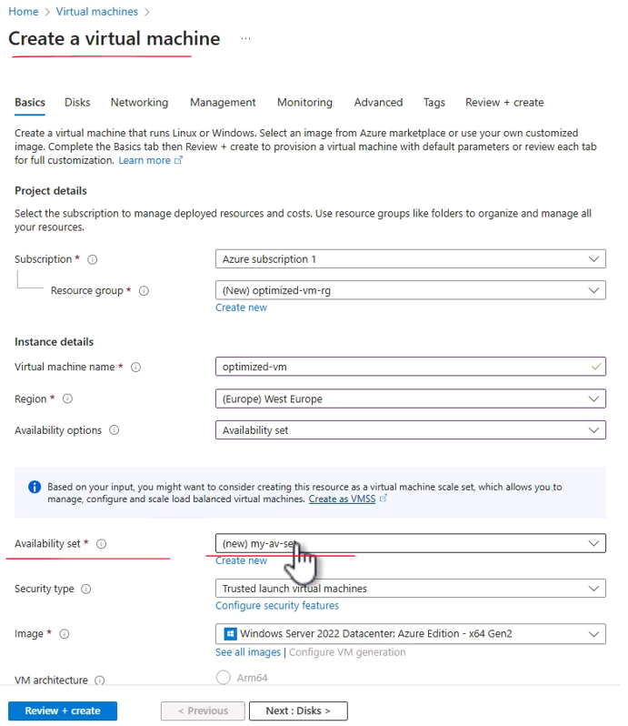

And currently, this is the availability sets that will be created and assigned to our machine. And again, that means that if you will create in the future another virtual machine and will assign it to the same availability set, then this machine will not be located in the same fault domain and update domain as the one that we just created now. Great. So for now, let's stick with Availability zone. This is usually the preferred option, and let's select Zone 1. And let's move on with the definition. And note, this message, you might not be seeing that because this comes and goes as the capacity of Azure is used.

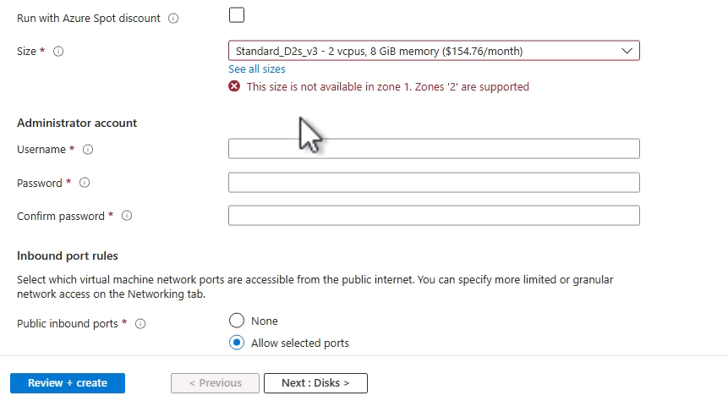

So basically, what it tells us is that this specific size, the D2s v3 is not available in Zone 1. However, it is available in Zone 2. So let's again open this list. And instead of Zone 1, go to Zone 2, and now we don't have this error. Now make sure that the image is Windows Server 2022, and let's set the username and password. So as usual, I will go with memiadmin and select the password that you want. And here is the password I will be using. Great.

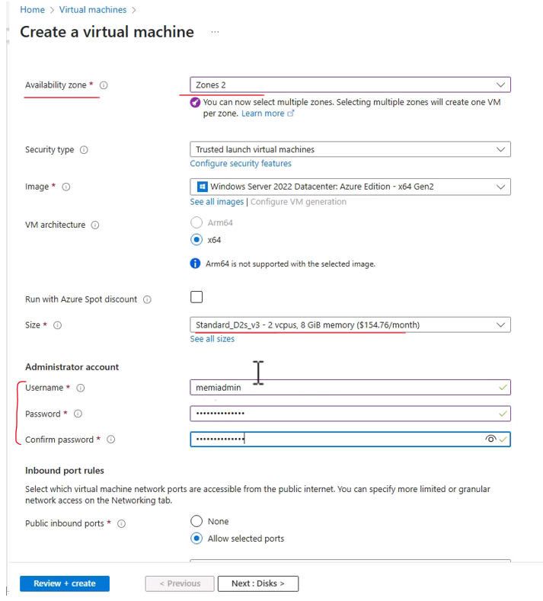

And the port is as usual. Now, before creating this virtual machine, I want to discuss some more topics just to make it more optimized.

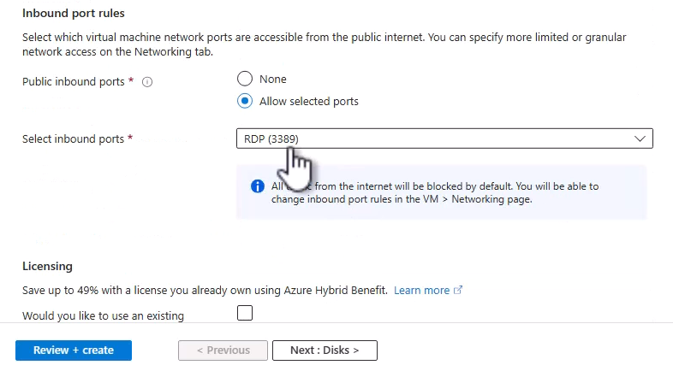

For Linux VMs it would be like this instead

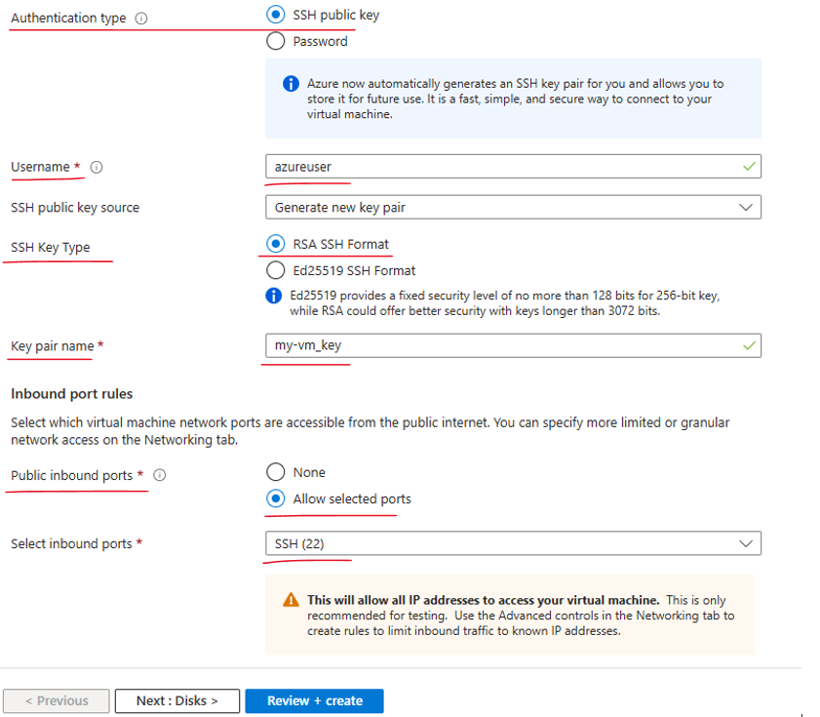

And the first one is the spot discount. And remember, that spot machine basically is a machine that Azure can evict whenever it wants. So if it needs a capacity of the machine for other paying customers, it'll simply take the machine from us. So if you need the machine to run continuously, then Spot discount is not for you. However, if the machine is running a temporary workload or something that can be stopped and continued later, then you should definitely consider spot discount. So let's see what happens if we check this box.

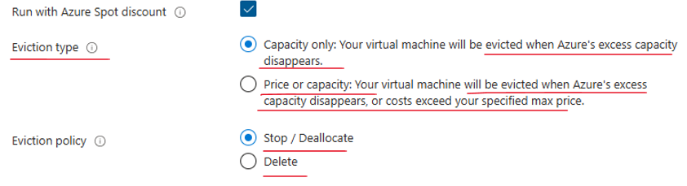

**Eviction Type (i) :** Azure Spot offers two eviction methods: Up to pay as you go and max price. Up to pay as you go will allocate capacity to you until Azure requires the capacity for pay as you go workloads. Max price will allocate capacity to you until either the platform price is greater than your set max price, or until Azure requires the capacity for pay as you go workloads.

**Eviction Policy (i) :** Choose what happens to the virtual machine when it's evicted. Upon eviction, the VM can either be stopped and deallocated if you plan to re-deploy or need access to the disk after eviction, or the VM can be deleted to clean up the VM and disks

So basically, we just indicated for Azure that we want this machine to be part of the Azure Spot discount. And again, that means that the machine can be evicted at any time. When we want Azure to evict the machine. And we have two options. The first one is when Azure needs the capacity and the second one is either when Azure needs the capacity or the price of the machine is exceeding the threshold that we defined. We'll stick to the default. Another option is what we want to happen when Azure evicts the machine. Whether to just stop and deallocate the machine, meaning we can start it later, or to completely delete the machine. Again, that depends on the type of workload that you are running on the machine. So you should select the options that best suits your needs. Of course, in our case, we don't want to use the spot discount, so we'll simply uncheck this box.

Next, let's take a look at the disks of the machine. And as we mentioned, by default, Azure will offer us the Premium SSD disk, which is one of the most expensive one. And note that we can also set the redundancy of the disk. So it can be locally redundant storage, which means that the data is replicated within a single data center, or a zone redundant storage, which means that the data is replicated to three zones, of course, in the same region. So the default one is Premium SSD, and we have Standard SSD and Standard HDD, which offer much cheaper alternatives.

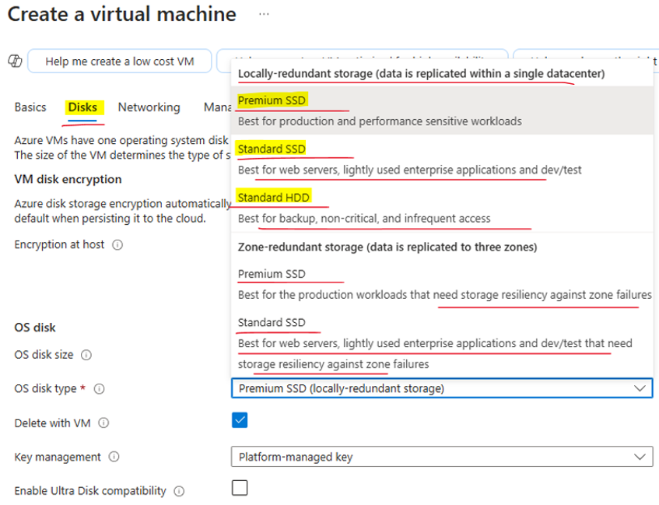

Now, of course, don't go for HDD, unless you really don't care about performance, but Standard SSD should usually do the job. However, don't change it now. We are going to change it later when we'll discuss templates. So just note that you have to look at the type of disk that Azure offers you and make sure you select the best one for you. So that about disks, now go to Management. And before we discussed the auto-shutdown feature of virtual machine, and let's see how it works. So here is the auto-shutdown, and check the box near Enable auto-shutdown right here. We can select when we want Azure to shut down the machine.

**Under the Management Tab**



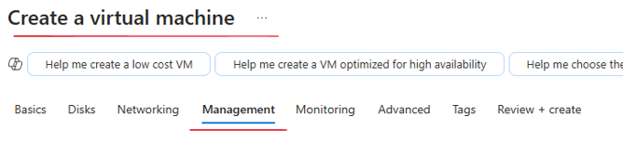

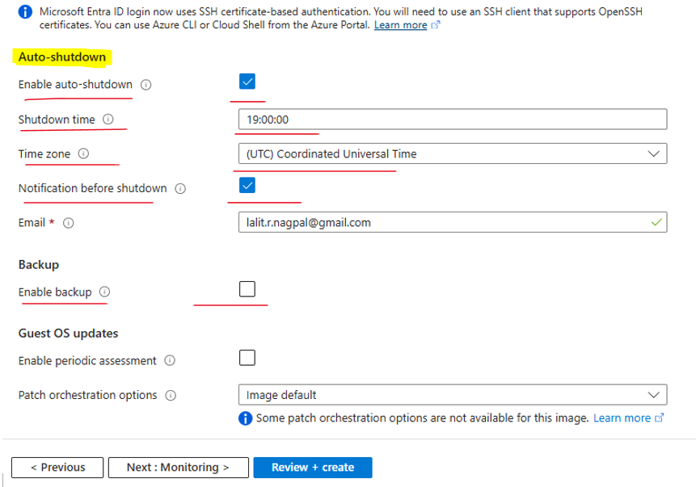

So the default is 7:00 PM on the UTC time zone. Feel free to select another time zone. And also you can ask Azure to notify you before the shutdown by sending you an email to this email address. So you can change the email address to whatever email address you want. And let's say that the defaults are okay for us, and we'll simply move on when the auto-shutdown is checked. So Review + Create, and Azure will now validate the configuration. And as before, it'll take a few seconds. So let's wait for that to complete.

Now, don't click the Create button, but instead click this link, Download a template for automation.

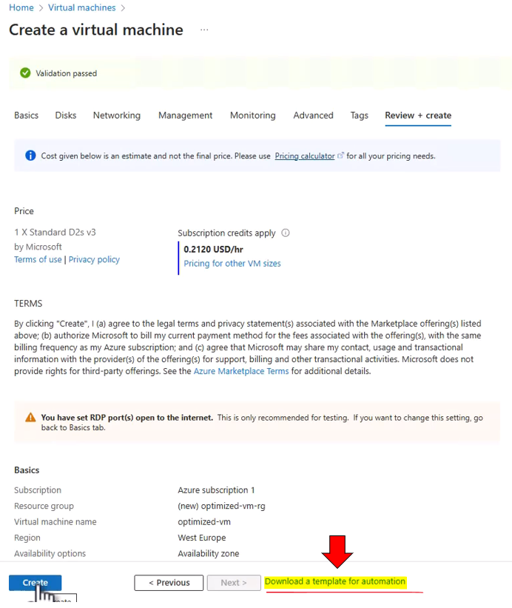

We get the following on clicking the Download a template for automation

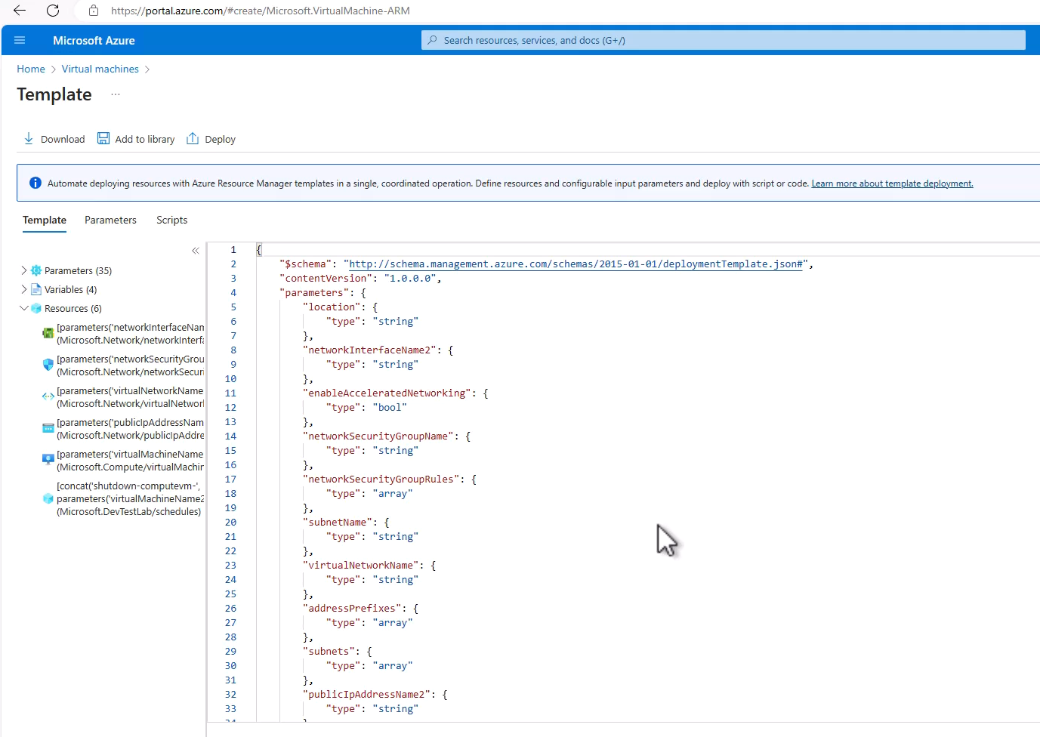

### ARM Template

ARM template stands for Azure Resource Manager template, and basically, that's a JSON file describing the resources that Azure wants to create. This file is used by Azure in almost all deployments. Now that means that when we create a new resource using the portal, then at the final step of the creation, Azure actually creates ARM template, and then, passes it on to the deployment engine of Azure. So, for almost all resources, this is the process. Now what's nice about ARM template is that it can be exported, modified, uploaded, and deployed because, again, basically, it's a file, and we can modify it as we can modify any other file, and, of course, it can also be created from scratch. What we saw in the previous demo is that we extracted the ARM template from the virtual machine we wanted to create, but, in fact, you can create one really from scratch.

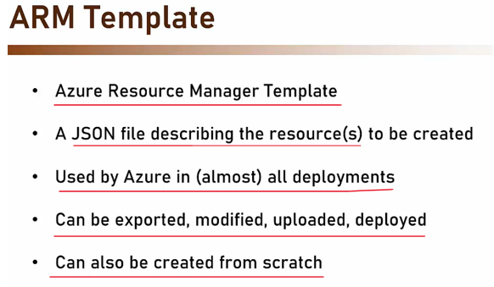

ARM template is a declarative way of deploying resources

Now, ARM template is a declarative way of deploying resources, and to understand this statement, let's see what is the difference between declarative and imperative. So when we say that something is declarative, we mean that this something describes the end result, and really, as we will see in a minute, the ARM template describes what is the end result of the process, what are the resources that are going to be created, and how should they look like?

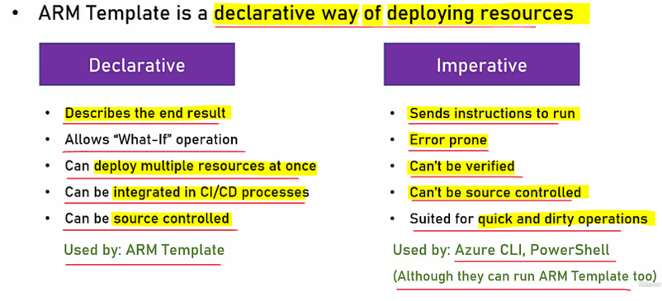

It allows a what-if operation, so we can simulate the creation or the deployment process and figure out what are the actual resources that are going to be created based on this template. In addition, using ARM template, we can deploy multiple resources at once. We don't have to have a different file for each resource, and actually, as we will see in just a minute, when deploying virtual machine, there are, in fact, multiple resources in a single file. In addition, ARM template can be integrated into CI/CD processes and be added as a resource to this process, and of course, it can be source controlled because since it's a file, then, as any other file, I can store it in source control and keep previous versions of it.

Imperative, on the other side, sends instructions to run. It doesn't represent the end result, but rather, using imperative mechanisms, we send instructions that tell the platform what to do. This is also error-prone because it's very easy to make mistakes in these instructions when sending them, and, in addition, it can't be verified because I can't look at the instruction and know whether there is any mistake in here. Only after sending it for processing, I can see whether there are any problems with the instructions. Also, it can't be source controlled because, again, it's not a file, it's an instruction. So imperative methods are best suited for quick and dirty operations. If I want to create now a new virtual machine, then I will probably go with imperative method. If I now want to build a full Azure environment, then of course, the declarative way is preferable.

Now, the ARM template is using the declarative method, and the imperative method is used by Azure CLI or PowerShell, which sends instructions to Azure. Now, I do want to mention that using Azure CLI or PowerShell, I can send ARM templates to Azure instead of specifying different instructions for different resources. So, that's a combination that is also widely used, and if you don't want to use the portal for resources deployment, then you can definitely use the CLI or PowerShell with ARM template for creating resources in Azure.

### ARM Template in Action – Using ARM Templates

Let's go back to the portal where we stopped the last time.

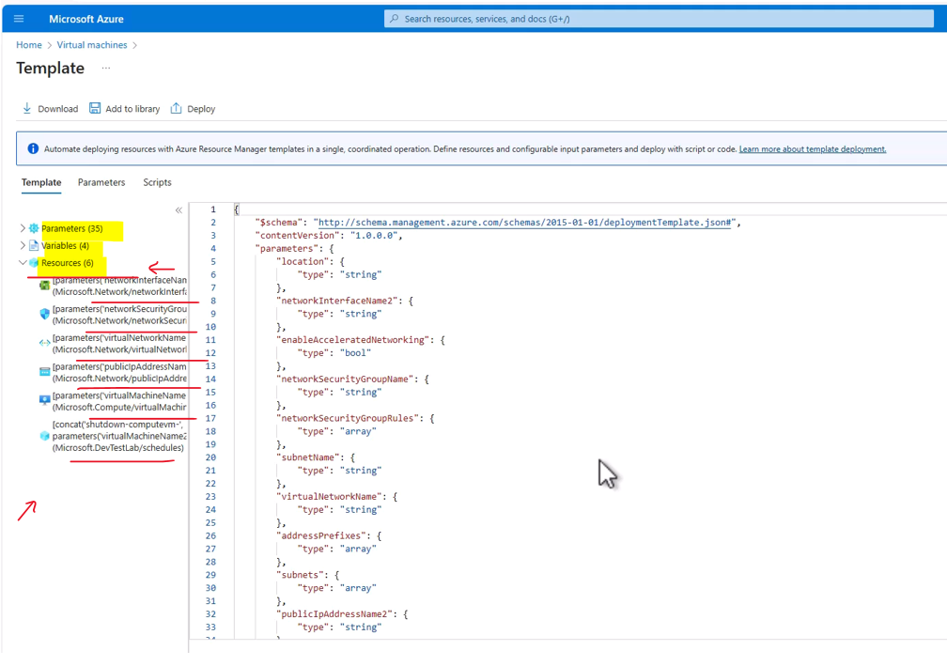

And what we see basically is an ARM template that was generated by Azure when we tried to deploy the virtual machine. And let's see what we have here. So let's move this one. And you can see that the template basically has three parts. It has the parameters part, the variables part and the resources part. And usually the resources is the most important part, because here you can see what are the resources that the ARM template is basically going to create. And let's go through these resources. So first we have a network interface here which as you can guess is a network interface that will be used by the virtual machine. Then we have the network security group.

We already discussed this, and we say that this is basically a mini firewall controlling the access to the virtual machine. Then we have the virtual network and the public IP address that will be used to access the machine. And then of course the virtual machine itself. And here we have another thing which is a schedule. And this one sets the auto shutdown that we discussed before. Now let's see how it actually looks in the template. So click the virtual machine resource right here. And now we see here that the window jumped to the virtual machine part.

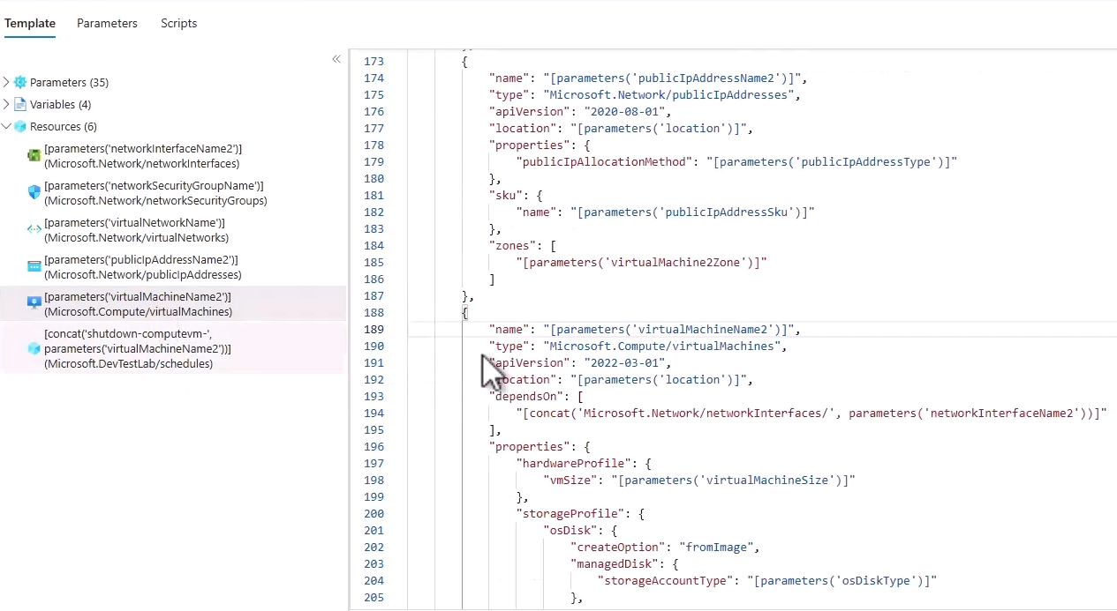



So this is where we define the virtual machine that we are going to create. And we see that there are various fields of the virtual machine defining its characteristics. So for example we have a name for the virtual machine. And we see that the value of the name is a parameter. And the name will be taken from a parameter named VirtualMachineName2. Now if you will expand the parameters section here and take a look at the list here, then you can see there is here a parameter named VirtualMachineName2 and click it.

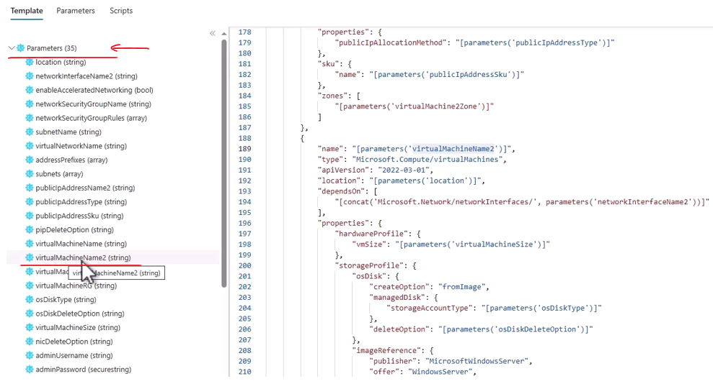

on Clicking we get to see

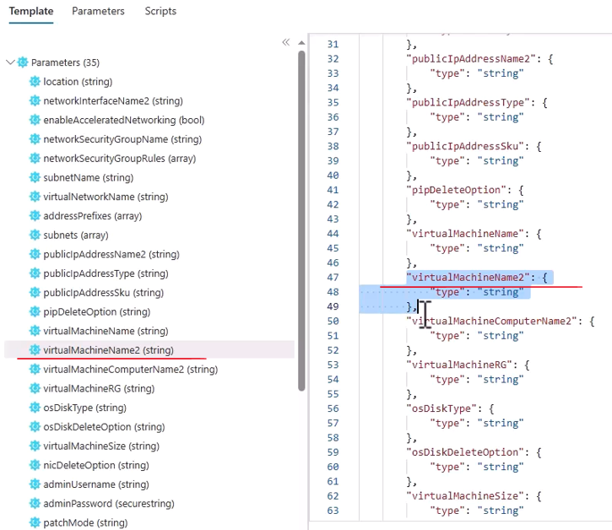

And you can see that this is where the parameter is defined. Now note that here we only defined that there is a parameter named virtual machine name two. And we also define its type. But we don't see here the actual value of the parameter. And we will see that later. So let's move on with our overview of the virtual machine definition here. So let's close the parameters section and go back to the virtual machine okay. So we have the name. We have the type of the resource which is of course virtual machine. And we can see that the location is also a parameter named location. Also the size or the instance size is based on the parameter. In addition, you can see also that we have a field named storage account type. And this is basically where we define the type of the disk of the machine. And if you remember we left it as is to be premium SSD. And we say that we want to change it to standard SSD. Now you can see here that the value of this field, the storage account type is in the OS disk type parameter.

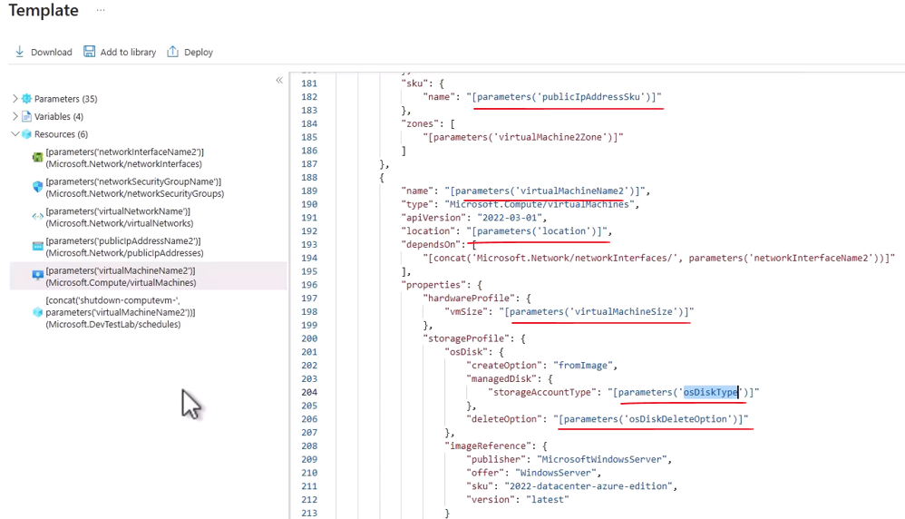

So how can we view the values of the parameter. Well it turns out we cannot view the parameters from here. And if we want to actually view them, then we need to download the template and a parameter file and then take a look at the parameters and maybe even change them. So for that click download from here and click Open File. And you can see here that a zip file was downloaded to your machine containing two files, one named template.JSON, which is basically what we just looked at, and another one named parameters.JSON. Now let's copy these two files to our machine.

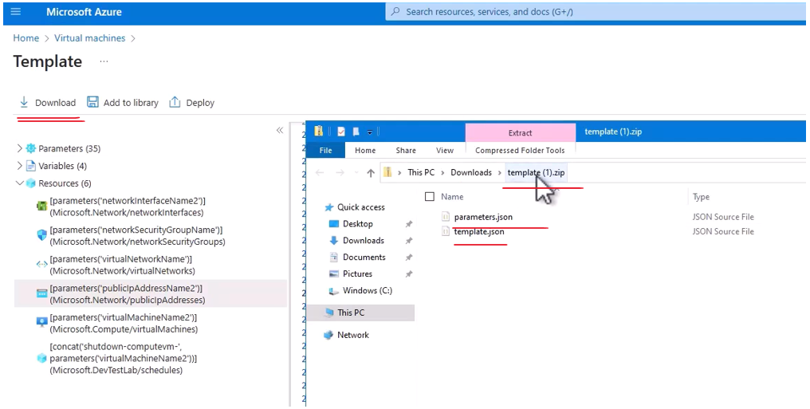

And now let's open VSCode to view these files. And then we can have a good view at what they contain. And we can also edit them. So right click and open with code. And remember that you can also open VSCode here by typing here cmd and open the code command from this folder. So let's open this code. And here we see the two files.

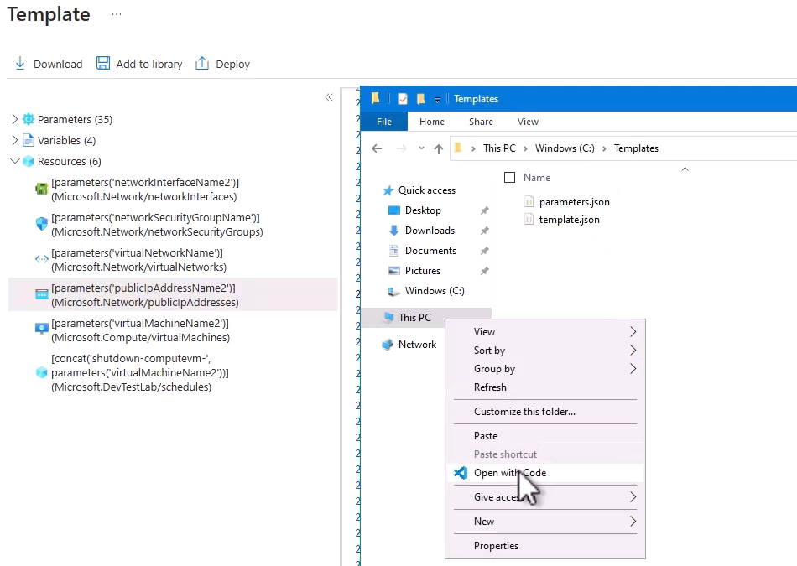

So first let's open the template JSON. And you can see that it looks just the same as we saw before. So for example let's look for the OS disk type. And here is the field that we just looked at before.

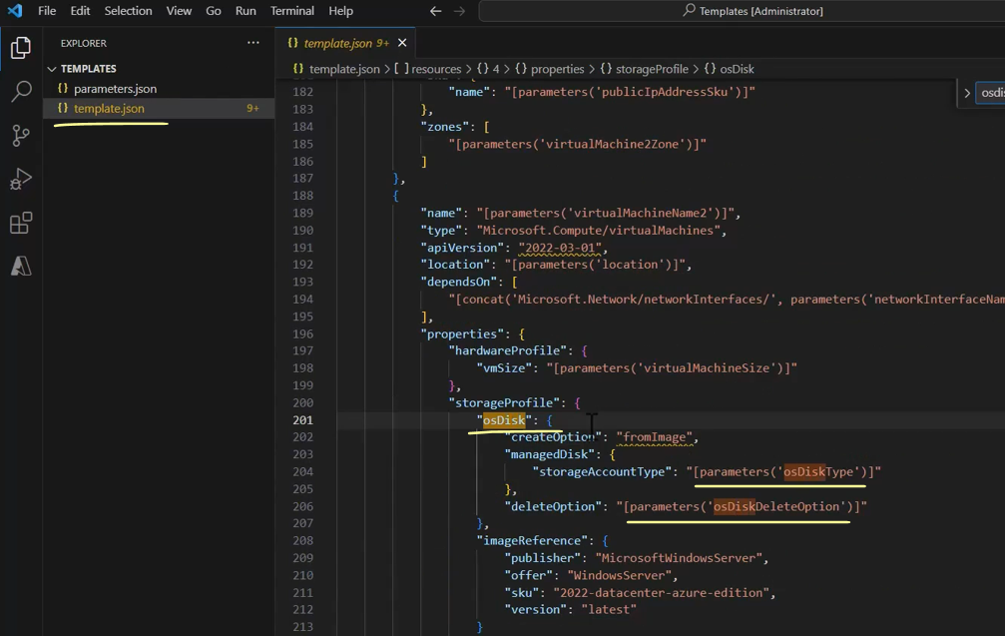

But the more interesting file is the parameters file which contains the actual value of the parameters.

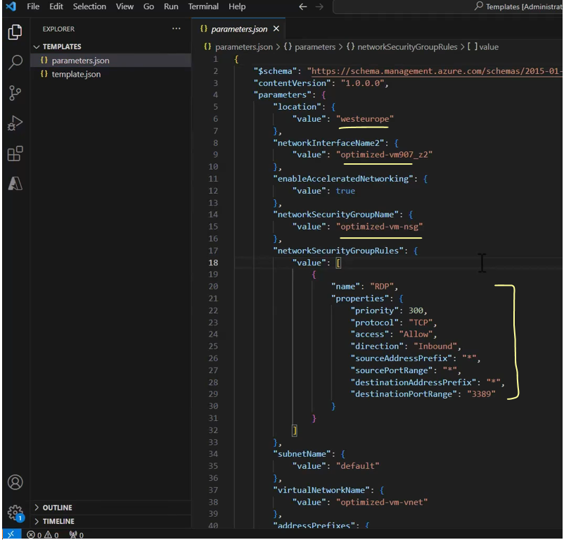

And now let's also here take a look at the OS disk type. And you can see here that the value is premium LRS. And we want to change it. If you remember we said before when deploying the virtual machine that we want the disk to be standard SSD and not premium.

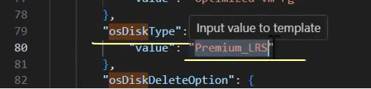



And we also say that we are going to change that using the template, which is exactly what we are going to do now. So in this field, replace the premium word with standard SSD. And then note that if you will write here only standard and not standard SSD, then the disk will be standard HDD, which is not what we want.

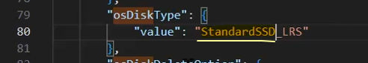

So this is one change we need to do here. But actually there is another one. And if you will look a little bit down at the admin password field, then you need to also set here the password for the virtual machine. And note that this parameter was not downloaded because this is a security risk and might expose passwords of virtual machines, and therefore this field stays blank.

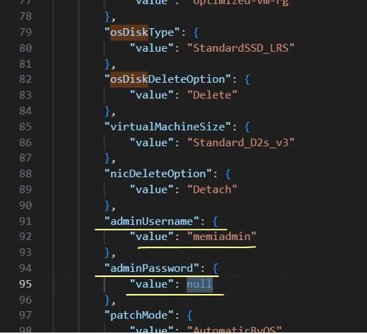

So now type here the password of the virtual machine that you want to create. So we made the two changes and let's save the file and we can now close VS code.

So we have the template and the parameters file ready. And now it's time to actually deploy them.

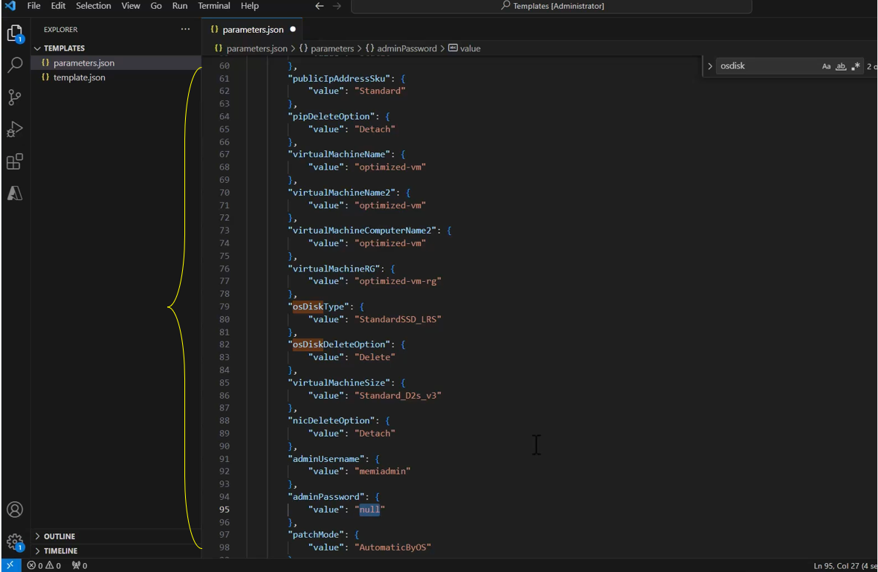

Now how can we do that. Well you can see that there is a deploy button here in the template page. But in fact using this deploy we cannot deploy parameters file only template file.

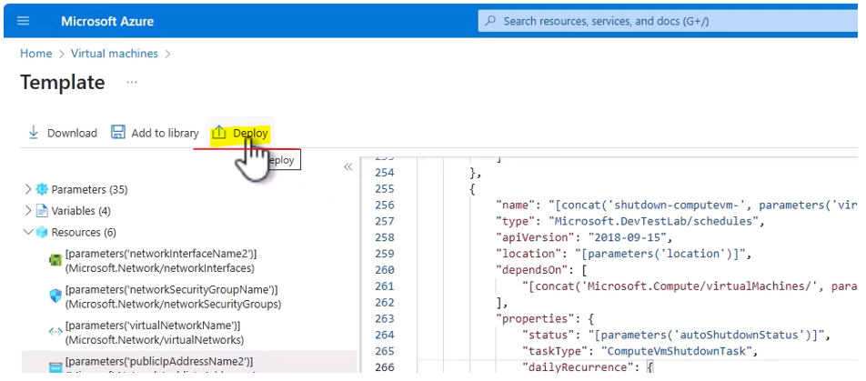

And if we want to deploy also parameter file then we have to do it in another way. And let's see how to do that. So first I want to take a look at the resource group in which we are going to deploy the virtual machine. And actually this resource group was created as part of the virtual machine deployment. And even though we didn't deploy the VM yet, the resource group was created. So in the search bar type optimized-vm-rg. And here is the resource group.

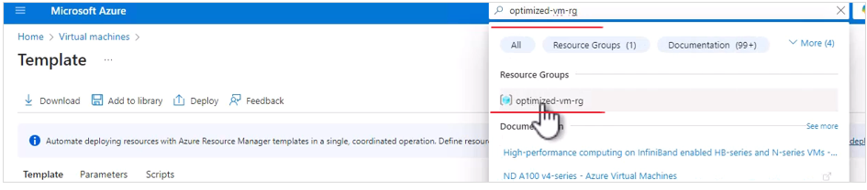

So click it. And yes we want to leave the page. And this is a resource group. And naturally currently there is nothing in it.

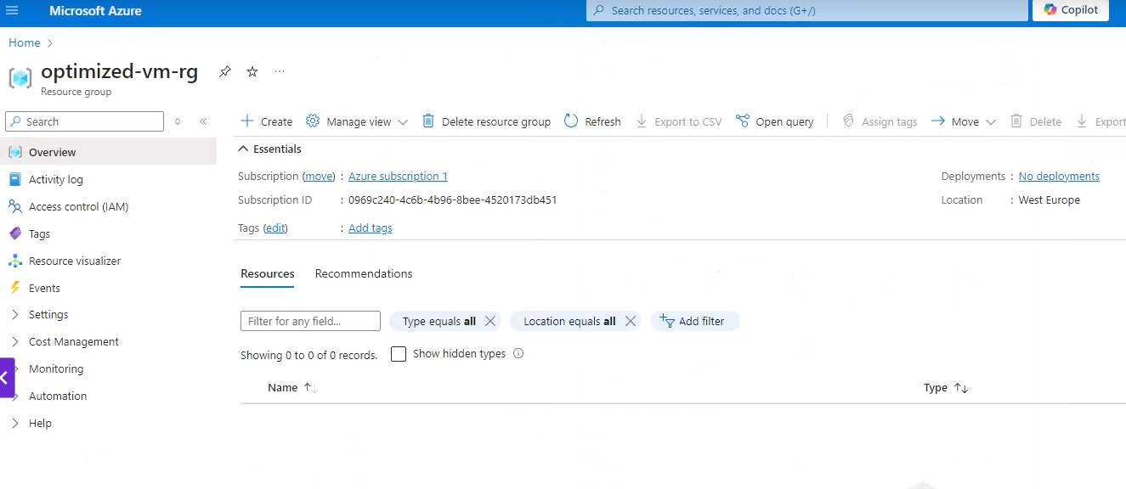

And now we are going to deploy the template and the parameters. And we are going to do that using Cloud Shell. And remember that we already learned what Cloud Shell is and how to use it.

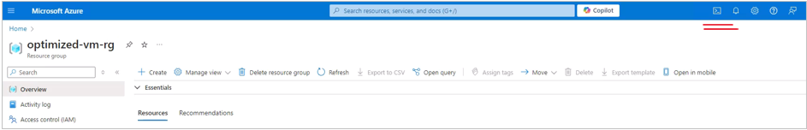

And now we are going to use it to run the deployment command. So open cloud shell from here and here it opens. And the first thing we want to do in the shell right after it will connect is to upload the files that we walked in, which are the template and parameter file. So let's wait for the terminal to connect. Great. And here it is. And now let's upload our files. So click the Manage Files button right here and upload.

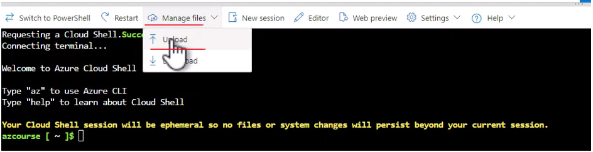

And let's navigate to the templates folder that we created earlier. And here are both the files that we worked on. So select both the files the parameters and the template JSON files and click open. And you can see that these two files were successfully uploaded.

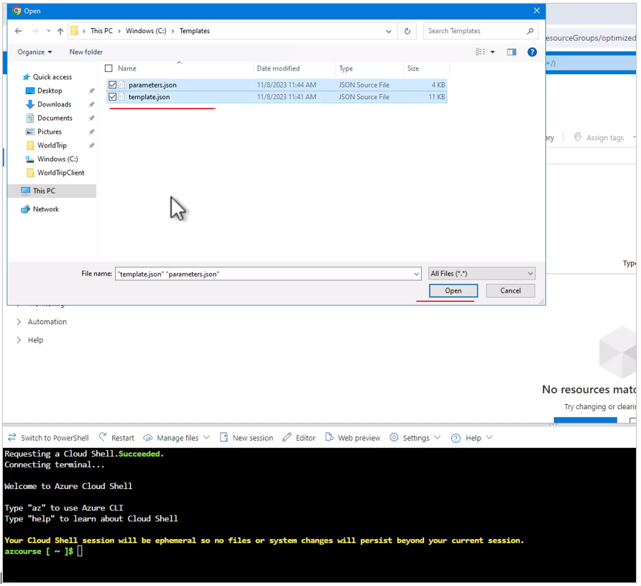

Let's close this. And just to make sure that these files are indeed here type the command ls. And you can see that indeed we have the parameters.json and the template.json files in our cloud shell.

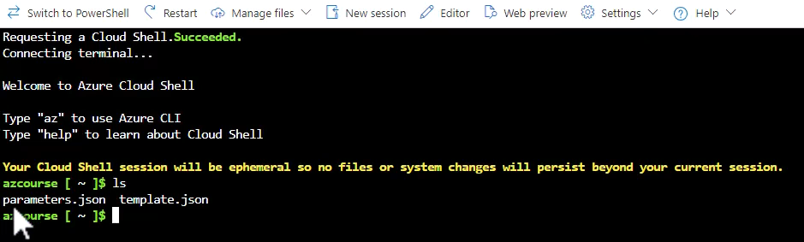

And now we want to use these two files to deploy our optimized virtual machine. And for that open the arm template command.txt file that can be found in the resources of this lecture. And copy the command that you see there and paste it to the cloud shell. So it should look something like this.

**ARM template deployment command**

**===============================**

**az deployment group create**

**--resource-group** optimized-vm-rg

**--template-file** template.json

**--parameters** parameters.json

So this is a command and let's go through it. So it begins with AZ which as we said before is always the prefix for Azure CLI commands. Then the type of resource that we want to work with, which in this case is **deployment** **group** because we want to deploy group of resources. Then the actions that we want to take, which is of course **create** in this case because we are creating a new deployment group. Next, we are going to specify the **resource** **group** in which we want to deploy the resources and note the name of the resource group optimized VMs, which is identical to the resource group that you see right here. And then we specify the **template** **file** and the **parameters** **file** again identical to the file names that we just uploaded to Cloud Shell.

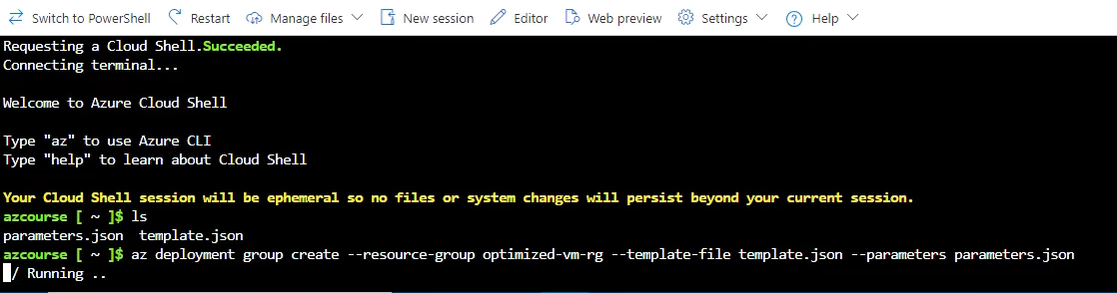

So this is the command. And now let's run it. So hit enter. And now Cloud Shell is deploying the resources in the template and the parameters file to Azure. And note that this can take a few minutes. So let's wait for that to complete. Great. And the deployment completed successfully. You can see here in the provisioning state that the status is succeeded.

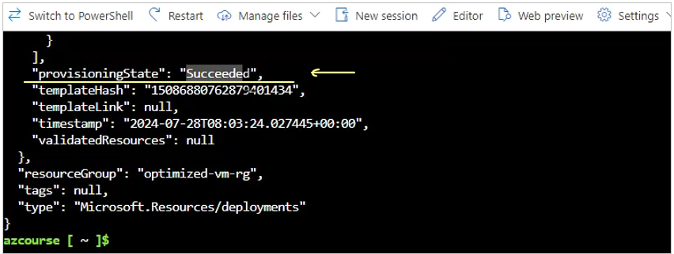

Let's scroll a little bit up and see what exactly was deployed. So we can see that we have here the NSG. We have here a VNet, and we also have an IP address and also a network interface and some more resources. But again, the most important thing here is that deployment succeeded.

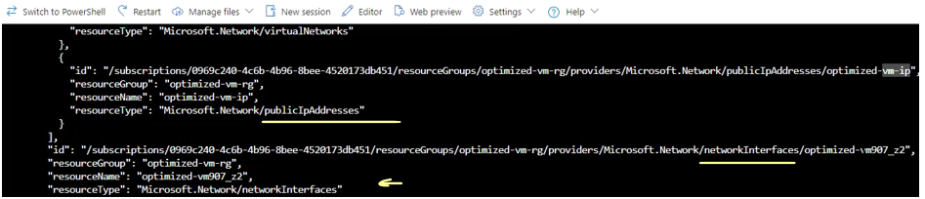

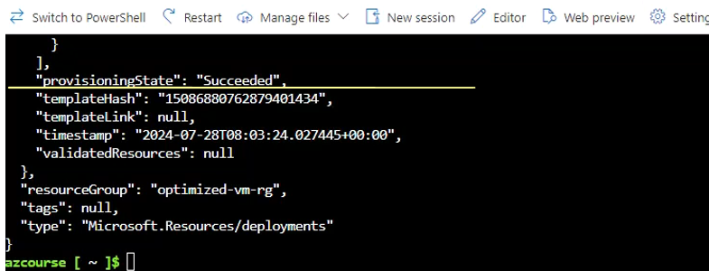

And now let's go back to the resource group that we see right here. And note that currently it's empty. But now hit refresh here. And now we have six resources inside this resource group. So you can see that we have virtual machine public IP address, network security group, virtual network, network interface and of course the disk.

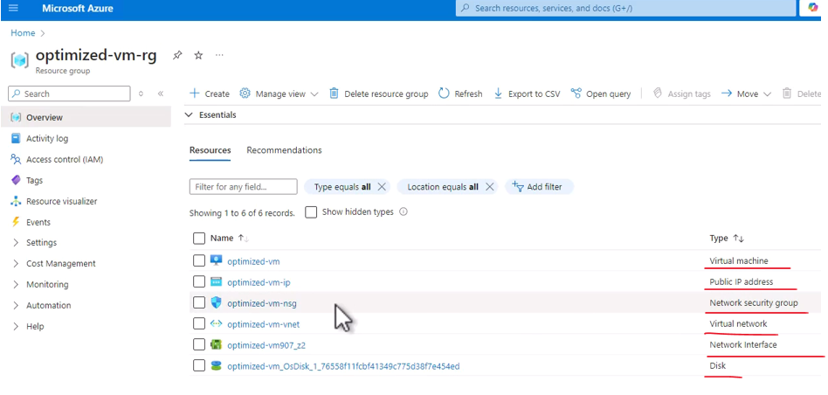

We can now close the cloud shell. And let's take a look at what exactly we have here. So let's go into the virtual machine.

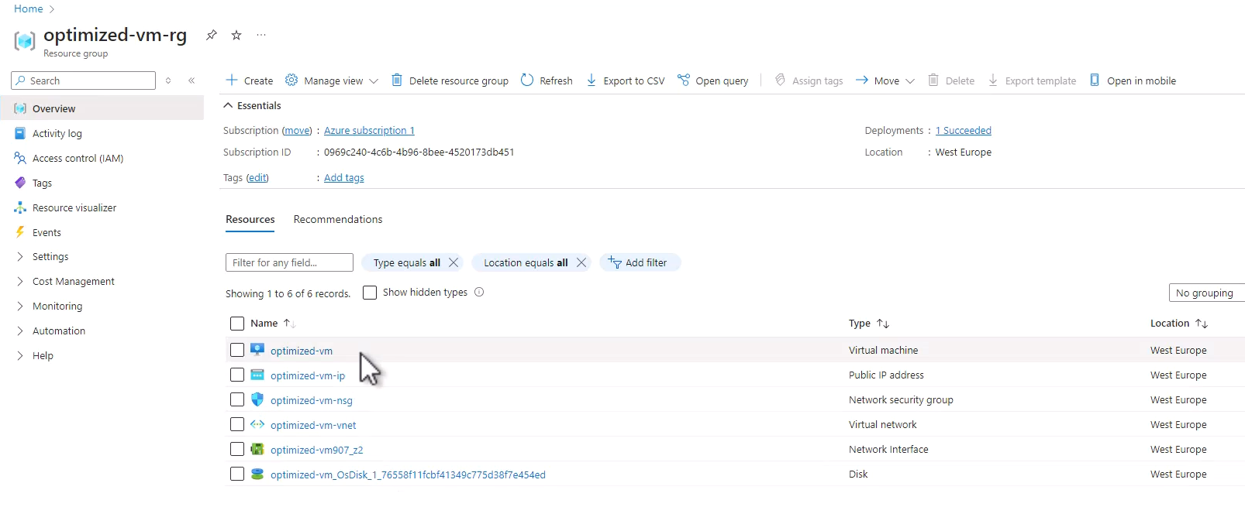

And here are the details about this virtual machine a completely normal virtual machine. Nothing special with it.

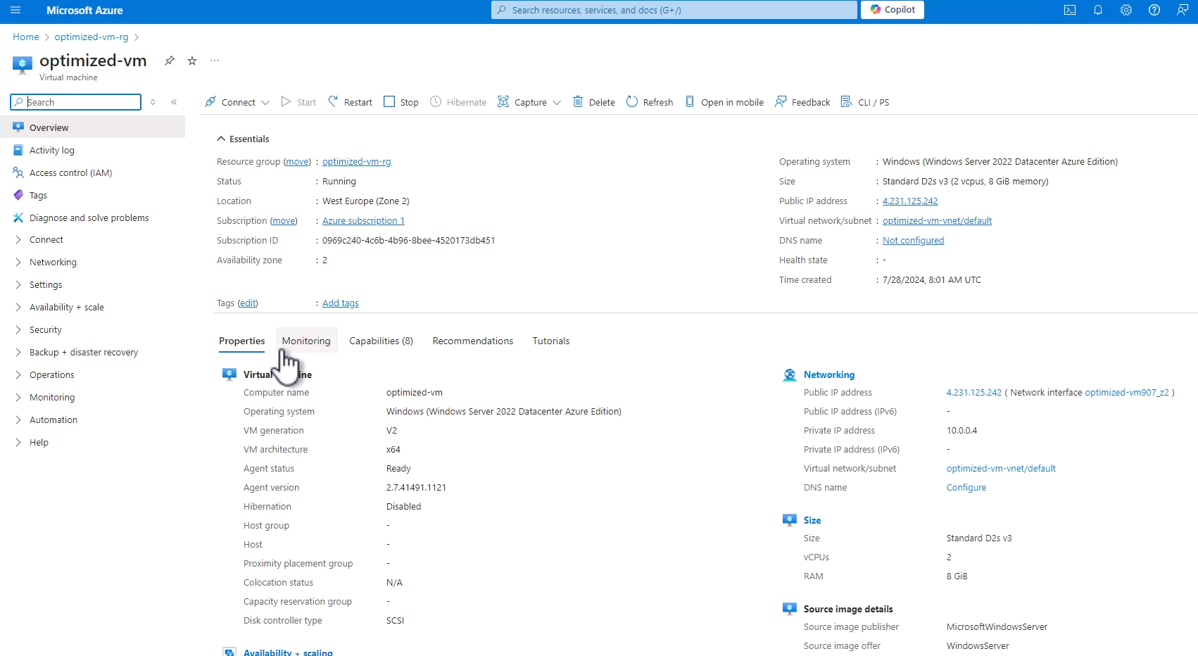

So you can't see that it was deployed using an ARM template instead of the portal. From the point of view of Azure, this is a completely normal virtual machine. Now let's take a look at the disks of this virtual machine. So for that expand the settings section and click disks. And here is the disk that this virtual machine has. And note the storage type. And you can see that the storage type is indeed standard SSD ls which is exactly what we specified in our ARM template.

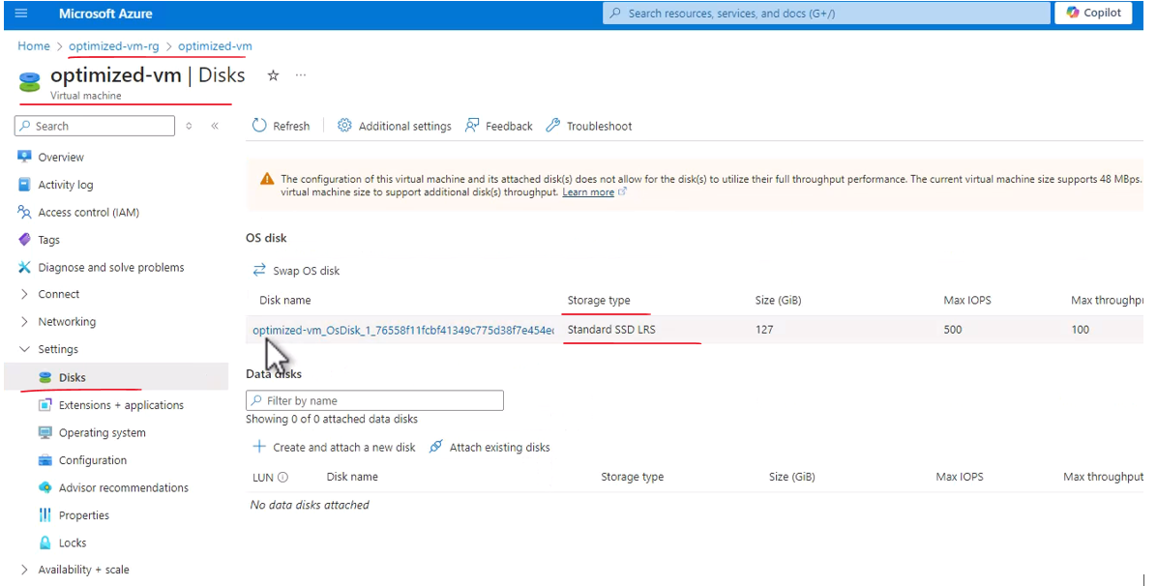

And that means that the change was successful and the actual deployment indeed used the value in the parameter that we manually changed. So this is how you can deploy resources using ARM template. And again you don't have to do that. You can deploy resources from the portal using ARM template or using commands in Azure CLI or Azure PowerShell. We are going to use mainly the portal in this course. But again, always remember that you have other options for doing that.

### Deleting Virtual Machines

So let's take a look at it, go back to the overview here and click delete. And note what we see here. Azure shows us the resources that were created with this virtual machine, and we can decide whether we want to delete these resources together with the virtual machine or we want to leave them.

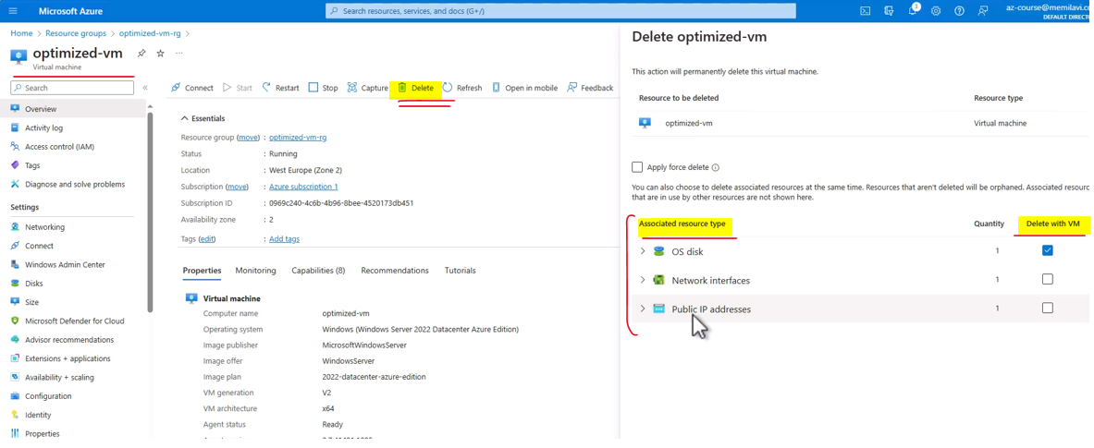

So for example, we can decide that we don't want to delete also this IP address because we might want to use it on a different virtual machine. Or also we can decide that we don't want to remove the disk because we want to attach it to a different virtual machine. So whenever you delete a virtual machine, you should select which resources you want to delete with it. So in this case, we want to delete all of the resources and check this checkbox and delete. And now all the resources associated with the virtual machine and, of course, the virtual machine itself are going to be deleted.

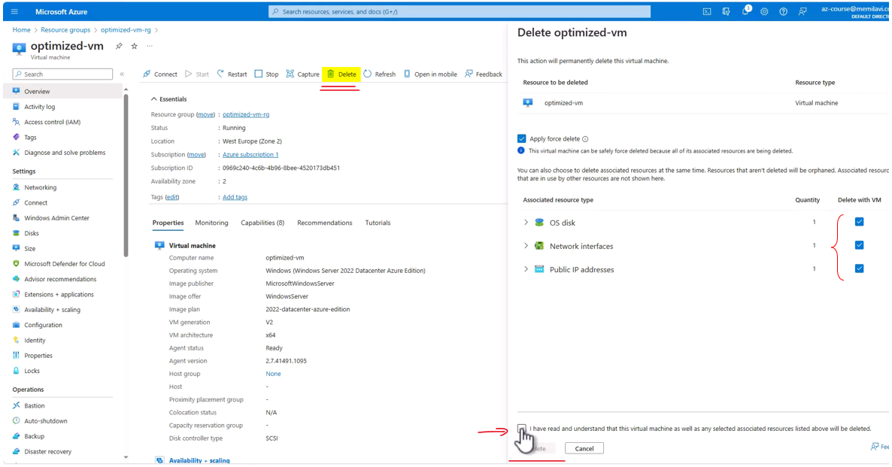

And actually we're not going to wait for that to happen, but we will go to the resource group itself right here, and let's delete the whole resource group with all the resources within it. So again, check the apply force delete and type the name of the resource group.

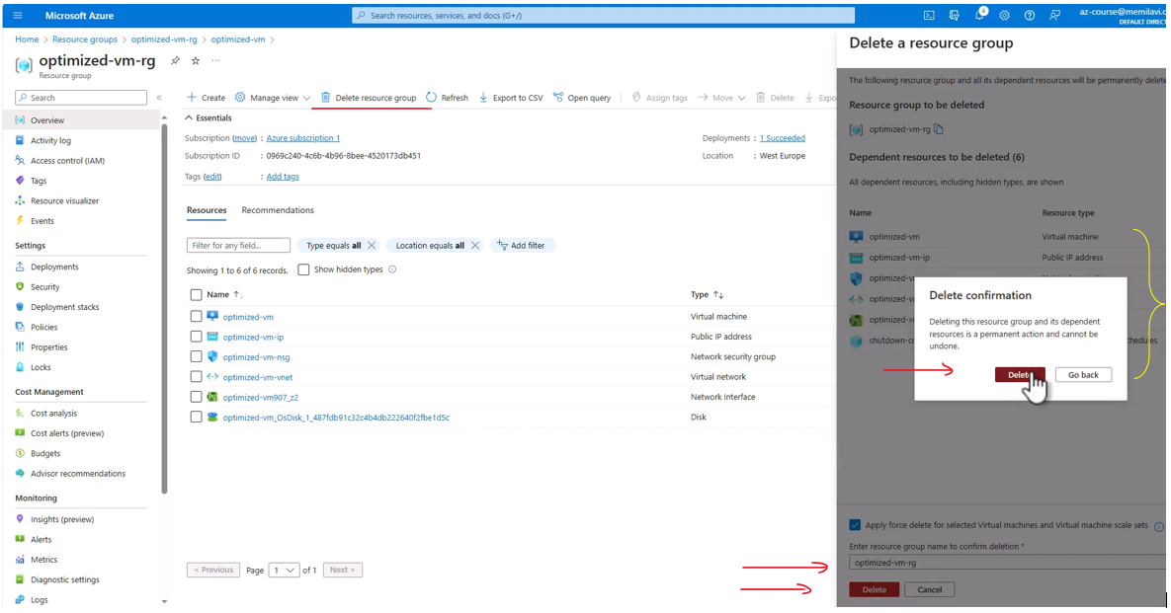

You can alternatively simply copy it from here and paste it here. And delete and delete. And now all these resources are going to be deleted from Azure. And now let's move on. information alert Schedule

### Virtual Machine Scale Set

Virtual Machine Scale Set is a group of separate virtual machines sharing the same image. And all those virtual machines are managed as a group, which means that they can be scaled out or in, either manually or according to predefined conditions, which means this is great for handling unpredictable load. So what it basically means is that we create a group of virtual machines, identical virtual machines, and we tell the Scale Set to monitor these machines. And when the Scale Set detects a heavy load that is applied on this machine, then it can scale them out, meaning it can add additional virtual machines based on the same image so that the load will be distributed more effectively across these machines. And, in addition, when the load is no longer there, then the Scale Set can scale them in, meaning it can drop the machines that are not needed anymore and return to the original number of active virtual machines.

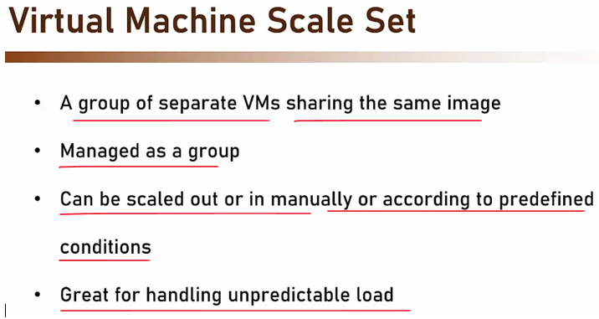

Now, what's important to note about Virtual Machine Scale Set is that once it is set up, the machines should not be modified. So, for example, you should not change files or install applications, et cetera, on these images. And why? Because new machines that will be created by the Scale Set will be based on the original image, and basically your changes will be lost. So there is no point in changing these images. These changes will simply be lost the next time the Scale Set will be scaled out or in. So if you want to update the image of the virtual machine, you should create a new image and modify the base image of the Scale Set. So make sure when you create a Scale Set to base it on a final image that will not be changed anytime soon.

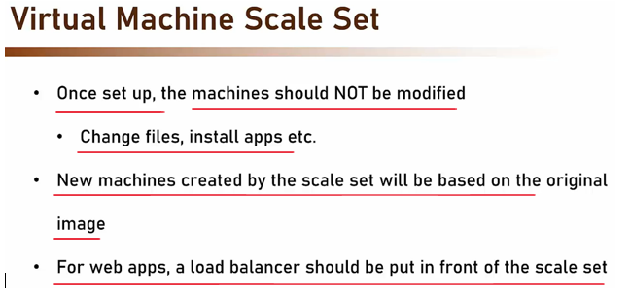



|  |  |
| --- | --- |
|  | Now for web apps, a load balancer should be put in front of the Scale Set. And that's because for web apps the end-user calls a specific address, whether IP or a domain name. And when we have more than one instance, then we have to tell the client which instance to go to. And this is the exact role of the load balancer.  So, the load balancer connects to the Scale Set and it knows how many instances are there in it, and it performs the actual routing to the active instances. In addition, the load balancer exposes a single address, which is where the end user will go to. So this is how it'll look like for WebOps.  So in the front we have the load balancer, which receives the calls or the requests from the end-users, and it routes the request to the Virtual Machine Scale Set, which contains the actual virtual machines. Now, what about pricing? Well, Scale Set is basically free. The Scale Set mechanism itself costs nothing. However, you of course pay for the virtual machines deployed in it. So, for example, if you began with two virtual machines, and naturally you are now paying for two virtual machines, and the Scale Set decided to add two more instances, then you are going to pay for those two instances. But again, the Scale Set itself, the mechanism that scales out and in and monitors the virtual machines, is free. |

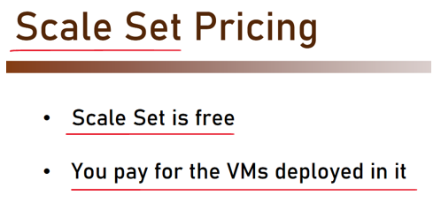

### Using Scale Sets

Let's see how to create, configure, and use virtual machine scale set. So, as usual, let's begin with a search bar and type here scale set, and click virtual machine scale sets. Right here, and let's create a new one, so Create. And we're of course going to use our subscription and let's place a scale set in a new resource group, and let's name this resource group vmss-rg as virtual machine scale set dash resource group. So, that would be the name of the resource group, the name of the scale set itself will be my-vmss.

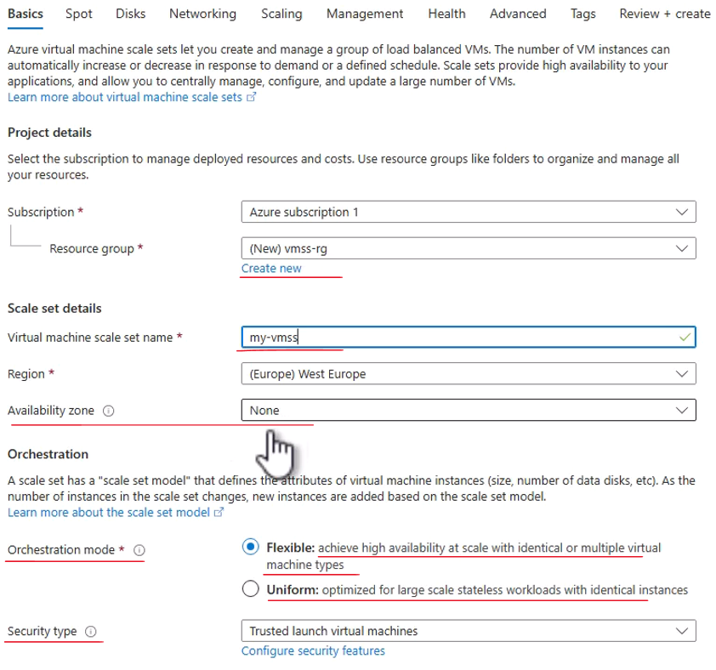

Regarding region, place it in whatever region you want, I will use a regular one with Europe. We don't need any availability zone here, and we can select the orchestration mode.

The flexible mode basically adds new instances with size that is based on the analysis that Azure does to the actual activity of the scale set. So if Azure thinks that we don't need such strong machines and we can do with smaller ones, then it will add smaller machines, and vice versa. With the uniform mode, then we set the size of the VMs that we are going to create. So, just to show how we took like, let's go with a uniform

Let's scroll down, we don't need any special security type, so we can go to Standard here. We are going to use a Windows Server 2022 image, and this size will be this one as usual. And you can see that basically, a creation of a scale set is quite similar to what we see in regular virtual machines. So again, let's move on with the setup. And as usual, let's go with the username, so pick your username and password (keyboard keys clicking) and confirm the password. Licensing is not really relevant for us, so Review + create.

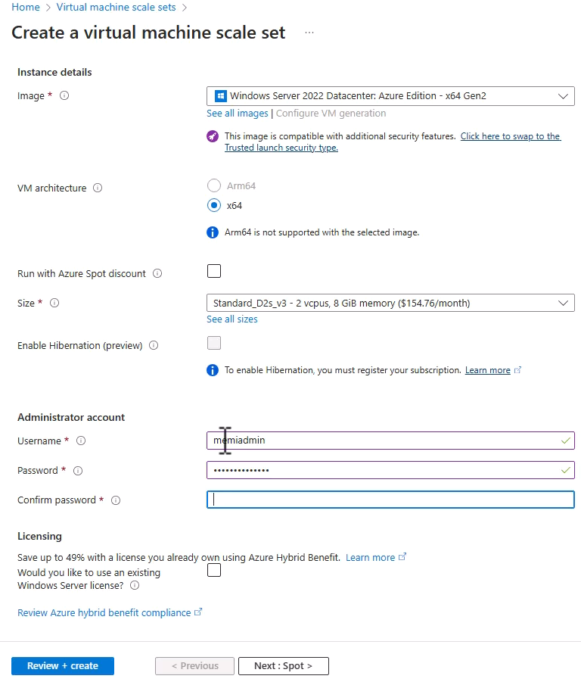



Let's wait for the validation to complete, great! And note the initial instance count right here, which is two, meaning, the scale set will be created with two instances. It can be changed of course while creating the scale set, but for now, we will stick to it, so Create.

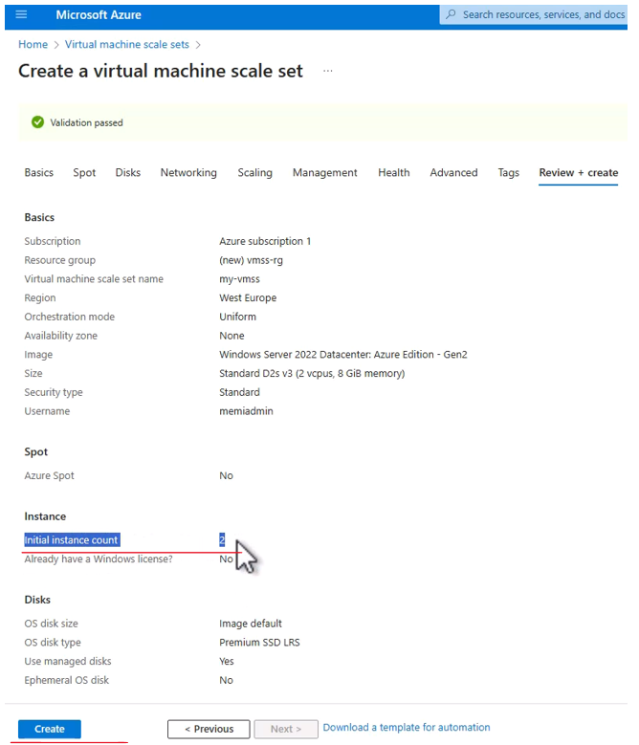

And now, Azure is deploying our scale set. This might take a few minutes. And here is the deployment tasks. Great, and the scale set was deployed. Now, let's take a look at it. So, click Go to resource. And here is our scale set.

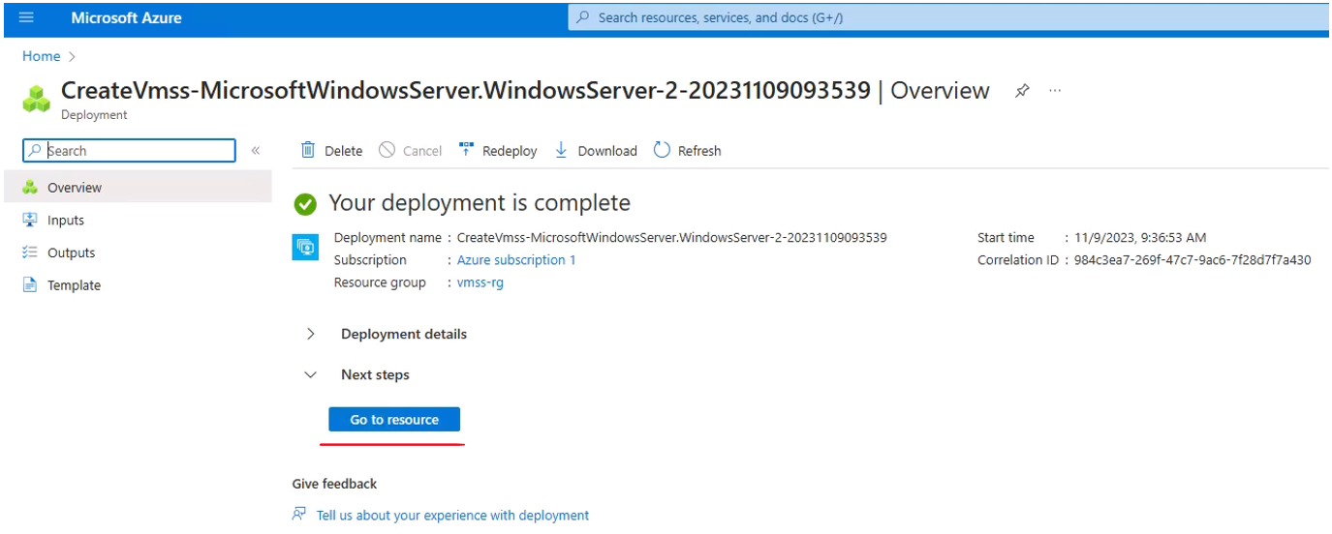

Now, the most important part in the overview section is this one, the status of the scale set, and you can see that deployment of two out of two instances succeeded.

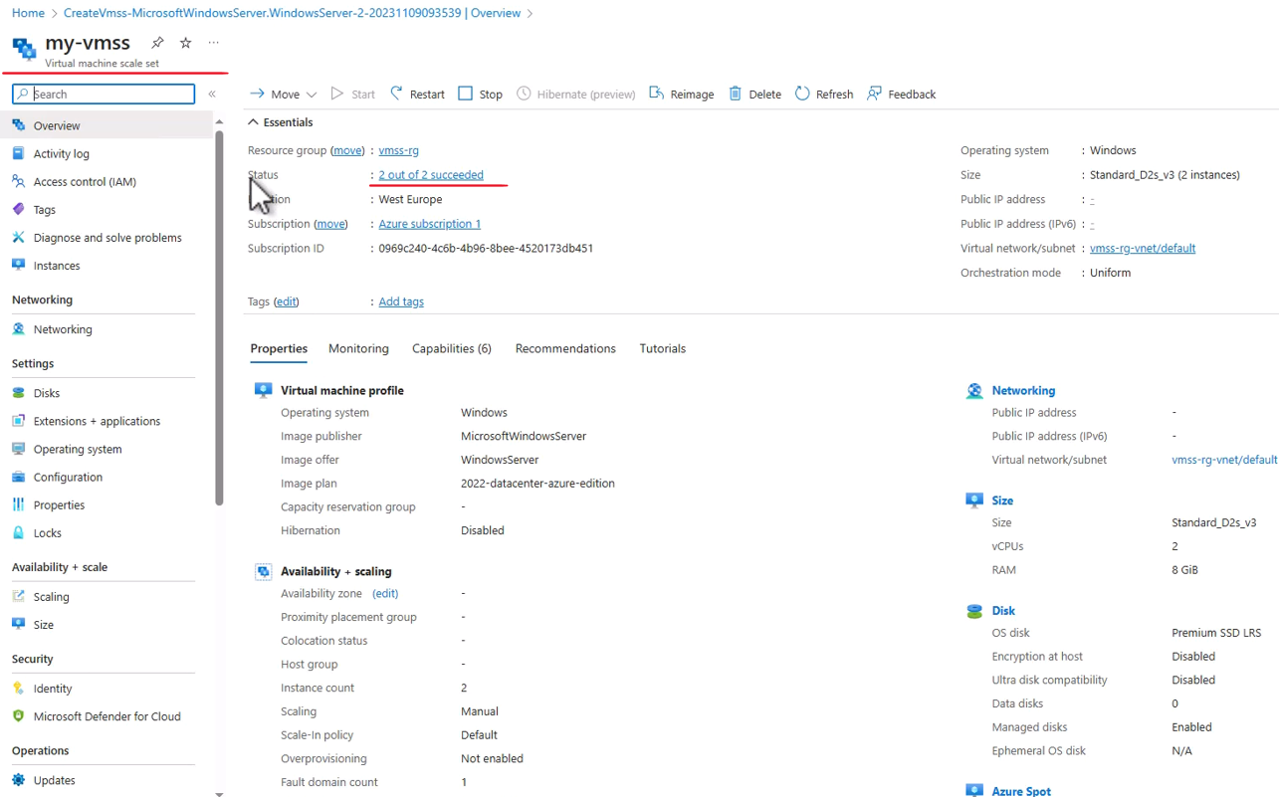

So, let's click it, and we can see that the provisioning of the instances was indeed succeeded.

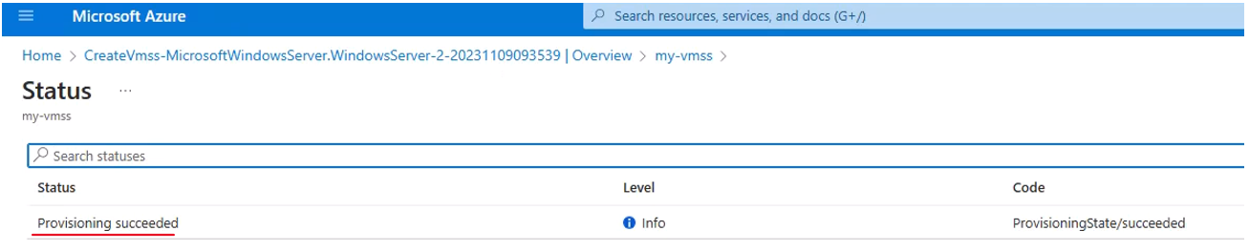

So, let's close that, and now click the instances item in the menu right here. And we can see that we have now two instances, and note the name of the instance.

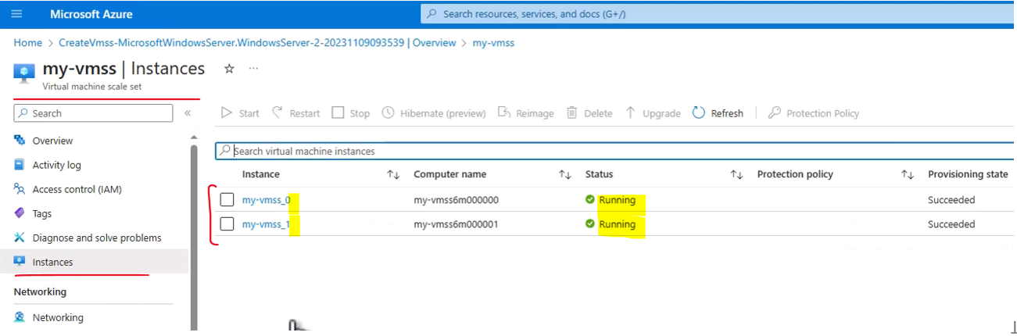

The name is my-vmss, which is the name that we assigned to the scale set, you can see it right here. And after that, underscore and a number. And this number indicates the number of this instance within the scale set. So, we have the first one numbered zero, and the second one numbered one. The status of both instances is running and their provisioning was indeed successful. Great. Now, one of the most important parts in scale set is the way it scales, and we can define conditions to scale out and scale in the scale set. And let's see how to do that. So, in the menu here, click Scaling. And here, we can define how exactly we want this scale set to scale. And note that currently, the scale is set to manual scale, meaning, the number of running instances is a constant one, which is two.

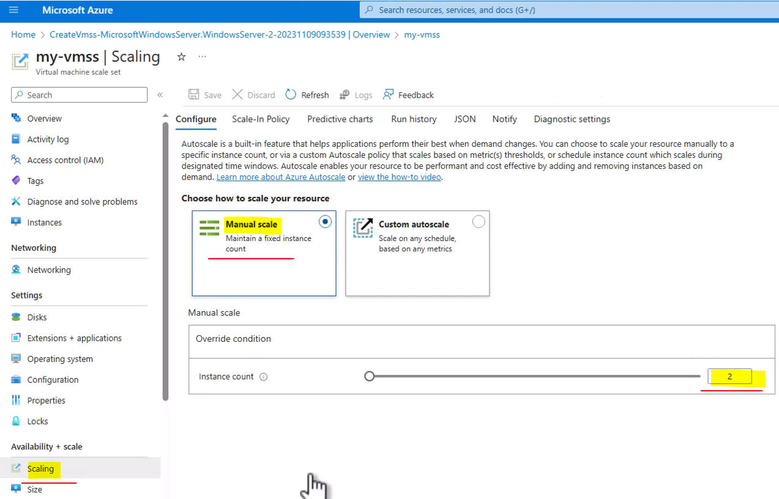

We can change that of course using this slider, here, we're not going to set it to 1,000 of course.

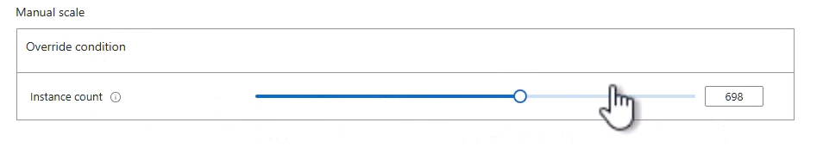

Currently, it is set to two, and this is a default when going with manual scale. But the more interesting part of the scale set is to define autoscale. And this is done using this link. So, click this button, the Custom autoscale, and now we are going to define the condition based on it, the scale set will scale either in or out.

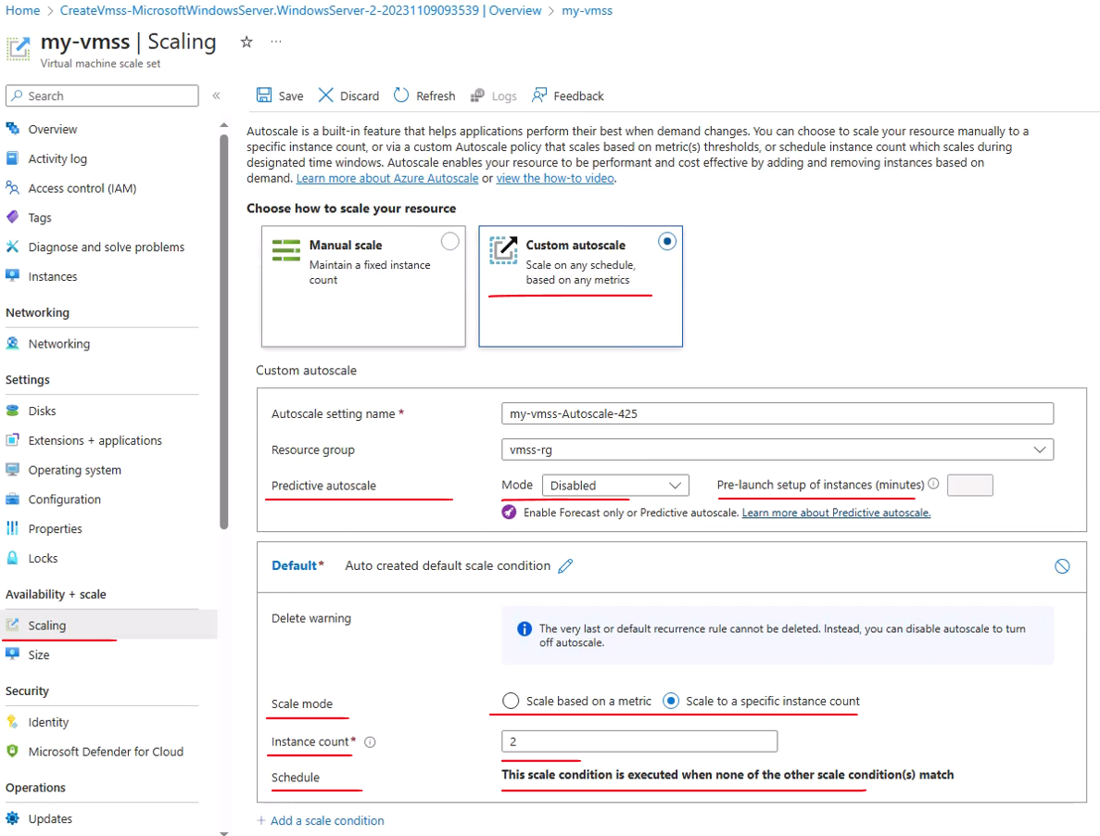

First, in the scale mode, change it to Scale based on a metric. And that means that the autoscale will run based on a metric that the scale set will monitor, and according to this metric, it will perform either scale in or scale out. Now, in order for the scaling to be effective, then let's change the instance limit here, and we want the minimum instances running to be one and the maximum is two.

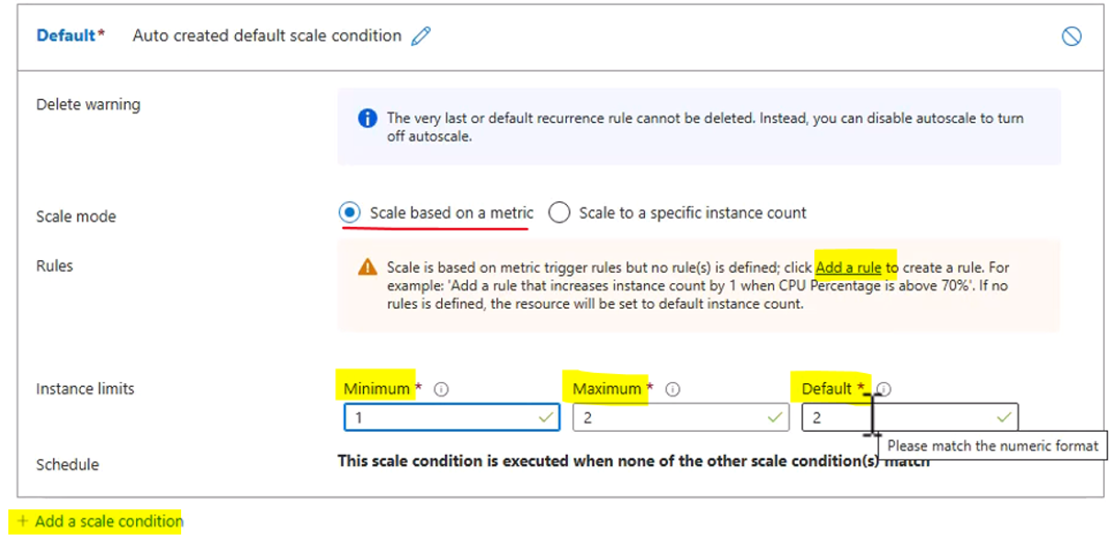

The default of course is two, which is what the scale set was created with. Now, in order for this condition to actually do something, we need to define a rule. And this rule will define what is the metrics that we are going to look at, and how often we are going to look at it, and what to do if the rule was triggered. So, click Add a rule here.

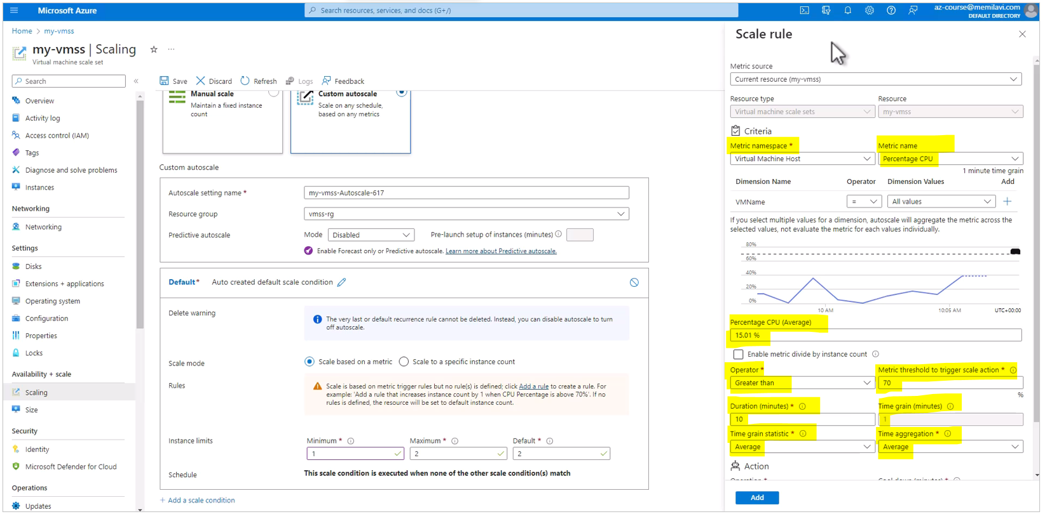

And in this pop-up, we can set the rule that will monitor the metrics that we want to look at and execute the required actions when a specific threshold is hit. So, what do we see here? First, this is of course the resource that we want to look at, which is the my-vmss scale that we just created. And here is the metric names that we want to look at. And the default that Azure offers for us is a percentage CPU or the percent of utilized CPU that the scale set has.

|  |  |
| --- | --- |
| Now, if you will open this list, you can see that there is quite a few metrics that you can choose from. There are metrics regarding the disks and the network, and the OS disc, and the CPU of course, which we're looking at right now. And some more metrics that we can use. We will stick to the percentage CPU, which frankly is the most used metric that is usually used in VMSS.  Okay, now we can see the actual CPU that is currently used in this VMS, we can see that currently, the percentage is around 38%, quite below the metrics that we are going to set. So, let's see what we want to do with this metric, and take a look here. So here, we see the following, if the percentage CPU is greater than, and know that we can select greater than or equal to less than equal to, et cetera. |  |

So if it is greater than 70%, and let's change it to 80. And you can see that the line here just went up, and it does so for 10 consecutive minutes, let's change that to 5, for example. And the chart changes accordingly. And let's scroll down, and we see that the time grain statistic is average, meaning, if the average of the CPU in the 5 consecutive minutes is more or greater than 80%, and we can set that not only to average, but also to minimum maximum count, and some which is less relevant here, then this is what we want to do. We want to increase the count, the count of the running virtual machines in the scale set by one. Or in other words, add an additional virtual machine to this scale set.

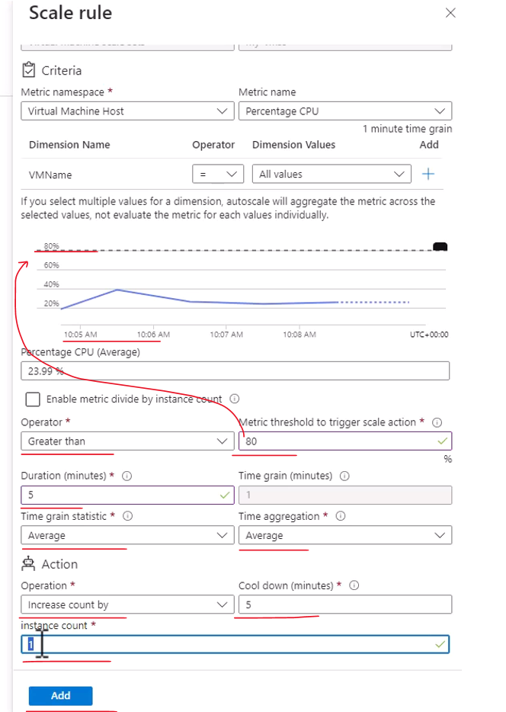

Now, note that we can select various operations here. So, the default is increased count by 1. We can also select increase percent by, meaning, let's say we have four running instances under this scale set. So if you will set the increased percent to, for example, 50, then that means the scale set will add 50% of the virtual machines that are currently running. So if we have four virtual machines running, and we set 50%, then after this rule, will run, we will have six running virtual machines under the scale set. So, this is increased percent by. Next, we have the increased count to, and that sets the final number of virtual machines that will be running under this scale set.

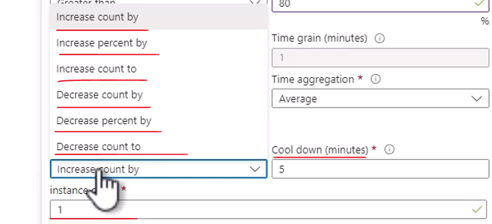

So, for example, if you will set this number to let's say five, then no matter how many virtual machines were running before the rule triggered, after it was triggered, the number would be 5. You will usually use the increased count by, and note that in addition to the increased action, we have also decrease action, which are exactly the same, only of course, on the other direction. You can remove machines and not only increase them, and you will usually remove machines when the metric goes below some threshold that you set, and you will do that in the next rule that we will set. Okay, so let's stick to increase count by, and let's set this to one. So basically, what we say here, if the average of the CPU utilization in the last five consecutive minutes is greater than 80%, then add an additional virtual machine. So, click Add, and we see that the rule was added here, and you can understand it, it is written in plain English, so.

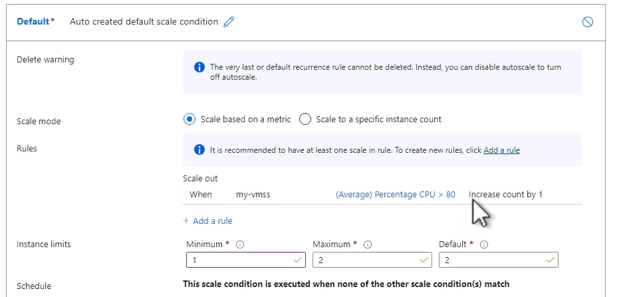

When my VMSS on average has presented CPU, which is greater than 80%, then increase count by 1. And this is how we set scale out rule. However, we want to have also scale in rule so that the virtual machine scale set will decrease the number of virtual machines when needed. So, let's add another rule. We are going of course to work with the same metric, and this time, we will change the operator to less than.

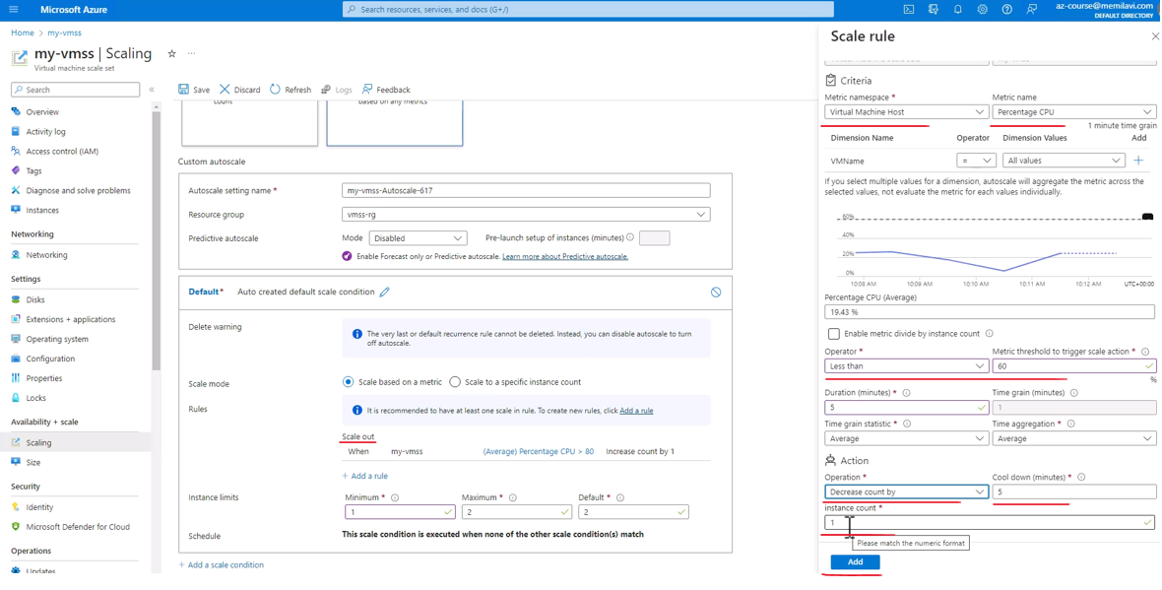

And when it is less than let's say 60%, and you can see that currently, the percent is around 5, which means that we are going to be much lower than this number. And again, let's say that we are going to measure that for let's say one minute. Oh, and we have this warning, so let's change it to five minutes, let's say. Then in this case, we want to decrease the count by one. So if currently we have two machines, then after running this rule, we expect to see one machine that is running. Now, note the cool down here. And basically, what this cool down in minutes says is that after triggering the rule and changing the number of virtual machines that are running, wait five minutes before running this rule again and monitoring the metric, because we don't want that the number of the virtual machine will fluctuate all the time. So, after changing it, wait for five minutes. So, click Add. Great, so now we have two rules, and you can see that the first one performs scale out, and the second one performs scale in.

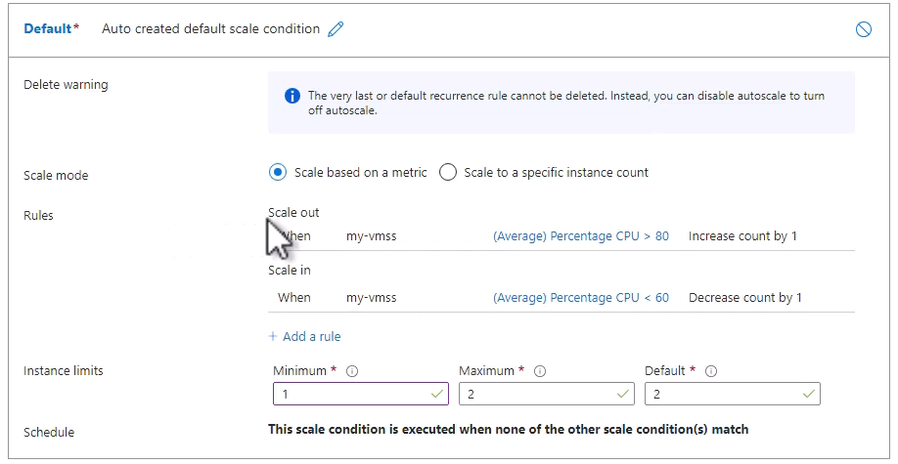

Now, before saving it, let's go to the Scale-In Policy right here. And here, we can set how exactly the scale set is going to decide which machine to delete, when it needs to do scale in. So, let's open this list and see what are the policies that we have here.

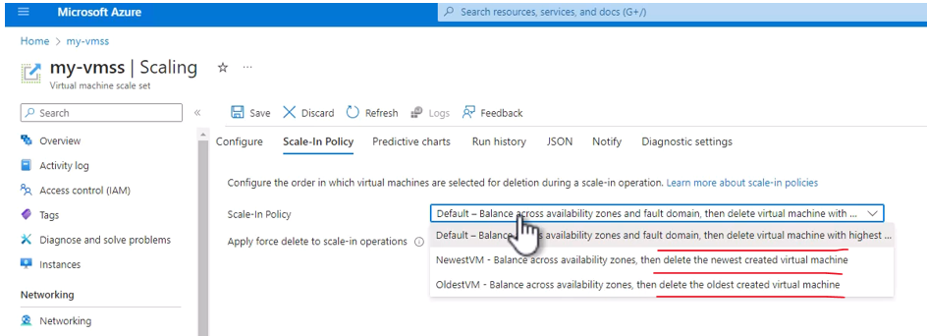

The default policy basically says that when the scale set remove a machine, it makes sure that there are another available machines in different zones or fault domains, and then it deletes the machine with the highest instance ID. Now usually, highest instance ID indicates that this machine is the newest one, but this is not always the case. This is, again, the default policy. Next, we have the newest VM, meaning, the scale set will remove the machines that was created last. And we have the oldest VM policy, meaning, the scale set will remove the oldest spiritual machine when it needs to scale in. We will stick to the default, let's go back to Configure here. And again, this is a scaling rule that we just defined, and let's save it.

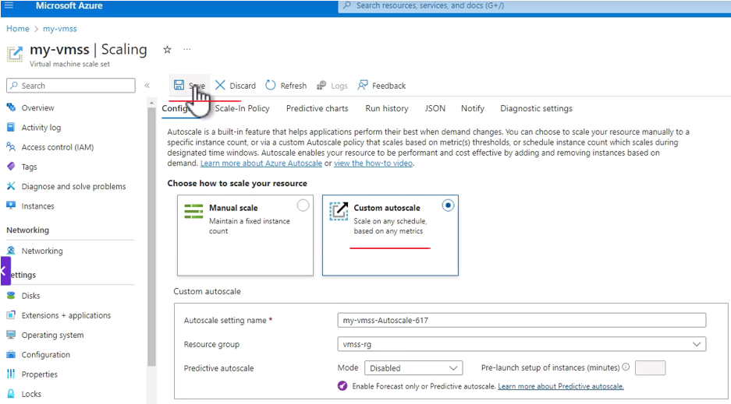

Now, you might see this arrow. And note what we see here. Let's open the notification and note the texture. The subscription is not registered to use namespace Microsoft Insights.

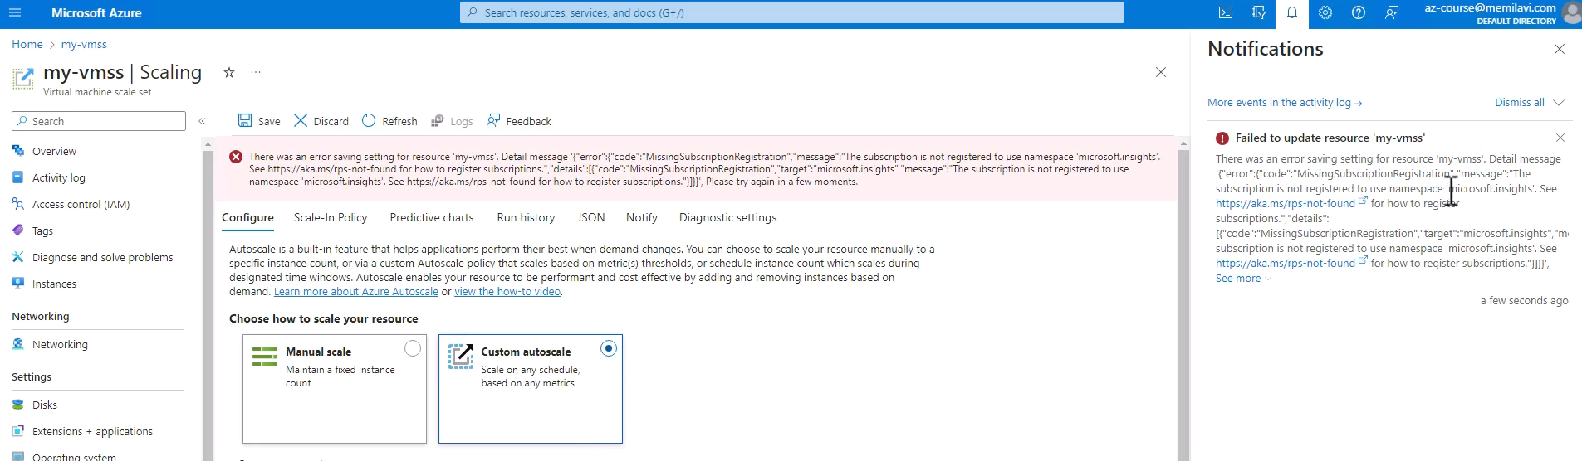

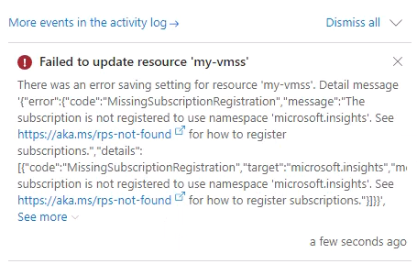

That means that a specific provider or resource provider and resource provider in Azure is something that provides services to Azure, is not registered in our subscription. And we need to register it. Now luckily, this is quite an easy action to do. So, duplicate our page because I don't want to lose this configuration. And here, go to Subscriptions.

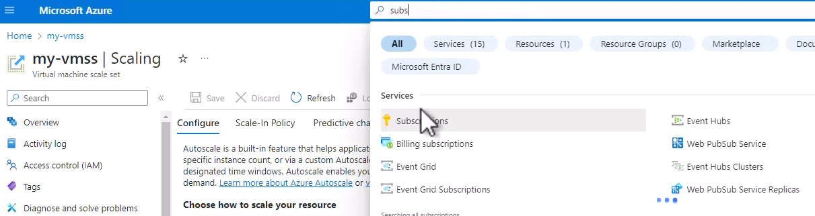

So, click Subscriptions, and click on our subscriptions, it should be the only subscription that you see here. And let's scroll down here in the menu and click Resource Providers.

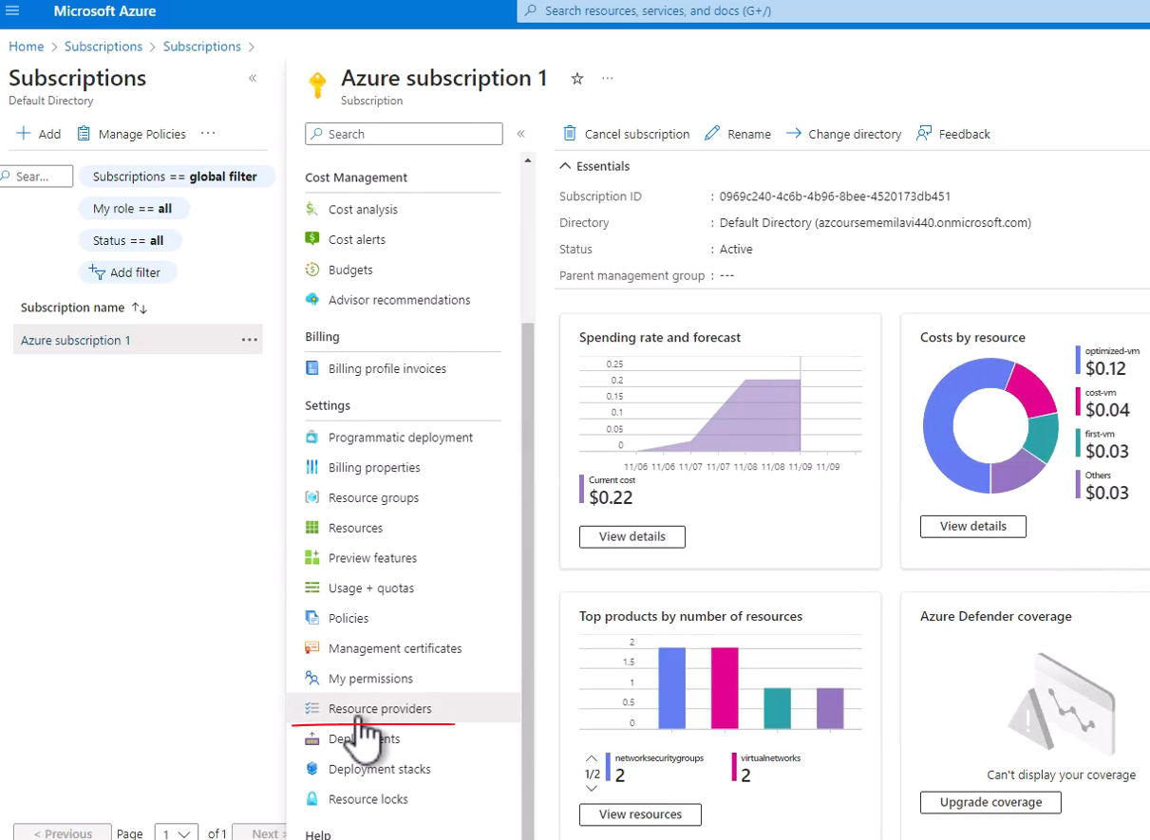

So, now we see a long list of resource providers, which as we said before, basically provide services to Azure. Now, we want to look for the Microsoft Insight resource provider, so type here insight.

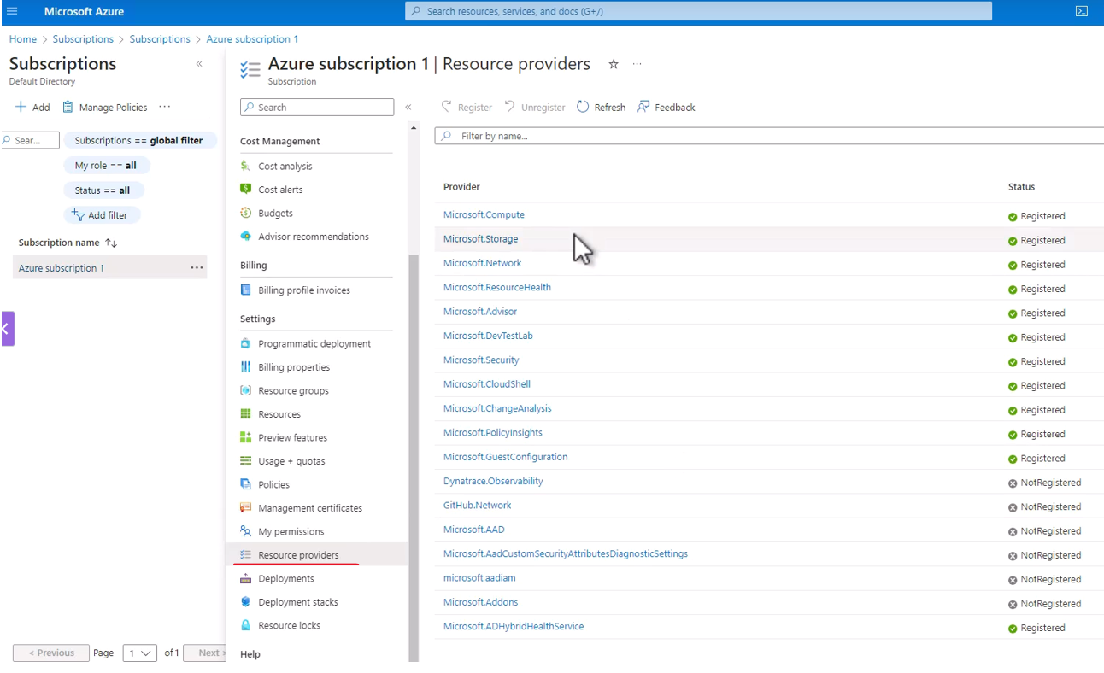

And this is the resource providers that we want to register, and note that its status is NotRegistered.

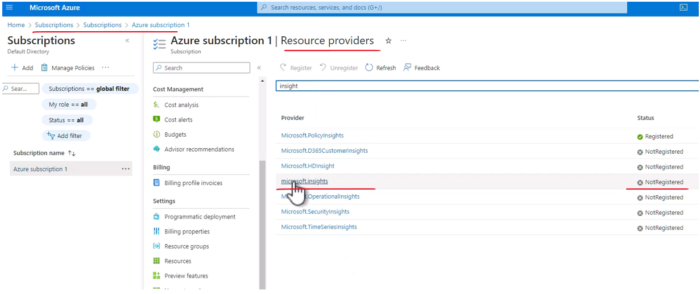

So, click the line note not to click the resource provider itself, because then a details pop up will pop up, and this is not what we want, so click the line, and click Register. And now, the status of this resource provider was changed to registering.

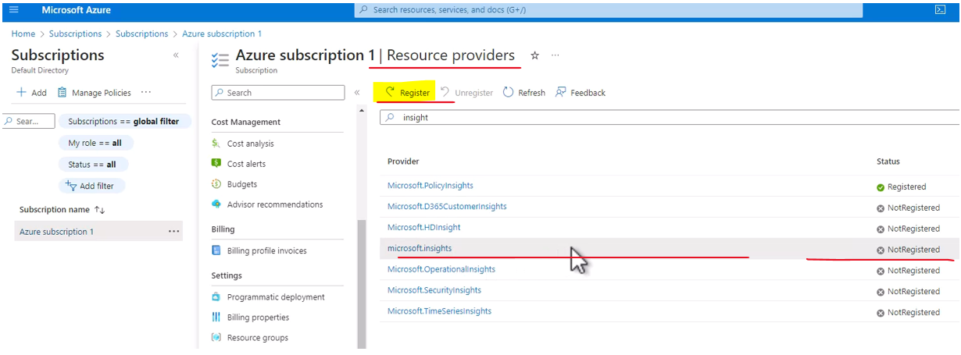

Click on the line and not the text – else details of microsoft.insights will pop up



Now note, there is a nasty bag in the Azure portal, which says that the status of the registration of resource provider will not change in time, and you might be waiting here a few minutes, although the provider was already registered. So, the best way to find out what is the status of the resource provider is simply to go to Cloud Shell and ask Azure to tell that for us. So, let's do that, open the Cloud Shell. Great, and run the following command, you can find it also in the file in the resources of this lecture. So, type the following. az provider show, (keyboard keys clicking) we want to show the status of a specific provider and namespace. And here comes the name of the provider we just registered. Microsoft.insights, like this. And we want the output to be -o table. Like that, so hit Enter. And we see, that the status is indeed registered. And actually, we can see that the status was changed also in the portal.

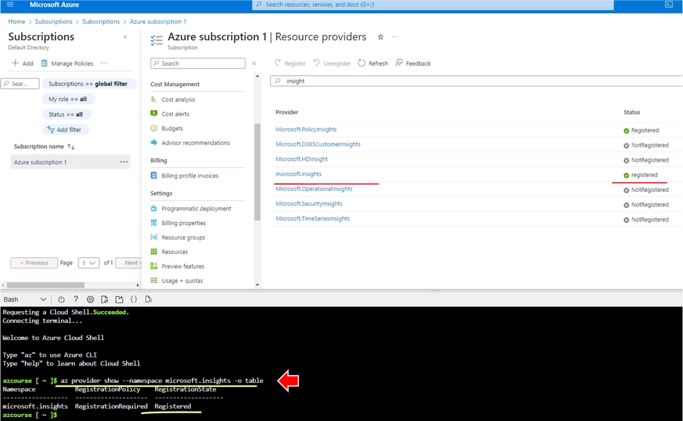

So if you see that the status was not changed to registered afteDr a few minutes, then feel free to run this command in the Cloud Shell and see what exactly is going on. Great, so the resource provider was registered, and now let's go back to our scale set, and simply click Save again. And let's see what will happen now.

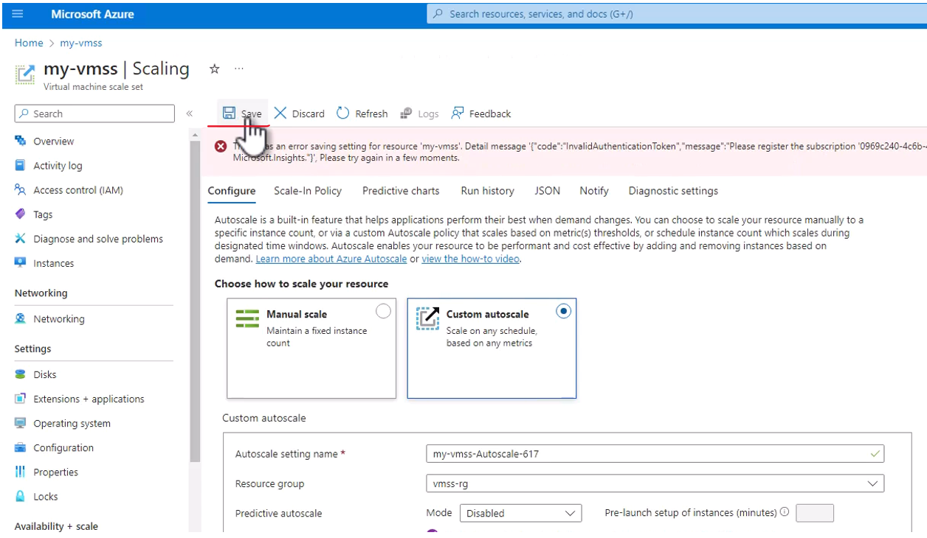

So, we still see an error with the resource provider, so let's wait about a minute, so that the change that we just made with the resource provider will reflect on our subscription. So, wait about a minute and then we will continue.

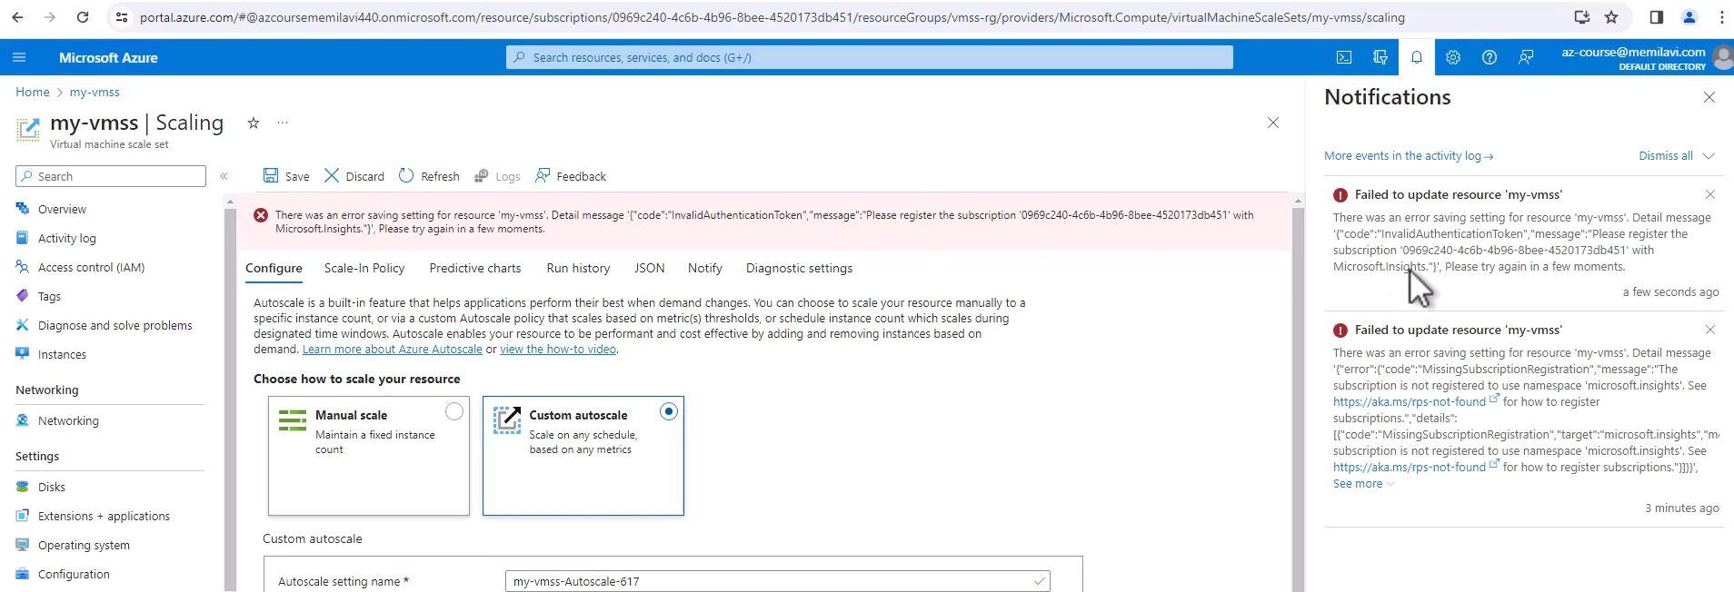

|  |  |
| --- | --- |
| So, let's try that again, so click Save, and let's see what happens.  And the configuration was saved.  And now, we have scaling rules for this virtual machine scale set ( see screenshot below ). |  |

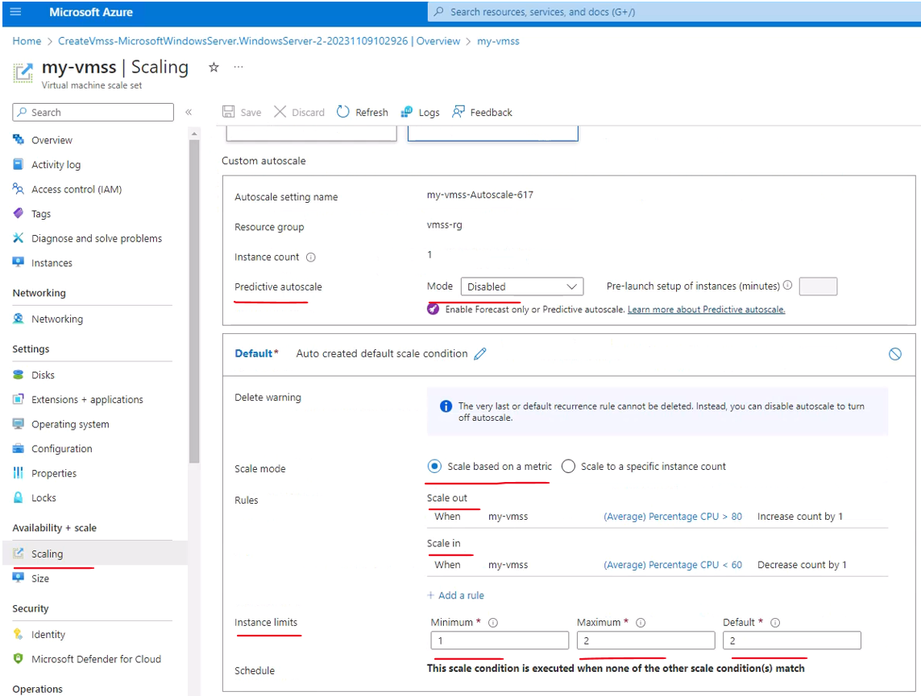

Now, note that usually, if we want to use this scale set, for example, web app, we will put in front of it, a load balancer. And this load balancer will balance the load between the various instances of this scale set. And we are going to discuss load balancer in length in the networking section. So, this is the scale set and this is how to work with it, and now let's just delete it because we don't really need it for the rest of this course.

So, go to the Overview, and let's delete the whole resource group.

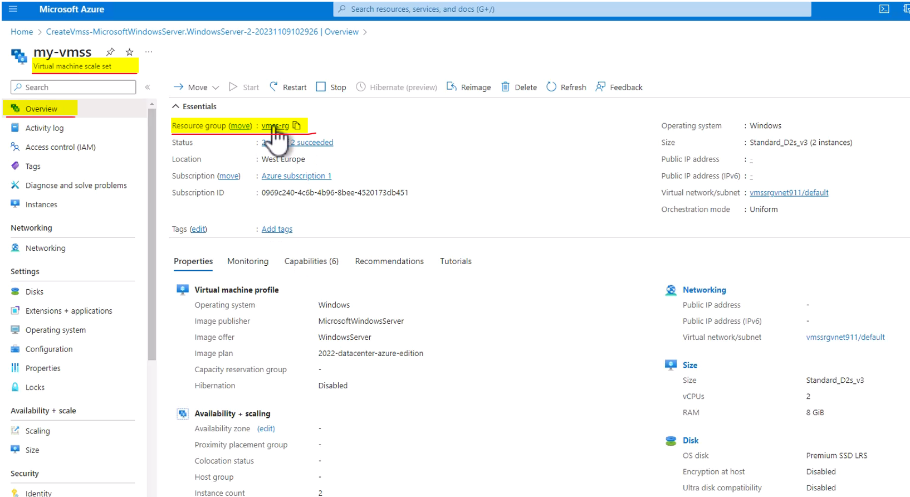

So, click the resource group name and Delete resource group. And copy the name of resource group. Let's check this box and paste it here. And Delete and Delete again.

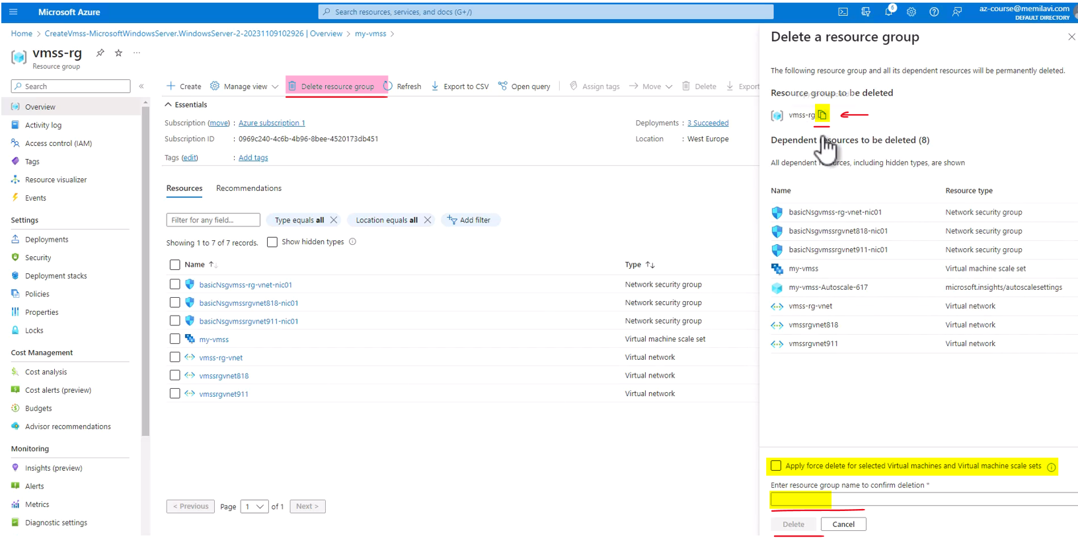

And now, the resource group is being deleted.

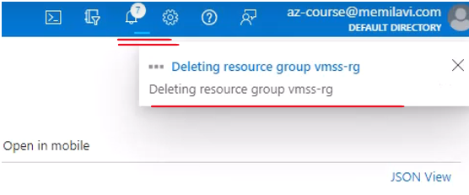

### Azure Instance Metadata Service

Now this feature of Azure is actually a little known feature of Azure VMs which is not really known and used by many Azure developers and architect. What it is is a rest API that is accessible from the virtual machine and it's providing a lot of information about the machine. For example, this info can include the SKU or the instance size of the virtual machine, the storage, the networking and some schedules events and of course, a lot more details that can be accessed using this API. Now this API is accessible only from the VM. You can't just go to the address of the API that we'll see in a minute from outside the virtual machine. So basically, it's a way for the virtual machine to query Azure about the various capabilities and properties of the virtual machine itself.

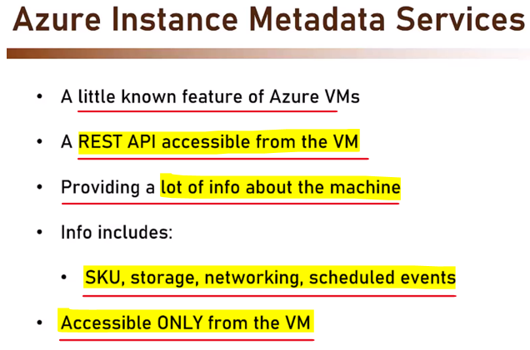

Now one of the nice things with the Azure instance metadata services is that with scaleset, the virtual machine gets notification about upcoming eviction. So if the scaleset decides to remove this specific instance, then it sends a notification to the virtual machine. And if you are listening to the metadata service, you can know that an eviction is in place and that in a few seconds, this virtual machine is going to be deleted. And if there are some final actions you want to run as part of this eviction, then you can be notified about that and perform these actions.

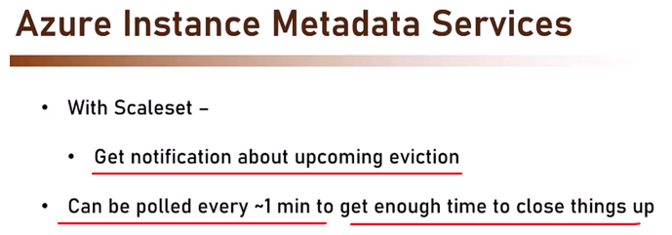

So this metadata service can be polled every one minute to get enough time to close things up in the case of scaleset eviction. So let's see how this metadata service looks like and how to query it. So for that, let's go back to the portal and create a new virtual machine. So in the search bar here, type virtual and click virtual machines and create Azure virtual machine. And let's define the new virtual machine. And for this demonstration, we are going to create a new resource group. So click here, create new and let's name this resource group mds-demo-rg like that. And the VM name is going to be mds-demo-vm and select in the image Windows server. Let's go with this one. It doesn't really matter. And scroll down and set the username and password. And you are already familiar with this process so I will go with meme admin and my password and again and that would be all. So review plus create.

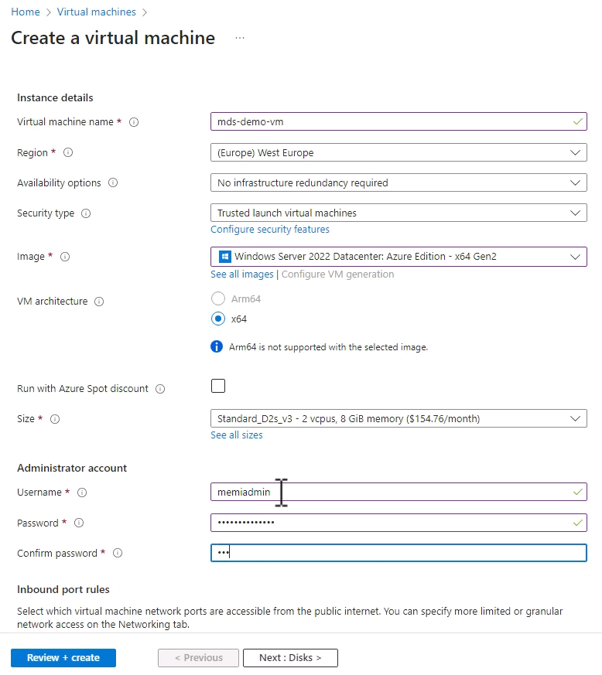

And if you get this error message, then click Networking and make sure a new vnet is populated here which is fine.

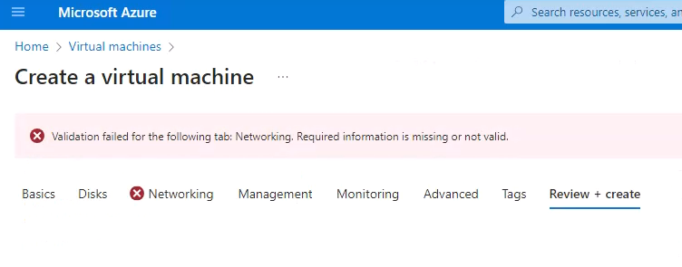

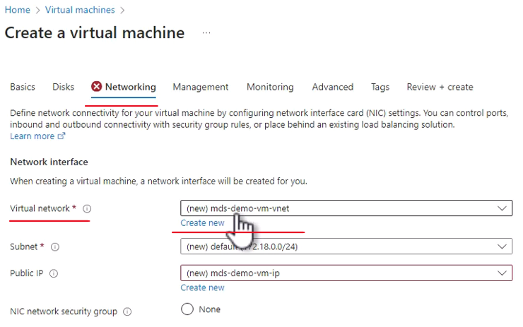

And again, review Plus Create and Create.

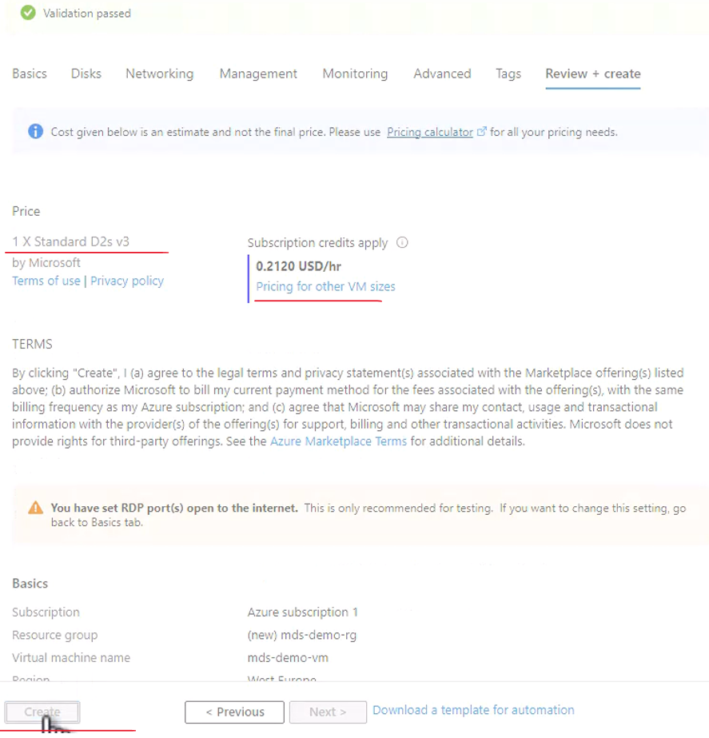

So Azure is now creating our new virtual machine. You are already familiar with this process. So let's wait a few minutes for the deployment to complete. And then, we will access this virtual machine and use the Azure instance metadata services on it. So our virtual machine is ready so let's go to it.

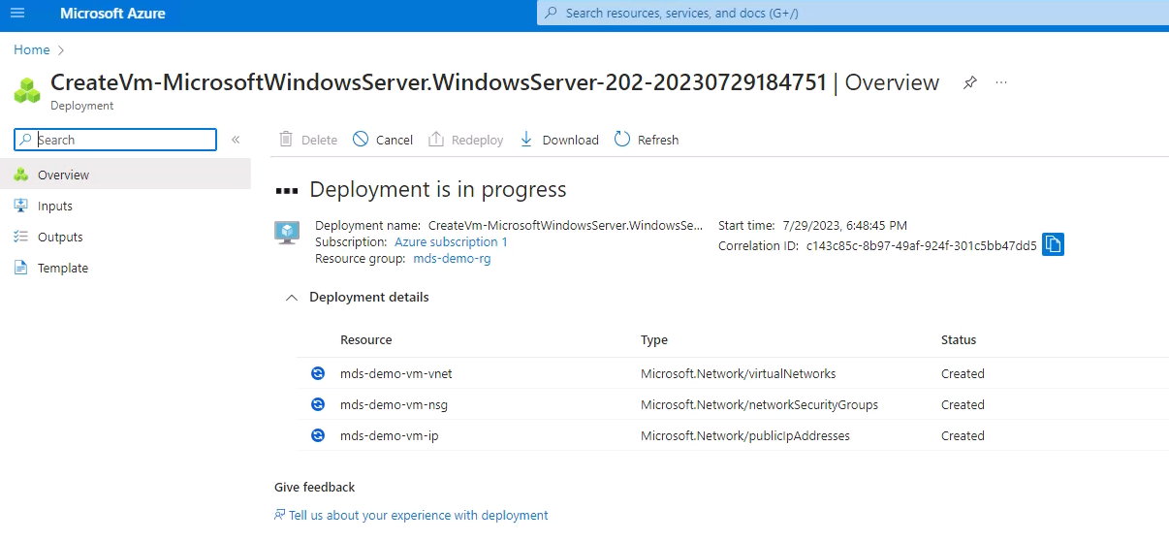

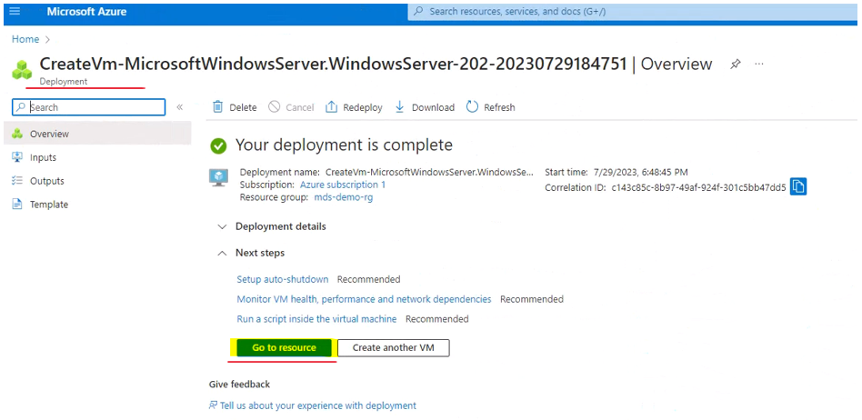

And here is our virtual machine. We can see that it is indeed running. Great. So now let's connect to it.

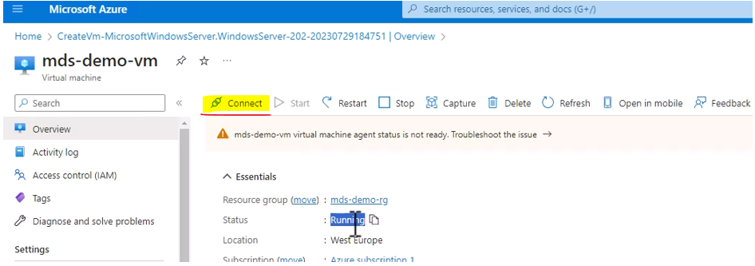

So click Connect

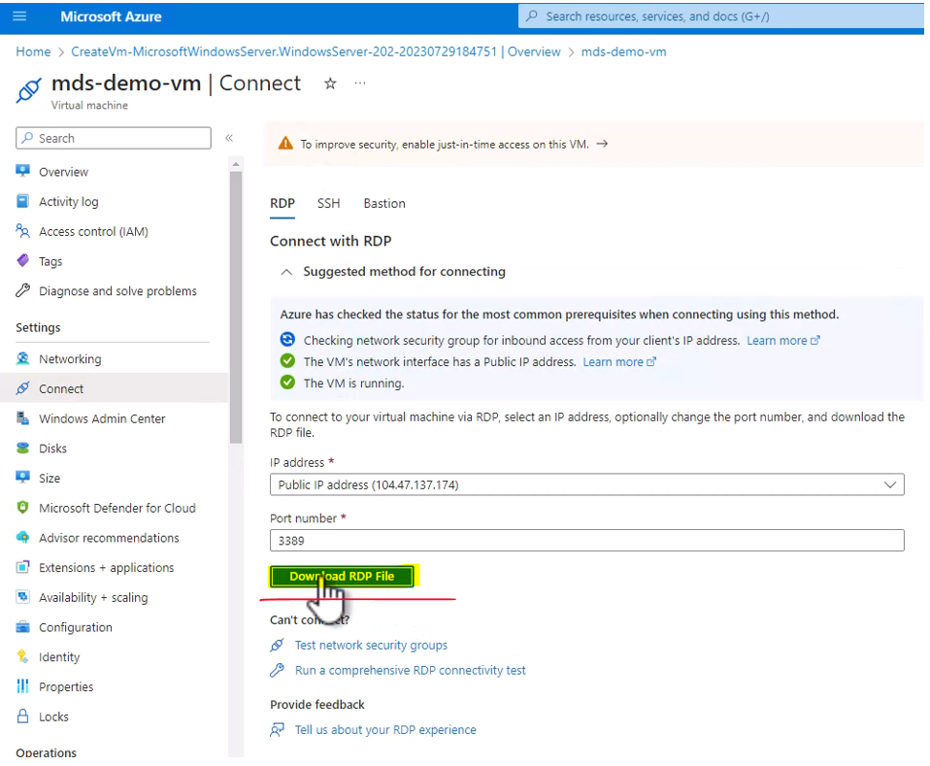

Download the RDP file and click it and connect.

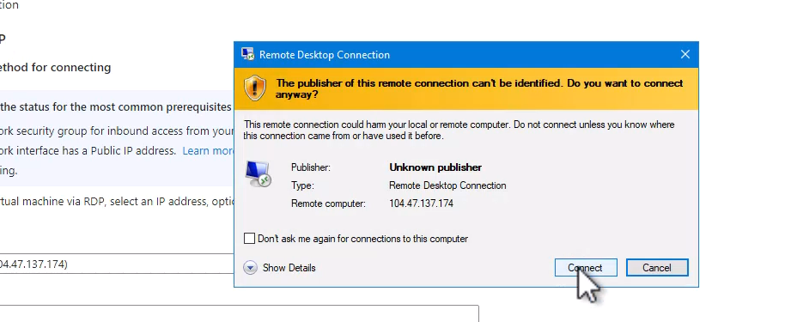

Type here your username and password. So in my case, that would be the username and the password.

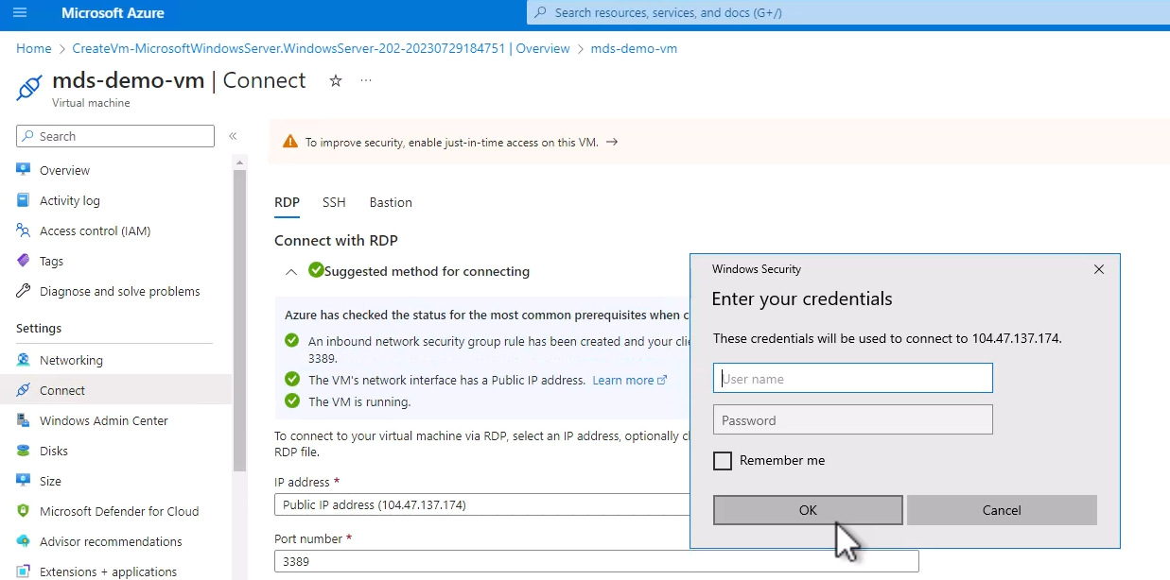

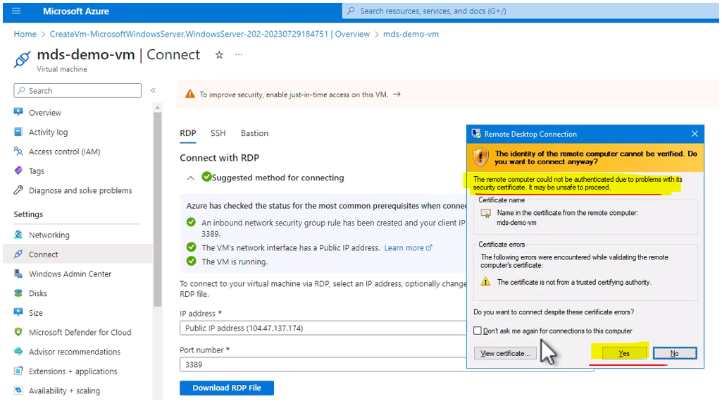

And yes, and we are now connecting to the virtual machine.

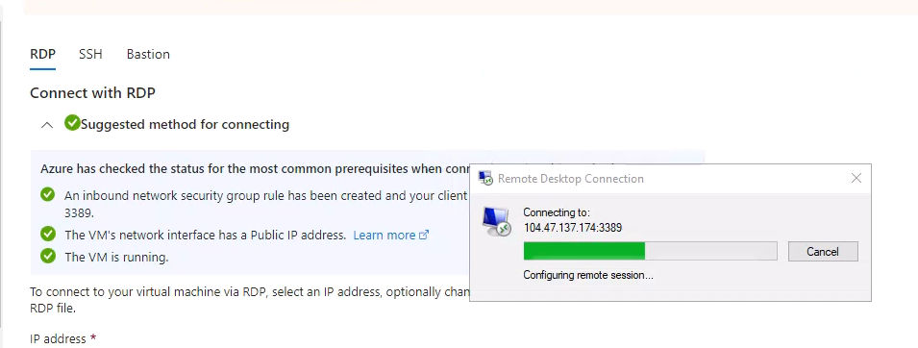

Let's wait for the first start to complete. It might take a few seconds. And our virtual machine is up and running and we are now connected to it.

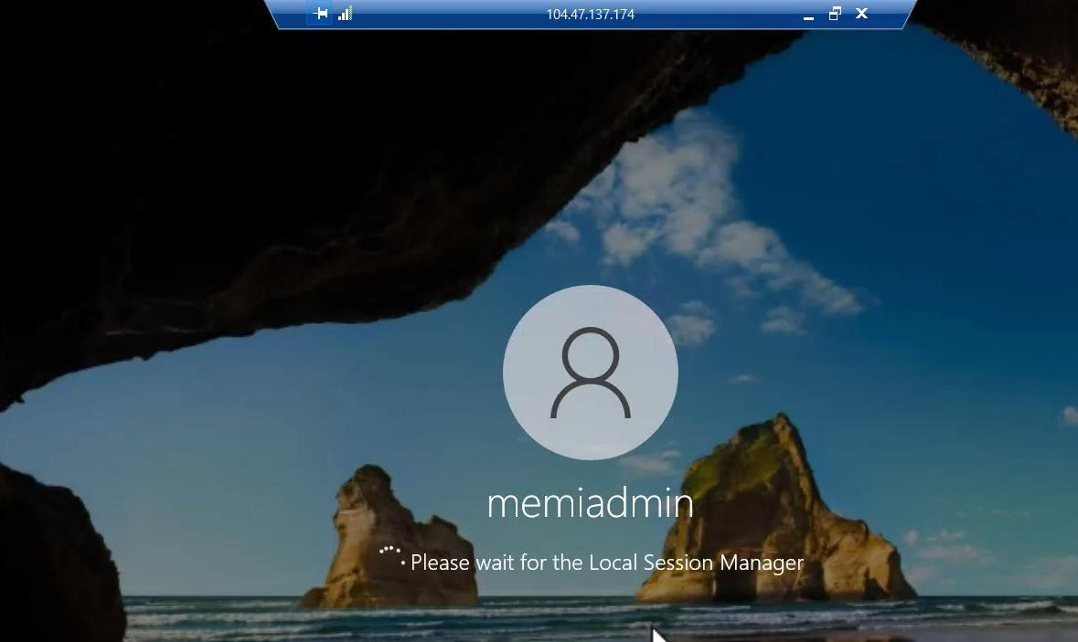 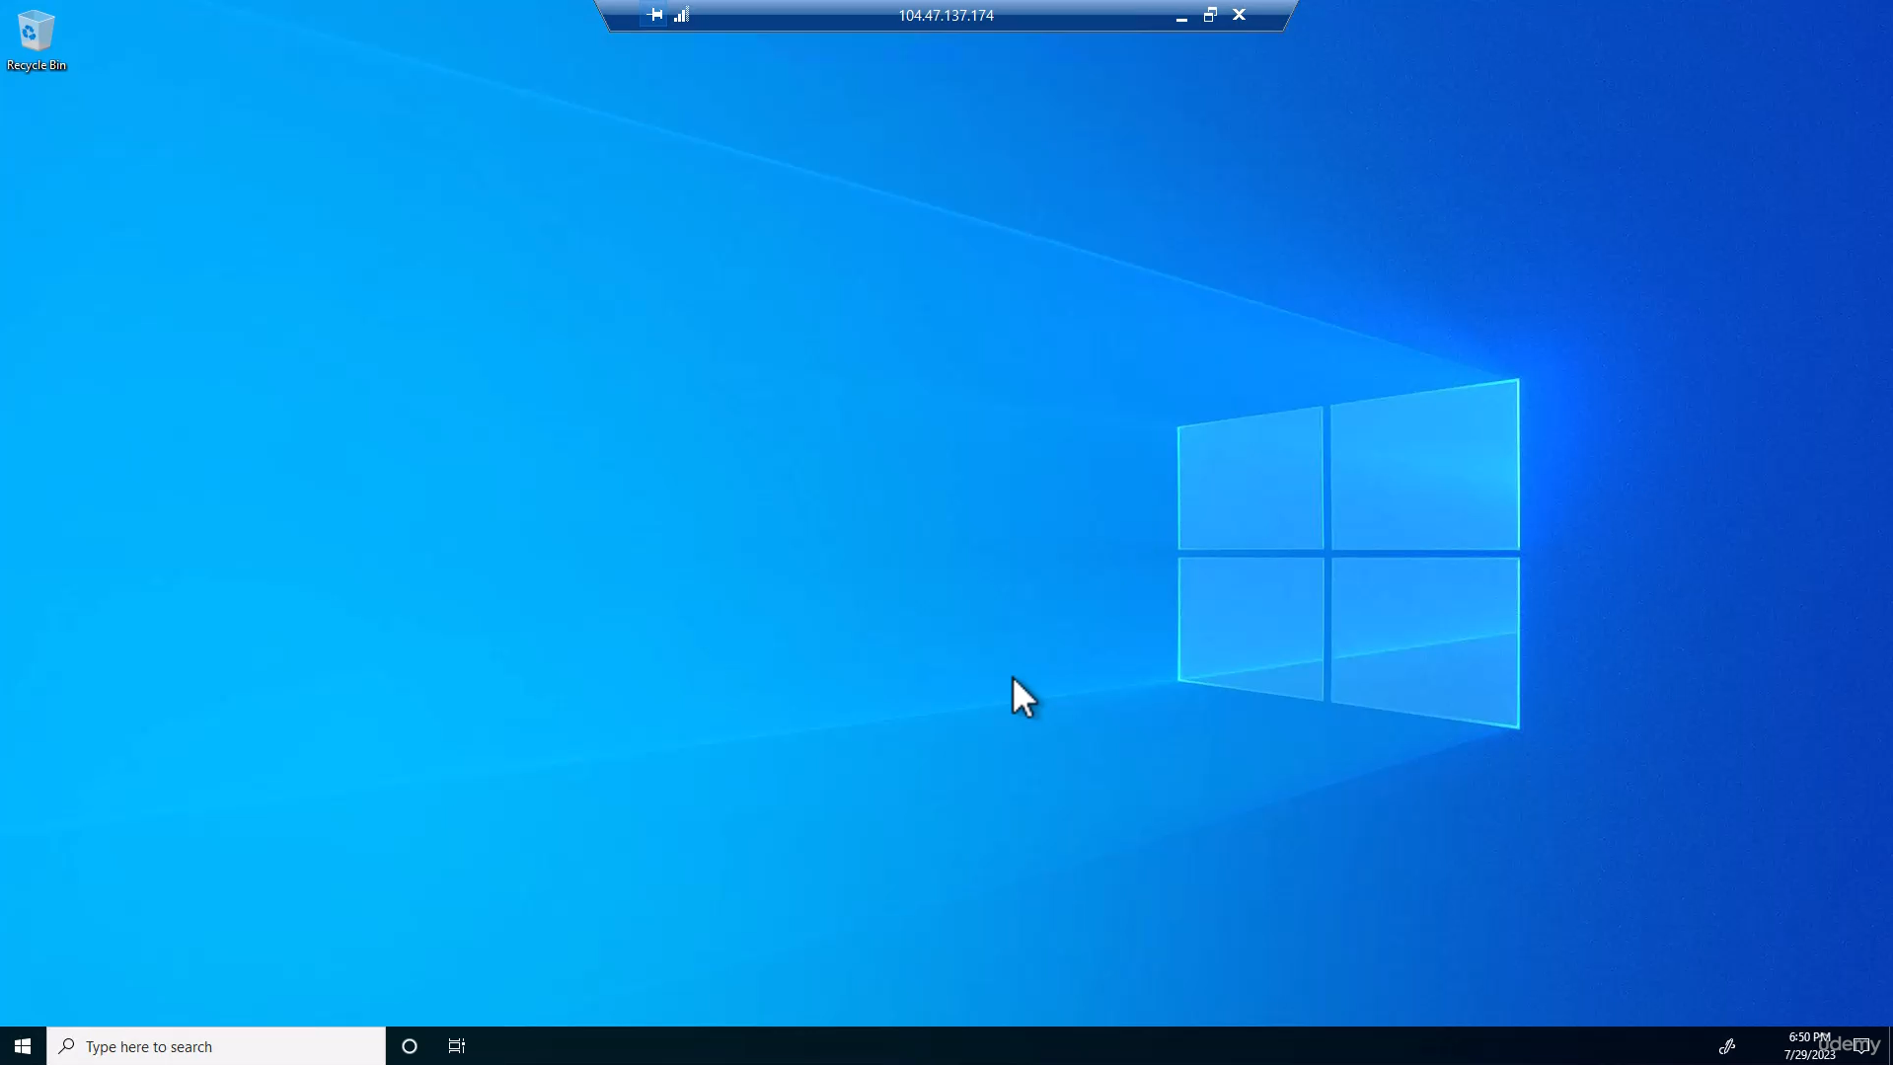

So what we want to do now is to download Postman which is a great tool for testing rest APIs. And the way to access the metadata services is using rest API. So here and we can close this. So here in the menu of Windows, go to Microsoft Edge. And here in the search bar, oh let's just skip these pages. Great and here in the search bar, type download Postman like this and click the link leading to the Postman website. So click it and click the operating system that you are currently using. In my case, that would be Windows 64 bit. So click it. And now the installation file is being downloaded and looks like download is almost complete. So let's wait for it to complete and click Open File. Great and Postman is installing. So it's running.

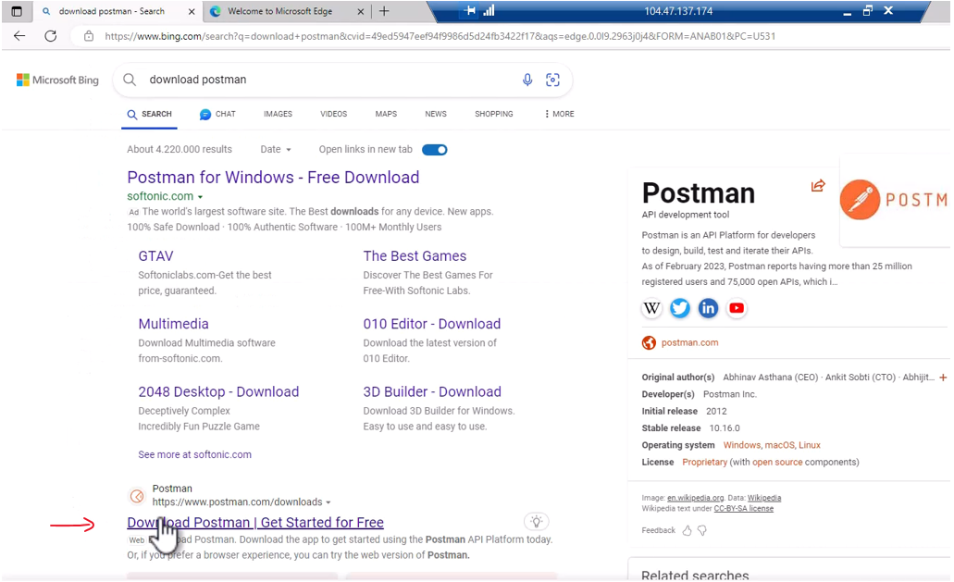

And in this page, simply click Skip and go to the app.

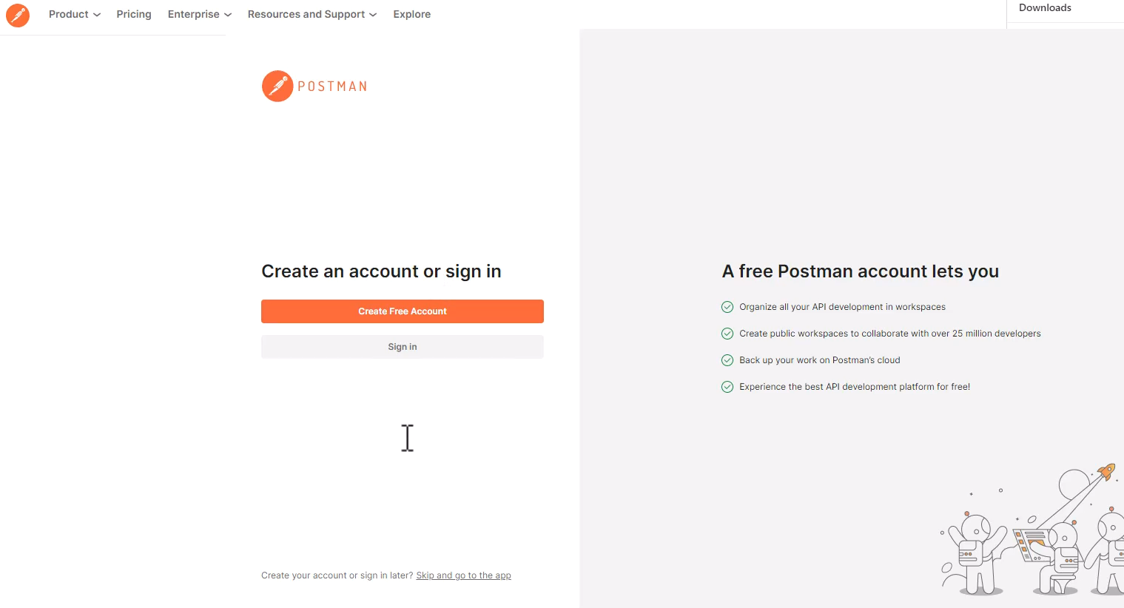



Great and here is Postman. And here, we can type the URLs that we want to test using this tool, using Postman.

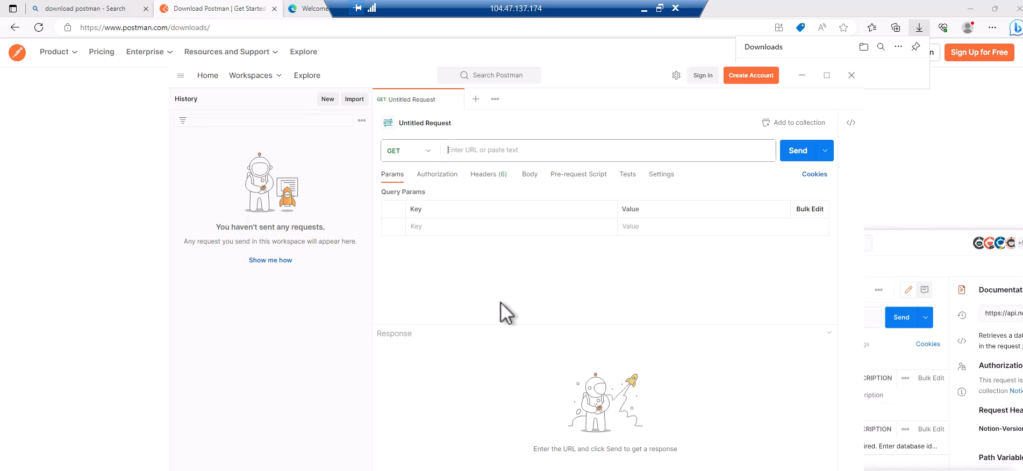



Now the third thing we want to do is to set a header. And we need to use this header in order to indicate to Azure that we are using this URL as a metadata source for our instance. So for that, go to the header's tab right here and click here and type the following name for the header. It's going to be named Metadata like that and the value is going to be true. So here we are indicating to Azure that we do want to retrieve metadata using this service.

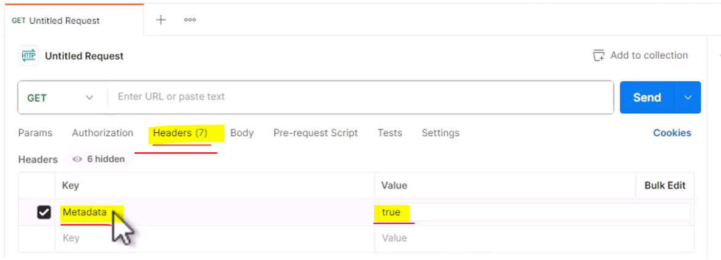

So this is the header and now go to the following URL and you can copy it from the file in the resources of this lecture. So go here and note that this URL points to a very specific IP address. This one. And this is the constant IP address that you are going to use when accessing Azure instance metadata services. So even in your instances, this is the IP that you are going to use. So basically what this URL asks for is the metadata of the instance that we are running in right now and not the API version.

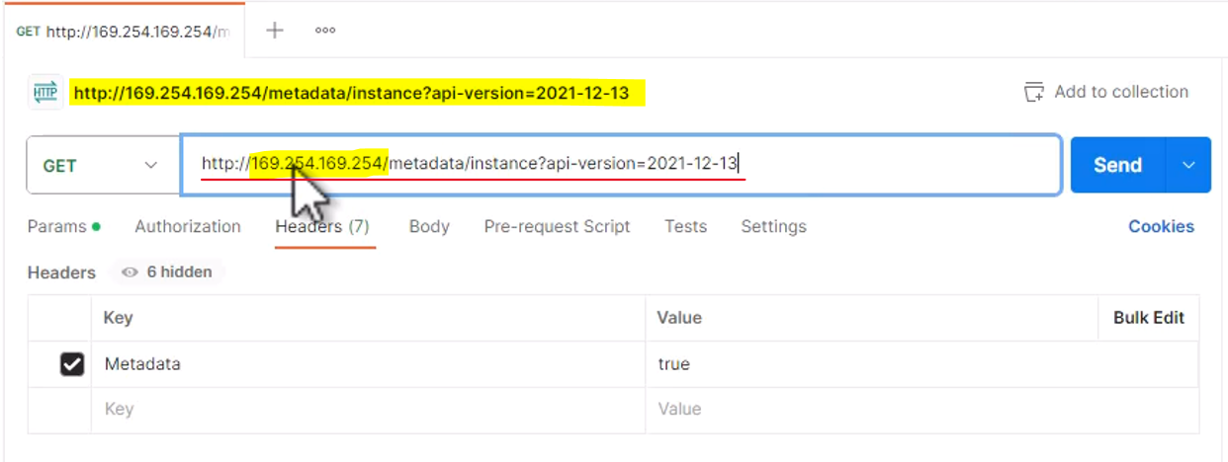

This is the API version that you should use in order to get the most up-to-date data about this instance. So again, this is the URL. Again make sure that you set up the metadata header with the value of true and click Send. And here is the response.

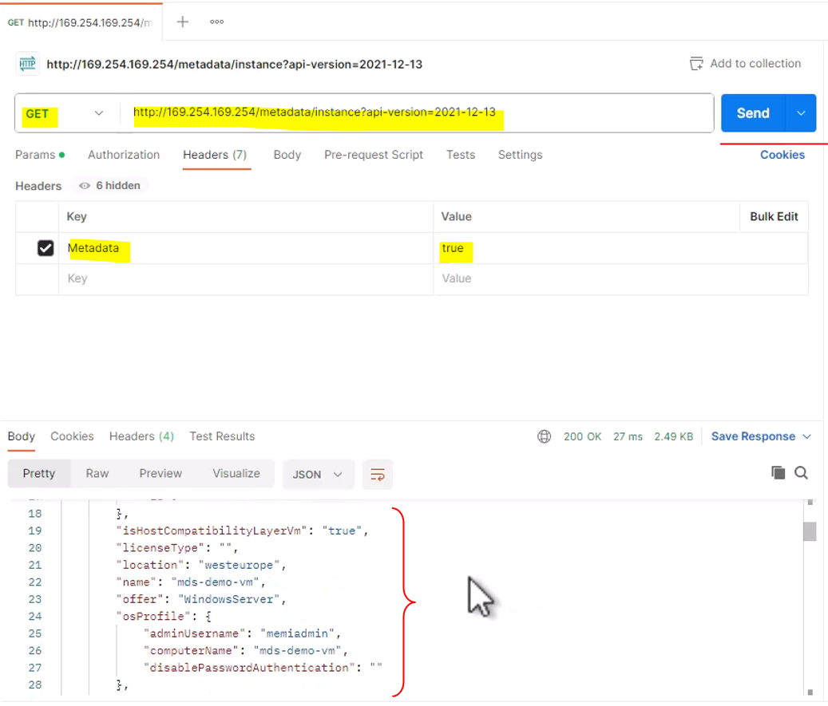

And you can see that we've got quite a lot of data about the instance that we are running in right now. And you can go through the data and learn quite a lot about the virtual machine that you are currently using. Let's take a quick look at it. So let's scroll to the top. And you can see that currently we are running inside Azure Public Cloud and not for example the Azure DOD or Department of Defense Cloud. And we can scroll down even more and see some more interesting data.

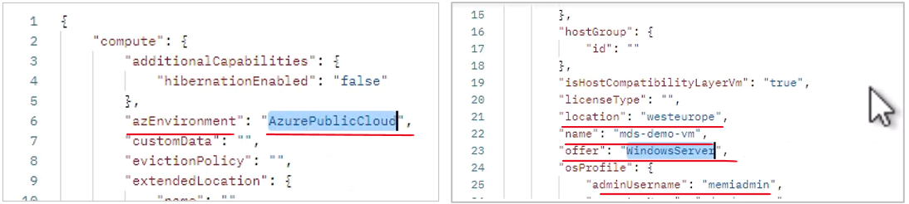

For example, we are running inside the West Europe region. This is the name of the virtual machine and this is operating system that we are using. You can even see your username and if you will scroll down even more, then you can also see the private IP address of this machine.

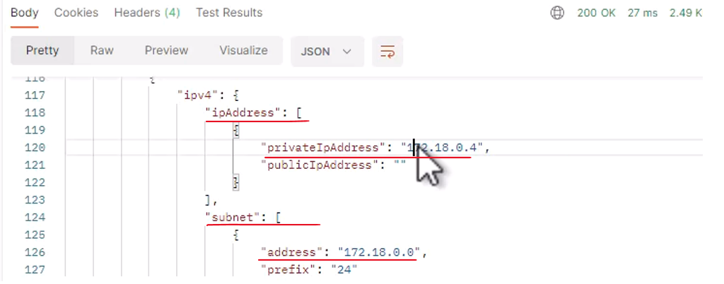

So all in all, quite a lot of data that you can use using this metadata service. But this is just one endpoint for this metadata service and now let's take a look at another one. And this is this one. And note that currently we are asking for the scheduled events of this instance.

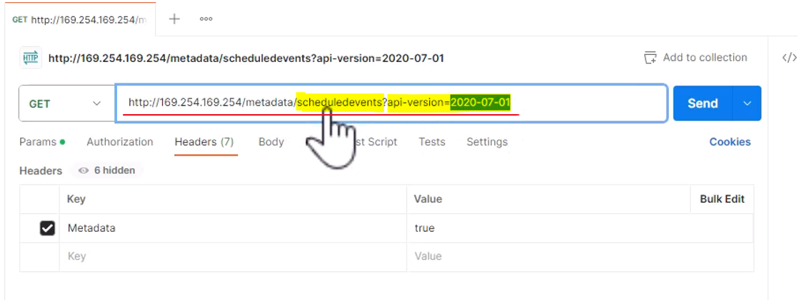

And note also that the API version here is different. And this is the API version that you need to use in order to access the scheduled events. And basically, scheduled events is a great way to find out whether Azure is planning something for our virtual machine. May need to shut it down, whether as part of a scaleset scale in or even as part of some maintenance actions that Azure is planning to do in our virtual machine. So click Send again and note that calling for scheduled events from the metadata service can take some time. So let's wait and see what exactly we are going to get. And here is the response.

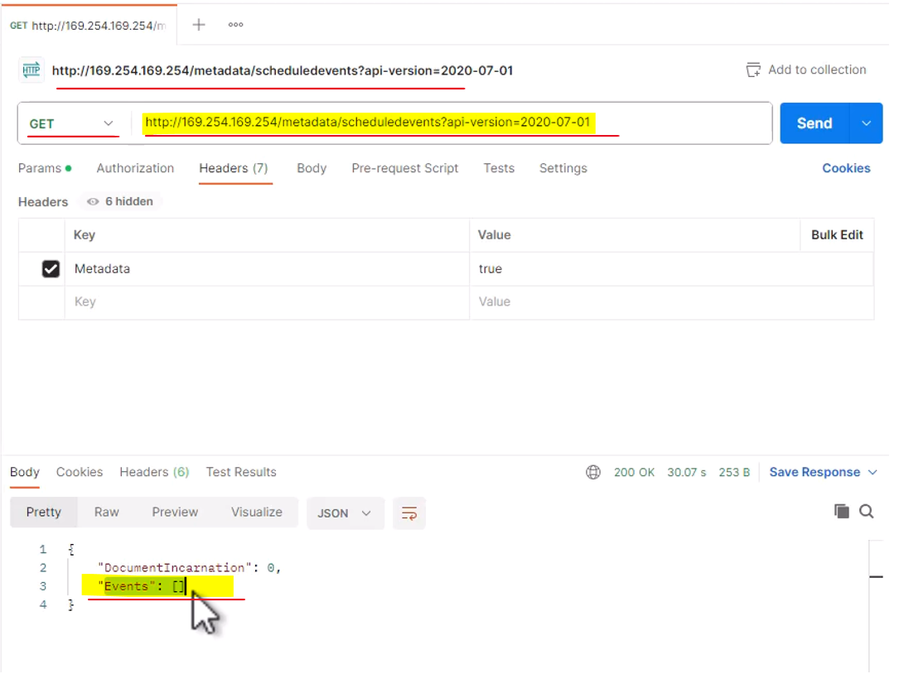

So currently, we see that the list of events is empty. So there are no planned events for this virtual machine. Now if you know that your virtual machine might be reduced or deleted or removed by Azure sometime in the future and again, this might be the case. If you run as part of a scaleset and you want to be notified when this is going to happen, then querying this scheduled events endpoint is a great way to find it out. So, this is an example of using the Azure instance metadata service and you should definitely be familiar with it and know how to use it. So now of course we don't need this virtual machine anymore so let's remove the resource group. So disconnect from the virtual machine and go to the overview of the virtual machine and to the resource group and click Delete Resource Group. And here, type the name of the resource group which is mds-demo-rg and check this box to apply false delete on the resources of this resource group and delete and confirm it again right here. Great, so Azure is currently deleting this resource group and now, let's move on to the next topic.

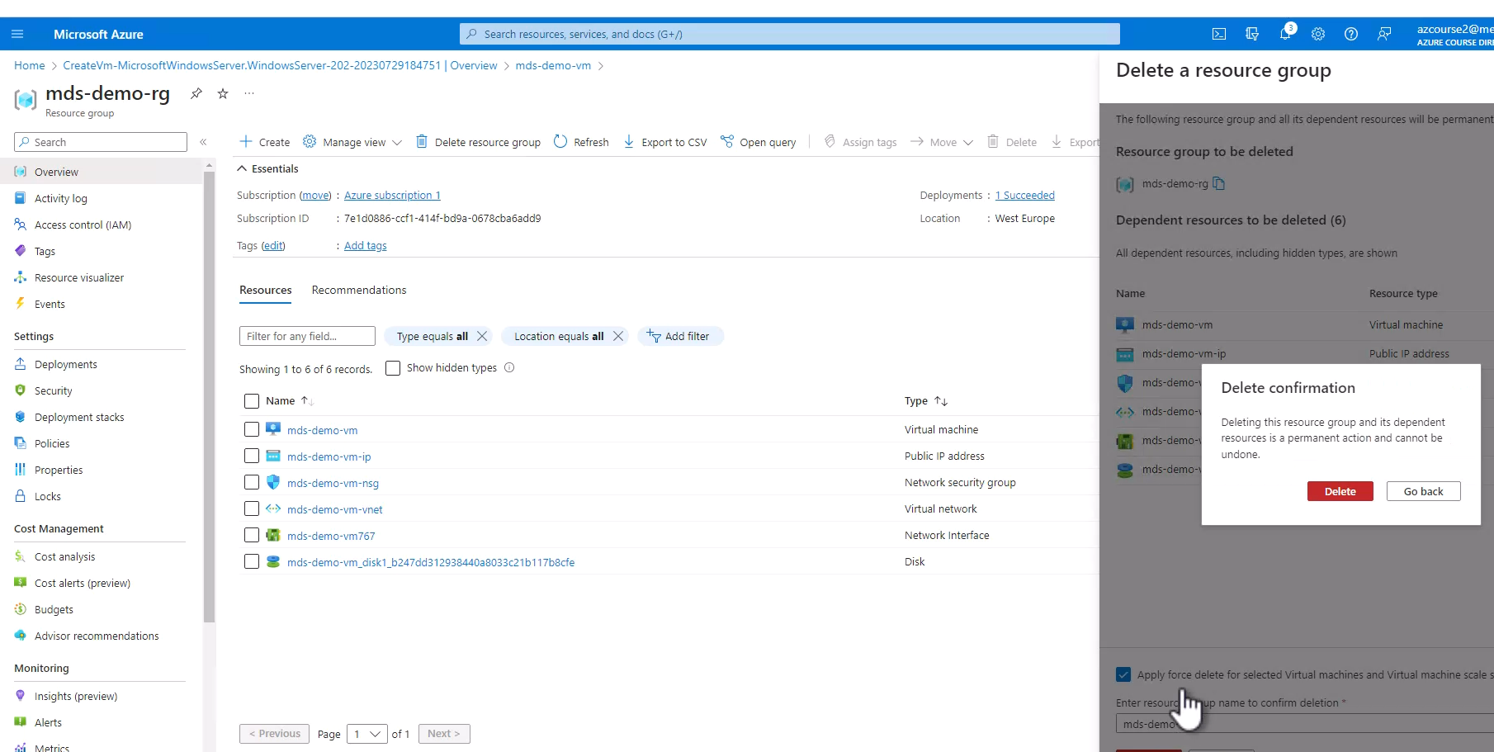

**ReadIt Resources Helper List**

In the next lecture, we're going to begin working with the ReadIt web app in Azure.

While doing that, we're going to learn about many cloud elements that will be used in our app, including various compute services (VM, App Services, Azure Kubernetes, Functions), networking (VNets, NSGs, App Gateway), data (Azure SQL, Cosmos DB, Storage Account, Redis Cache) and lots more. When working with so many resources, it's quite easy to lose track of all the resources we have and how to access them. So for that, I've created the Resources Helper List, which can be found in the resources of this lecture. In this file (can be downloaded as an Excel spreadsheet or a PDF) you can enter the various addresses and connection strings of the resources we'll use, so that it will be easy for you to go back to them, test them, and modify when needed. This list will greatly simplify the navigation between the various resources, and I highly recommend to use it. And now - let's build our first ReadIt service in Azure!

|  |  |  |  |  |  |  |  |  |  |  |  |  |  |  |  |  |  |  |  |  |  |  |  |  |
| --- | --- | --- | --- | --- | --- | --- | --- | --- | --- | --- | --- | --- | --- | --- | --- | --- | --- | --- | --- | --- | --- | --- | --- | --- |
| |  | | --- | | **Compute** | | Catalog URL | | Weather API IP address | | Inventory URL | | Cart URL | | Order Function URL | |  | | **Networking** | | App GW - Catalog URL | | App GW - Inventory URL | |  | | |  | | --- | | **Data** | | Azure SQL Connection String | | Cosmos DB Connection String | | Storage Account Connection String | | Redis Cache Connection String | |  | | **Security** | | KeyVault Connection String | |  | | **DR** | | Traffic Manager URL | | Front Door URL | |

### Setting Up the Catalog App

The first thing we are going to do is to deploy the catalog part, which we already run locally into a virtual machine in Azure, and let's see how to do that. So first, open this code in the catalog app if it's not open yet. So let's open that, and what we are going to do now is to prepare a published version of the catalog app, and basically that means that dotnet will create a special folder with the files that should be published to the virtual machine because we are not going to simply copy these files to the virtual machine because they won't know what to do with it. So let's do that. Open the terminal, and type the following command dotnet publish -o publish. And basically what this command means is make this app for publishing and put the result in a folder named publish. So hit enter, and now the code is building, and right after that, the folder will be created with the files that are required for publishing. Let's wait for that to complete. It will take a few seconds, and we're done. You can see the new folder right here. Let's see how it looks. So right click it and reveal in File Explorer, and this is the published folder right here so click it, and these are the files that should be copied to the virtual machine once it's ready for us.

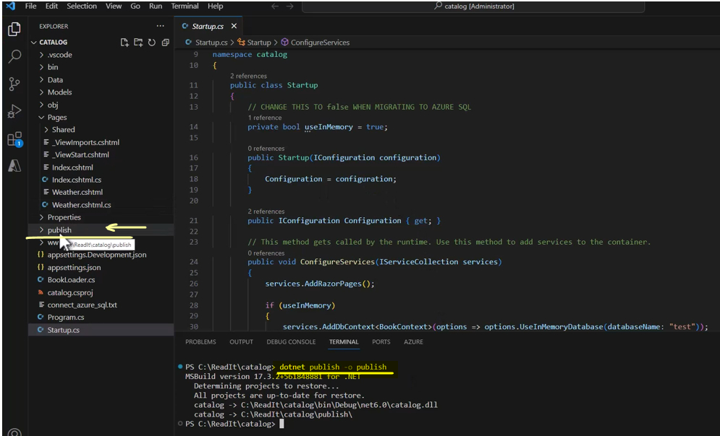

So let's deploy the virtual machine for the catalog app. So let's go back to the portal and let's create a new virtual machine.

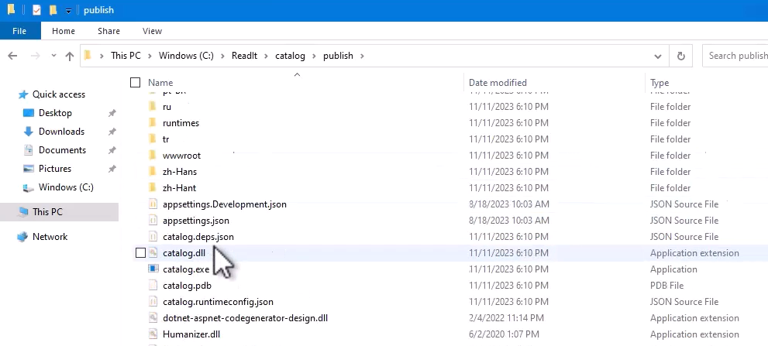

So click virtual machines here, or you can go there through the virtual machines in the search bar and create Azure virtual machine, and let's start configuring it. Now, I'm going to create a new resource group for this virtual machine, and note that this resource group is not going to be deleted because we are going to use this resource group for all the resources that are related to our Read It app, and therefore, we are going to name this resource group for the Read It app. So click create new and name the resource group readit-app-RG as in resource group. So, okay, and the virtual machine name is going to be catalog-vm like that. For the region, select region that is close to you. We are not going to deal with availability for this machine. And for the image, select this image. Windows Server 2022 Data Center.

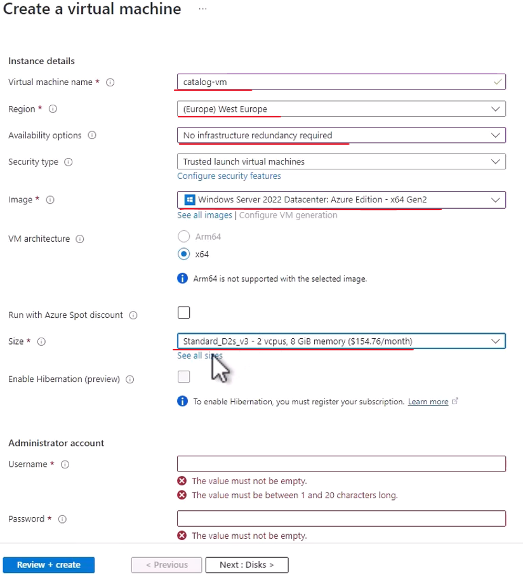

Let's scroll down. And for the size of this machine, let's pick a different one and note the D2SV3 the regular one. So click see all sizes, and go for the B2ms. This size.

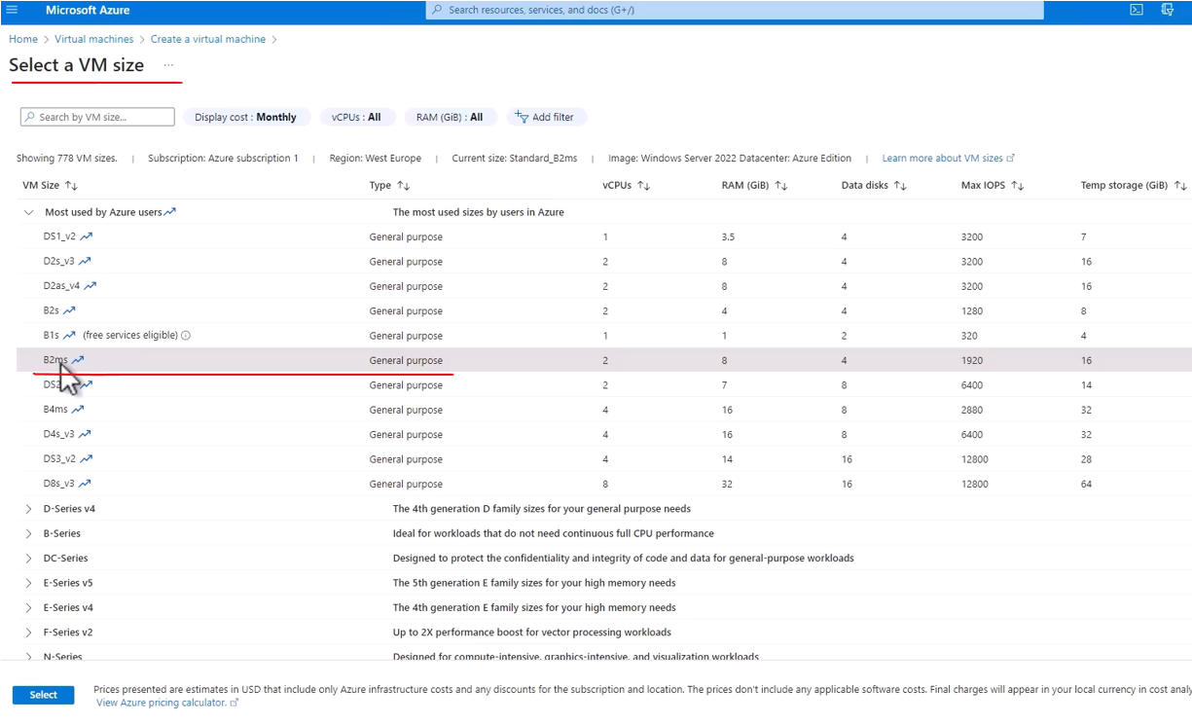

And the reason we are going to go for this one is because the B series targets burstable machines, or machines that are not going to be up 24/7 but are used periodically, which is exactly the case with our machine. And note the price difference between the D2sv3 machine with a price of $154 per month, and the B2ms machine, which is $75 per month. This is quite substantial, and therefore, we are going to use it. This is more than enough for what we actually need.

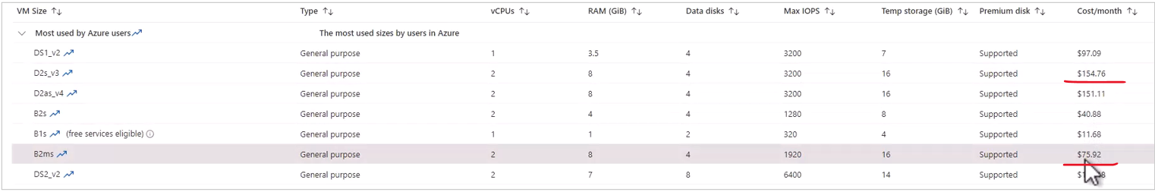

So select this size. Great, and as usual, set the username and password, pick whatever username and password you want. I will go with the regular one and confirm the password. Great, and make sure the port, the RDP port is open, and now let's go to disks. And what we are going to do here is as before, we are going to change our OS disk from premium SSD to standard SSD, again, to save costs.

|  |  |
| --- | --- |
|  |  |

Great, now let's move on to networking. And here, there are two changes I want to make. The first one is the name of the virtual network that our machine is going to be in, and know that currently, by default Azure is offering this name catalog vm vnet. And I don't like this name because it hints that this Vnet is going to be used only by the catalog VM, and this is not necessarily the case because this Vnet is going to be used by the Read It app. So let's click create new and simply change the name to readit-appvnet like this. Okay, great.

Now, the next thing I want to change is the IP address of this machine. Now by default, Azure will create a new IP address, which is dynamic meaning whenever we restart the machine or simply shut it down and then turn it on later, then a new IP address will be assigned for it, and I don't like it. I want the IP address to be static so that we will always use the same IP address for this machine. This will make our life much easier when we'll connect this machine to load balancers and so on. So click create new, and I like this the catalog VM IP since this IP address is going to be used only for this VM, and make sure the assignment is static.

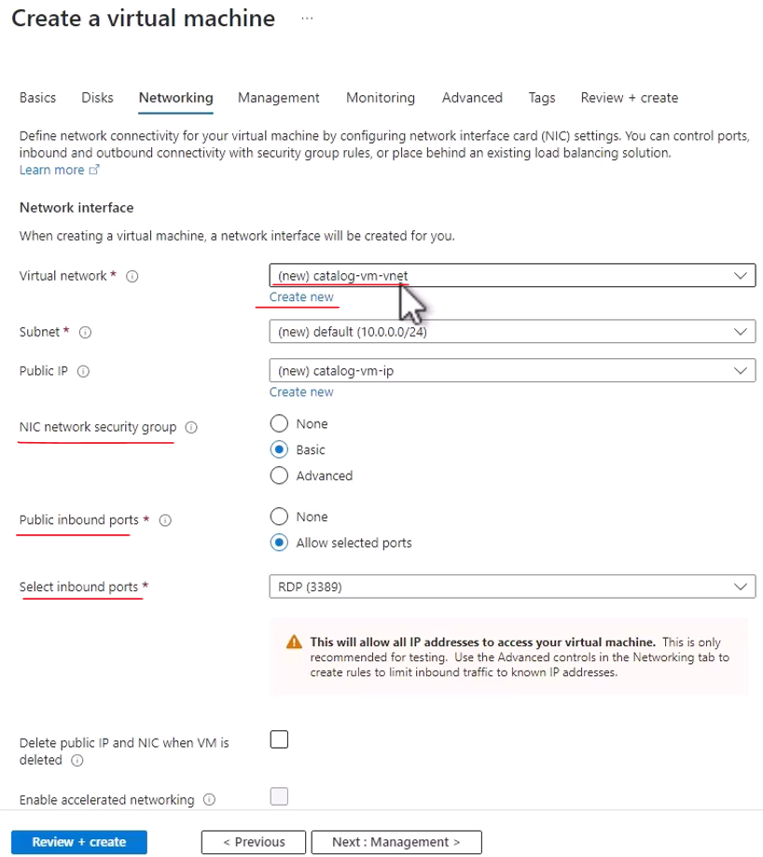

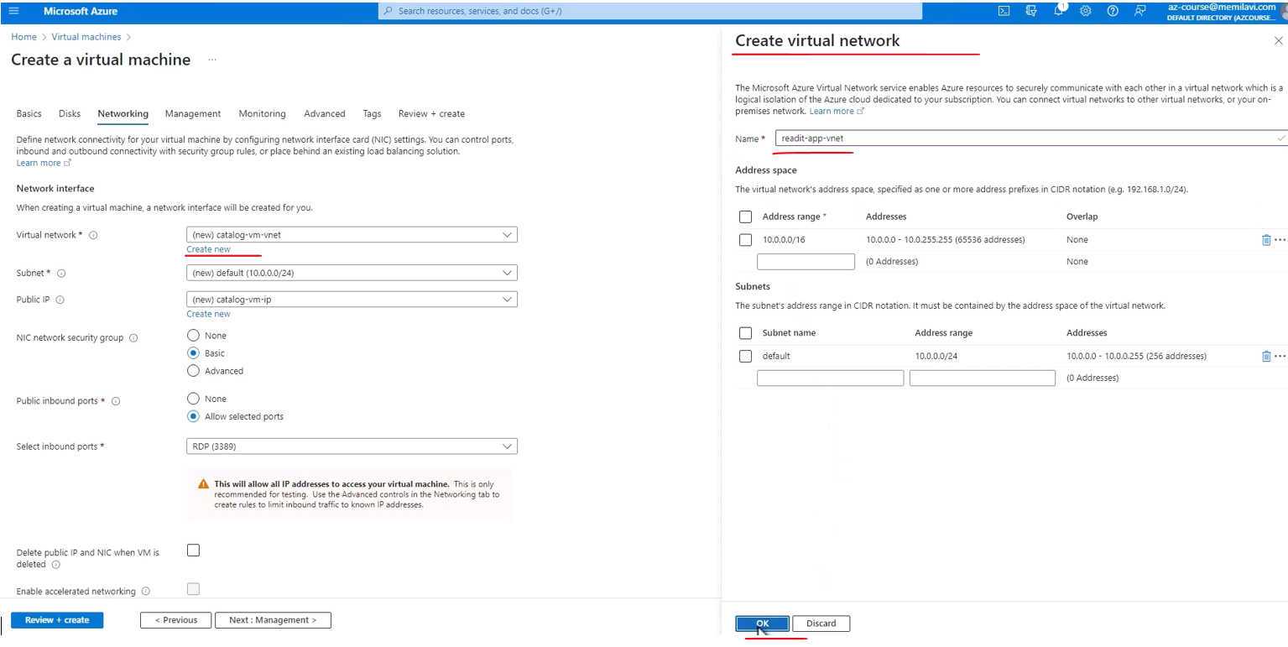

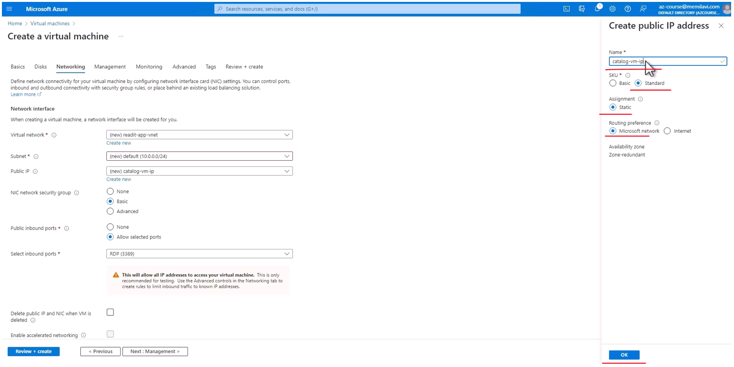



And okay, great, so this is all the configurations that we want to do for this machine.

And now Review + Create, and let's wait for the validation to complete. Great, and validation has passed so let's create this machine.

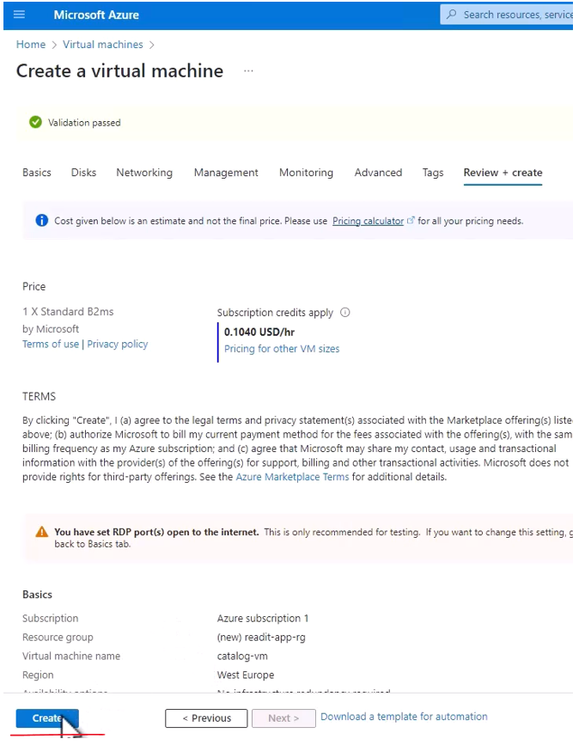

So now as usual, Azure will deploy this virtual machine for us, and let's wait for that to complete. Okay, great, and the machine is ready, and now let's connect to it and configure it for running our catalog app. So, go to resource and let's take a quick look at the overview section, and yes, everything looks fine. The machine is running and here is the public IP address, and indeed the size of the machine is B2ms, which is exactly what we wanted.

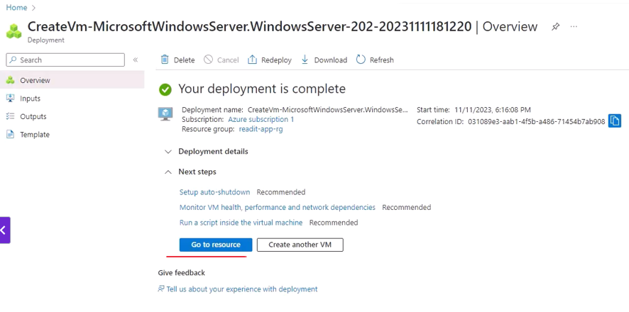

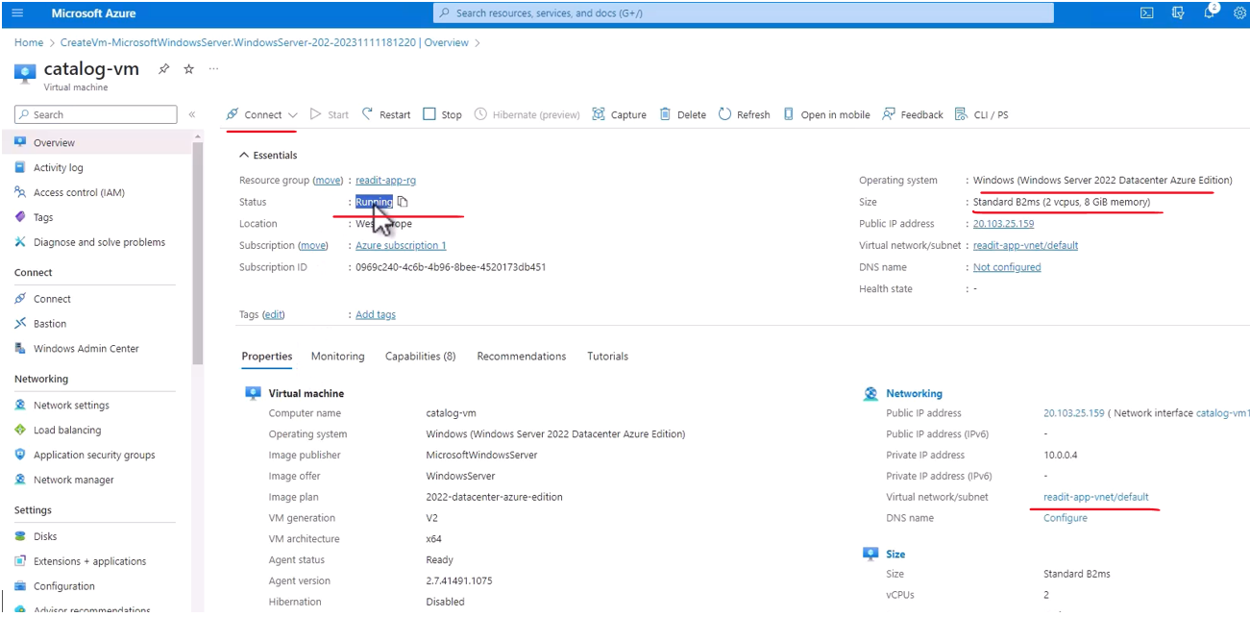

So let's connect to this machine and start configuring it, so click connect and connect, and we want to connect through native RDP. So select this, and download RDP file, and click it.

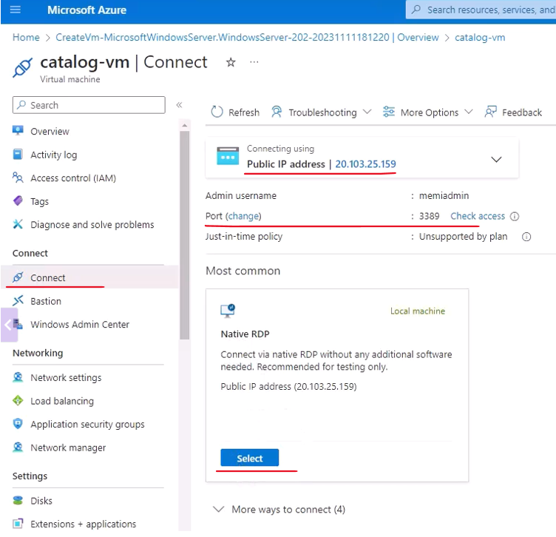

Yes, let's connect to this

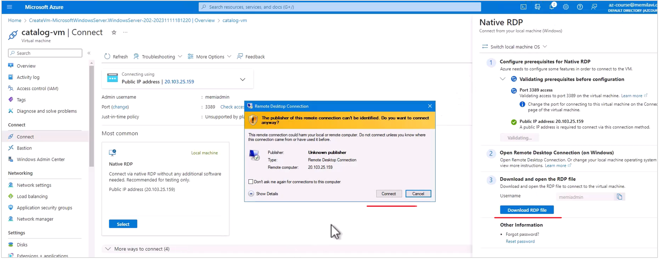

and now type the username and password that you selected. So that would be the case for me and the password. And yes, and we are connecting to this machine. Let's let it run. It will take a few seconds. Great, and here is the desktop of the machine. Now let's wait for this server manager to fire up because we want to configure our machine using the server manager. You can click here no, and here is server manager starting.

So what we basically want to do now is to configure this machine as a web server, which is off by default. So here click add roles and features, and if you get this message, then wait a few seconds and then try again. Okay, so again, let's click this link, and we want to make our machine a web server. So next, and next again, and again next, and here we select our machine for the one that we want to manage, and now let's select the role that we want for this machine, and what we want to check here is this one, web server.

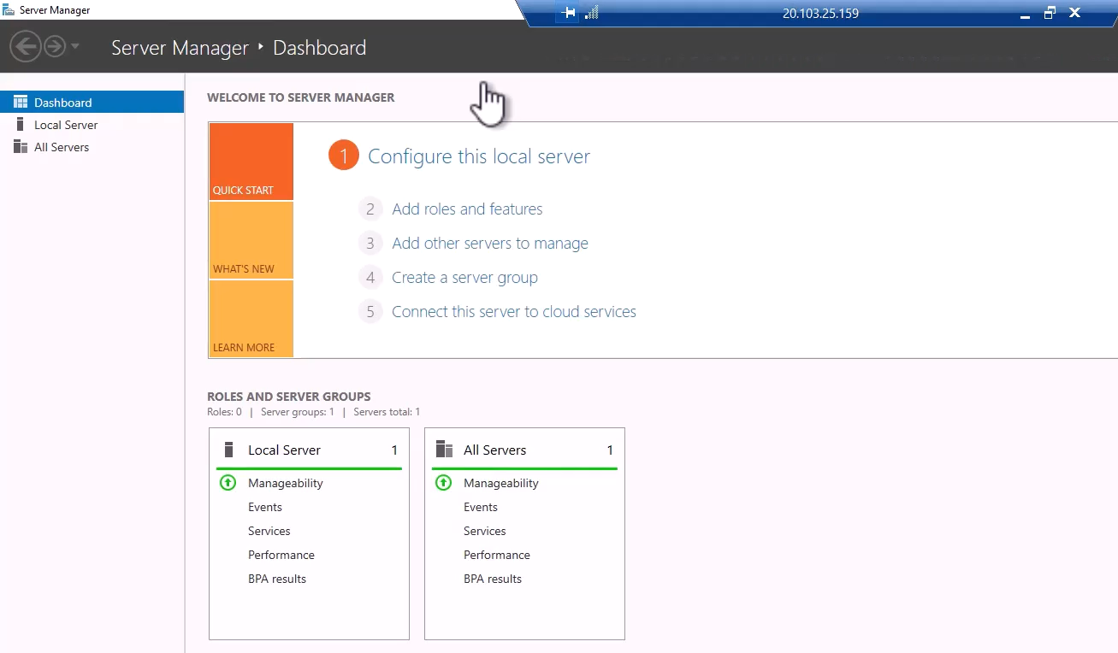

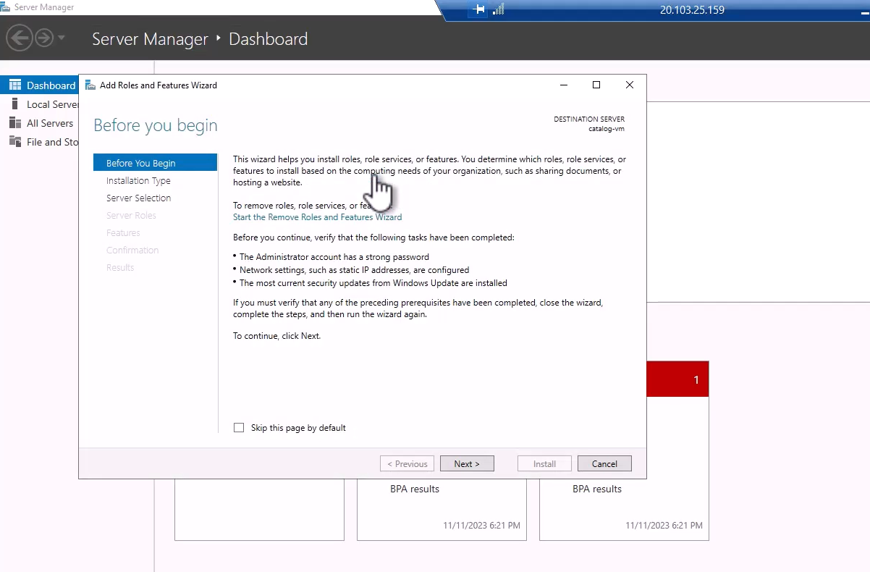

So these are the features we want to add, so click add features, and next, and these are the specific components that are going to be installed, and actually we don't need to customize anything here. We have everything preselected for us.

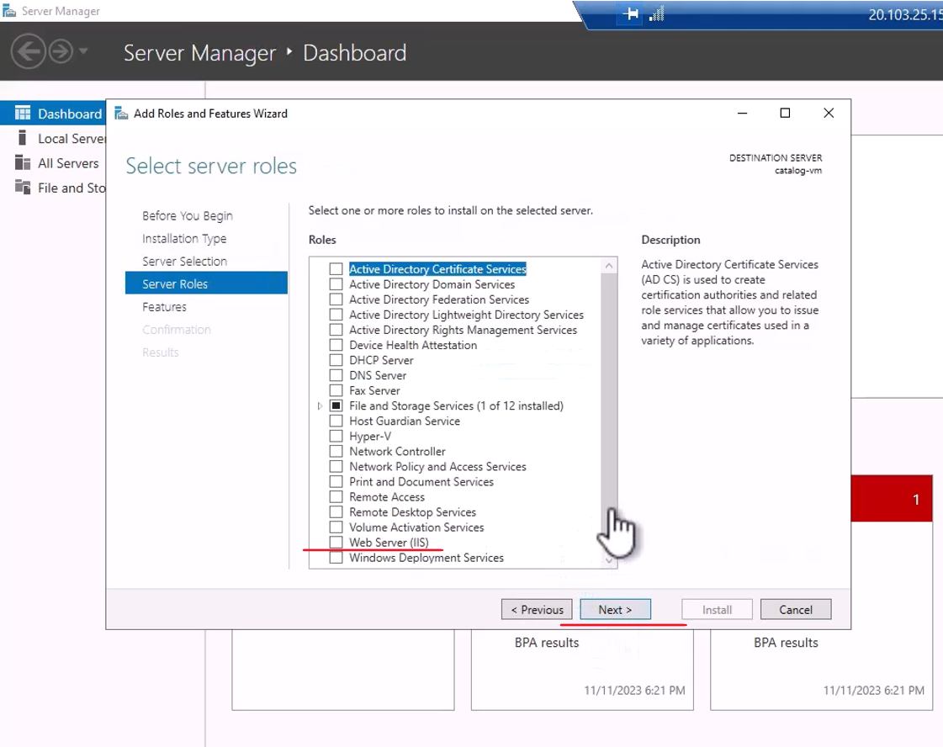

We are going to install another component after configuration is done, which is specific for .NET six applications. But we will do that after configuring the server rule. So again, click next and next, and here just for fun, let's also select custom log in and log in tools, and next again, and install.

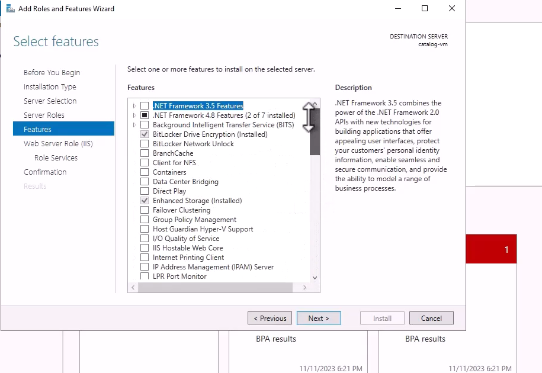

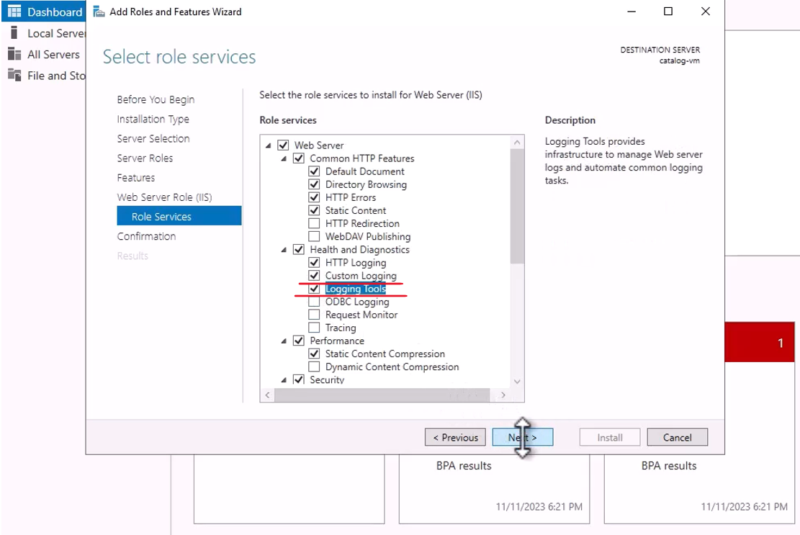

And now Windows is configuring this machine for the web server role so let's wait for that to complete. And installation was succeeded, and this virtual machine is now configured as a web server. Now let's make sure this is indeed the case. We can close that and let's open our browser, which is Edge in this case.

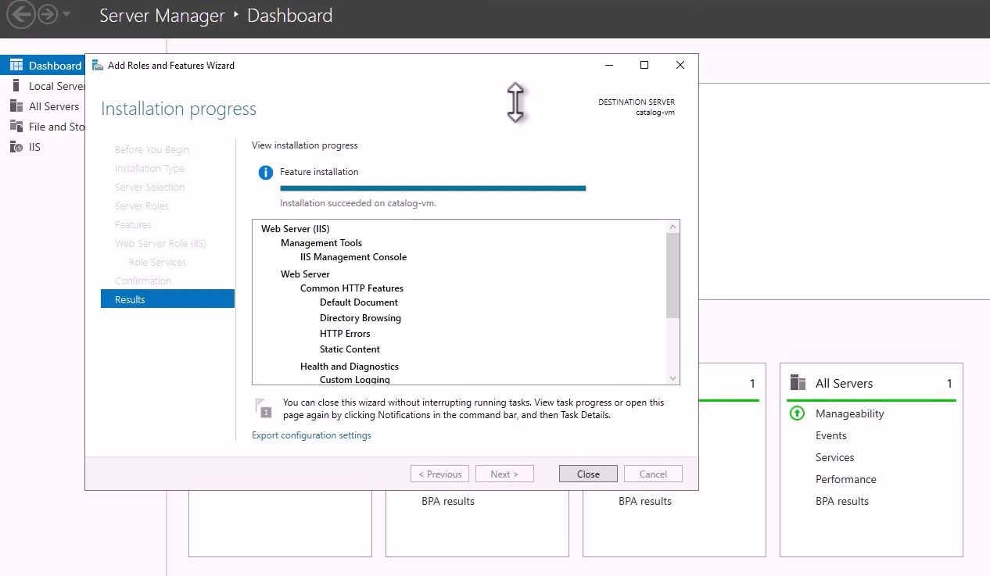

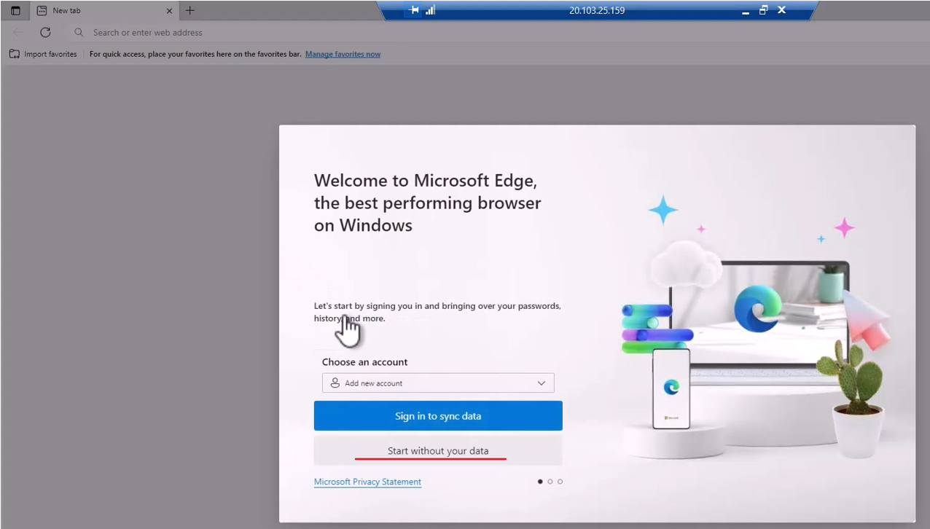

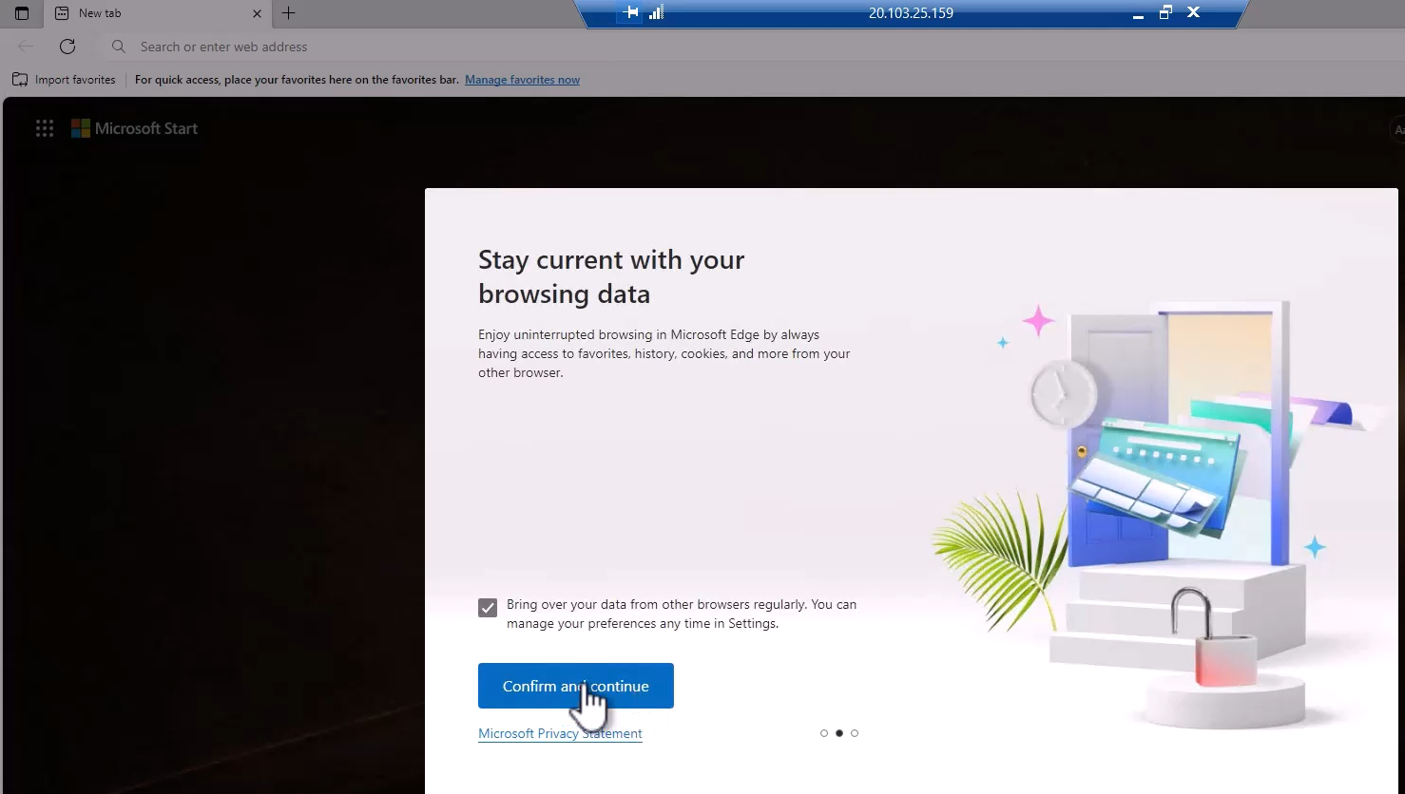

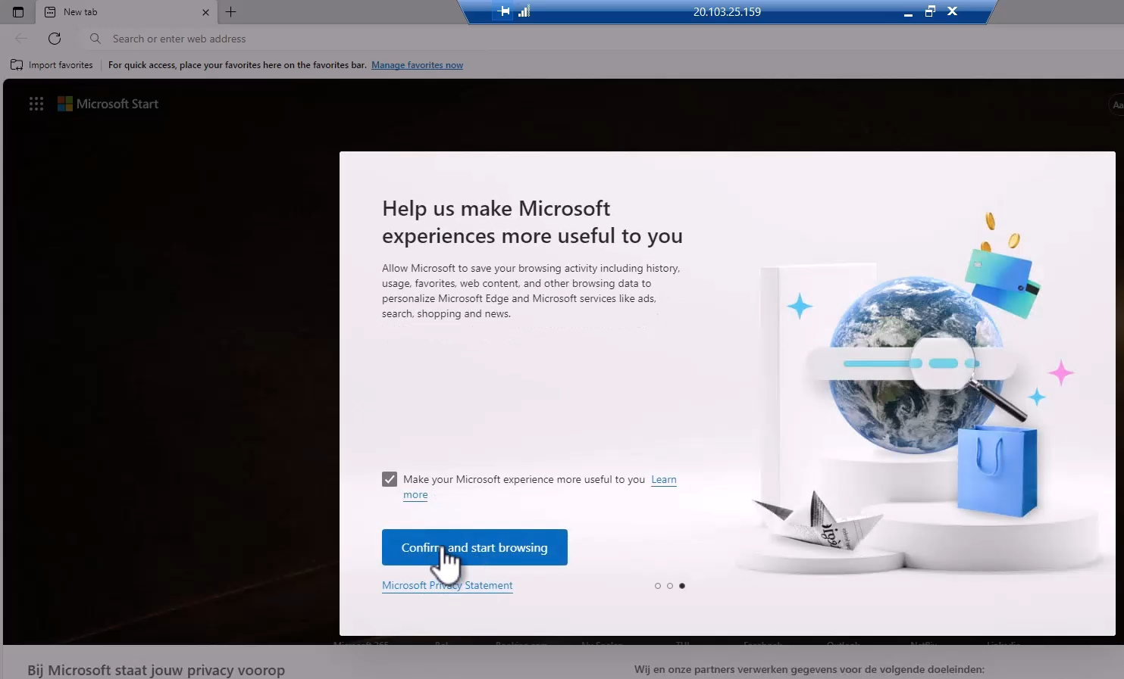

Let's wait for that to open, and we want to start without our data, and confirm and continue of course, and confirm and start browsing. Great, and now in the navigation bar, navigate to local host like that. And yes, we can access our web server, meaning our machine is now configured as a web server, which is great.

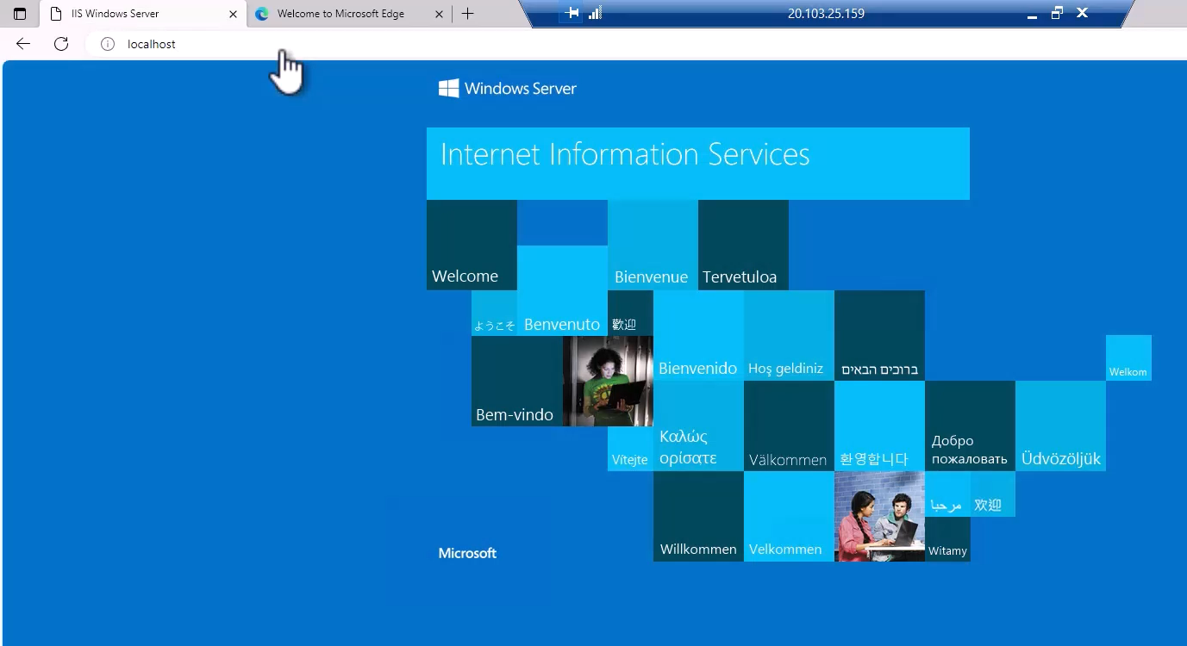

Now, before we can install and draw our catalog up on the server, there is one last thing we need to do, which is to install the hosting bundle of dotnet eight. And this hosting bundle is basically integrated into IIS, and will allow it to run dotnet eight apps. So let's do that. Go to the following URL, which is dotnet.microsoft.com, the language download dotnet and eight, which is basically the same URL we used before to download and install the SDK. So let's go there, and this time, we are not going to download and install the SDK, but something that is called hosting bundle, and here is the download link for it. And again, it's really important that you will not download and install any other thing from this page. So do not click these links, which will download and install the runtime of asp.net, but click the hosting bundle. This hosting bundle knows how to integrate into IIS while the other run times are standalone run times and will not affect IIS. So again, click hosting bundle, and now it's downloading.

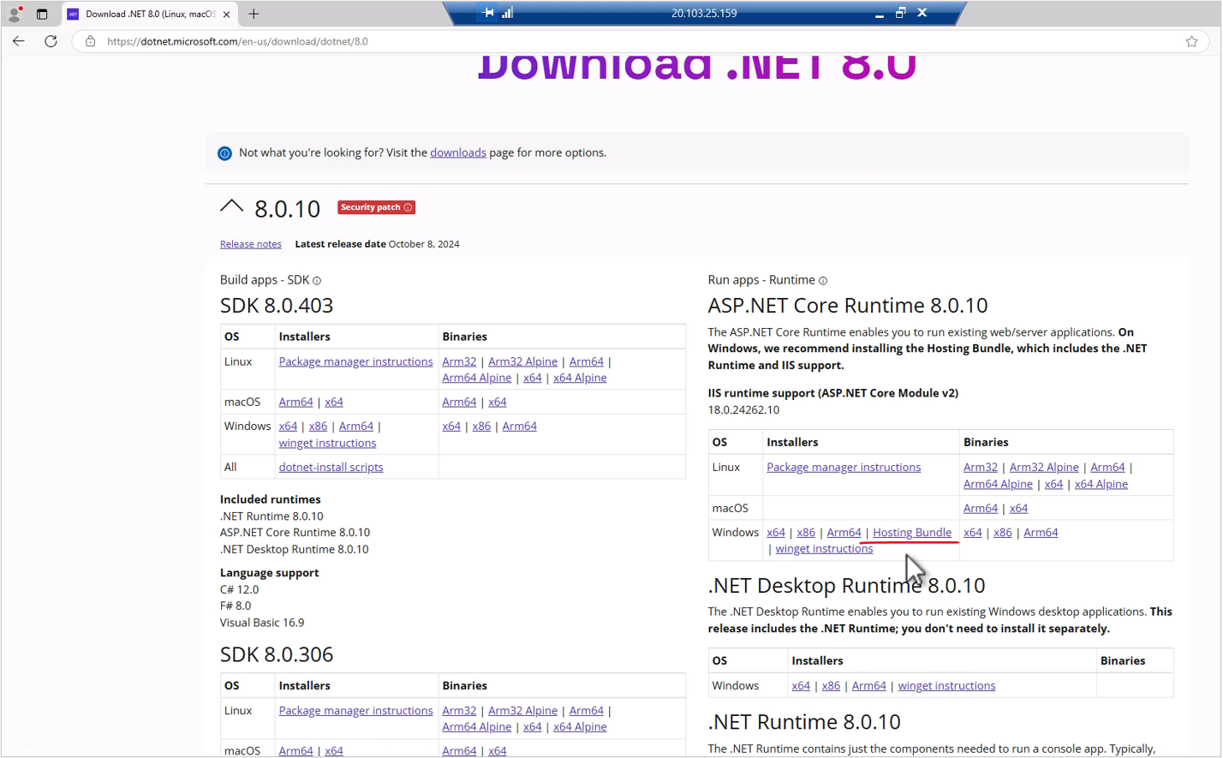

Let's wait for that to complete, and let's open it, and of course we agree to the license terms and conditions and click install. Let's wait for that to install. Great, and the installation successfully completed, and now we have the Windows server hosting bundle of dotnet eight installed on our machine and integrated into IIS, and our computer is basically ready for running dotnet eight apps.

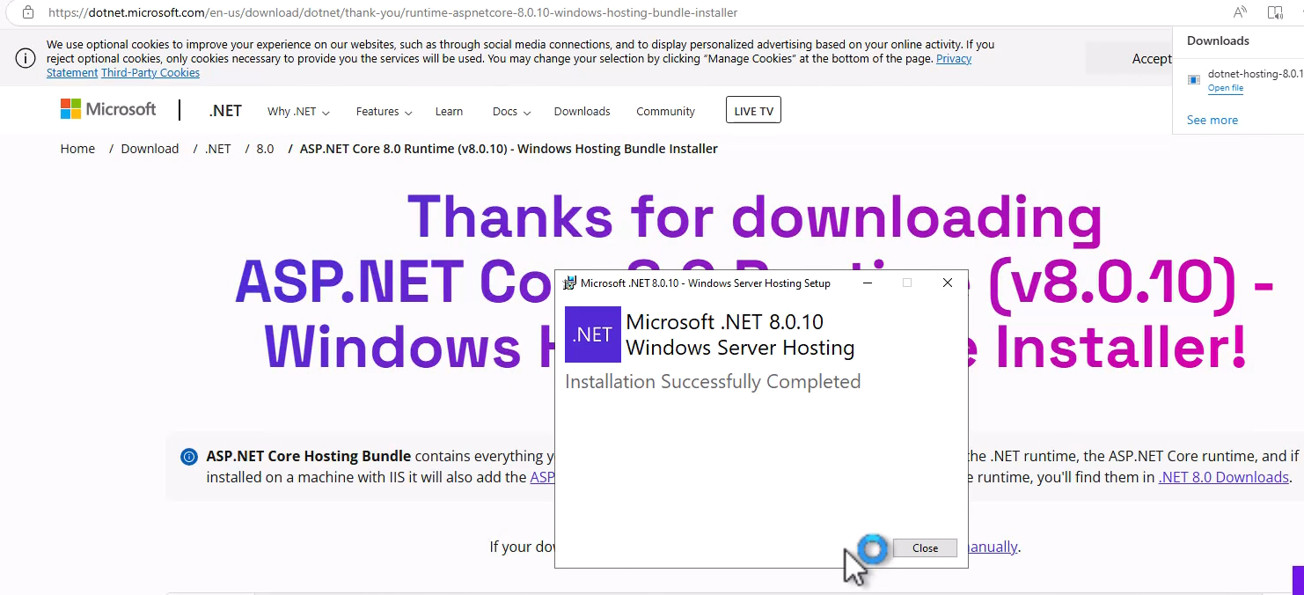

So now let's install and run our catalog app. So first let's close installer and we can also close the browser, and also the server manager. And the first thing I want to do is to prepare a folder for our catalog app. So right click here and File Explorer, and let's go to the C drive, and let's create a new folder. So right click here, and new, and folder, and let's name this folder catalog. And again, our catalog app is going to be stored right here.

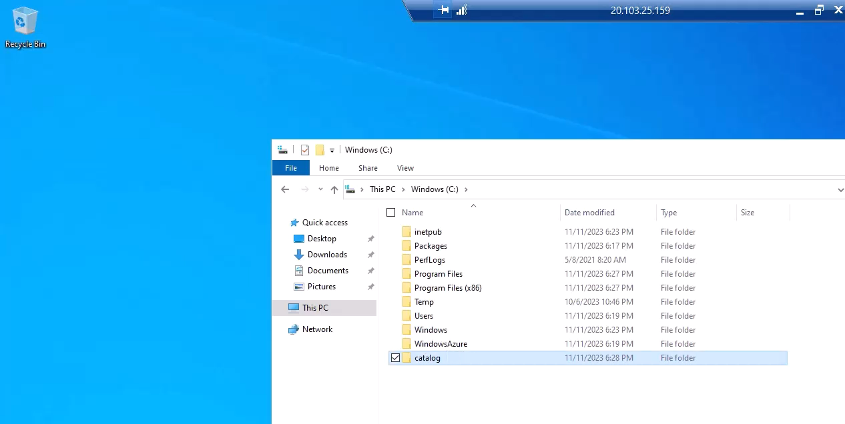

And now let's go back to our machine, our local computer, so you can resize this window, and we are now back on our machine. And remember the published folder that we created from VS code? Well, now we are going to copy its content to the catalog folder in the virtual machine we just created. So go back here and make sure you are in the published folder, and select all the files and copy. And copying files to virtual machine is basically the exact same as a regular copying. So again, simply copy the files with Ctrl + C and go to the virtual machine. Let's maximize this again and go into the catalog folder and paste the files to this folder.

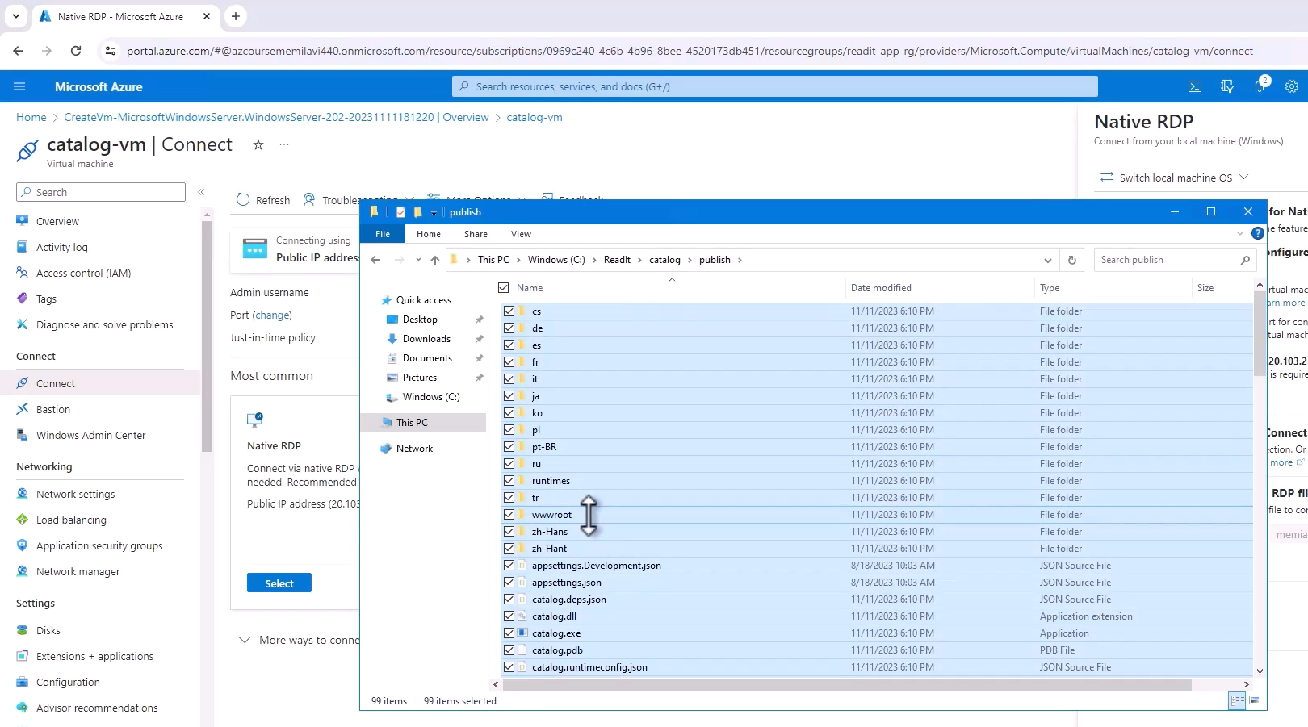

Now, these are quite a lot of files so it might take some time. So let's wait for that to complete. Great, and the copy was complete. And now the last step is to configure the web server on this machine, which is IIS. In this case since it's a Windows machine, so we need to configure IIS so that this folder will be basically a web app. So here in the search bar, type IIS and open it, and here is IIS. And now let's create a new website on our virtual machine.

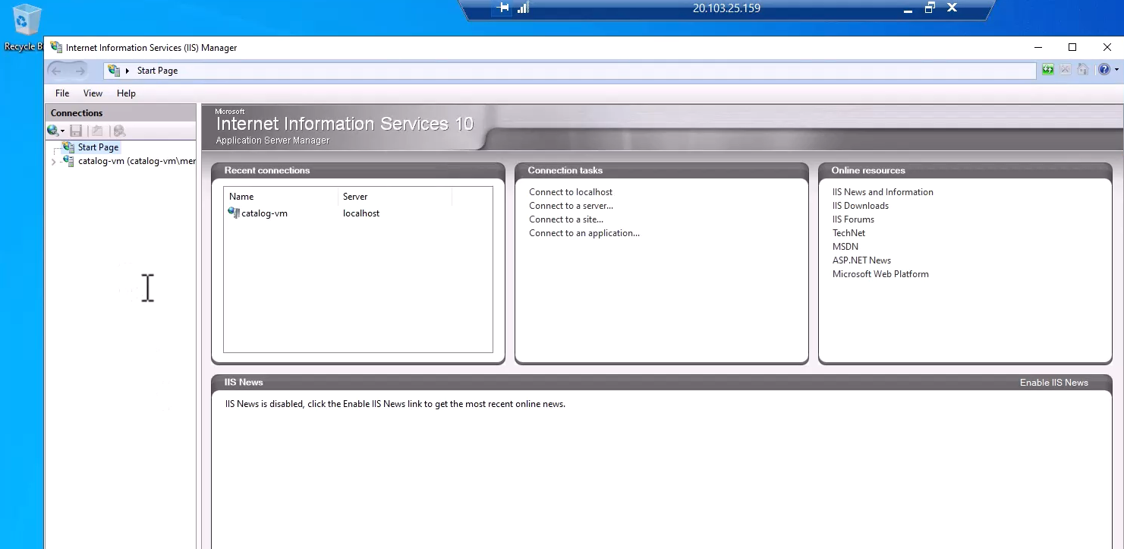

So expand this, the catalog VM node, and on sites right click and add website.

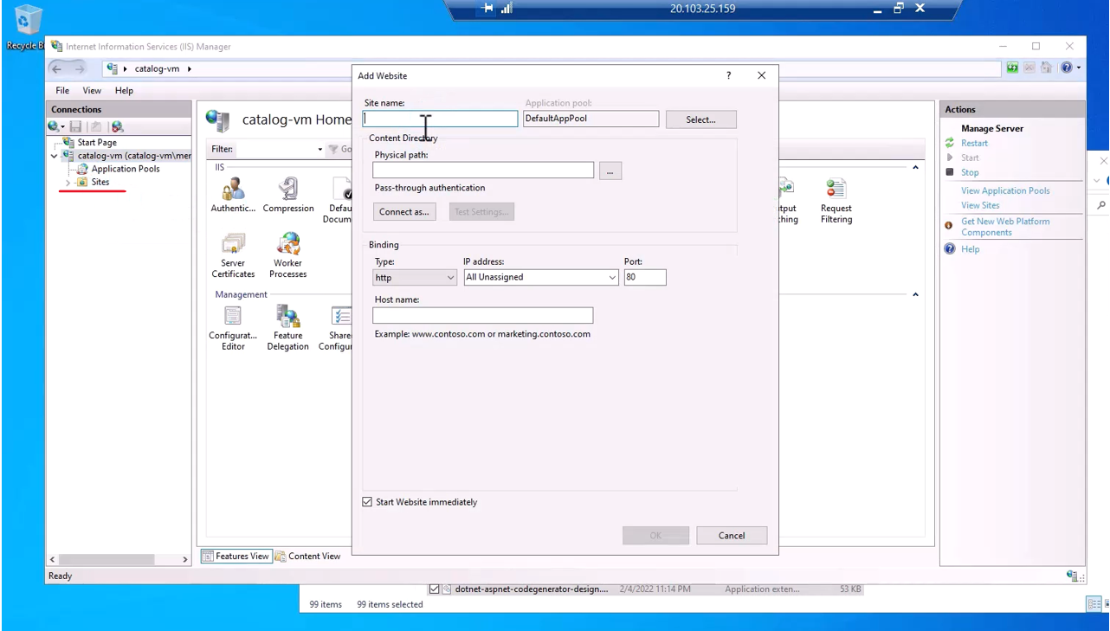

Now the name of the site as you can guess is going to be catalog. And click here and point IIS to the folder of the catalog, which is this one.

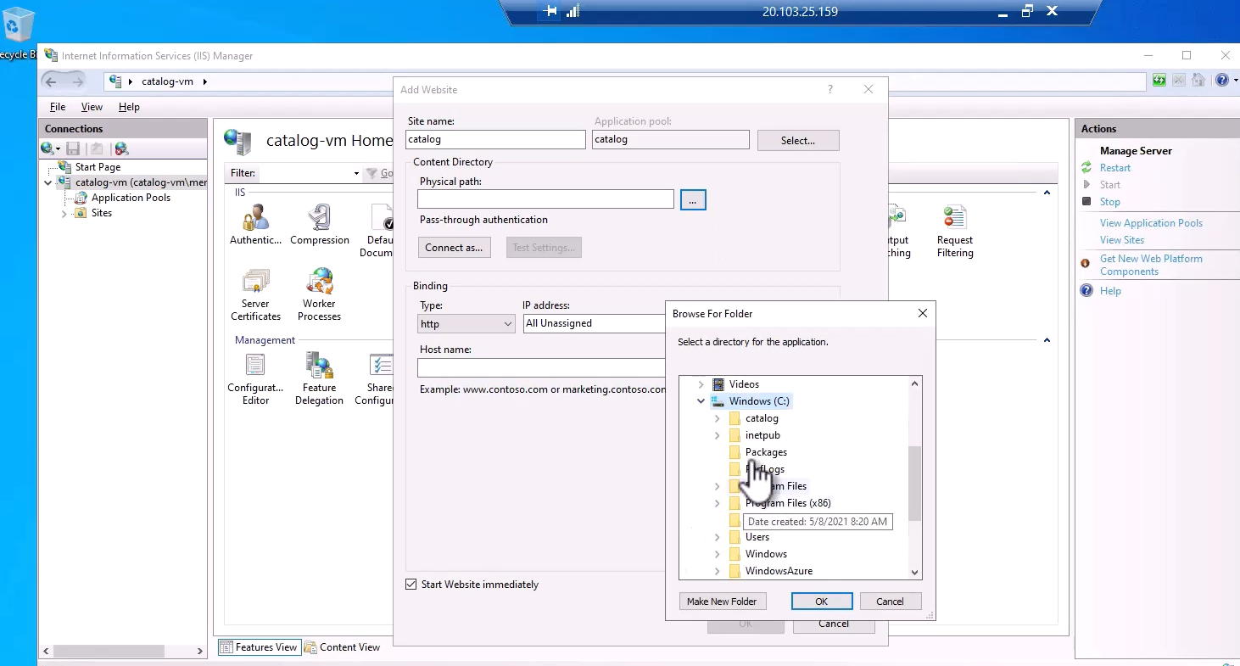

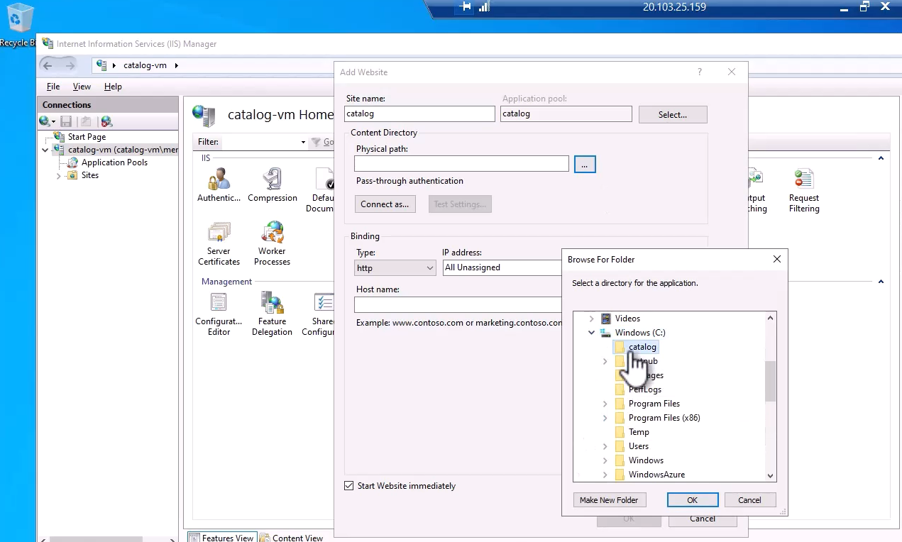

So select it and okay, and let's change the port to be 8080 and not just 80.

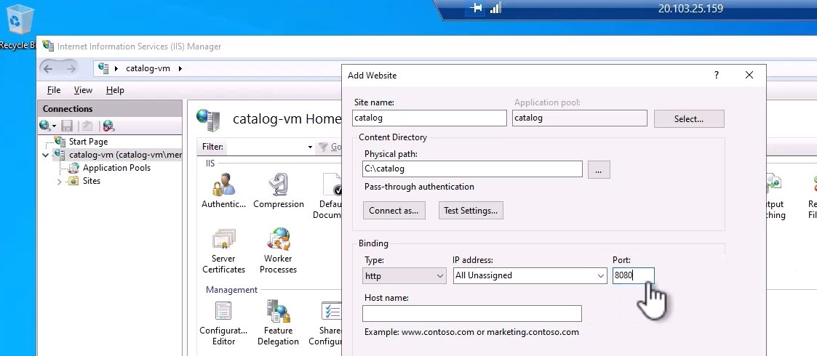

And okay, and that's it basically. We now have our catalog app configured as a web app in IIS, and let's see whether this is indeed the case and whether we can browse our catalog. So in IIS, click this link browse in the 8080 port.

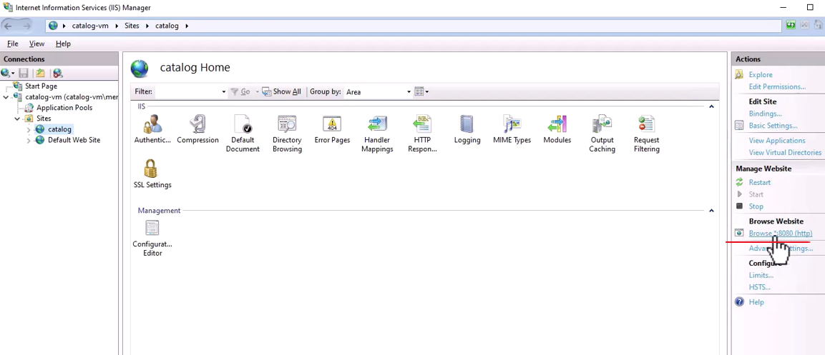

So click it, and the browse window was opened. Let's see what we are going to get, and here is our catalog. So now our catalog is fully deployed in a virtual machine in the cloud.

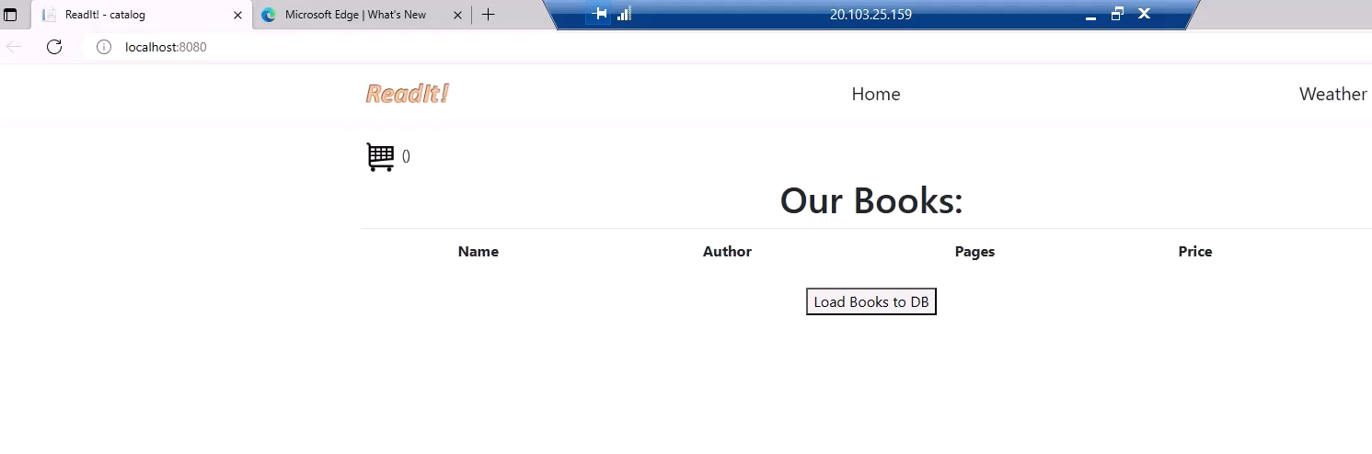

Let's just make sure we can actually use it. So click the load books to DB, and indeed it is working just fine.

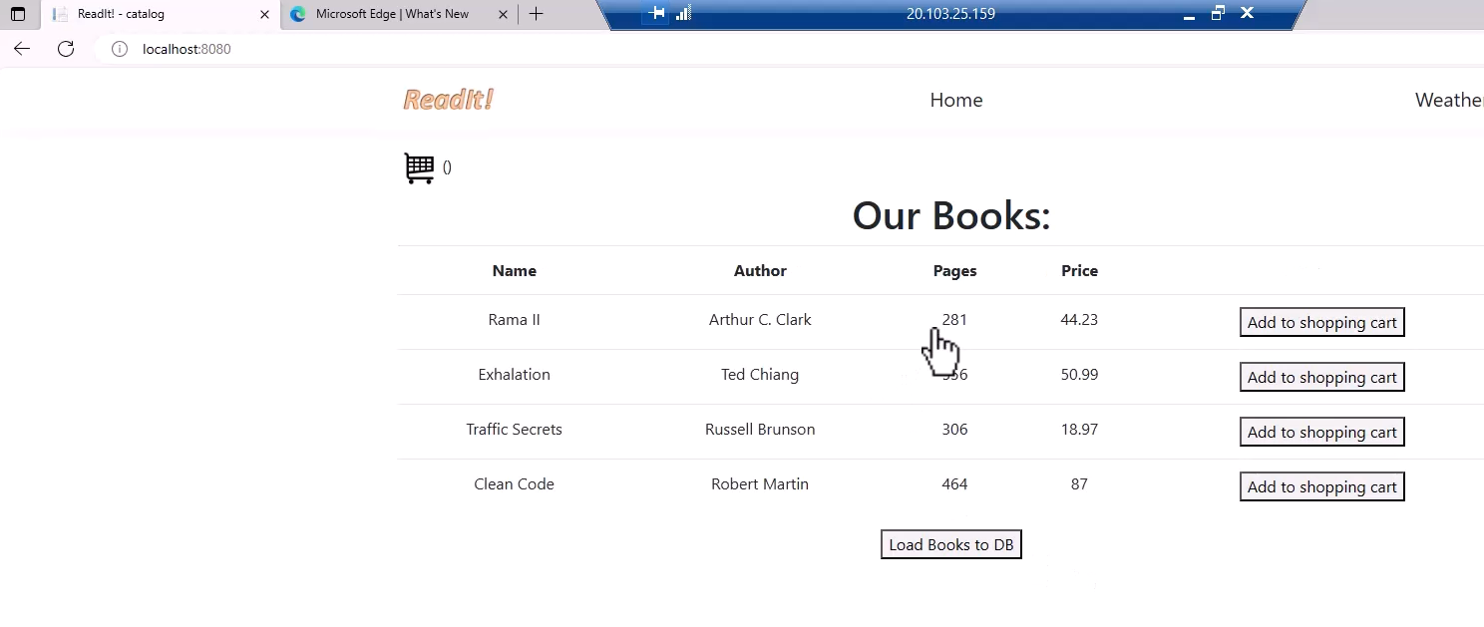

So our catalog is working and we saw how to deploy it to our virtual machine, but now let's see whether we can actually access from the outside because of course, we don't want to be able to browse to it only from within the virtual machine. So resize the virtual machine and let's take a look at its public IP address, which is this one. So copy the IP address and let's open a new browser tab and paste the IP address right here and add the port, which is 8080, and hit enter, and let's see what we will get. And you can already see that it takes too much time. Let's wait a little bit more. And still we don't get anything, and it looks like we have a problem and we cannot browse our website.

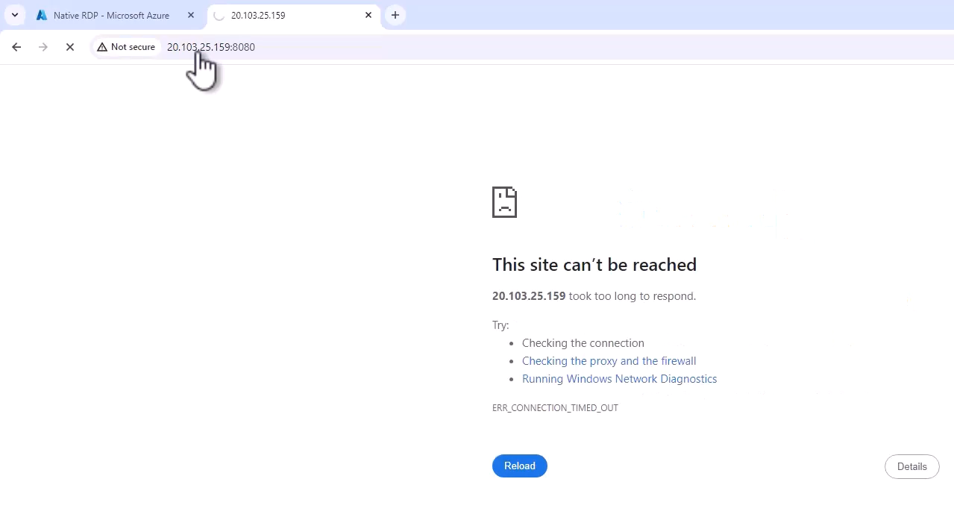

So let's go back to our virtual machine, and one of the reasons for that is because the built-in firewall might be blocking external access. So let's go to the firewall here, firewall and network protection, and click public network, and note the incoming connections.

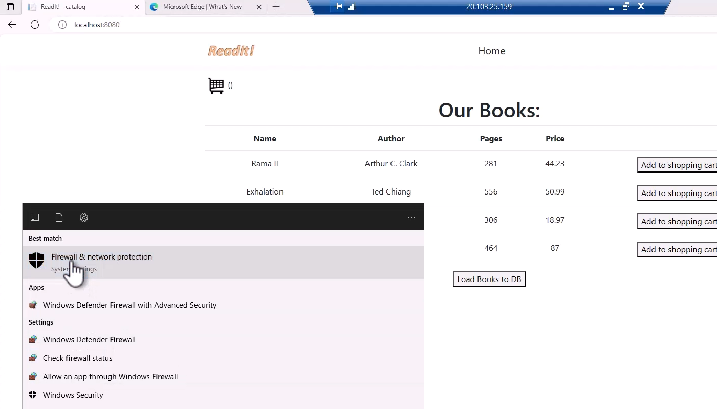



And it looks like this machine or this firewall currently does not block any incoming connections. So it looks like the firewall is not a problem here. So why can't we access this machine from the outside? Well, the reason is Azure, by default blocks access to virtual machines unless we explicitly allow such an access, and we didn't allow this access for this machine. The only access that is allowed for this machine currently is RDP access, which we are using right now.

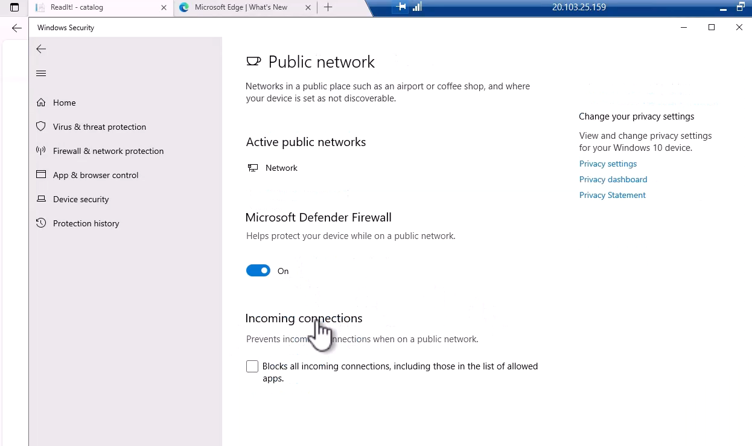

And later in the networking section we will see how to configure the machine so that external network access is allowed to it. So anyway, we now have our catalog app deployed in virtual machine in Azure, which is exactly what we wanted to happen.

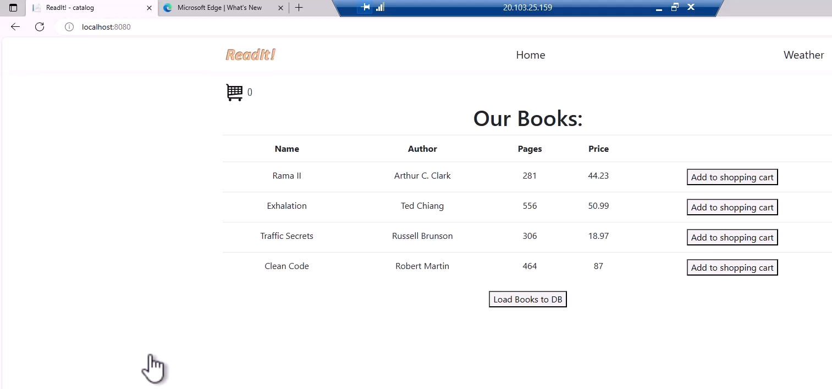

### Setting up the Weather API

Now, if you take a look at the header of our catalog app, you will see there is a link to a weather page

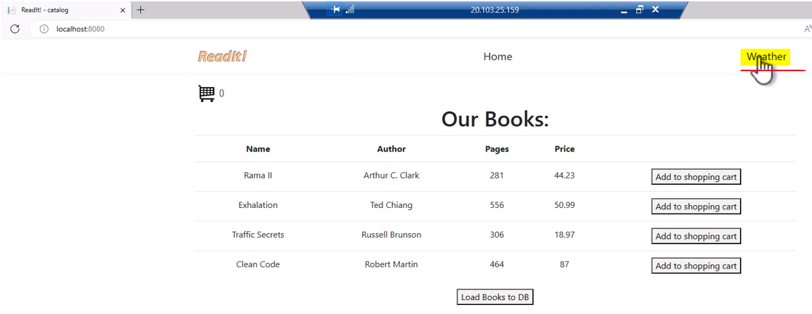

and if you will click it, then you will navigate to this page, where you can type in the IP address of a weather server, and then get a forecast for today, and you might be wondering why a bookstore needs a weather page. Well, that's because the users might want to know what is the weather near the bookstore before visiting it, so that they will know whether they should take a coat with them or not.

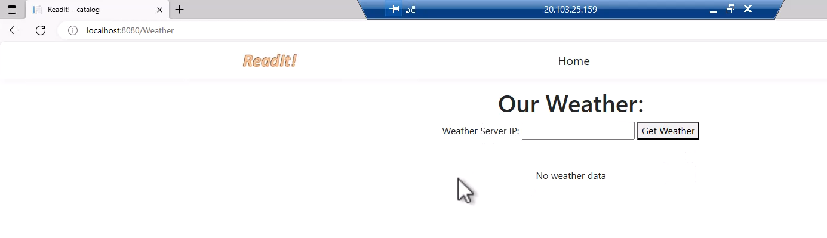

Now, currently the weather API is not working and we are going to create it now, and for that, we will use another virtual machine, only this time, this machine is going to be based on the Linux operating system, and not Windows. So, let's do that together. So, let's go out of this RDP connection and back to the portal, and, as before, let's go to virtual machines, and let's create the weather virtual machines. So, Create and Azure virtual machine

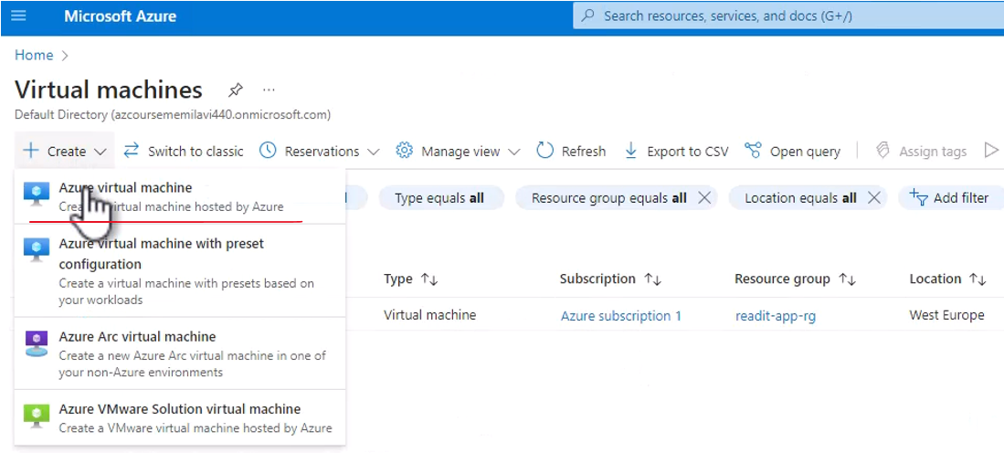

We will use the same resource group that we used before, the, "readit-app-rg," The name of this machine is going to be, "weather-vm," use whatever region you want, as long as it's the same region that the catalog VM is used. We don't need any Availability for this machine, and for the image, we are going to go for Ubuntu, so pick this image, the, "Ubuntu Server."

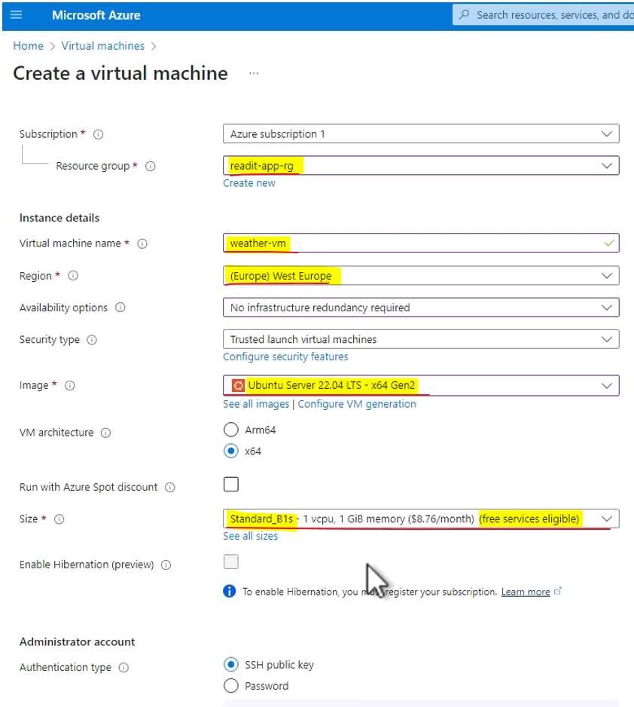

Great, and let's scroll down here, and actually, for this machine, we can use even smaller instances than the B2ms, because Linux machines usually require less resources than Windows, so see all sizes, and let's go for the B1s, right here. This should be more than enough, so select this size, and this is what we are going to use.

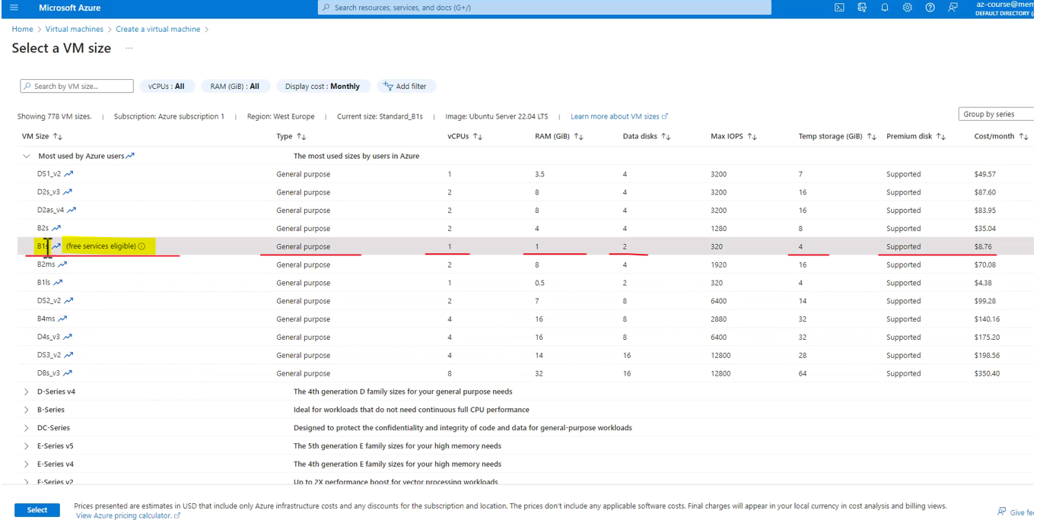

Great, now, let's scroll down here, and here, we set the authentication for this machine.

Now, we are going to connect to this machine using the portal, so it doesn't really matter what are the details of this publicly, but note the username that is assigned to us by default, and we are going to ask Azure to create a new keeper for the authentication, and let's name that, "weather-keys," like that, and let's leave port 22, which is a default SSH port, open.

Next, let's go to Disks, and, as before, let's change the type of the disk from Premium SSD to Standard SSD

|  |  |
| --- | --- |
|  |  |

and let's also take a look at the networking, and here, we want to make sure that this machine will be stored in the same vnet where our catalog VM is stored, and we are going to need that, since these two machines are going to connect to each other. So, again, make sure they are both in the same, "readit-app-vnet." Let's also click here to make sure that the IP address is indeed static, which it looks like is the case, so, okay, and that's all, basically, so Review + create, and let's create the machine

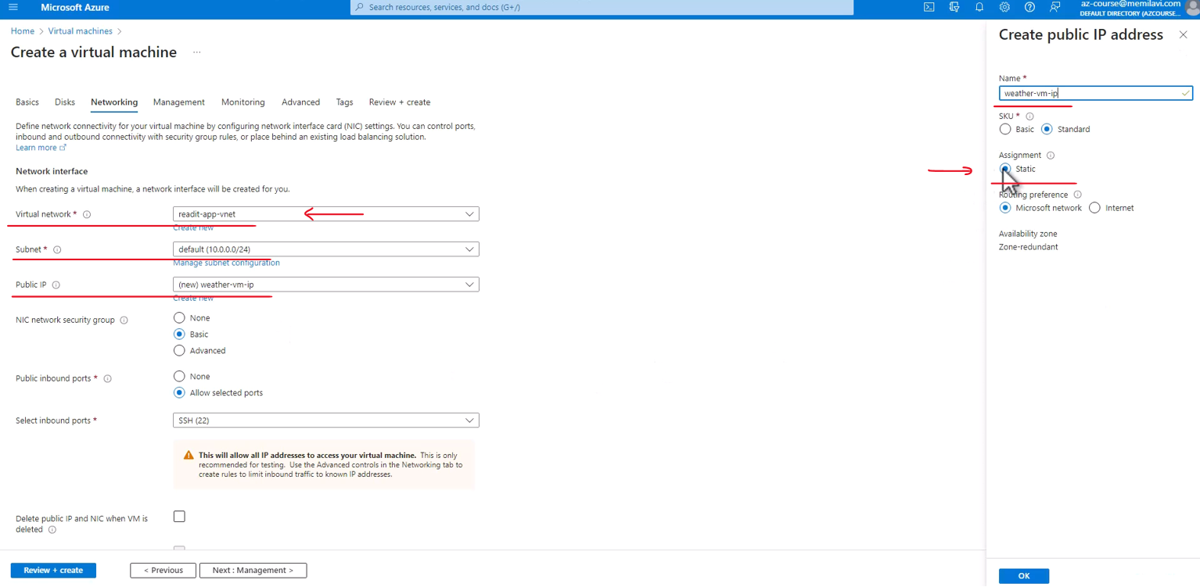

Click the, "Download private key and create resource." You will need this private key when connecting to this machine outside of the portal,



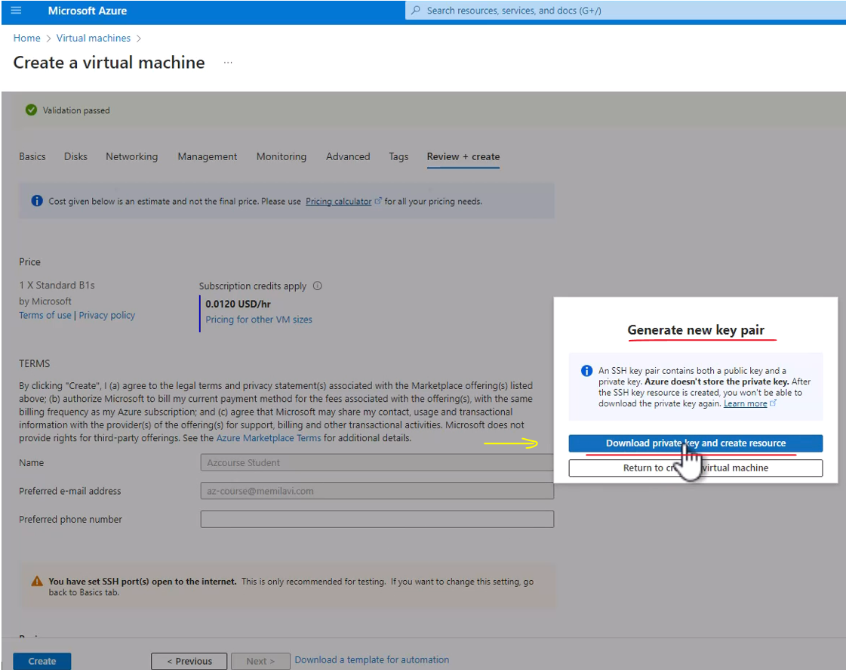

and this is the machine you will use. We are not going to use it right now, so let's wait for the deployment to complete. So, the virtual machine is ready, and now let's go to it.

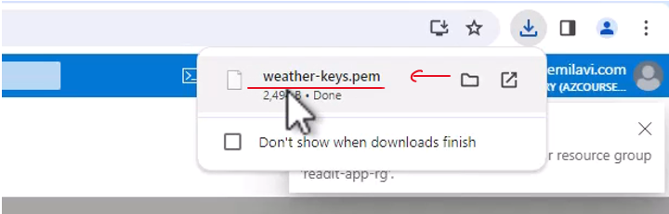

So, here is the virtual machine, note, again, the operating system right here, which is indeed Linux, and now, let's connect to this machine and start working on it.

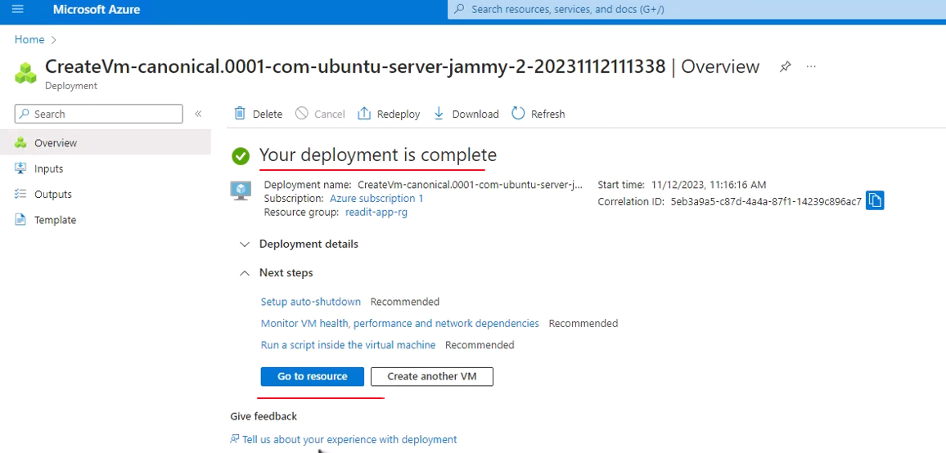

So, click Connect and Connect,

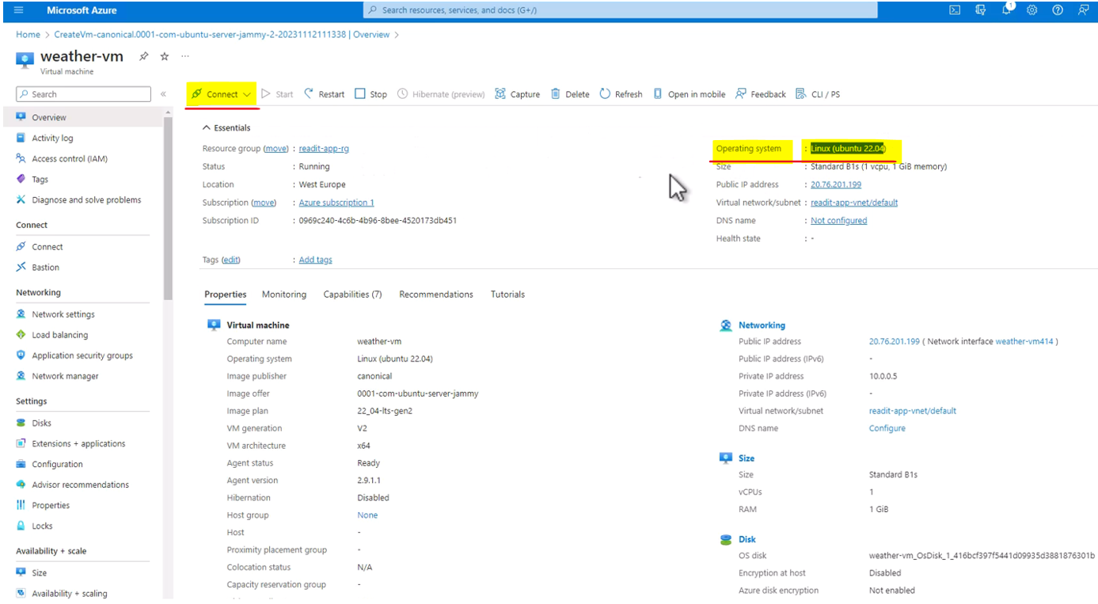

and here, click Select, right here, under the, "SSH using Azure CLI," so click Select, and let's wait for the validation here to complete.

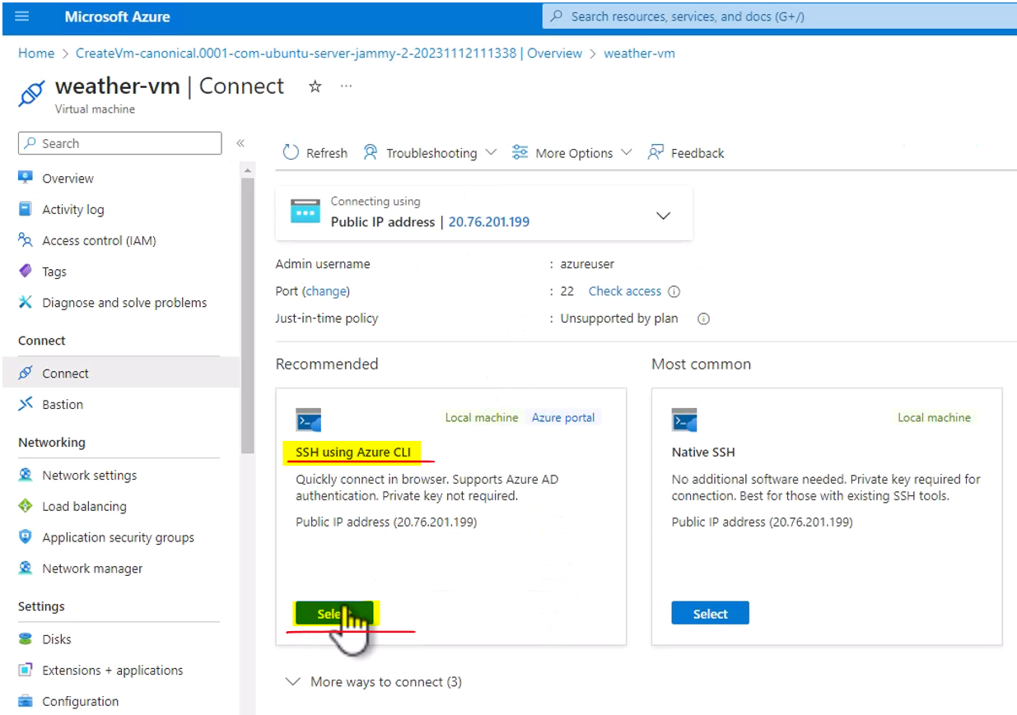

The first time might take a few seconds.

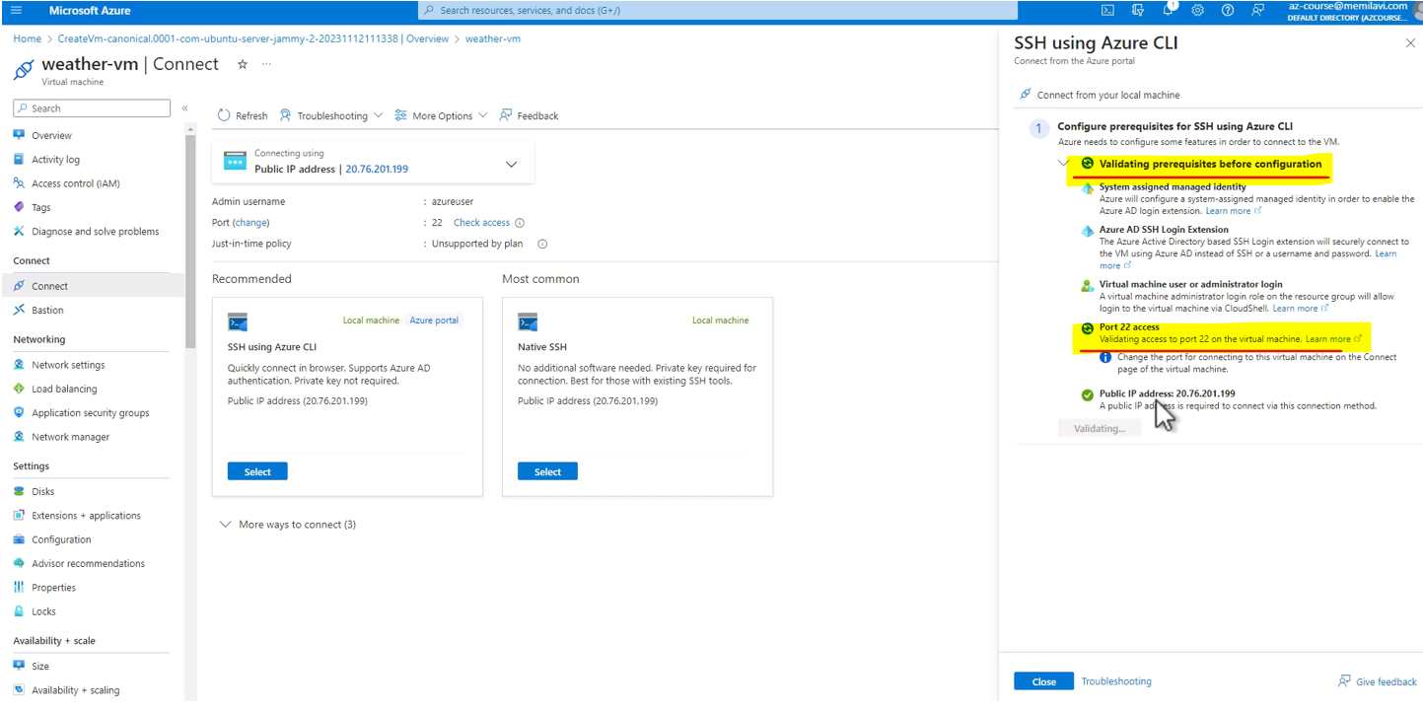

Great, check this box, and Configure + connect, and now, Azure is configuring this machine, so that we will be able to connect to it from the portal.

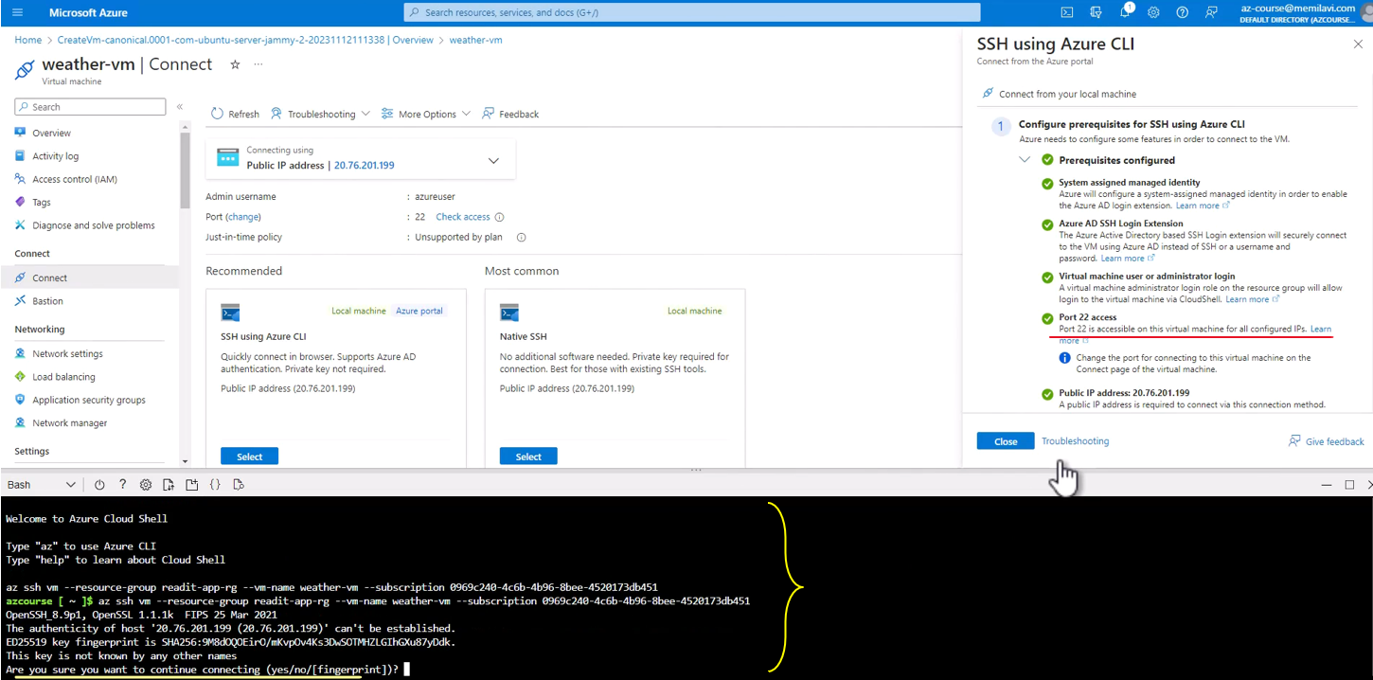

Again, this will take a few seconds, and it is required only in the first time that we connect to this machine. Great, and Azure Shell is now opening, and we can connect to the machine using the Cloud Shell. So, "Are we sure we want to continue connecting?" Yes, we are. So, let's continue with that.

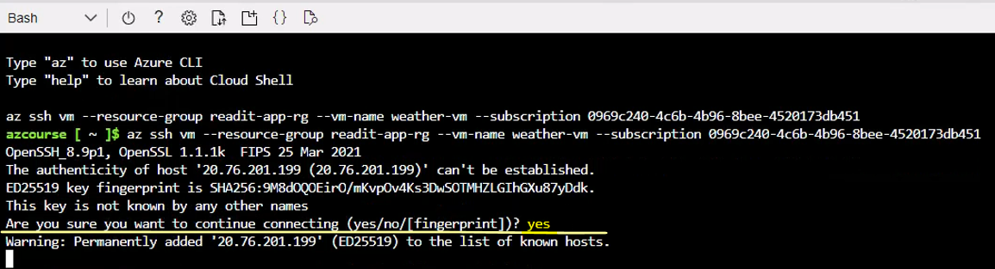

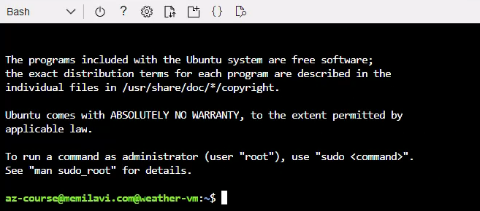

Now we are connected to this machine using Cloud Shell, and note, that until a few months ago, then you had to download an external tool, such as PuTTY, in order to connect to a Linux VM in Azure, but now, with this new addition, it's much easier to do that using the cloud shell and Azure CLI. Great, now, what we want to do now is to configure this machine for running .net apps, and then install the weather API, and for that, download and open the weather API commands .txt file from the resources of this lecture and open it, so I will do that, also. Here is the file, let's open it, and yes, I want to do that in Notepad.

$ sudo apt install git

$ sudo apt update

$ sudo apt install nodejs

$ sudo git clone https://github.com/memilavi/weatherAPI.git

$ cd weatherAPI

$ sudo apt install npm

$ npm start

Let's just resize the window, so that it will be easier for us to see what exactly is going on here, and we can close the Downloads page, and these are basically the commands that we are going to run here, so let's do that, and let me first enlarge the text, so it will be easier for you to see what exactly I'm doing here. So, now, we are basically going to simply copy and run the commands in this text file, and at the end of this process, we will have an up and running weather API, providing a, well, random weather forecast to anyone who is calling it. So, the first thing we need to do is to install the Git package on the machine. Note that this package might already be installed on the machine, but just to be on the safe side, let's install it here, so paste and hit Enter, and yes, Git, in this case, is already installed on the machine, which is great.

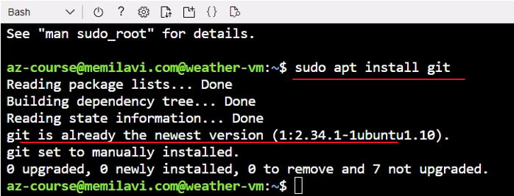

Next, let's make sure all packages are up to date, so copy the second command, and again paste it here, and run it. Okay, and we are up to date. Next, we need to install nodejs, and the reason for that is because the weather API is developed using nodejs, so we need to install this runtime on this machine, so, again, copy this command and run it, and yes, we are sure we want to continue, and it will take a few seconds.

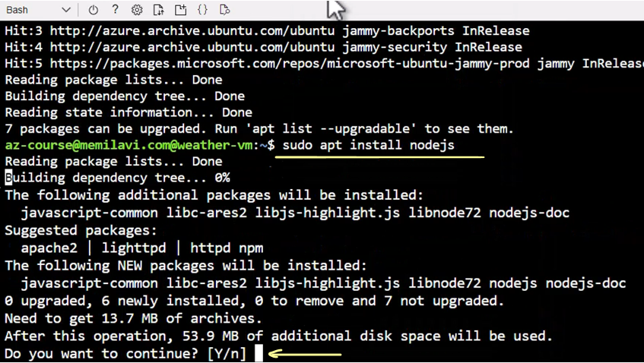

Great, and nodejs is installed. Next, we are going to clone the weather API from GitHub, and I have a public repository with this code, so all we need to do is simply to clone this repository, so copy the git clone command from here, and, as before, simply paste it here and hit Enter. Great, and the code was cloned.

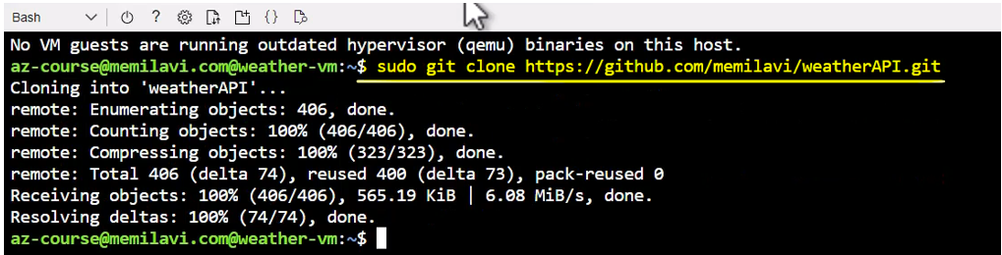

Now, let's go into the weather API folder that was created for the clone, so either copy or simply type, "cd weatherAPI," and here is a new folder. Let's take a look at what exactly is in this folder, so, "ls," and these are the files inside this folder. So, we have the index.js, which is the most important file here, and the ones that's getting the request and returns will random with a forecast. We have the package.json, indicating the required packages for this API and the node models folder, containing all the packages that are required for this API to run. Great, so, we are in the weather API folder.

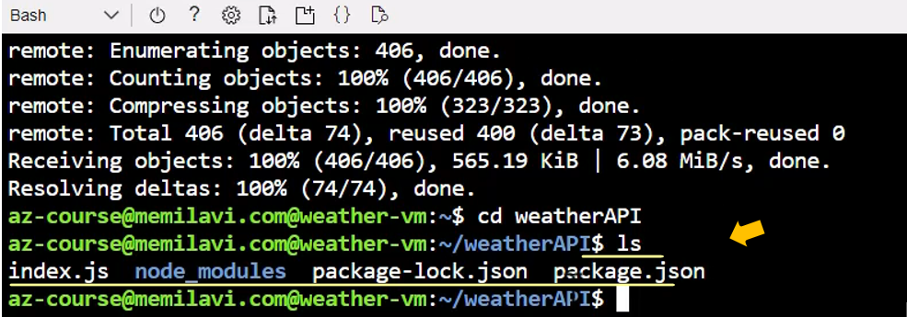

Now, we need to install npm, and npm is required to manage the packages in node.js and to run the app. So, now, copy this command and paste it here, and yes, we definitely want to continue.

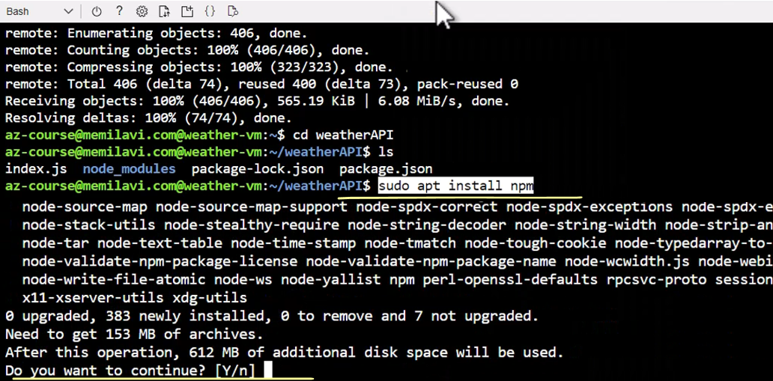

Great, and npm is now installed. So, the last thing that we need to do is to actually run this API, and for that, we have the last command, "npm start," so you can either copy it or simply type it here, which is what I will do. So, "npm start," like this, and hit Enter, and let's see what will happen. So, our app is up and running and is listening on port 8080

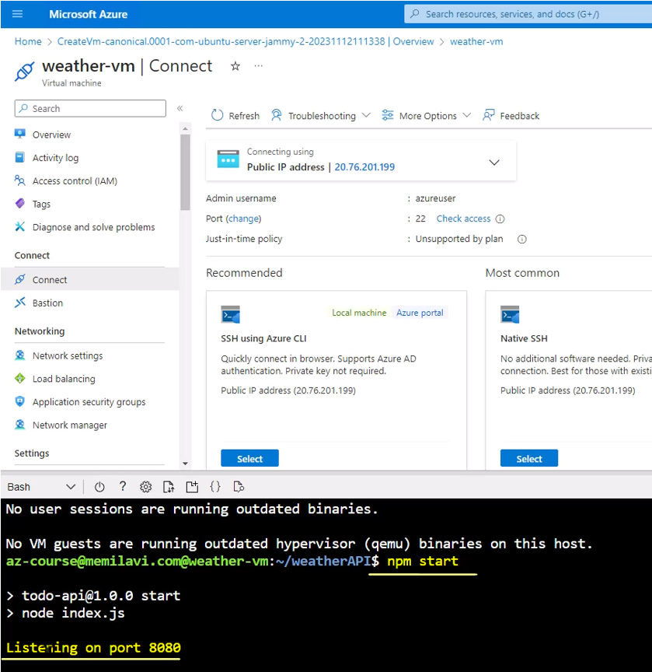

So now, let's find out whether it actually works. Now, for doing that, let's go to the overview here, and make sure not to close the Cloud Shell, and note the private IP address here, and we are going to use this private IP to connect from the catalog VM or from the catalog app to the weather VM, and we are going to use private IP address, because they are both located in the same vnet, or the same network, and therefore, can connect using the private IP address.

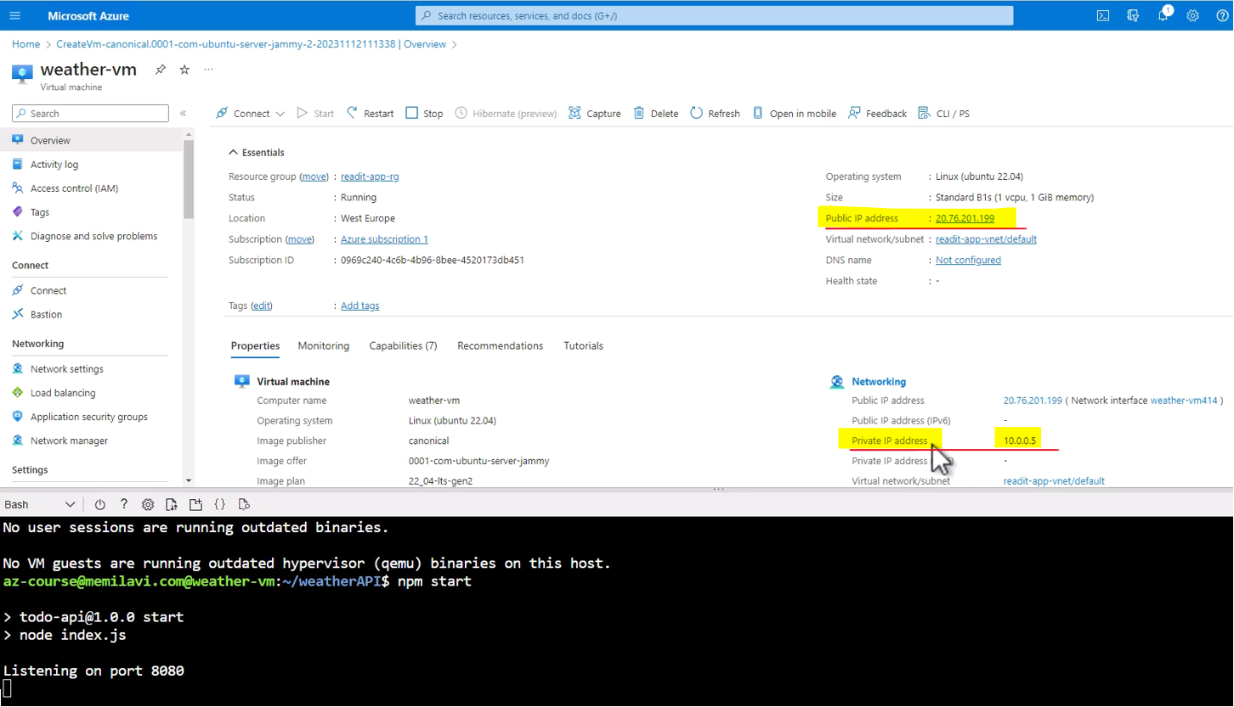

So, let's see whether that's indeed the case, so copy this IP address, and go back to the RDP connections that we have for the catalog VM, and paste it here, and add the port, 8080, and click "Get Weather," and here is the response. We've got a response from the weather API with a weather forecast. Let's try that again, so click "Get Weather," again, and it looks like it is running.



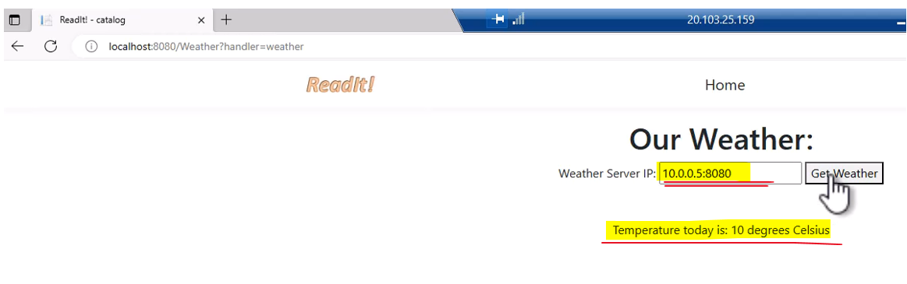

Now, note again, that we are using the private IP address of this machine. What will happen if you will use the public one, which is this one, in my case, so let's see. Let's copy this IP address, and go back to the RDP

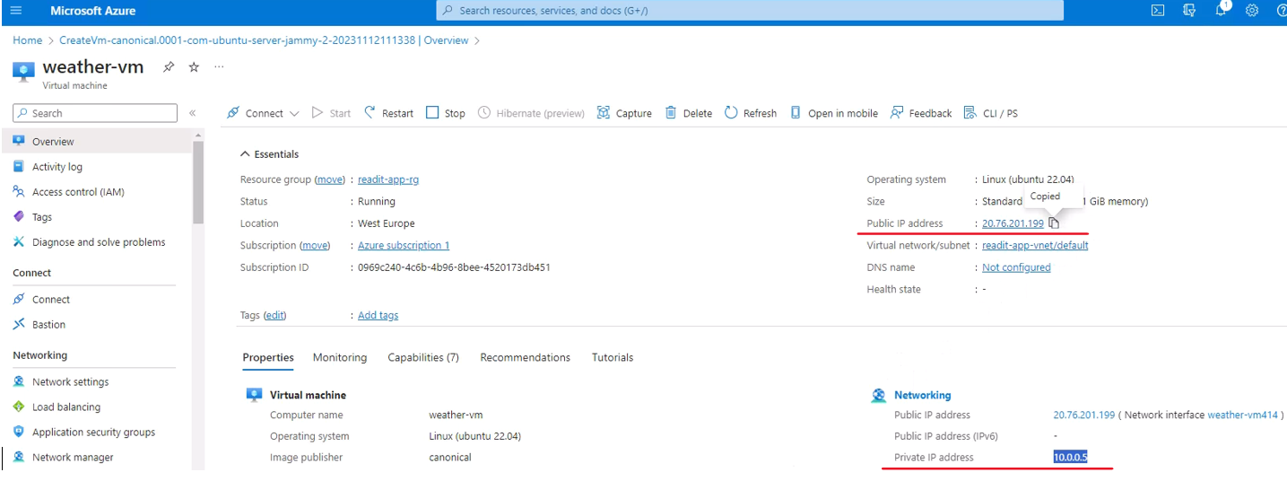

and replace this IP address with this one, and click "Get Weather," and it looks like, now, the catalog app has a hard time accessing the weather API. You can see that we get no response.

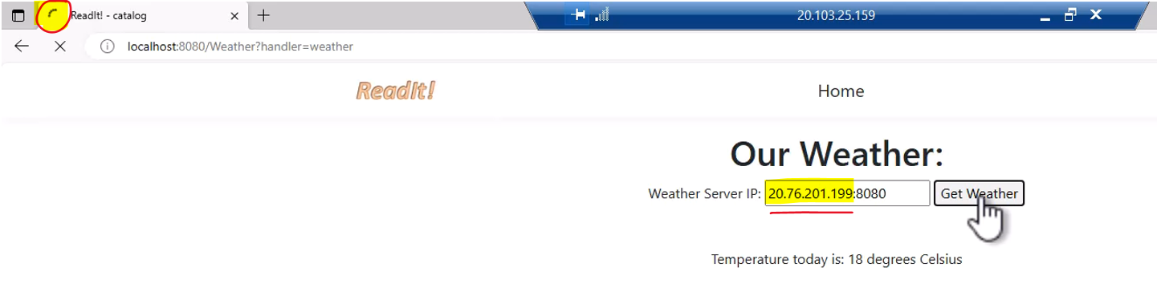

Let's give it another few seconds, and some more, and we've got an error message, and basically we get this error since we can't really access the weather API from a public IP address, and did that, because we didn't allow this connection to happen

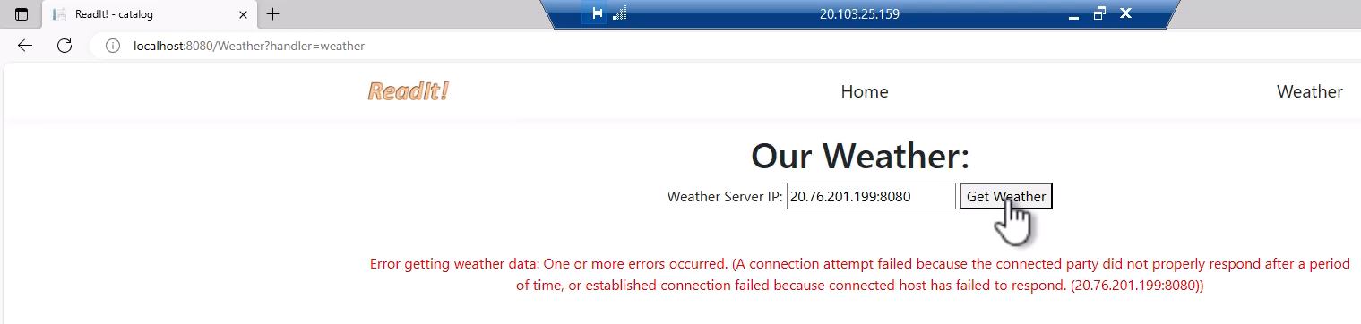

and the only way to connect to the weather API is through its private IP address, and this way, we can make sure that only allowed parties can access this weather API. So, let's go back to the private IP address, so again, copy it from here, and back to the catalog VM, and, as before, let's paste the private IP address, and try again, and again, we get a response.

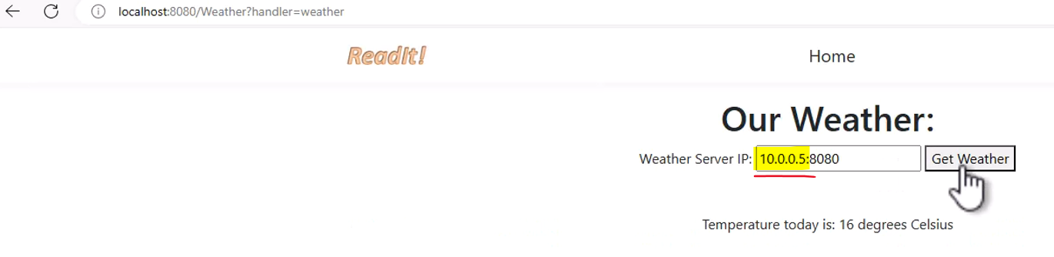

So, our weather API is up and running, and now, we have two virtual machines, one for the catalog and one for the weather. They are both in the same virtual network and can connect with each other.

### Virtual Machine – Tips and Tricks

* If your VM needs more disks, in addition to the default one provided by Azure, then go to the Disks page for that, and add whatever disk you need. Don't forget that disks have costs, and check it in the calculator beforehand.
* Want to backup your VM so that it can be restored in a case of failure? Check the Backup page, where you can define the frequency of the backup and the retention period.
* You can define DNS name for the VM, so that it will be accessible not just using its IP. This can be done by clicking the DNS Name: Configure link in the Overview page.

Don't forget to write down the addresses (IP + Port) of the Catalog app and the Weather API in the Resources Helper List, this will come in handy later. Have you done that?

**. . . contd in next document as this one becoming too large . . .**